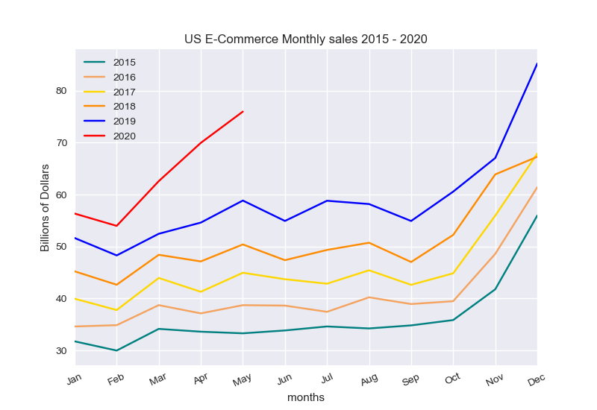

The above chart shows in store sales for five full year from 2015 to 2019 and for 2020, the first five months. We can see historically March is the first month to show an increase in monthly sales each year, in fact all retail sales follow the same basic monthly trends whether in store or online. We see above that April sales for online purchases generally drop off, though in 2019 there was a slight increase, and for May there has been a consistent increase. However, for 2020, due to the COVID situation and lockdown starting mid-March, E-commerce has shown a considerably steeper increase in March sales than normal, followed by increased April sales, rather than the norm of a drop.