This was first attempt to set up ad-hoc wireless (on the ZBox)

$ sudo service network-manager stop
$ sudo ip link set wlan0 down
$ sudo iwconfig

lo no wireless extensions.

eth0 no wireless extensions.

wlan0 IEEE 802.11bgn ESSID:off/any
Mode:Managed Access Point: Not-Associated Tx-Power=15 dBm
Retry long limit:7 RTS thr:off Fragment thr:off
Encryption key:off
Power Management:off

$ sudo iwconfig wlan0 mode ad-hoc
$ sudo iwconfig wlan0 channel 8
$ sudo iwconfig wlan0 essid '<ssid here>'
$ sudo iwconfig wlan0 key <key here>
$ sudo ip link set wlan0 up
$ sudo ip addr add 192.168.4.1 dev wlan0

This is part of second attempt... may have affected third attempt as it's still in the file (ZBox)

sudo nano /etc/network/interfaces

add these lines at the end of the file

auto wlan0

iface wlan0 inet static

wireless-mode ad-hoc

wireless-channel 1

wireless-essid '<ssid here>'

wireless-key <key here>

address 192.168.4.1

netmask 255.255.255.0

gateway 0.0.0.0

Third and final attempt, but still doesn't work 100% of boots (ZBox)

Right-click wireless icon in taskbar, “Create new wireless network...”

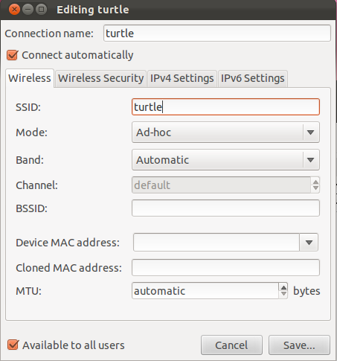

Now, on the second computer (laptop)

Connect to the network with SSID you set on the ZBox (might take a while to show up)
It'll fail after a while (even with right password)

Edit the connection
Go to the IPv4 tab
Choose Manual
Address 192.168.4.2
Netmask 255.255.255.0
Gateway 0.0.0.0

After that, connection is successful

