Doug Branton
COSC 519
Homework 1

1. Install Ubuntu VM on your own Desktop or Laptop to do this homework. You can also use any other VM or Linux environment of your choice and also use our labs.
[Done]

2. Learn about 50 distinct commands of Linux/Unix OS by running them on thesystem. Each command must be a distinct one, not with different optionsin the same command.
1-5. ls, cat, cd, head, tail
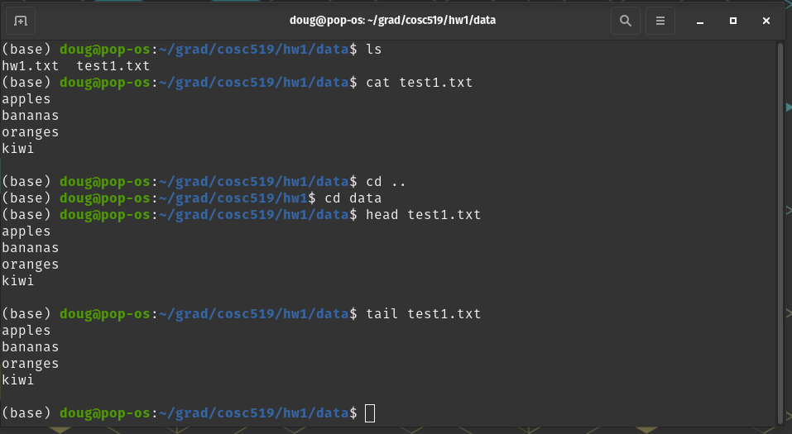

6-20: mkdir, pwd, mv, rm, touch, cp, id, who, w, ps, uname, uptime, hostname, date, last

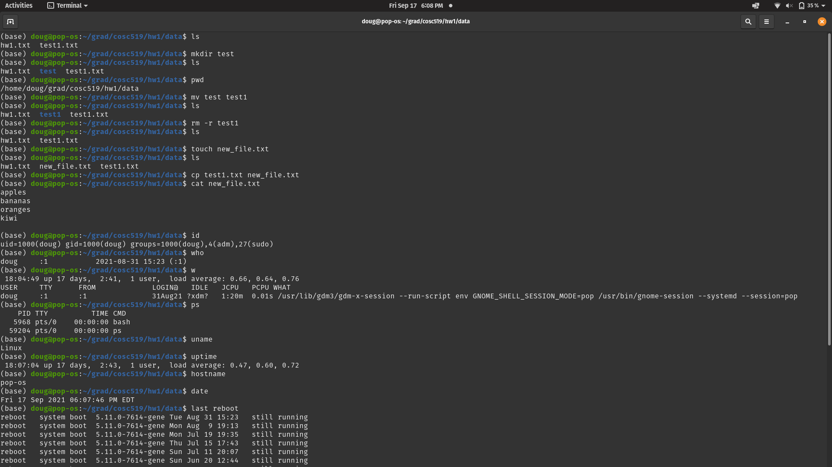
21-26: chmod, cal, whoami, df, sudo, fdisk
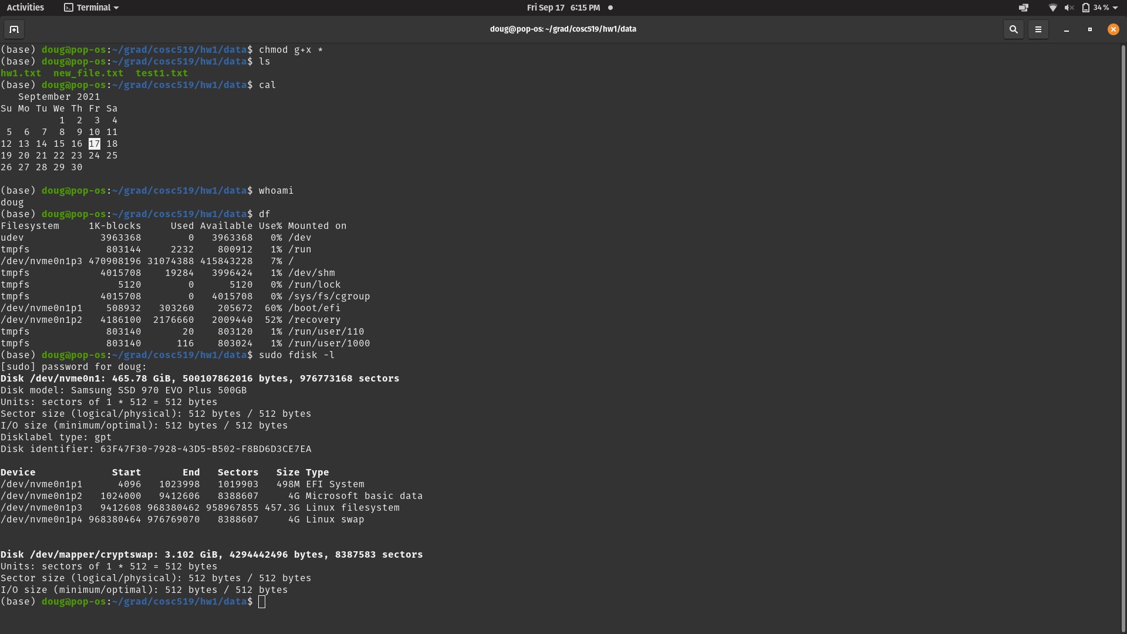
27-30: netstat, ifconfig, cmp, comm

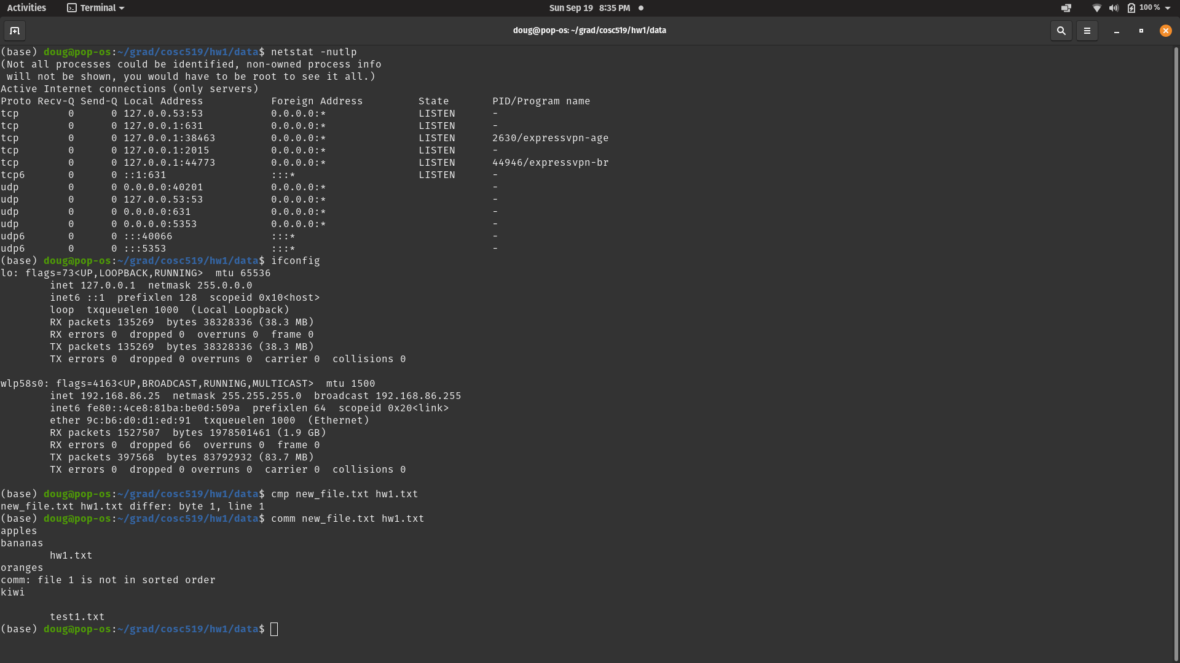
31-39: diff, dir, diff3, dircolors, dirs, du, file, gzip, gunzip
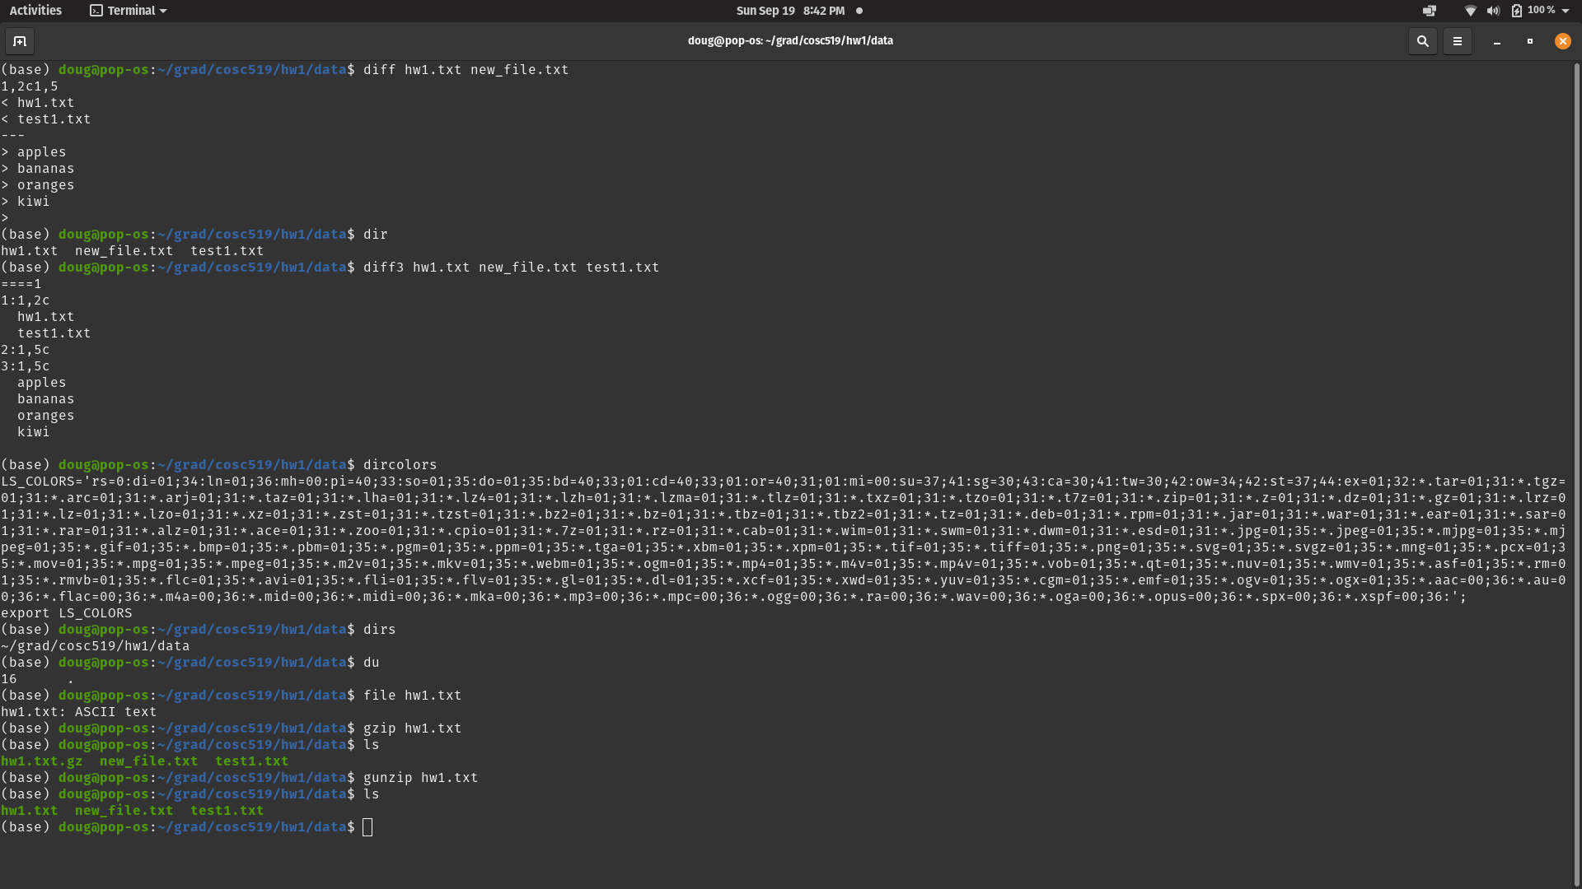
40-50: logname, nl, rev, scp, sort, sum, type, tty, which, !!, vmstat

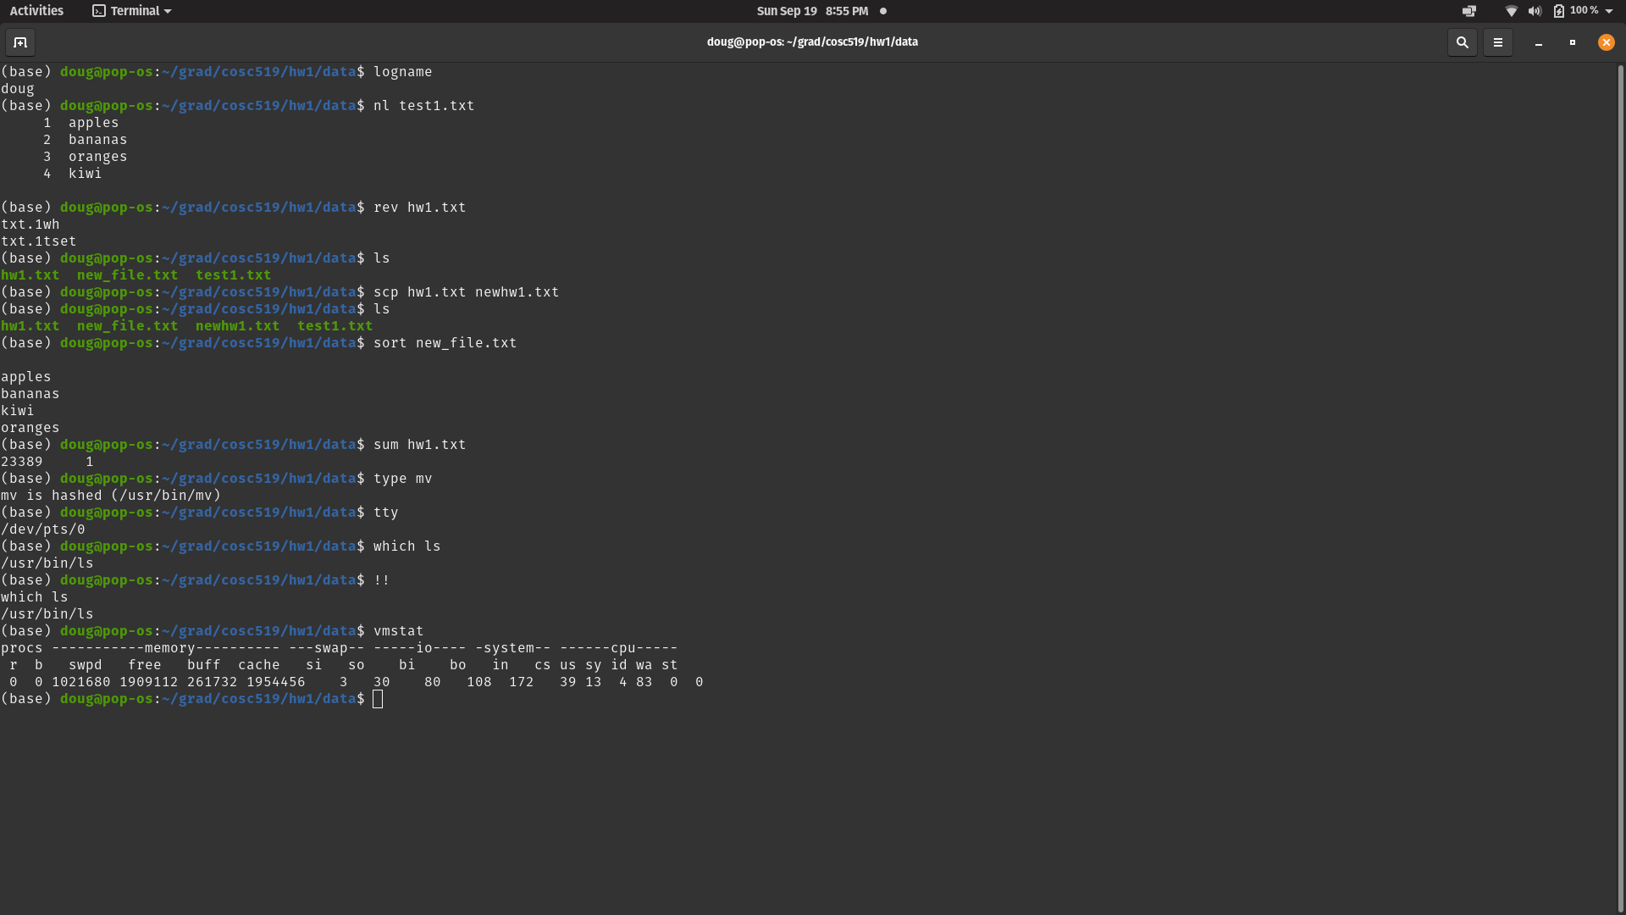
3. Learn the command (Objdump ) some options to capture output. Use some real *.obj or *.exe files to test this command.
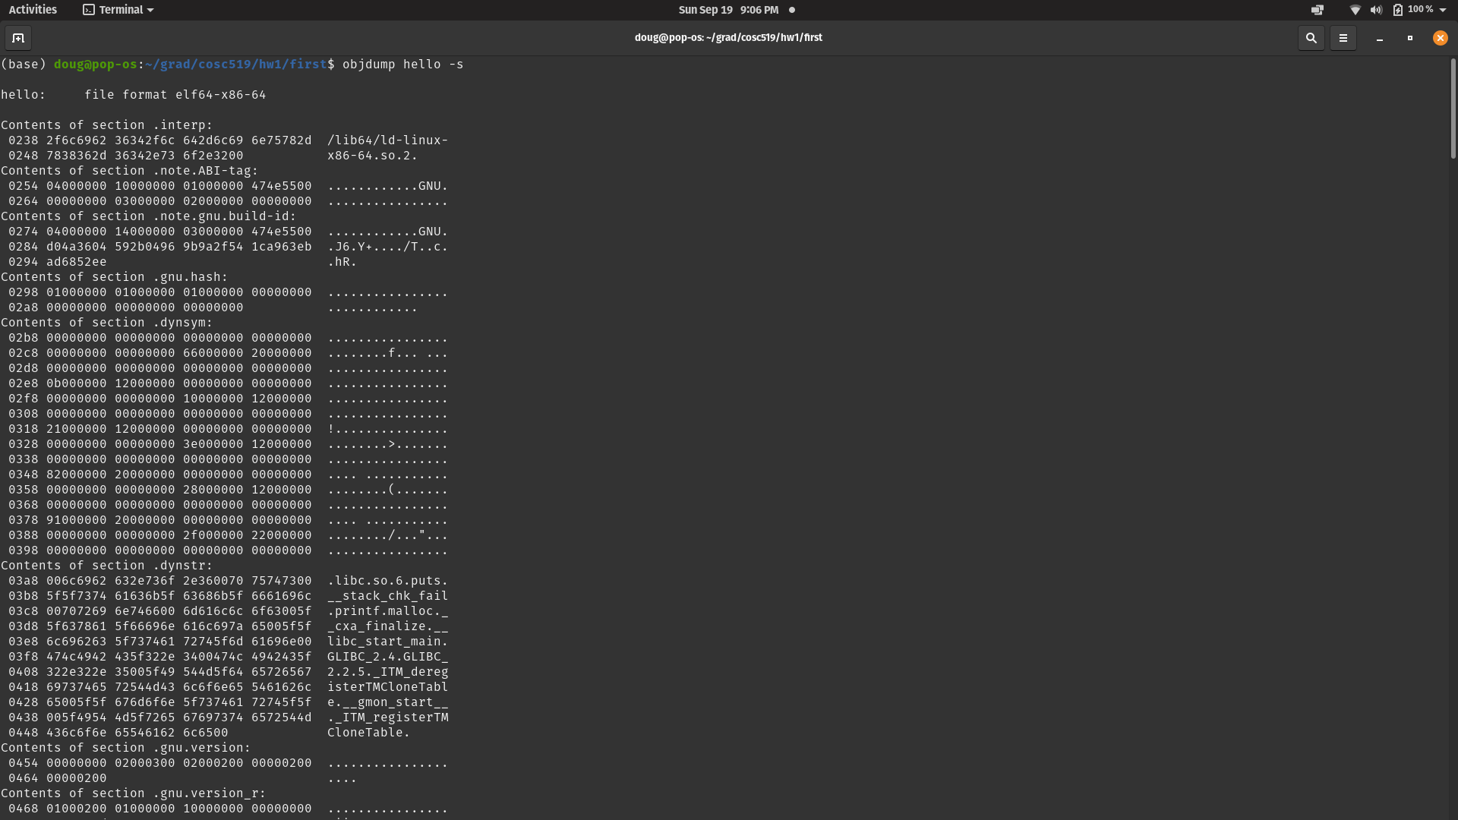
[Results truncated]
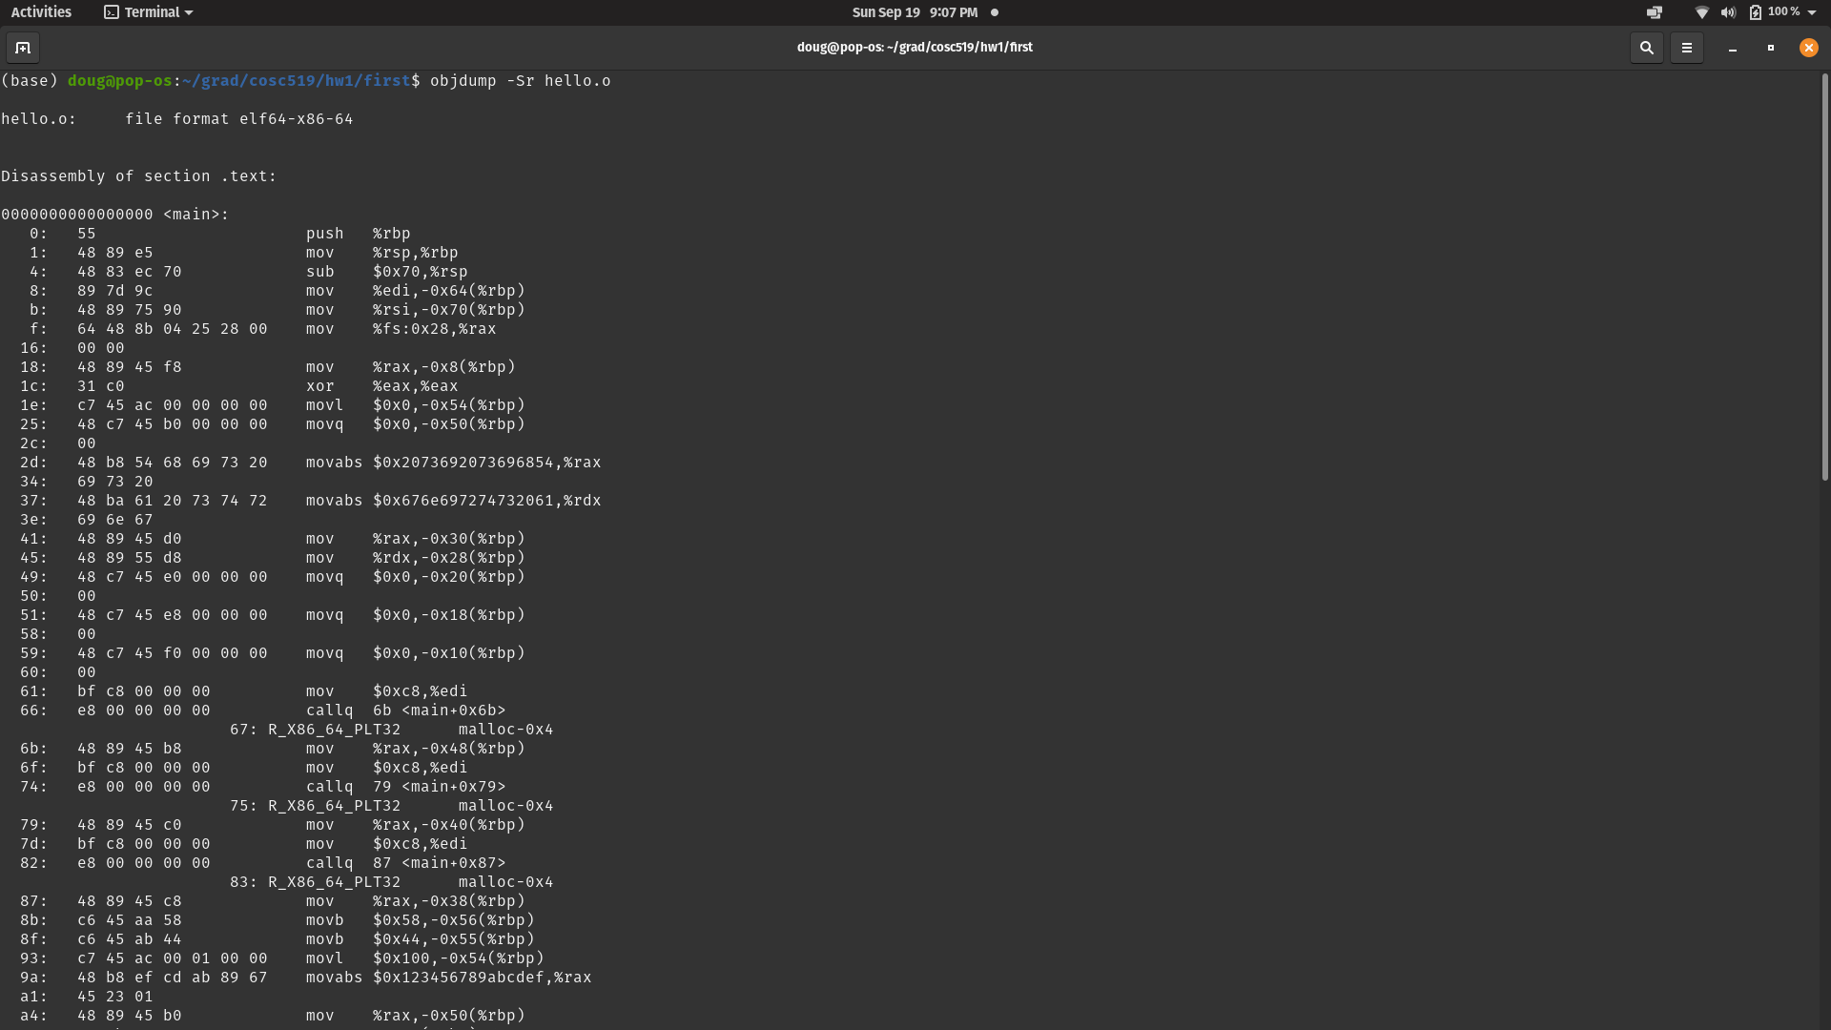
[Results Truncated]

4.Learn “find” and “grep” commands and show some examples of their usage. Create some dummy directories and data to test these commands.
Find: Search for files and directories based on specified conditions
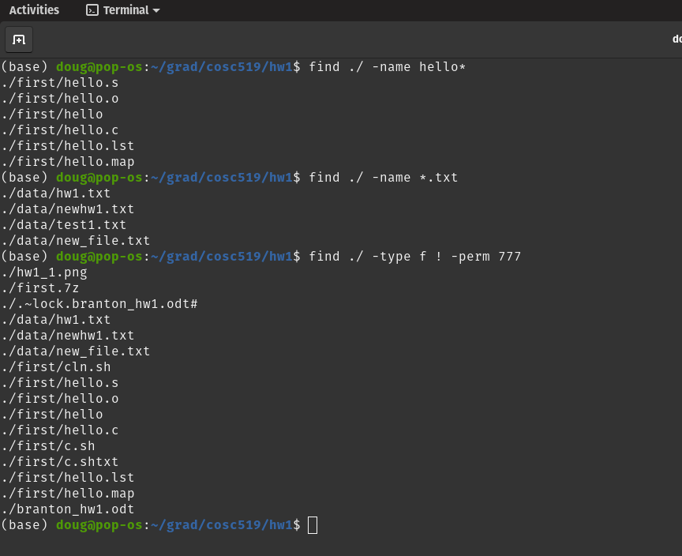
Grep: Search files for specified character patterns
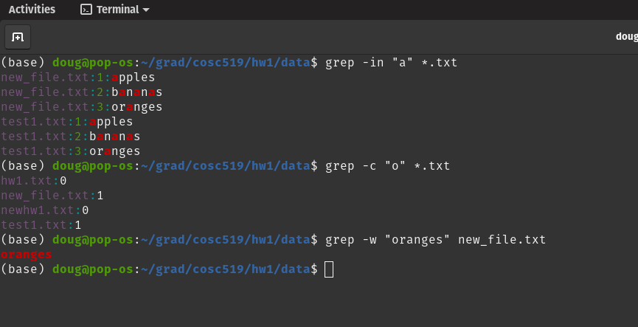

5.Write a small Linux shell program or get any sample from the Web and run it and show the results. Include your shell program and results with the homework (a reasonable size shell program).

save_sum.sh file and output:
