Flex

Flex is a C++ program which uses regular expressions to parse an incoming file. The most common tokenization function is a string tokenizer where we create strings by using white space as a delimiter. A common idiom for string tokenization is to start with an input stream then parse it into tokens like:

String input;

StringTokenizer stTok = new StringTokenizer();
while(stTok.hasMoreElements()){
String token = stTok.nextElement();
}

To create a compiler we first tokenize the file with the program code in it, then we build a parse tree, we annotate the parse tree by creating metadata which we will cover in later documents and we submit the parse tree to an assembly language generator which in our case is a MIPS simulator. Even though none of our computers run MIPS assembly code, we can still see functioning output using the simulator. Creating a hello world program or any program with a text output should work. This skill is required for open source components like Apache Pig, Apache Hive, and any open source database which implements SQL.

This handout starts with the easy lexical analysis examples first as none of the documentation is clear on what lexical analysis does beyond the simple statement of tokenization. The difference between using flex and the simple string tokenizer statement above is we are using regular expressions to reduce the amount of code we have to write. The simple string tokenizer example above only creates a string of tokens. We have to not only create a string of tokens but we have to figure out when a token is a comment which we ignore, a reserved keyword, a definition of a class, a variable, an error, a class, a type, a function, an expression, or a statement. Each of these cases requires implementing additional logic which we implement in c/c++ and flex rules.

To use flex lets start with the simplest example.
1) Copy cool.flex.SKEL to cool.flex,
2) run make lexer and then
3) run lexer test.cl where test.cl contains the DARROW symbol or =>

You should see an output which looks like:

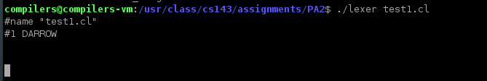
The output for the lexer is the list of tokens denoted by #1. This is the line number of the token.

In file cool-parse.h you will find a list of tokens. The PA1 assignment handout briefly mentions this but it should be made more clear. No way someone seeing this for the first time will understand the implicaitons of the short explanation in the handout.

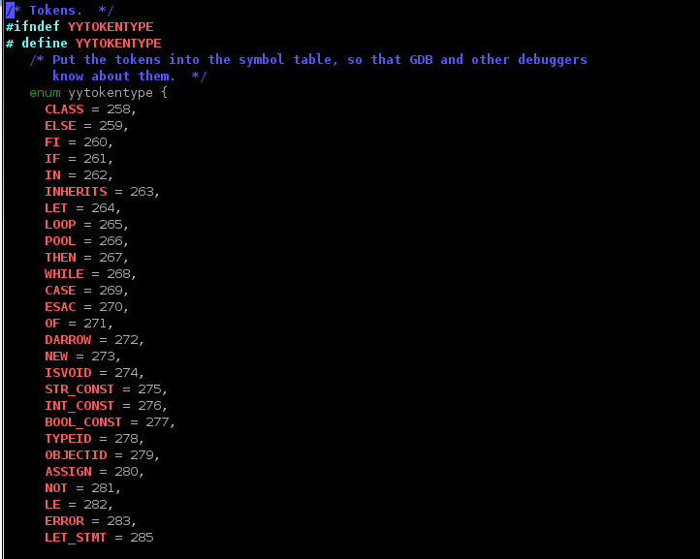

The screenshot above only captures part of the list. Scroll down in your display to see the rest.

The simplest tokens are the keywords most of which are reserved words. Some of the RED BOLD words are not simple keywords like INT_CONST, STR_CONST, BOOL_CONST, ERROR, LET_STMT, iSVOID, and TYPEID.

The cool.flex.SKEL gives an example using the DARROW symbol. Unfortunately there is no explanation. We are supposed to return tokens which are ints defined using an enum yytokentype.
To use this we create FLEX rules which recognizes the keyword in a cool code text file matached with an ENUM yytokentype. So for the keyword “class” we return the token CLASS. The example he gives us uses matches the symbol “=>” with the token DARROW. Under the flex section denoted with a starting %% and ending %% add the strings to cool-parse.h types defined in yytokentype. Here is an example

%%
class {return CLASS;}

%%

1) Create a test file named test.cl with only the term class in it
2) add the class above which returns CLASS
3) run make lexer then ./lexer test.cl

Once this works, add all the terms in the cool-parse.h file which seem to have reserved words in it. The assignment doesn't give you the reserved words. Nor does the language specification. They should as this underspecification makes it hard to learn.

Keep on adding more terms and rules incrementally. I created a separate file test1.cl with
=>
if
fi
case
esac

Output below:

#name "test1.cl"
#1 DARROW

#1 CASE

#1 IF

#1 FI

#1 CASE

#1 ESAC

The line numbers are all #1 because we haven't added rules to look for \n and increment the line number when we see a new line.

Add this rule and verify you see the line numbers:

[\n] {curr_lineno++;}

compilers@compilers-vm:/usr/class/cs143/assignments/PA2$ ./lexer test1.cl
#name "test1.cl"
#1 DARROW
#2 CASE
#3 IF
#4 FI
#5 CASE
#6 ESAC

Boolean identifiers are either true or false. Create a cool.cl file with the values true and false verify you can get true and false in the output.

Add the following rule for boolean values and run make lexer and ./lexer testbool.cl where testbool.cl contains the boolean values true and false on separate lines.

true|false {
if(strcmp(yytext,"true")==0){;
cool_yylval.boolean=1;
}else{
cool_yylval.boolean=0;
}
return BOOL_CONST;
}

Our cool.flex file now looks like:

*
* Define names for regular expressions here.
*/

DARROW =>
LE <=
DIGIT [0-9]
LETTER [a-zA-Z: _]
SPACE [ \t\f\r\v] /*not sure about the \v vertical tab */
%%

{DIGIT}* {
/*this is wrong? should use add_int? after converting string to int*/
cool_yylval.symbol = inttable.add_string(yytext);
return INT_CONST;
}

/*
* Nested comments
* this is hard, requires keeping some state...
*/
/*
* The multiple-character operators.
*/
/* trick darrw is ge symbol */
{DARROW} { return (DARROW); }
{LE} { return LE; }

/*
* Keywords are case-insensitive except for the values true and false,
* which must begin with a lower-case letter.
*/

class {return CLASS;}
else {return ELSE;}
fi {return FI;}
if {return IF;}
in {return IN;}
inherits {return INHERITS;}
let {return LET;}
loop {return LOOP;}
pool {return POOL;}
then {return THEN;}
while {return WHILE;}
case {return CASE;}
esac {return ESAC;}
of {return OF;}
new {return NEW;}
isvoid {return ISVOID;}

true|false {
if(strcmp(yytext,"true")==0){;
cool_yylval.boolean=1;
}else{
cool_yylval.boolean=0;
}
return BOOL_CONST;
}

/*
* String constants (C syntax)
* Escape sequence \c is accepted for all characters c. Except for
* \n \t \b \f, the result is c.
*
*/
[\n] {curr_lineno++;}
%%

Test the lexer using a file with true and false in it.

compilers@compilers-vm:/usr/class/cs143/assignments/PA2$ cat testbool.cl
true
false

You should see:

compilers@compilers-vm:/usr/class/cs143/assignments/PA2$ ./lexer testbool.cl
#name "testbool.cl"
#1 BOOL_CONST true
#2 BOOL_CONST false

Change the boolean rule to the Cool Reference manual where the boolean constant true begins with a lower case t and the letters after t can be upper or lower case. Same with false. (this is a waste of time to define such a rule. Time should be spent on other aspects of the lexer. Unwise definition of assignment)

t[Rr][Uu][Ee] {
cool_yylval.boolean=1;
return BOOL_CONST;
}

f[aA][lL][sS][eE] {
cool_yylval.boolean=0;
return BOOL_CONST;
}

OK create a test file to test this lexer rule.

compilers@compilers-vm:/usr/class/cs143/assignments/PA2$ cat badbool.cl
true
false
tRUE
tRuE
fAlse
fALSe

compilers@compilers-vm:/usr/class/cs143/assignments/PA2$ ./lexer badbool.cl #name "badbool.cl"
#1 BOOL_CONST true
#2 BOOL_CONST false
#3 BOOL_CONST true
#4 BOOL_CONST true
#5 BOOL_CONST false
#6 BOOL_CONST false

IntConstants are integer numbers. We should have a set of rules to over all the numeric types which include floating types, exponents and everything which you see in a normal programming language. I'm not sure if this is part of the Cool programming language specification. Add a rule to identify int constants. In a statement like int a =10; lets try to recognize the 10 first. A test file for this just contains numbers. We have to use regexs to determine what an int constant is. For now lets just assume a string of digits is an int constant.

{DIGIT}* {
/*this is wrong? should use add_int? after converting string to int*/
cool_yylval.symbol = inttable.add_string(yytext);
return INT_CONST;
}

String Constants: there is a difference between a string constant which is a string delimited with quotes and a string which is an identifier. The PA1 assignement handout has some strange rules, let's ignore those for now and assume a string is just a series of letters starting with a double quote and ending with a double quote. This gives us practice with the stringtab.h tables first before getting confused with too many new topics.

A simple string constant is a pattern defined starting with a quote and everything before the next quote. This isn't the Cool definition but let's start with a simple case first. A “asdf” is a string constant.

The start condition

Single characters are returned as characters and not tokens. These include end of line terminators like the semi-colon. Add this rule and return the character. Don't return a reserved token. They didn't do a good job explaining this in the lecture. We will need this for expression evaluation (won't make sense till later).

Single char punctuation characters.

"+" {return '+';} /* for expressions, not implemented yet do nothing fo$
"-" {return '-';} /* for expressions, not implemented yet do nothing fo$
";" {return ';';}
"{" {return '{';} /* begin scope do nothing for now*/
"}" {return '}';} /* end scope do nothing for now*/
"." {return '.';}
"(" {return '(';}
")" {return ')';}
":" {return ':';}

Identifiers. There are different types of identifiers. An identifier can be at variable name like the variable a in the program statement “int a =10”. We have a flex rule to recognize the 10 which we just completed. The file stringtab.h describes a symbol table which holds the data structures for storing identifiers. The handout mentions we use the symbol tables to save memory and we need to use the data structures for other tasks like error detection such as determining if a class name has already been used.

What happens if we see some input which does not match any of the flex rules? This creates an error condition and generates an error message. The error detection logic isn't part of a grammar.

Variable Identifiers:
There is a difference between a statement like class foo, void foo() and foo=10. In the first case the identfifer when it follows the class keyword is a class identifier. In the second case foo is a function identifier, and in the third case foo is a variable identifier. We don't perform the disambiguation here in the lexer. Our job is to determine if the word foo is an identifier. Since we know class is a reserved word we know class won't be classified as an identifier. The function identifiers in foo() and the variable identifier foo=10 are both equivalent. Let's write a rule to filter identifiers following the assumptions above. This isn't the cool language specificaiton. We are starting with a simple case first then we will modify it to fit cool.

TYPEID identifiers:
Types and classes are the same in Cool; they both begin with an upper case.

OBJECT IDs: begin with lower case and represent objects in Cool. Function names are object Ids.

Flex Notes, for me only. Can't remember how to use it:
This isn't necessary for creating the rules:
yylval is the global variable shared between yacc and flex. Yacc builds a parse tree and flex tokenizes the input file. As we tokenize the input stream of a program we have to annotate and do processing of tokens. Simple tokens like reserved words require no processing but identifiers require a lookup to make sure there are no duplicates. When processing inheritance we have to copy data from the parent class into the child classes. When tokenizing we add data into yylval which is passed to yacc which uses the additional information in the union to build nodes in the parse tree.

This is extremely confusing. First cool.flex has:
#define yylval cool_yylval which takes the global yylval variable and creates a pointer called cool_yylval to the same memory location.

Then they use YYSTYPE cool_yylval which declares cool_yylval and yylval to be of type YYSTYPE which is a union defined in cool-parse.h. He could have just left it at yylval using extern YYSTYPE yylval.

The union is defined in YYSTYPE using typedef union YYSTYPE in cool-parse.h. This union looks like:

Boolean boolean;
Symbol symbol;
Program program;
Class_ class_;
Classes classes;
Feature feature;
Features features;
Formal formal;
Formals formals;
Case case_;
Cases cases;
Expression expression;
Expressions expressions;
char *error_msg;

NOTE: we have to set the error_msg pointer to a valid error message when we see a lexical error.

- yylex is a reserved word and reserved function with the signature int yylex(). The yylex() function is called by yacc when it wants the next token. We use global variables to communicate between the 2 programs.

YYUSERACTION: This is a reserved function allowing you do put in functions in the flex workflow. Flex generates file cool-lex.cc which is linked in with the rest of the code.

yyloc is the column number of where you are in the file. This is required for error messages so you know where in the line the error is. We have to pass this location of each token from the lexer to the parser.

