**Munin/Nagios Install, configuration and testing.**

The goal of this document is to create a customizable monitoring system for MongoDB consisting of munin and nagios. Munin is the server collecting statistics from MongoDB where Nagios is the alterting mechanism.

References: Learning Nagios 3.0 , Wojciech Kocjan ,Packt Press

References; web search for Munin. All material from online search.

There are some parameters you will need access to. These are my personal observations on how MongoDB works in the last 2 weeks so they may not be relevant in the Mongo 2.2. I am using Mongo 2.06.

1. Global Write Lock: mongodb has a global write lock. There is a way to display the write locks using the github mongo_lock script. This is not available from MMS. If a global write lock on collection A blocks the writes and READS on collection B then this is a good place to find out why writes to collection B are being blocked.
2. One of the most common queries is select count(*) from table X. Mongo_BTree gives the size of the collection and parameters of the btree allowing debugging of the speed of read queries. By default all count(*) queries from MongoDB are slow.
3. Scans are slow, they are slower if there are other collections are being updated at the same time. (verify w/test case)
4. Read/write performance on different collections
5. System level stats like disk usage. Disk sizes grow until a compaction. The OS may report a disk full error message.
6. Memory usage, mongodb doesn’t page in indexes before data. This can be bad and is not the way relational databases work. This can result in unexpected performance degradations if users are expecting relational db performance. Mongo_mem for debugging if the indexes are in memory.

**The current mongo_X scripts need further debugging and have to be contributed back into the open source community. They aren’t production quality.**

**Munin setup:**

Install munin which consists of the Munin daemon and the munin node packages:

>sudo yum install munin munin-node

Note there are 2 separate packages being loaded and there are 2 separate conf files.

1. Munin.conf: uncomment the 4 directories

#

dbdir /var/lib/munin

htmldir /var/www/localhost/munin

logdir /var/log/munin

rundir /var/run/munin

#

# Where to look for the HTML templates

tmpldir /etc/munin/templates

# a simple host tree

[localhost]

address 127.0.0.1

use_node_name yes

#

1. Munin-node.conf, user from root to ec2-user

user munin

group munin

Restart the munin node:

>sudo service munin-node start

1. Install Apache Server,

>sudo yum install httpd

Once httpd is installed. Start the Apache server using >sudo service httpd start

Verify you can see the default Apache start page:

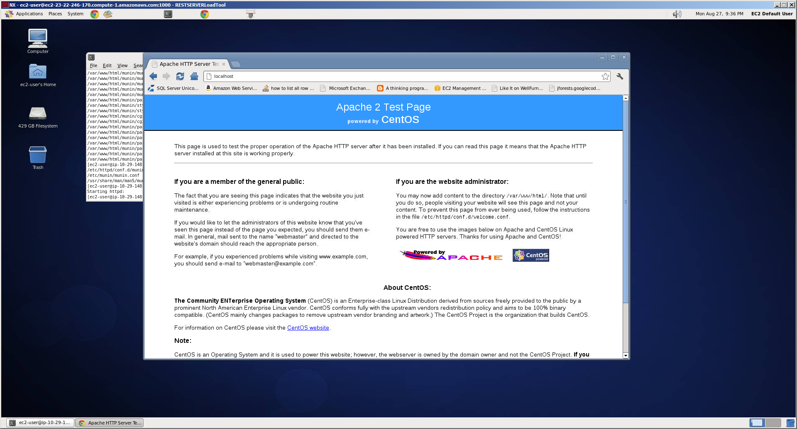

To make munin work you have to configure Apache or the httpd service to display the index.html from the munin subdirectory instead of the default Apache directory.

Modify the httpd.conf file to point to the Munin home directory.

Modify DocumentRoot entry: Httpd.conf: DocumentRoot,

Munin installs itself under /var/www/html. Note under the directory munin there is an index.html file. This index.html file is the default page Apache needs to display instead of the default index.html provided by Apache. To do this edit DocumentRoot to /var/www/www/html/munin or whatever path the munin index.html is at.

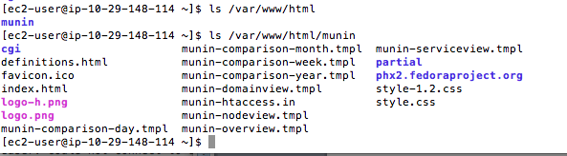

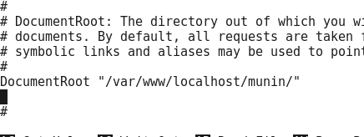

ExtendedStatus On

<Location /server-status>

SetHandler server-status

Allow from all

</Location>

Modify the server name:

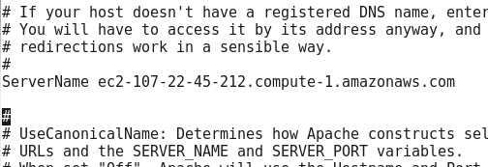

#

#

ServerName ec2-107-22-45-212.compute-1.amazonaws.com

#

If

Modify the Satisfy Any line under <Directory> tag. Comment it out so Apache won’t ask you for a login name/password when you try to access the munin pages.

<Directory />

# Satisfy Any

Allow from all

Options FollowSymLinks

# AllowOverride None

</Directory>

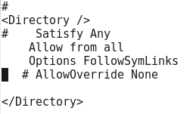

If after modifying httpd.conf you are still stuck with a munin login:

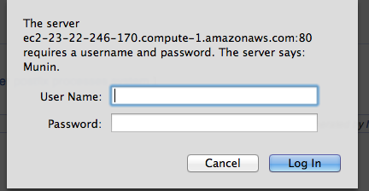

The files which control the munin login are under /etc/httpd/conf.d. The file munin.conf is appended to httpd.conf. You are supposed to leave httpd.conf as standard as possible and modify munin.conf for customizations. This isolates the changes to one file and allows people to reinstall httpd in a manner which doesn’t affect other services which may be depending on httpd.

Modify munin.conf as follows:

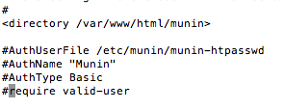

Restart munin-node using

>sudo service munin-node restart after modifying the munin.conf file.

Restart httpd after modifying httpd.conf

>service httpd restart

Goto <http://localhost>

Webpage should look like:

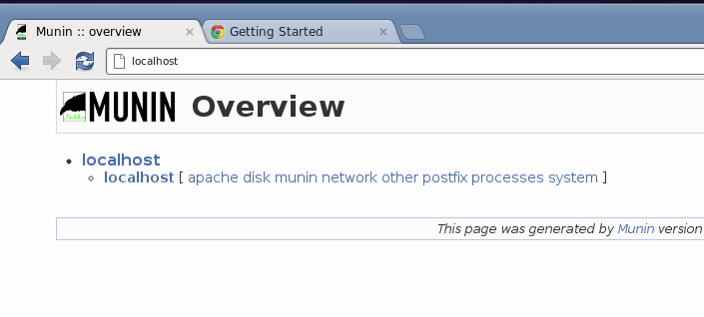

Click on one of the links to get the graphs.

**Starting munin:**

On power on munin does not automatically start for the default options after installation. Start httpd and munin-node to get the munin webpage.

Macintosh HD:Users:dc:Desktop:Screen Shot 2012-08-29 at 11.37.58 AM.png

Macintosh HD:Users:dc:Desktop:Screen Shot 2012-08-29 at 11.38.04 AM.png

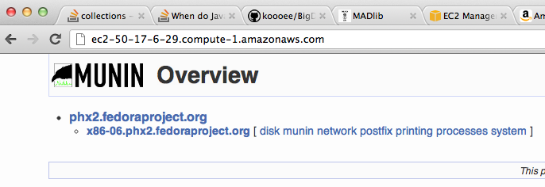

If a service is listed under /etc/init.d it may not be turned on when the instance/server is powered on.

TO turn on a service:

chkconfig httpd –add

chkconfig httpd on --level 2,3,5 (pick the level)

The levels of 2-5 will determine under which subdirectory your service start command goes under:

Macintosh HD:Users:dc:Desktop:Screen Shot 2012-08-29 at 11.50.41 AM.png

To turn off a service on the power on sequence:

chkconfig httpd off

On AWS after starting up a new instance, munin-node and httpd don’t start automatically if they aren’t in the rc.d directory under /etc/

**MongoDB Cluster mode:**

For MongoDB cluster mode you need to add an entry into munin-node.conf for each slave which lists the host name of the slave and allows the server into the node.

/etc/munin/munin-node.conf

host_name db1-ec2-174-129-52-161.compute-1.amazonaws.com

allow ^10\.194\.102\.70$

For the server you need to add into munin-node.conf an entry for each slave like:

[db1-ec2-174-129-52-161.compute-1.amazonaws.com]

address 10.202.210.175

use_node_name no

[db2-ec2-184-72-191-169.compute-1.amazonaws.com]

address 10.203.22.38

use_node_name no

There is a munin plugin especially for mongodb which provides B-Tree stats, current connections, memory usage and database operations(verify this is at least available in MMS)

The munin MongoDB plugin is only available via github checkout. wget http://github.com/erh/mongo-munin/tarball/master

Follow the tutorial for creating the load script, installing and coding it. This gives a good example of how to add in the additional munin plugins.

**How to test the Munin MongoDB plugins:**

>munin-run load, where load is the load.sh example.

Test the munin mongodb plugins by running munin-run on them. You should see text output:

A plugin generates text output and

**How to write a plugin:**

The plugin architecture for munin allows you to create customized reports for MongoDB. The existing github repos for monitoring MongoDB at: are not supported by MMS. If you want these reports you will have to install Munin and Nagios to provide alerts.

**Alerts: Use Nagios. Munin has problems when contacting more than one person/email. Hangs.**

**Nagios:**

Nagios comes standard in most Linux distribution repos.

>sudo yum install nagios should work for most distributions. 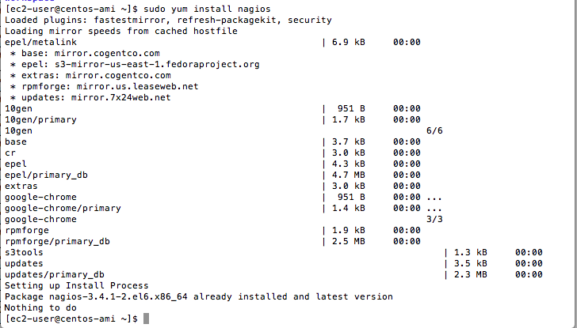

Nagios like all Linux services has it’s conf files in /etc/COMPONENT_NAME or /etc/nagios. We have to verify it works and is configured correctly to send out alerts.

After installation modify nagios.conf to turn off authentication so we can verify the install. This file is similar to the munin.conf file where we turned off Apache authentication:

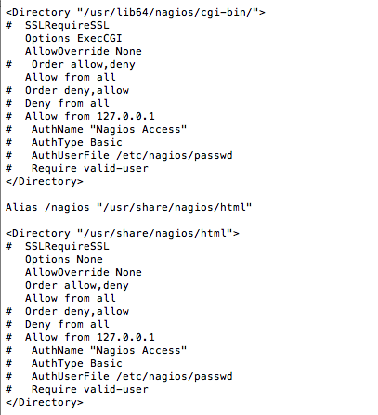

Go to http:://localhost/nagios

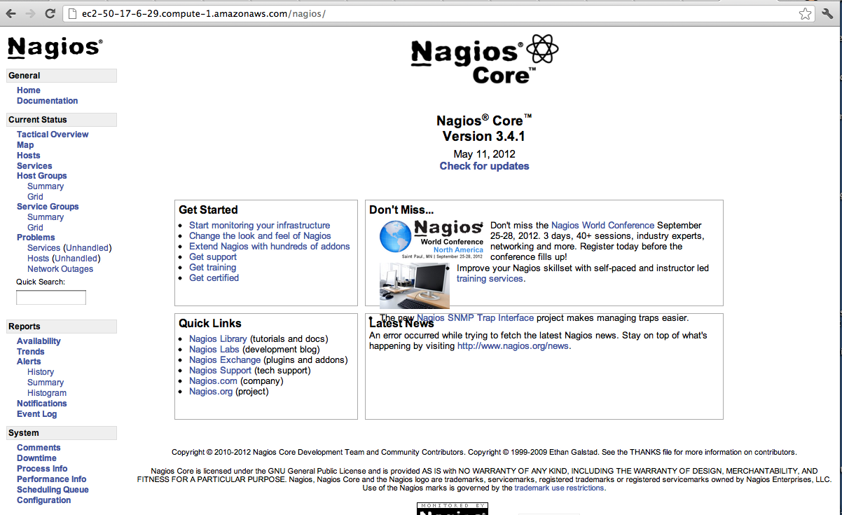

**Nagios:** [**http://www.susethailand.com/suseforum/index.php?topic=826.0**](http://www.susethailand.com/suseforum/index.php?topic=826.0)

**Change cgi.cfg use_authentication=1 to use_authentication=0**

**Missing section: have to add email configuration to AWS Servers, Need to set up DNS records.**

TBD. Low priority till MongoDB cluster runtime and testing done.

Reference: To setup munin alerts to Nagios:

<http://munin-monitoring.org/wiki/HowToContactNagios>

Munin communicates to Nagios via NSCA,

Install NSCA:

Download NCSA and cd into the directory. It should look like:

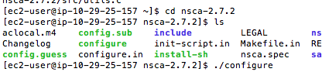

Install the gcc compiler and system libraries:

Macintosh HD:Users:dc:Desktop:Screen Shot 2012-09-04 at 9.16.26 PM.png

Macintosh HD:Users:dc:Desktop:Screen Shot 2012-09-04 at 9.15.32 PM.png

>make;make install

Once NSCA is installed, configure to work with Nagios.