Maven:

Maven is a Java executable which takes arguments specifying the action to take. One type of action is to build a jar from a collection of source files. Actions are either provided as default actions which come prepackaged inside maven or as custom actions which are available via a maven plugin. Like running a Jetty server using mvn jetty:start is a maven jetty plugin which executes Java code.

Maven is responsible for managing the dependency downloads. The popularity of Maven relies on the publication and adherance to conventions.

Maven doesn't integrate well with the point and click UI inside eclipse. They didn't do a good job architecting their solution and it adds cumbersome steps to a development workflow. Install the Maven plugin inside Eclipse using the Eclipse Marketplace.

Maven relies on a pom.xml file to distirbute dependency information For a Java project, at a minimum this refers to the external jars required for building your project. Other dependencies like JS files for a web project can also be specified.

Maven defines a hierarchy of pom files. Without specifying anything, there is a super pom which all maven projects inherit from, at: http://maven.apache.org/pom.html.

When run on your local machine, maven creates a directory structure with a list of jars downloaded into the the M2_REPO environment variable which by default is set to $HOME/.m2.

To create a maven java web project, either create your own architype or use the archetype generator to use one of the predefined poms.

For these notes, let's test some of the default maven archetypes to see what they give us:

>mvn archetype:generate | more gives an interactive response:

Most of these arechetypes are vendor specific for specialized jar/libraries which we don't care about for an intro. Unfortunately everybody with a different combination of UI framework/Server/library has to have a separate directory structure and hence different archetype.

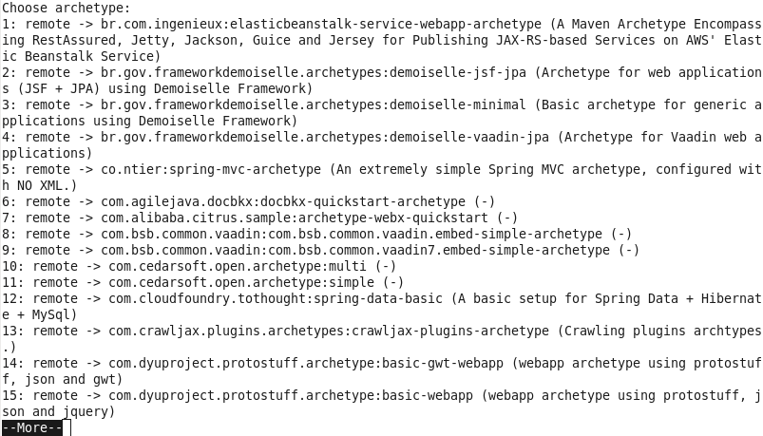
Let's build a simple webapp using Jetty/Spring with a simple MVC framework without using the

These archetypes are pretty much useless for providing guidance on how to do a current up to date Java MVC based webservice.

We add 2 examples,
- a MVC framework example using Spring without using the heavy weight MVC Spring framework or JSPs. This uses POJOs, Java Interfaces or Services, Domain Objects tied to the database using Hibernate, and jQuery for the FE.
- A Jersey/Guice/Jetty example.

These 2 examples should give examples of both approaches where you can mix and match idioms as necessary for your own use.

Define your own archetype:

Define your own archetype is easier than trying to cut and paste XML elements from web searches. This saves time by allowing you to build on your own work and not having to repeat bugs.

Step 1:

Create a directory with the same name as the archetype you want to define, cd into it and create a pom.xml with the following skeleton:

<project xmlns="http://maven.apache.org/POM/4.0.0" xmlns:xsi="http://www.w3.org/2001/XMLSchema-instance"
xsi:schemaLocation="http://maven.apache.org/POM/4.0.0 http://maven.apache.org/xsd/maven-4.0.0.xsd">
<modelVersion>4.0.0</modelVersion>

<groupId>my.groupId</groupId>
<artifactId>my-archetype-id</artifactId>
<version>1.0-SNAPSHOT</version>
<packaging>jar</packaging>
</project>

The above was from the maven website. The packaging tag is optional. Jar packaging is the default.

Step 2: create a subdirectory with path /src/main/resources/META-INF/maven in the same directory as you are in from the step above. Create an archetype.xml file with the following skeleton:

<archetype xmlns="http://maven.apache.org/plugins/maven-archetype-plugin/archetype/1.0.0" xmlns:xsi="http://www.w3.org/2001/XMLSchema-instance"
xsi:schemaLocation="http://maven.apache.org/plugins/maven-archetype-plugin/archetype/1.0.0 http://maven.apache.org/xsd/archetype-1.0.0.xsd">
<id>quickstart</id>
<sources>
<source>src/main/java/App.java</source>
</sources>
<testSources>
<source>src/test/java/AppTest.java</source>
</testSources>
</archetype>

Step 3: create a subdirectory /src/main/resources/archetype-resources. Under this file is the pom.xml which we will use to serve as a template for our own archetype. This is called the prototype pom.xml. This pom.xml is copied into the maven project you create using this archetype. A handy timesaver, as long as you remember to keep updated and none of the repositories move or go out of date.

<project xmlns="http://maven.apache.org/POM/4.0.0" xmlns:xsi="http://www.w3.org/2001/XMLSchema-instance" xsi:schemaLocation="http://maven.apache.org/POM/4.0.0 http://maven.apache.org/xsd/maven-4.0.0.xsd">
<modelVersion>4.0.0</modelVersion>
<groupId>${groupId}</groupId>
<artifactId>${artifactId}</artifactId>
<version>${version}</version>
<packaging>jar</packaging>
<name>My app</name>
<repositories>
<repository>
<id>maven2-repository.java.net</id>
<name>Java.net Repository for Maven</name>
<url>http://download.java.net/maven/2/</url>
<layout>default</layout>
</repository>
<repository>
<id>glassfish-maven2-repository.dev.java.net</id>
<name>Java.net Maven 2 Repository for GlassFish</name>
<url>http://download.java.net/maven/glassfish/</url>
<layout>default</layout>
</repository>
<repository>
<id>java.net</id>
<name>Java.net Repository</name>
<url>http://download.java.net/maven/2</url>
</repository>
</repositories>
<dependencies>
<dependency>
<groupId>com.sun.jersey</groupId>
<artifactId>jersey-server</artifactId>
<version>${jersey-version}</version>
</dependency>
<dependency>
<groupId>com.sun.jersey</groupId>
<artifactId>jersey-client</artifactId>
<version>${jersey-version}</version>
</dependency>
<dependency>
<groupId>com.sun.jersey</groupId>
<artifactId>jersey-json</artifactId>
<version>${jersey-version}</version>
</dependency>
<dependency>
<groupId>com.google.inject</groupId>
<artifactId>guice</artifactId>
<version>${guice.version}</version>
</dependency>
<dependency>
<groupId>com.sun.jersey.contribs</groupId>
<artifactId>jersey-guice</artifactId>
<version>${jersey-version}</version>
</dependency>
<dependency>
<groupId>org.eclipse.jetty</groupId>
<artifactId>jetty-servlet</artifactId>
<version>${jetty.version}</version>
</dependency>
</dependencies>
<build>
<plugins>
<plugin>
<groupId>org.apache.maven.plugins</groupId>
<artifactId>maven-compiler-plugin</artifactId>
<version>2.3.2</version>
<configuration>
<source>1.6</source>
<target>1.6</target>
</configuration>
</plugin>
<plugin>
<groupId>org.mortbay.jetty</groupId>
<artifactId>jetty-maven-plugin</artifactId>
<version>${jetty.version}</version>
</plugin>
</plugins>
</build>
<properties>
<jersey-version>1.7</jersey-version>
<guice.version>3.0</guice.version>
<jetty.version>7.4.2.v20110526</jetty.version>
</properties>
</project>

Install the pom and archetytpe using mvn install.

Then run mvn archetype:generate using the name of your new archetype.

Suppose we want an archetype which writes to a file like creating empty resource.iml files as an example. There are 2 ways to do this, use the ant plugin and run an ant task or create a maven plugin to do this task.

We need to illustrate both of these methods since you will see both of these in open source code and you will have to debug both cases in our future labs.

To define a spring/jetty/mysql archetype we start with a working example. Using mvn jetty:run starts the webserver to display:

