Storm capacity sizing w/number of users:

Storm-Nimbus,storm-ui on startup, no supervisors, no topologies loaded

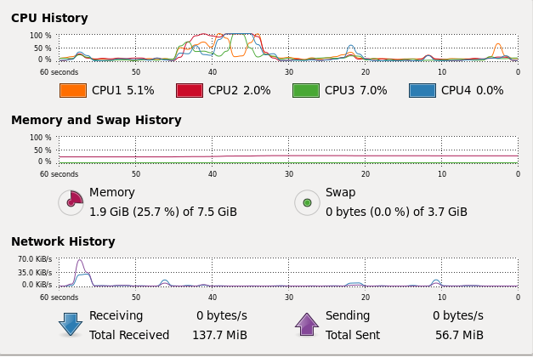
CPU activity spikes for ~20 seconds in the middle of the rolling window initializing system and performing cleanup from last time it was shut down.

Start the supervisor, we modified this with only 1 port open.

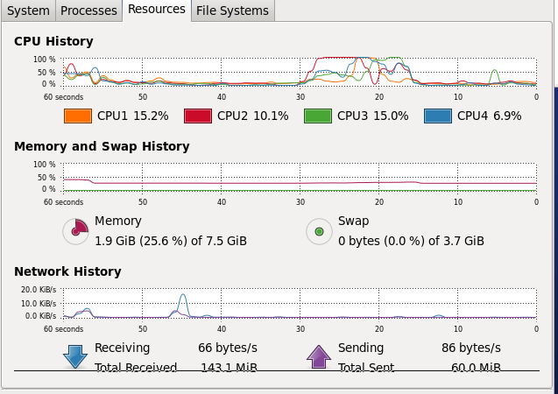

Same startup behavior as before.

Start a topology something small so we don't see a large effect.

Adding 4 of the same topologies causes a failure where we get the 4 CPUS at 100% and the system has run out of memory using the swap file:

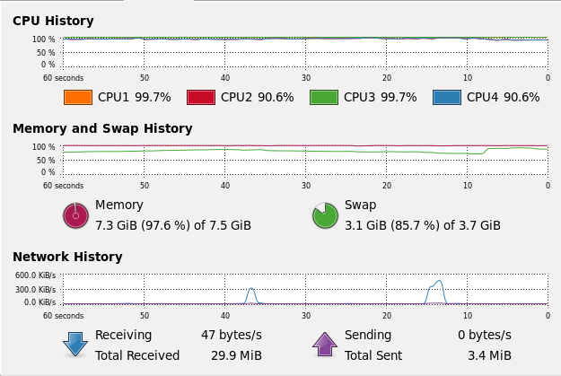

Use JConsole to get all the time history:

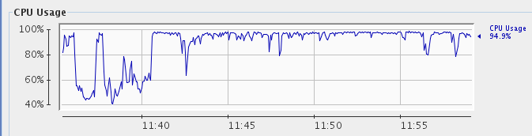
This is just for 1 JVM. Doesn't measure the complete system.

