Storm Architecture, Design and Deploy Document

Storm is a scalable processing API which can be run on multiple computers or nodes.

The API consists of spouts and bolts with a scheduler implemented in Clojure which uses the Java Disruptor Threads library to create threads and tasks inside a JVM running on a Storm Supervisor node. Zeromq is used to send TCP/IP traffic between the spouts and bolts.

Spouts and bolts can reside on different computers. In the figure below, boltB is on a separate computer.

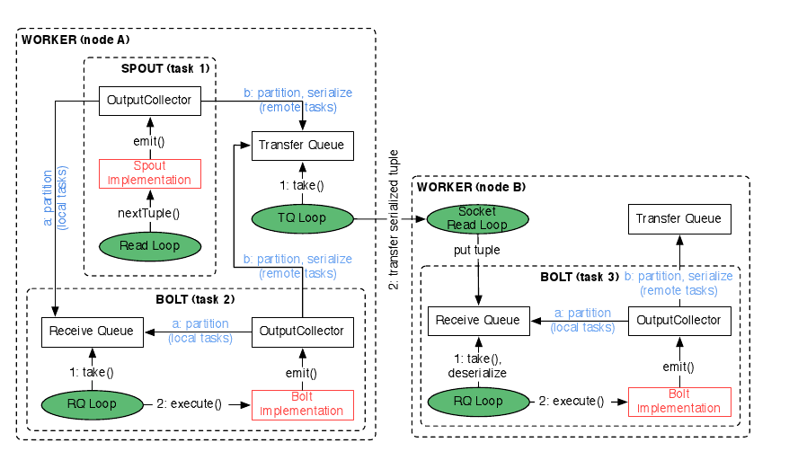

Data flow from a spout into a bolt is covered in Code repo #1.

There are 4 code repositories with associated documentation:

- Code repository(docs:StormIntro.doc) on how to use the Storm API using spouts and bolts, code examples include a description of the structure of how to write simple spout/bolt program with the associated data flow between a spout and bolt, code samples useful for debugging such as how to write to files, and examples of how to embed a HttpClient and HttpServer inside a spout and bolt.

- The second Code Repos(Storm2.doc) includes design patterns in Storm include how to move executable code between nodes, a description of how the internal scheduler works, and a description with code samples on how to add nodes as code is running on nodes.

- The third code repo covers Storm transactions(StormTrans.doc), how to schedule bolts after one another. Storm transactions aren't covered in any of the existing code samples and are necessary for designs which require one bolt to complete before another. These code examples are difficult because it requires the bolts are scalable. If bolt A is to complete before bolt B, the code for 1 instance of bolt A is simple. The code examples for allowing bolt A to be replicated across many bolts requires the slowest instance of Bolt A to complete before bolt B starts.

- The fourth code repository includes instructions on how to build Storm RPMs (how RPMs work), and monitoring code using the Monit daemon. (add puppet code if time and if approved as task to work on)

