Intro to Storm Programming

We are going to cover how to build a storm program and how this results in a program being scalable. A properly developed storm topology consists of bolts and spouts where you can specify there are N spouts and M bolts. The integers N and M refer to the parallelization of the bolts and spouts. If you can increase the count of N and M at will then you have a scalable program across a cluster.

There are 2 modes to Storm, local and distributed. The Storm documentation calls local mode remote mode.

A storm program is a Java class called a Storm Topology. A storm topology specifies the number of bolts and spouts to load into the cluster. The jar file containing the Storm Topology, Bolts, and Spouts are compiled into a jar and uploaded to the cluster.

A simple spout interface consists of methods open(), nextTuple(), declareOutputFields() ack() and fail(). This interface models a constant stream of tuples since there is no input to this interface. The output is nextTuple().

A simple bolt interface consists of methods prepare(), execute(Tuple input), and declareOutputFields(). The input to the bolt is the parameter Tuple input in the execute method and if the bolt has an output the collector.emit() method is called inside the execute(Tuple input) method.

The cluster consists of multiple JVMs running on different servers. Each JVM is a storm supervisor. Each JVM creates multiple Storm Tasks which runs either a bolt or spout. We will demonstrate this in a sample program.

First run the storm-starter jar to see if your cluster is installed correctly.

>cd into the storm-starter directory,

compile and upload the WordCountTopology into the cluster:

>mvn -f m2-pom.xml compile exec:java -Dexec.classpathScope=compile -Dexec.mainClass=storm.starter.WordCountTopology

You should see the program run in the terminal.

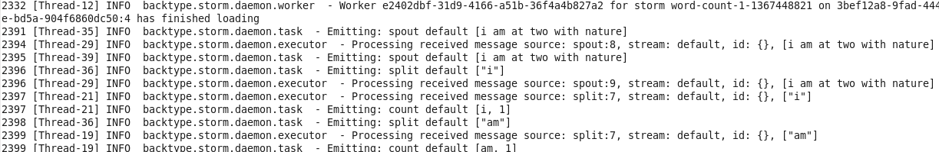

You should see 2 jars under /target as a result of having maven buiilding the jars:

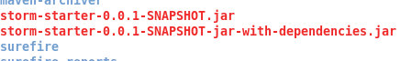
Another way to run storm topologies is to use the storm script under /opt/storm/bin.

/opt/storm/bin storm jar storm-starter-master/storm-starter-0.0.1-SNAPSHOT.jar storm.starter.WordCountTopology

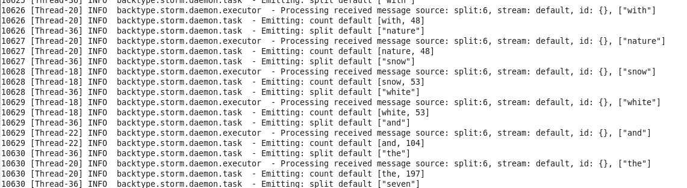
Create an Eclipse Java project, set the path to a storm github project directory, add a pom.xml and mvn install to generate a jar. Create a simple test program which is a replica of the ExclamationTopology.

