Week 1 Demo Tutorial/Doc

This is the result after the week 1 integration of Redis/Storm/Tomcat/Jquery FE

Objective: Develop a workflow for developing ASB Data Delete features

Installing a development environment for Storm/Redis/WebServer

S/W checkin flow:
Create a github account and clone the ASB related projects. Add/Commit/Push changes to your local repo then when you have a stable feature demoable merge the changes into the main repo.

The current project consists of many separate projects. The instructions below are for a git clone, change these commands to a git checkout/

- WebServer: git clone https://github.com/dougc333/AbsoluteSWDD
Run the webserver from Eclipse or standalone putting the WAR export into the /webapps folder under the apache-tomcat install.
- Redis code to load from Database tables: https://github.com/dougc333/Redis
- SQL code to extract from SQL Server for above database tables: https://github.com/dougc333/stormsql
- Storm test code: git://github.com/dougc333/storm.git

WebServer Screenshots:

Open the AbsoluteSWDD project and the index.html file, make changes and run on the webserver or run in standalone:

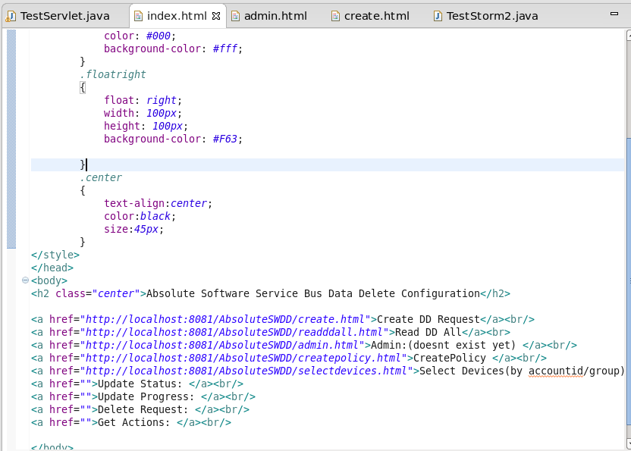
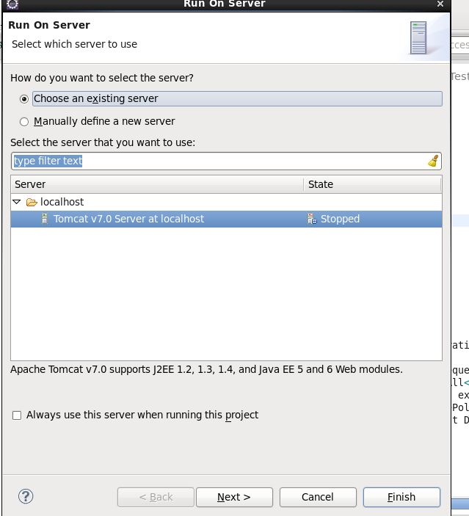

Once the server starts up you should see the webpage launch automatically:
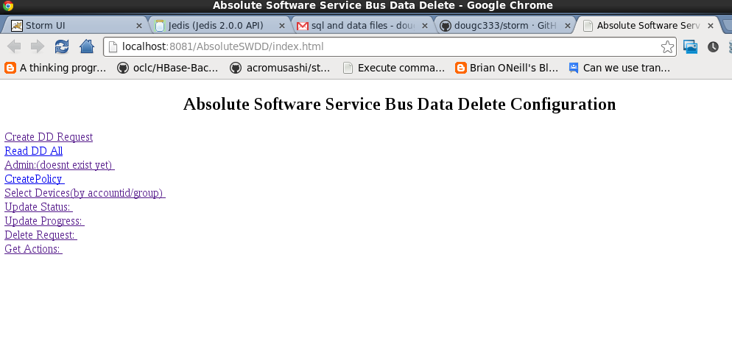
Load data into Redis:

Launch the redis server process or install redis as a service with the following file:
https://github.com/dougc333/storm/blob/master/scripts/redis

If installing as a service, copy to /etc/init.d and change permissions to 755. Run chkconfig redis on to run it on powerup. (check chkconfig command w/websearch)

To load the redis database, run the program: https://github.com/dougc333/Redis/blob/master/src/com/absolute/LoadRedisCSV.java

This connects to Redis and uploads 2 csv files which are:
1)https://github.com/dougc333/storm/blob/master/vwDDDevice.csv
2)https://github.com/dougc333/storm/blob/master/vwDDDeviceByGroup.csv

The files have been cleaned using Textpad replacing the \t space with ^. This removes some errors. Not all the rows are loaded from SQL Server into these csv files. Missing 10-20%. (Fix later)

Navigate to the Select Devices page which is the 5th link from the top. This assumes data is loaded into Redis.

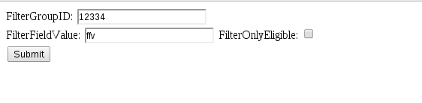

After hitting the submit button the server will block waiting for the bolt to finish with a list of ESNs indicating devices:

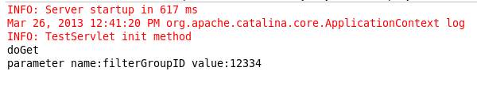
To test the block works, we can go enter in a value using the redis client:

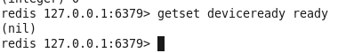
The server will output in the Eclipse console to show the redis entry is ready:

READY READY READY!!!!!!!!!!!!!!!!!
parameter name:filterFieldValue value:ffv
READY READY READY!!!!!!!!!!!!!!!!!

The Storm topology uses the same mechanism to communicate:
https://github.com/dougc333/storm/blob/master/storm-test4/src/main/java/test4/demo/TestDataDelete.java

