Configuring and Compiling Monit.

Recommended on Storm wiki website.

Monit is recommend in the Storm documentation for generating alerts when zookeeper or other services are down which storm requires.

Download the source code.

Install pam-devel.x86_64, openssl-devel.x86_64

using sudo yum install library_name

./configure
make
sudo make install

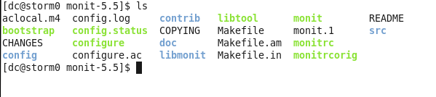
At this point you should have a monit executable and default monitrc configuration file.

Make sure monitrc is owned by root:
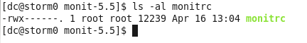

If you start monit as a user process, not as root, you end up with storm processes being run as the local user. This isn't correct but the Storm-UI will work for a while.

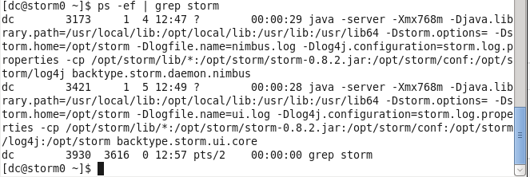

In the above screenshot you can see storm processes being run as user dc. The storm dameons should be running as root.

Make the following modifications to the monitrc file:
- add an email server and email formatted message.

- Uncomment the login account of admin/monit. This is the username and password. Change localhost to storm0, storm1

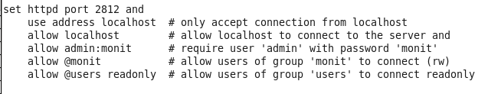

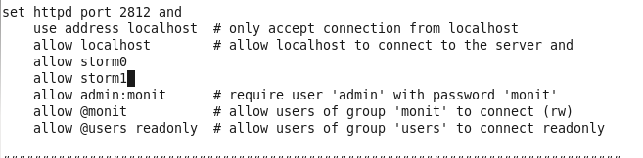

3) Add system performance metrics:
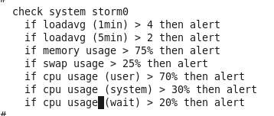
    - Add the monit services to monitor.
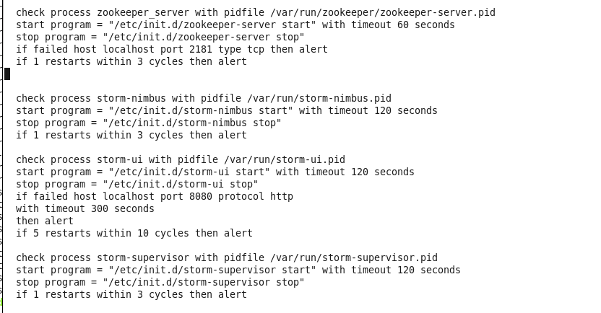

Run Monit as root!!!
[dc@storm0 ~]$ sudo /home/dc/monit-5.5/monit -c /home/dc/monit-5.5/monitrc

