CentOS EPEL Repository

There are 3rd party programs, especially utility programs which are a time saver and are needed in the demos we use as part of the Apache Bigtop working group.

Do a websearch for the EPEL repo location,

wget http://dl.fedoraproject.org/pub/epel/6/x86_64/epel-release-6-8.noarch.rpm

sudo rpm -ihv epel-release-6-8.noarch.rpm

Once we install the rpm we can go to /etc/yum.repos.d to verify there is a epel.repo file. The contents of the epel.repo have the “enabled” =1 indicating the first epel is enabled but the rest are not.



Other programs which we will need not in the REPO are xclip, from the webpage it is in a public epel repo as shown below:



Install xclip:

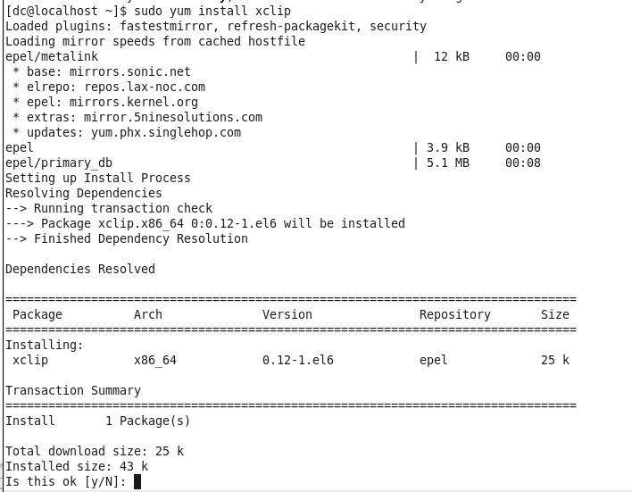

To use xclip, lets look for a file, then output the result into a file.

[dc@localhost ~]$ locate install_hbase.sh | xclip

This pipes the output of the locate command into xclip, now you can do nano shift-ctrl-v