Scheduler

A custom scheduler using the IScheduler is called every 10 seconds by the storm kernel. To run a simple test scheduler create the following file Scheduler.java file, export it as a jar and place it in /opt/storm/lib/

This 10 second default value can be changed using:

nimbus.monitor.freq.secs: 10

Scheduler.java:

import java.util.Collection;

import java.util.Map;

import org.apache.log4j.Logger;

import backtype.storm.scheduler.Cluster;

import backtype.storm.scheduler.EvenScheduler;

import backtype.storm.scheduler.IScheduler;

import backtype.storm.scheduler.Topologies;

import backtype.storm.scheduler.TopologyDetails;

public class Scheduler implements IScheduler{

Logger LOG = Logger.getLogger(Scheduler.class);

Map conf;

Topologies top;

Cluster cluster;

Long startTime = 0L;

@Override

public void prepare(Map conf) {

// TODO Auto-generated method stub

System.out.println("Scheduler prepare");

LOG.info("Scheduler prepare()");

this.conf = conf;

}

@Override

public void schedule(Topologies topologies, Cluster cluster) {

// TODO Auto-generated method stub

if(startTime==0){

startTime = System.currentTimeMillis();

System.out.println("Scheduler schedule elapsedTime:"+System.currentTimeMillis());

}else{

long elapsed = System.currentTimeMillis()-startTime;

System.out.println("Scheduler schedule elapsedTime:"+(elapsed/1000.00));

}

LOG.info("Scheduler schedule()");

this.top = topologies;

this.cluster = cluster;

Collection<TopologyDetails> topology = topologies.getTopologies();

System.out.println("num topologies:"+topology.size());

new EvenScheduler().schedule(topologies,cluster);

}

}

Then change storm.yaml to call this scheduler with:

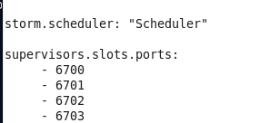

Start storm-nimbus using the sudo service storm-nimbus start

Wait 10 seconds before doing anything and you should see the output of the storm scheduler calling your custom scheduler:

F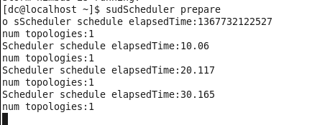rom the above printout the custom scheduler is called every 10 seconds.