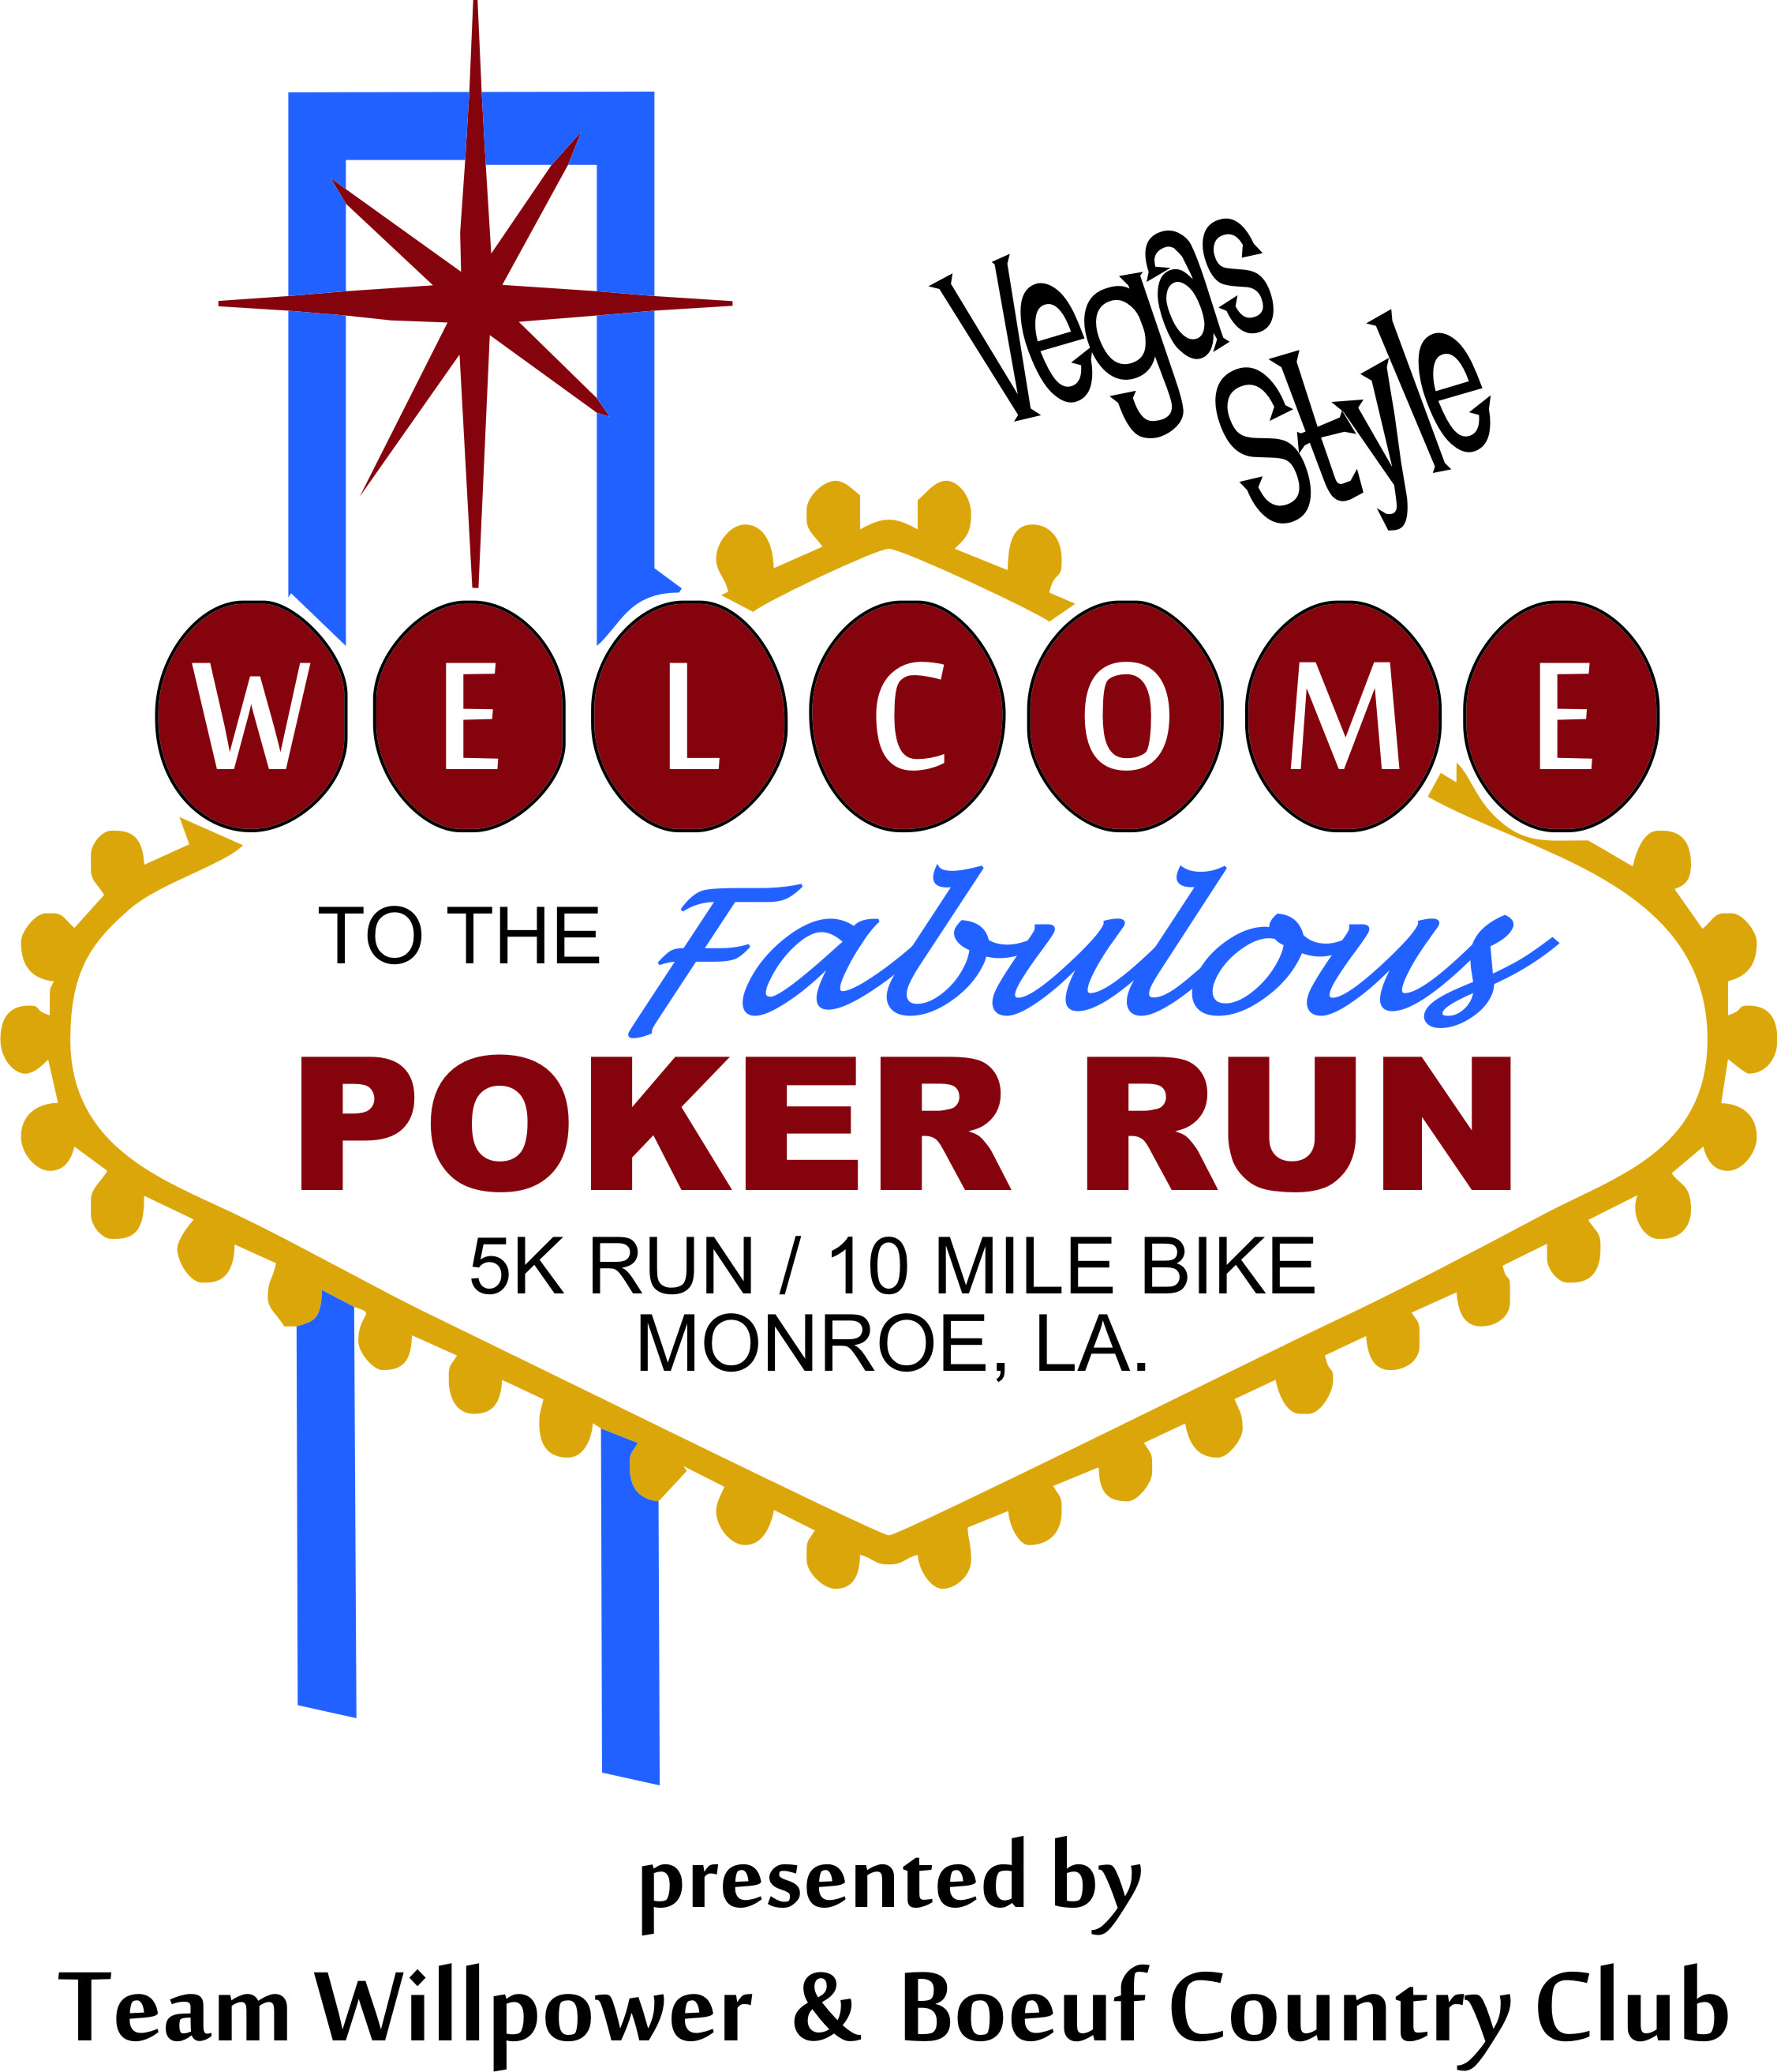
Team WillPower “Poker Run/ Walk/ Crawl/ Bike

ALL PROCEEDS DONATED TO ST JUDE HOSPITAL
SATURDAY, September 21, 2013 10:00AM
FORSYTHE PARK MONROE, LOUISIANA

ENTRY FEES: $30 ADULT $20 ages 11-17
Kids 10 and younger admitted free (no t shirt will be available)

ONLINE REGISTRATION: https://www.active.com (Team WillPower)

POST RACE: Food, music, beverages and good times

AWARDS: Best hand winner for both Men and Women in Run/ Walk/Crawl Division and Men and Women in Bike Division- MEN AND WOMEN’S WINNER IN BOTH RUN AND BIKE EVENTS WILL RECEIVE A TRIP TO LAS VEGAS!!!**

EVENT DAY SCHEDULE: 7:45-9:45 AM Late registration and packet pickup
10:00 AM Event Starts PROMPTLY

MORE INFO: Contact Mike at mmcgee1217@comcast.net 318-614-2474 / Ora Lea McGee-318-231-9123 / Rachel Madden-318-235-5321 /Amber Zambie-318-450-9737
** Must be 18 years old to win Vegas Prizes or other travel voucher destinations. Additional Prizes will be awarded to younger than 18

Registration Form

Name __________________________________________ M_______ F_________

Address ______________________________________________ E-Mail ____________

City ___________________ State_____ Zip _______ Phone _____________________

T-Shirt size (circle one): Youth L Adult S M L XL

Checks payable to: WillPower Foundation, Inc Mail to: Team WillPower Poker Run
(Pending 501c3) Attn: Sharon Drumwright
P.O. Box 14202
Monroe, LA 71207

RELEASE OF RESPONSIBILITY/WAIVER
In consideration of my being admitted to participate in the Team WillPower, Inc Poker Run, I for myself, my heirs and assigns, executors, and administrators, do hereby release and discharge the City of Monroe, Forsythe Park, and all sponsors, their employees and their agents, of and from any and all claims of demands for damages of liability in any manner arising out of my participation in said event. I agree to follow all rules and to permit myself to be removed from competition if, in the opinion of the event administrators, my competing would endanger my health or the health of others. I certify that I am in good health and that I am prepared to compete in this event. I understand that some roads may be open to traffic.

Signature __________________________________________________________ Date _______________________________
(Parent or guardian if participant is under 18 years of age)

