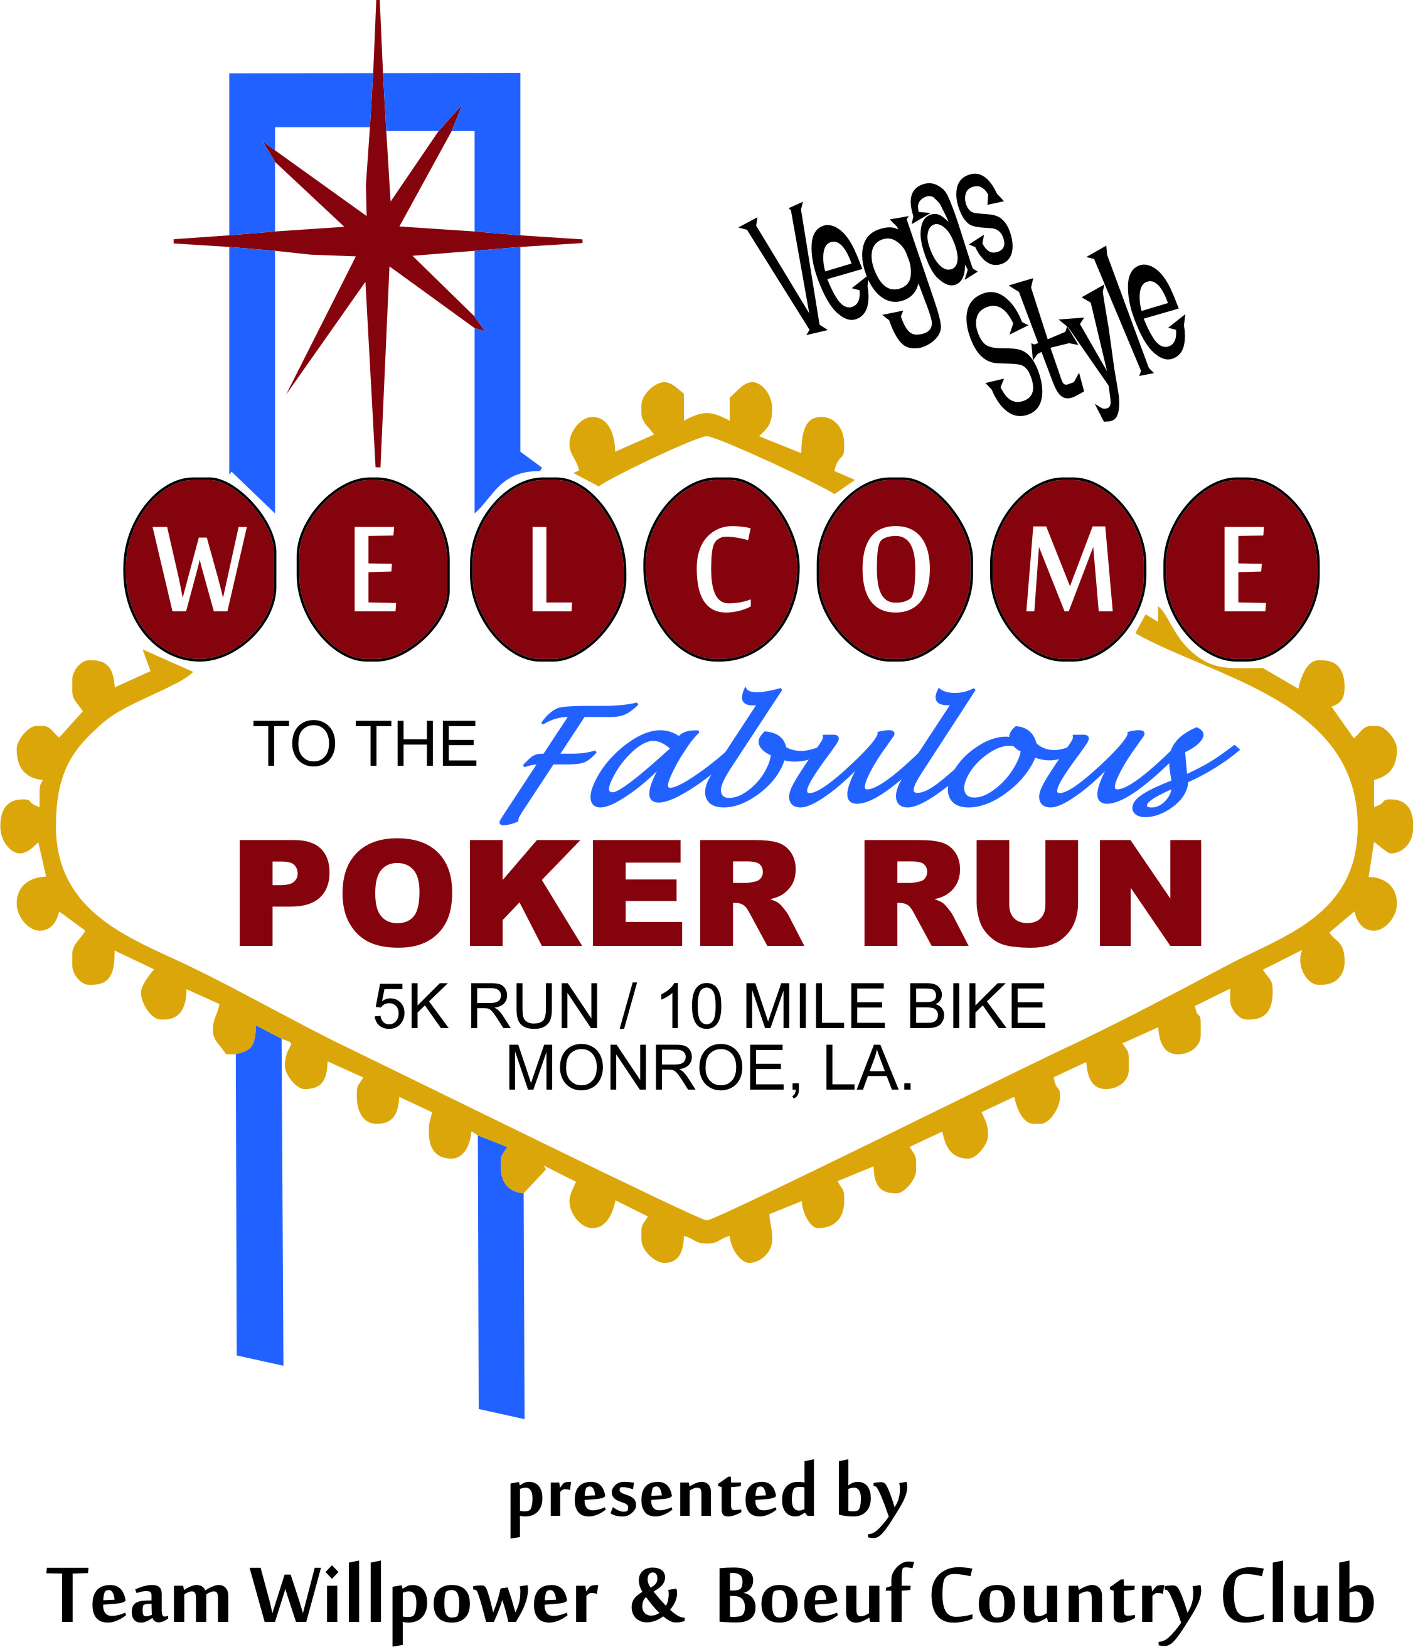  - september 21, 2013  10am-1pm  Fundraiser for St. Jude Children’s Research Hospital Our Sponsors: United Home Health, First National Bank, Progressive Bank, DeltaStyle, Bayou Life, Ageless Skin Laser Center, Dr. Hopkins Dermatology, Aspirations, Cajun CrossFit, Custom Carpets, Greg Manley State Farm and Premier Hospice.  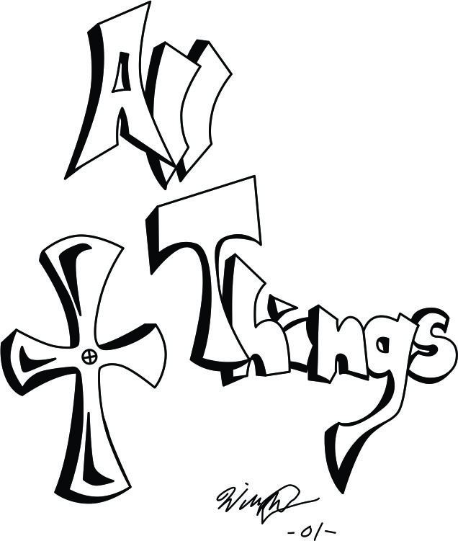 |  | Run, Walk, Crawl or Bike. Best hand wins the prize!  Top Male & Female of each event wins a trip for 2 to VEGAS*  Entertainment for the whole family!  Special Guest: Team Refuel’s 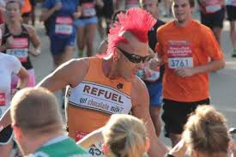George Melichar  [You Have Room for Another One Here!]  Register online @ www.active.com  *18 and up can win the trip prizes will be available for participants under 18  Advanced Registration $30 for adults/ $20 for 11-17 / Under 10 admitted FREE includes Hamburger Plate and shirt*(no shirt under 10)

