
30th Annual
DATE: Wednesday – September 24, 2014
TIME: Race will start at 5:30 p.m. in front of Hemphill Hall
CHECK-IN: Deadline @ 5:15 p.m.
ALL ENTRIES DUE BY WEDNESDAY – September 24, 2014 @ 12:00pm.
ULM INTRAMURAL OFFICE, ACTIVITY CENTER, 342-5305
*LATE REGISTRATION WILL NOT BE GUARANTEED A SHIRT
*PHYSICALLY CHALLENGED RACERS WELCOME
ENTRY FEE: ULM Student $5.00
Non-Student $10.00

MAKE CHECKS PAYABLE TO:
ULM Intramurals
AWARDS:
T-Shirt to ALL Entrants (while available)
Plaques Given to:
“Top 10” Male Finishers “Top 10” Female Finishers
“Top 10” Male Masters (Age 40 & Over) “Top 10” Female Masters
“Top 10” Juniors (Age 12 & Under) “Top 10” Physically Challenged

Sponsored By
ULM Intramurals
“HOMECOMING 2014”

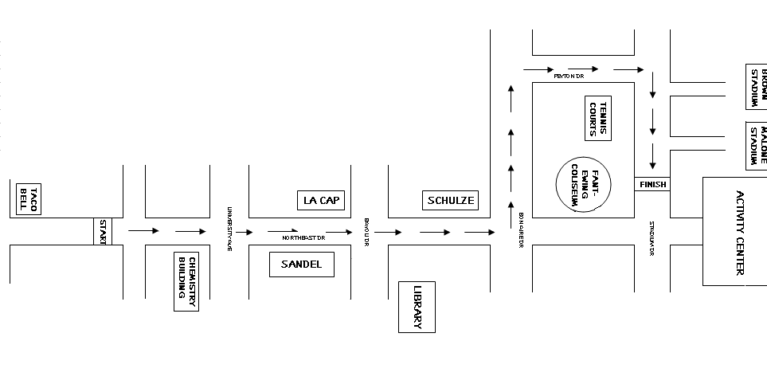

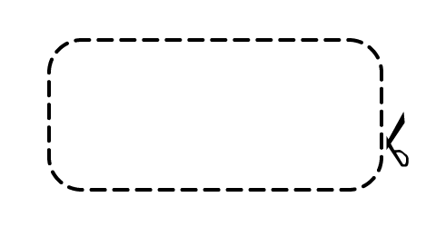


ENTRY FORM
(Please Print or Type)
Runner’s Name Age Sex Phone No.
Runner’s Address City State Zip
Approximate One-Mile Time ULM Organization/Dorm

Shirt Size: (ADULT) SMALL MEDIUM LARGE X-LARGE XX-LARGE

FOR AND IN CONSIDERATION of the acceptance of this entry application and permission to participate in “THE UNIVERSITY MILE”, I, for myself, my heirs, executors and/or administrators hereby waive any and all rights claims for damages of any kind which may occur for any reason due to participation in the above – referenced “THE UNIVERSITY MILE” against The University of Louisiana at Monroe, the City of Monroe, and any individuals connected with the sponsoring and/or administration of this race for any injuries, loss of property or loss of life sustained by me in the event. I further certify that I am in good physical condition for this race. I give permission for the free use of my name and any photography, videotape, motion picture, or any other record of my participation in this event.

Signature Date

