
Presents the INAUGURAL

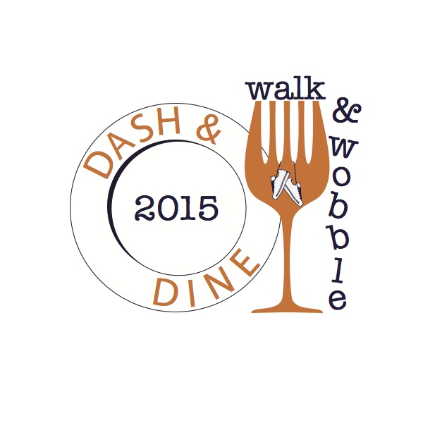

5K Run/Walk through Downtown Monroe/West Monroe
Saturday, October 10, 2015

Registration/Check 7:00-7:45am – Warehouse No. 1 Restaurant, 1 Olive Street, Monroe
5K begins at 8 a.m.
ONE REGISTRANT PER ENTRY FORM (Please Print)

Last Name: _____________________________________ First Name:__________________________________________

Mailing Address: ____________________________________________________________________________________

City: _____________________________________ State: _________ ZIP: ___________ MALE FEMALE

Age: ______ Date of Birth: _________________ Email: ____________________________________________________

T-SHIRTS ONLY GUARANTEED TO THOSE WHO REGISTER BY MONDAY, SEPTEMBER 28TH.

Circle One: Adult – S M L XL XXL

Race Entry Fee: $35.00 Entry Fee for Cool Down Celebration Only (No Race/No T Shirt) $10

Race Entry Fee includes: Race Registration, race bib, T-Shirt, Commemorative Wine Glasses or Beer Mugs for top award winners, entry into the Cool Down Celebration hosted by local restaurants featuring live music. Alcoholic beverages will be available on the premises of sponsoring restaurants along the route. Open containers are not permitted and only participants aged 21 or older with valid race issued wristbands will be able to partake of libations at restaurants.

Register online at www.northdeltafoodandwinefestival.com or Mail check payable to NLAC along with completed entry form to:
Tommy Usrey, Northeast Louisiana Arts Council, 2305 North 7th, West Monroe, LA 71291

(TO BE READ AND SIGNED BY PARTICIPANT (OR PARENT OR LEGAL GUARDIAN IF UNDER 18) RACE RELEASE: In consideration of this race, I myself, my heirs, executors, administrators, and assigns, do hereby forever release, discharge, hold harmless and indemnify the, State of Louisiana, Northeast Louisiana Arts Council, North Delta Food and Wine Festival, CenturyLink, the Cities of Monroe and West Monroe, the Parish of Ouachita, race officials, timing officials, their agents or employees, sponsors and volunteers, from any and all demands, claims for damages and causes of suit or action, and liabilities of whatever kind of nature, known and unknown, that I may have against them for any and injuries in any manner arising or resulting from my (or the minor child, if applicable) participation or involvement in said race. This release extends to all claims of every kind or nature whatsoever, foreseen or unforeseen, known or unknown. I attest and verify that I have full knowledge of any risks involved in the race, that I assume those risks (or the minor’s, if applicable) that I will assume and pay my own (or the minor’s) medical and emergency expenses in the event of an accident, illness or other incapacity, regardless of whether I have authorized such expenses, and that I am (or the minor is) physically fit and sufficiently trained to participate in this race. I release the rights to any and all photographic material and computer information that “Dash & Dine/Walk and Wobble” and other sponsors release for this event for any purpose without obligation or compensation to me. I HAVE CAREFULLY READ THIS LIABILITY WAIVER AND RELEASE. I FULLY UNDERSTAND ITS CONTENTS AND SIGN IT OF MY OWN FREE WILL.

________________________________________________ ________________________________________________________
Participant Name (Print) Participant Signature (Parent signature if under 18)

