1.1.1
One may implement the Euclidean distance function by (x-y)^{T}(x-y) where x and y are the D minesional vectors that you wish to calculate the distance between, by noticing that the one dimensional case (x-y)(x-y) yields x^2 + 2xy + y^2. Thus each entry will be X*X^T + 2*XY^T + Y*Y^T

1.1.2

def euclideanDistance(X, Y):
#square all elements of both matrices
XX = tf.square(X)
YY = tf.square(Y)
#sum all squares of EACH sample
XX_sum = tf.reduce_sum(XX, 1)
YY_sum = tf.reduce_sum(YY, 1)
#multiply sample by cluster
XY = 2*tf.matmul(X, Y, transpose_b=True)
XX_reshape = tf.reshape(XX_sum, [tf.shape(XX_sum).eval()[0],1])
dists = tf.sub(tf.add(XX_reshape, YY_sum), XY)
return dists
1.2.1 Yes. It is the minimum of the sum of convex functions.

1.2.2
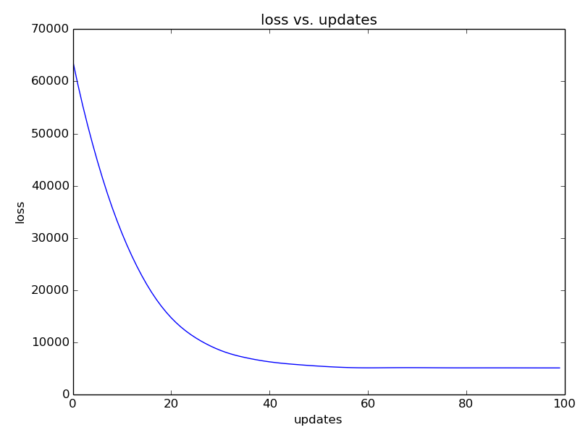

1.2.3
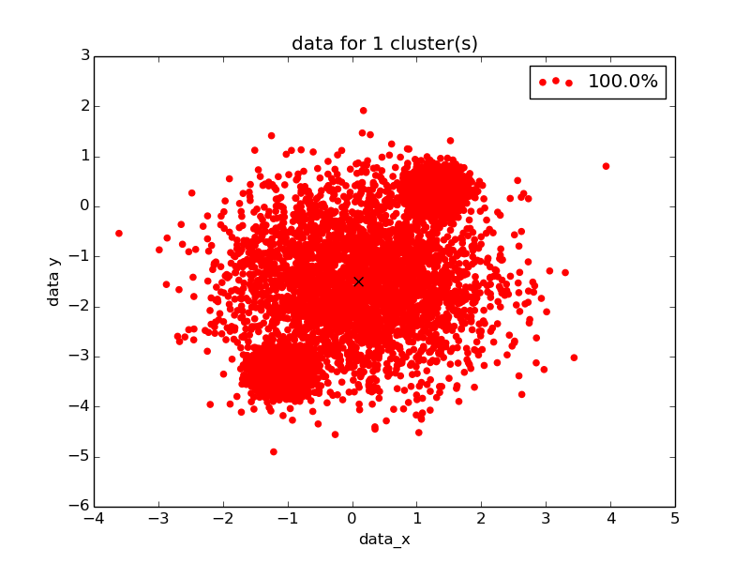

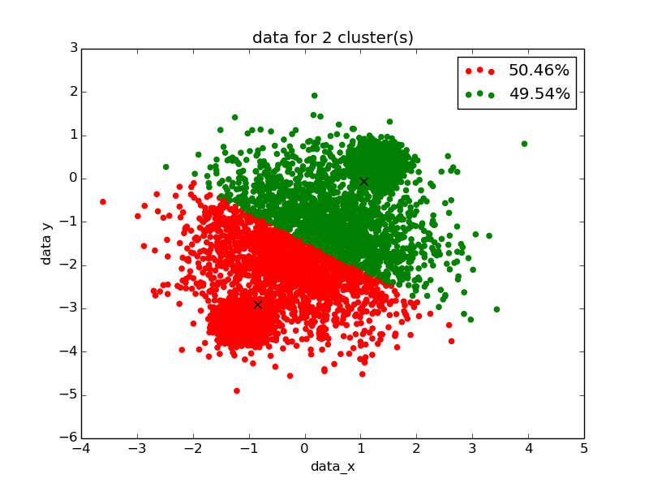

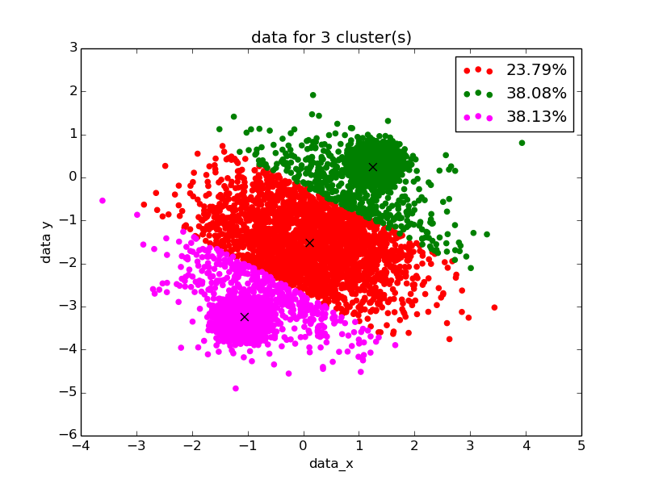
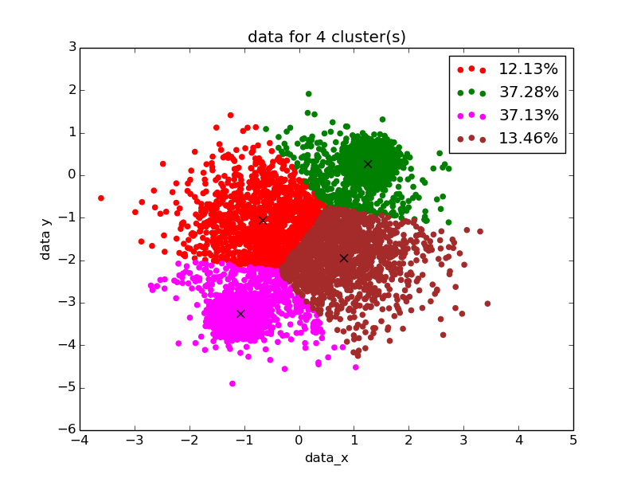

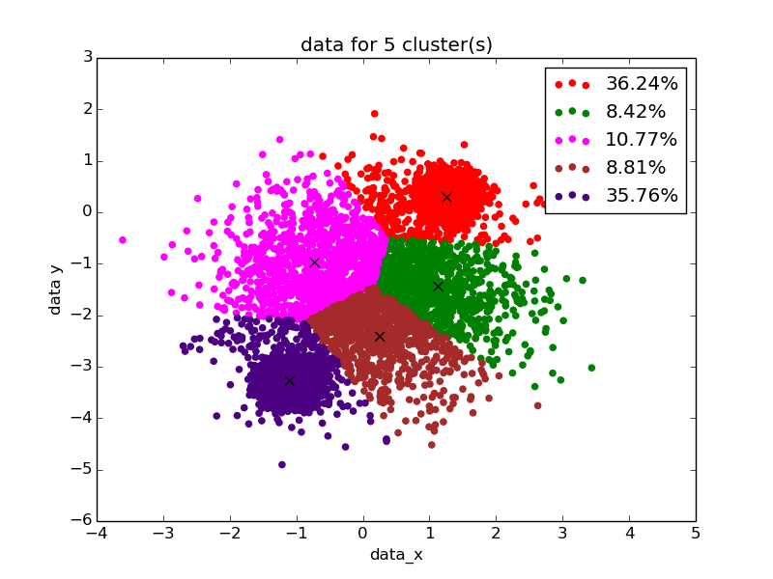

2 clusters looks “best.” Seems to get closest percentages

1.2.4 for 1 cluster final loss: 25493.1
for 2 clusters final loss: 6138.62
for 3 clusters final loss: 3418.71
for 4 clusters final loss: 2275.0
for 5 clusters final loss: 1914.05

Based on the final loss, 5 clusters looks best.

2.1

2.1.1

2.1.2

def get_lossfunc(out_pi, out_sigma, out_mu, y):
result = tf_normal(y, out_mu, out_sigma)
result = tf.mul(result, out_pi)
result = tf.reduce_sum(result, 1, keep_dims=True)
result = -tf.log(result)
return tf.reduce_mean(result)
2.1.3

2.2

2..2.1
2.2.2

2.2.3

2.2.4

Two clusters are likely in the data set. Visually these clusters are seen as darker spots.

