Incremental Learning for SEIRD models in the context of the COVID-19 Pandemic

Artículo 1

Abstract (jose)

1 INTRODUCTION (jose)

2. RELATED WORKS (Franklin)

Debería ser sobre aprendizaje incremental y su uso en tareas de predicción de enfermedades
.

3. INCREMENTAL LEARNING APPROACHES (Franklin)

4. OUR APPROACHES

4.1 PROCESS OF VARIABLE DEPENDENCE ANALYSIS FOR THE SEIRD MODEL FOR INCREMENTAL LEARNING (yullis)

4.2 OUR INCREMENTAL LEARNING APPROACHES (Edgar+Jose)

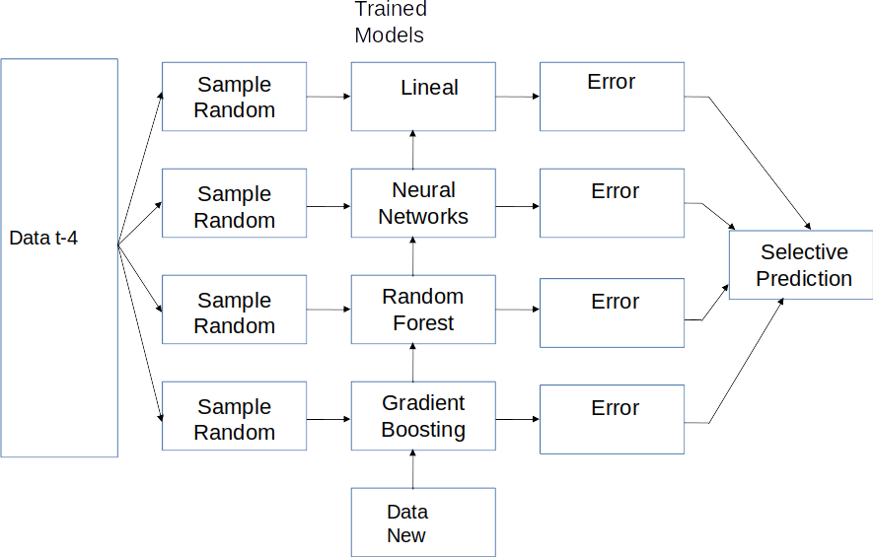

5. EXPERIMENTATION

5.1 Experimental context (Yullis+Edgar+Douglas)
(Data sets, casos que se estudiarán, metricas a usar)

5.2 Experimental Cases

5.2.1 VARIABLE DEPENDENCE ANALYSIS (Yullis)

5.2.2 Prediction Models (Edgar+Douglas)
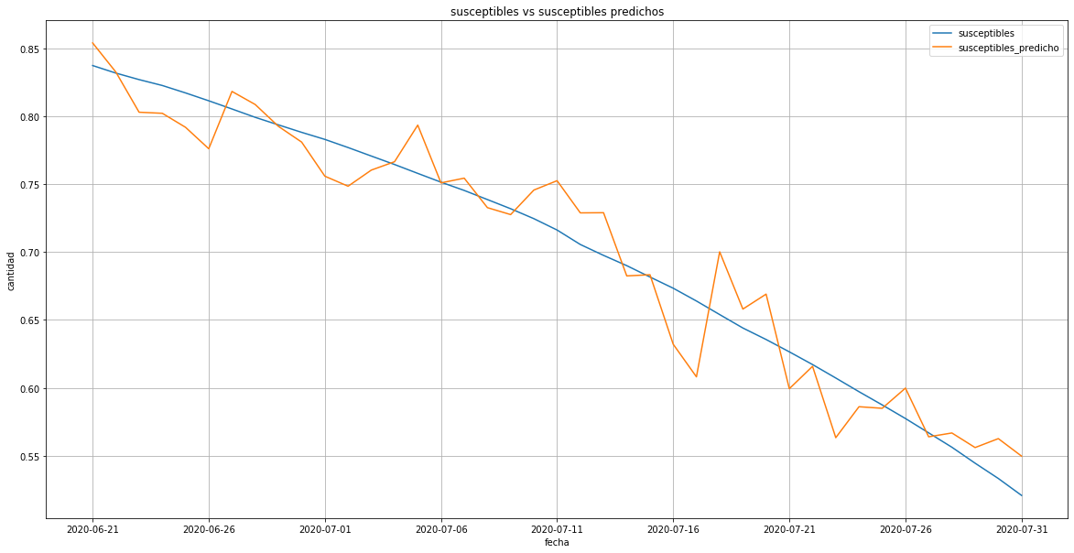
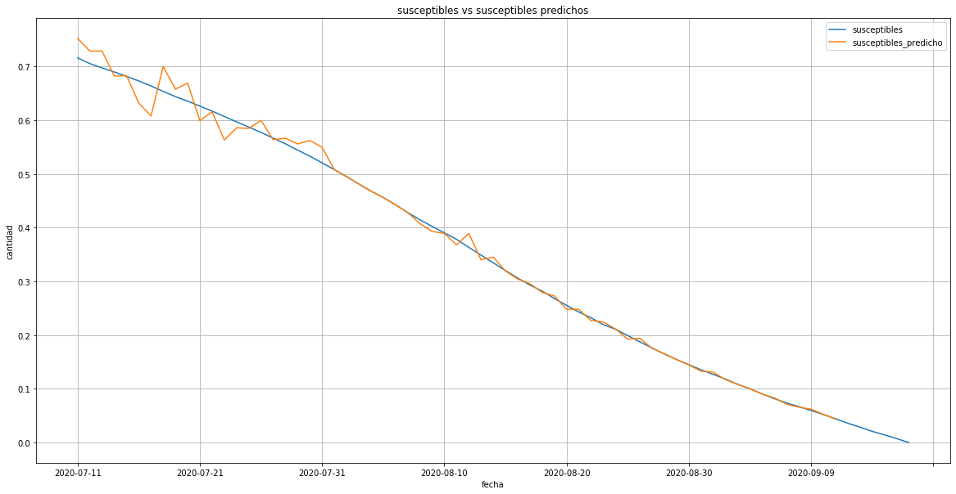

regression linear t-4 Susceptible Incremental learnings linear t-4 Susceptible
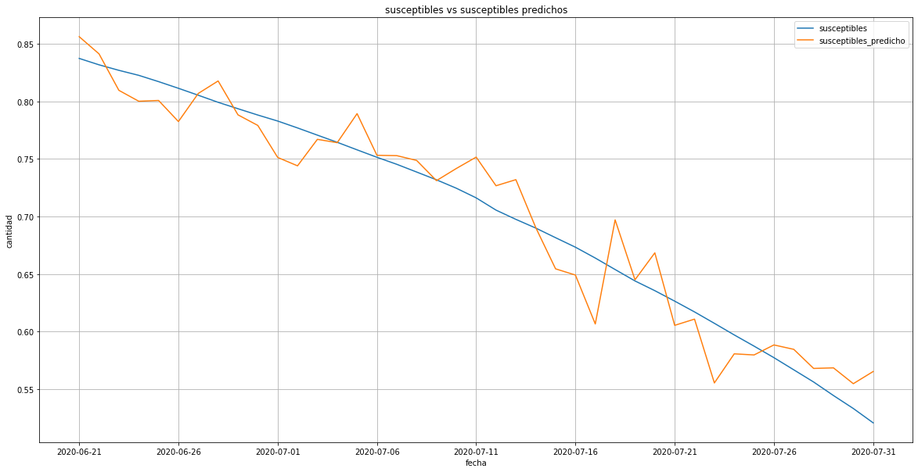
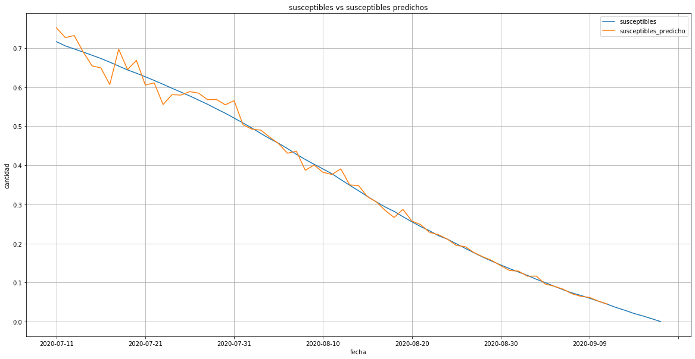

Neural Network t-4 Susceptible Incremental learnings Neural Network t-4 Susceptible
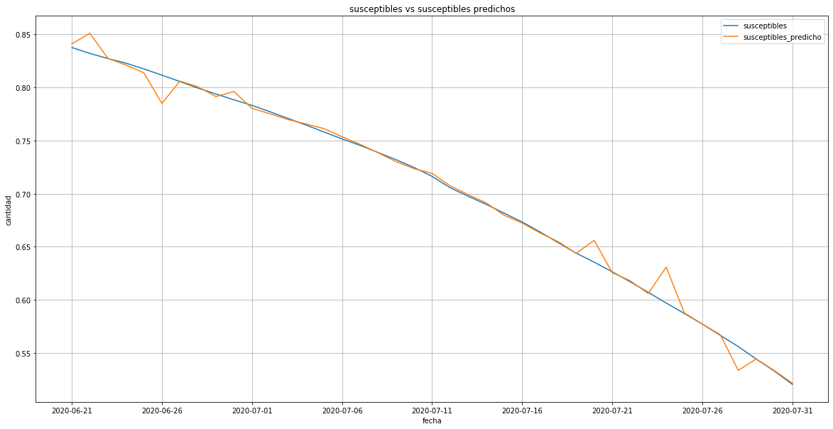
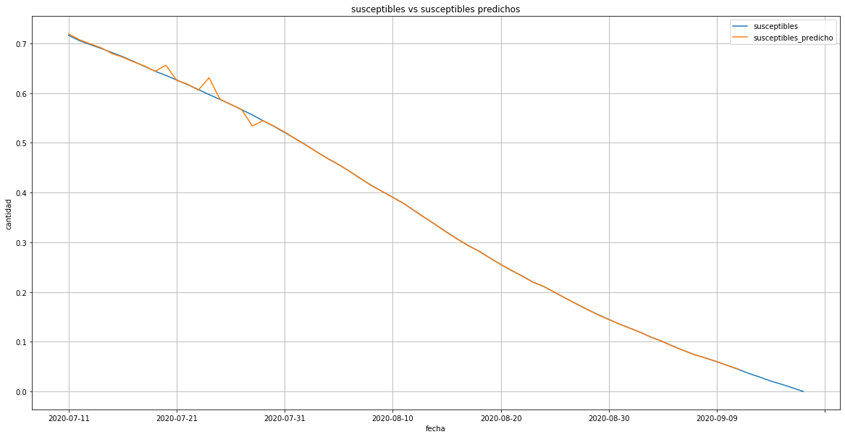

Gradient Boosting t-4 Susceptible Incremental learnings Gradient Boosting t-4 Susceptible
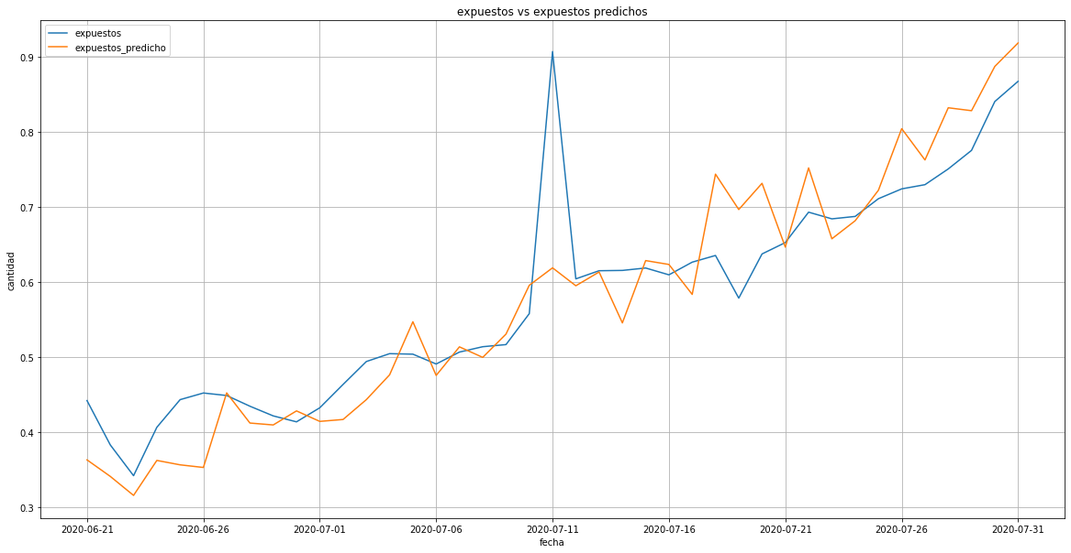
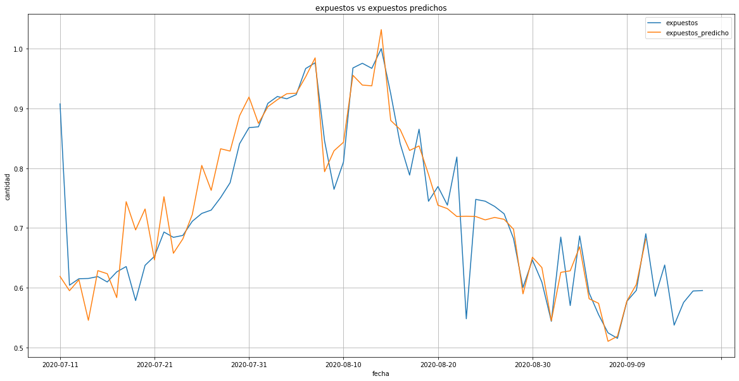

regression linear t-4 Exposed Incremental learnings linear t-4 Exposed

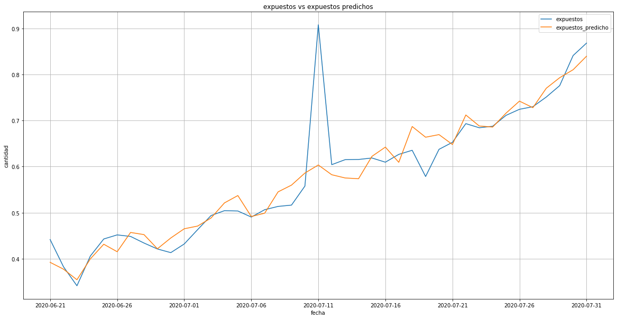
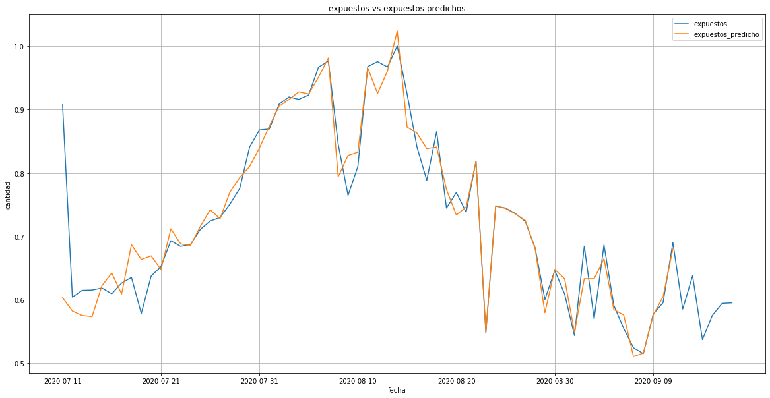

Neural Network t-4 Exposed Incremental learnings Neural Network t-4 Exposed
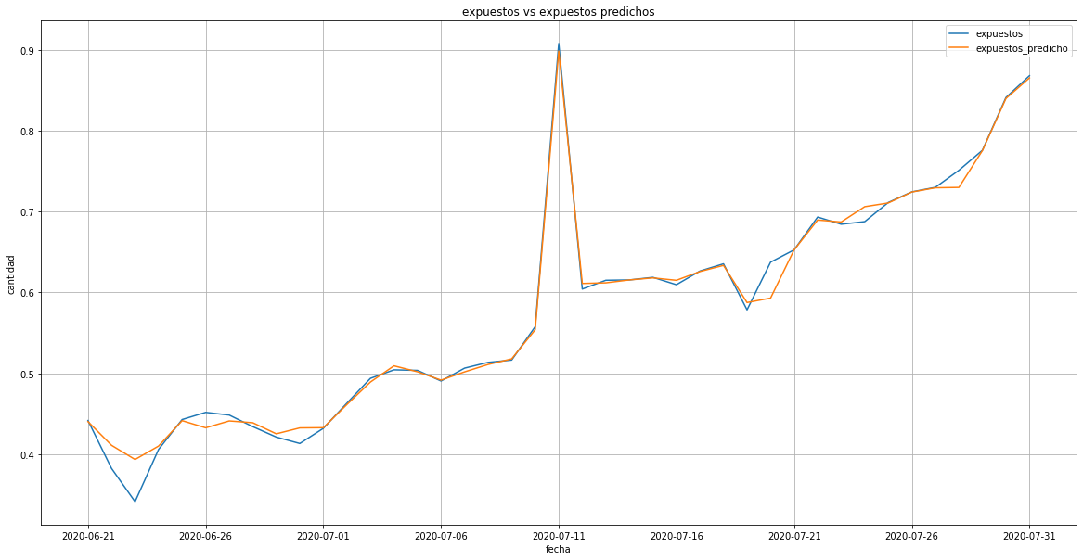
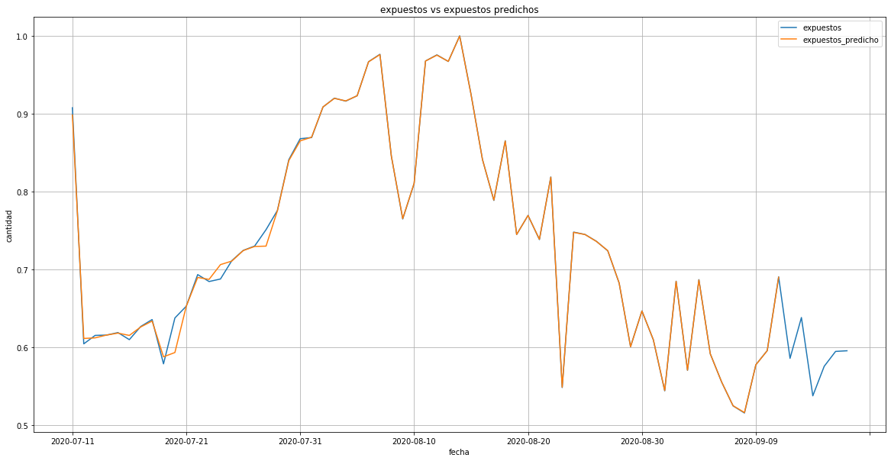

Gradient Boosting t-4 Exposed Incremental learnings Gradient Boosting t-4 Exposed

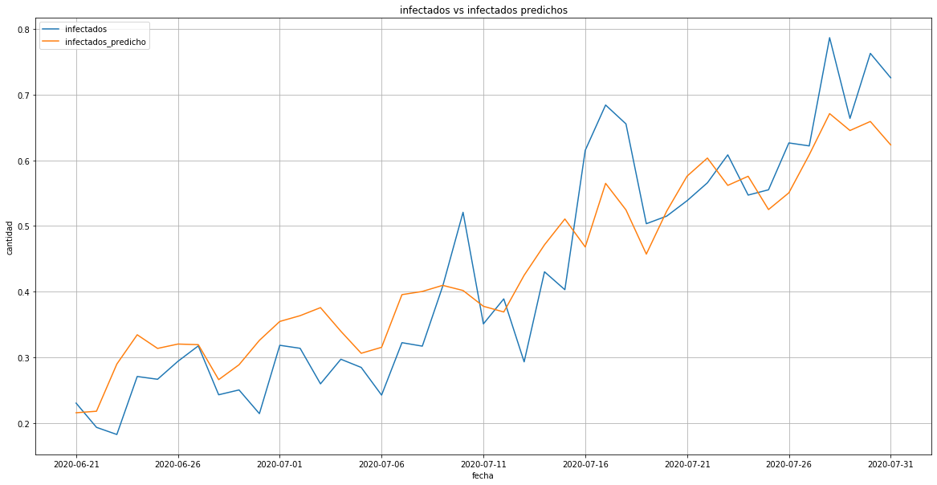
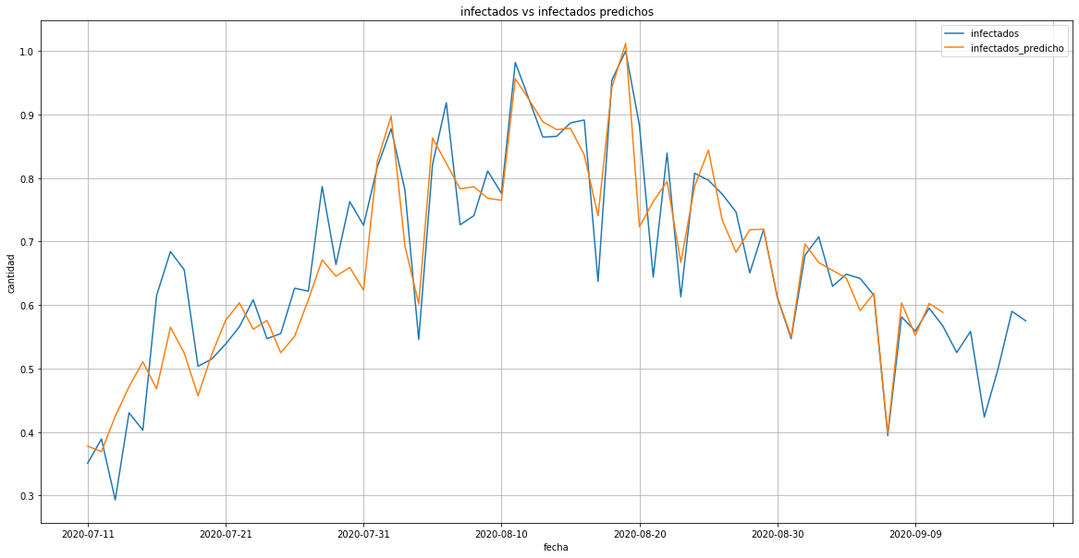

regression linear t-4 Infectious Incremental learnings linear t-4 Infectious

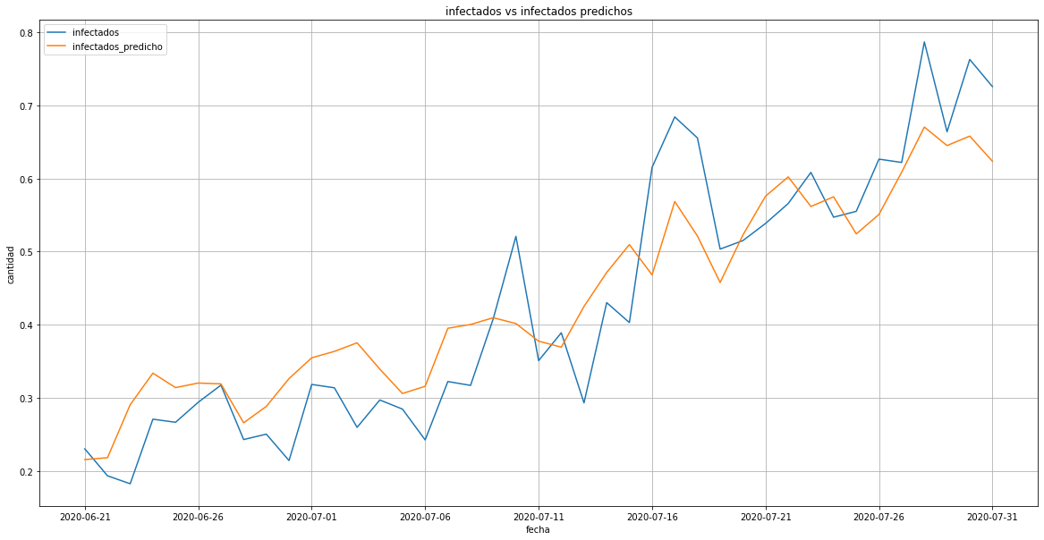
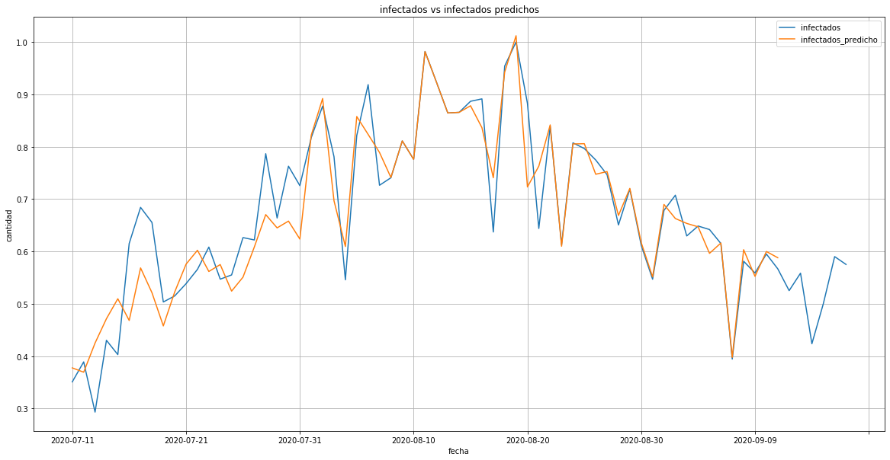

Neural Network t-4 Infectious Incremental learnings Neural Network t-4 Infectious

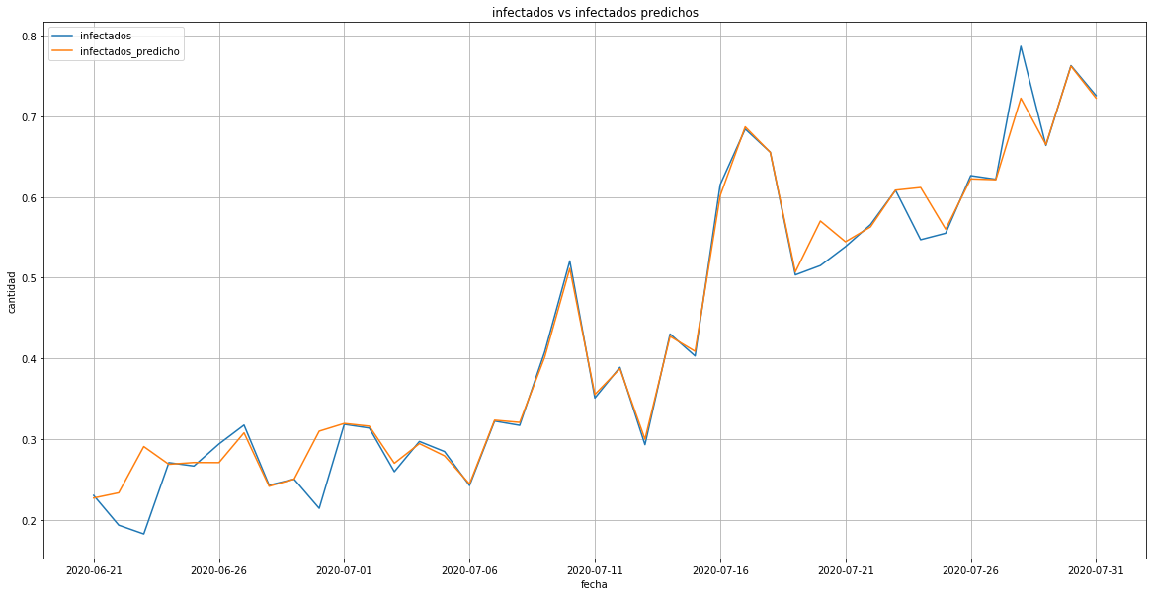
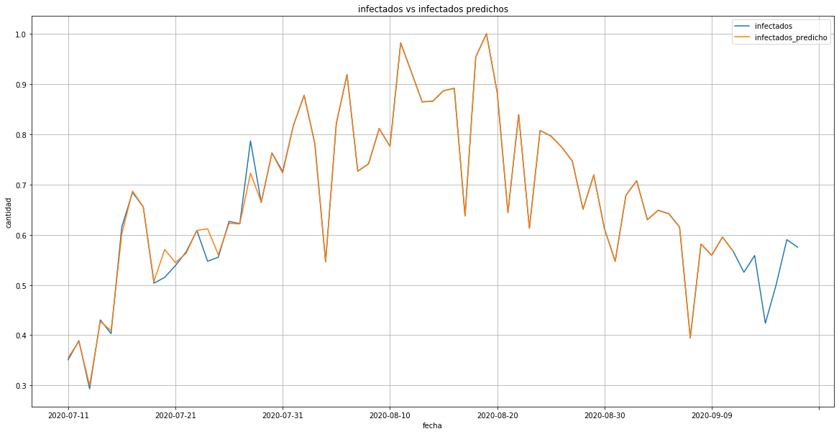

Modelo entrenado Gradient Boosting t-4 Infectious Incremental learnings Gradient Boosting t-4 Infectious

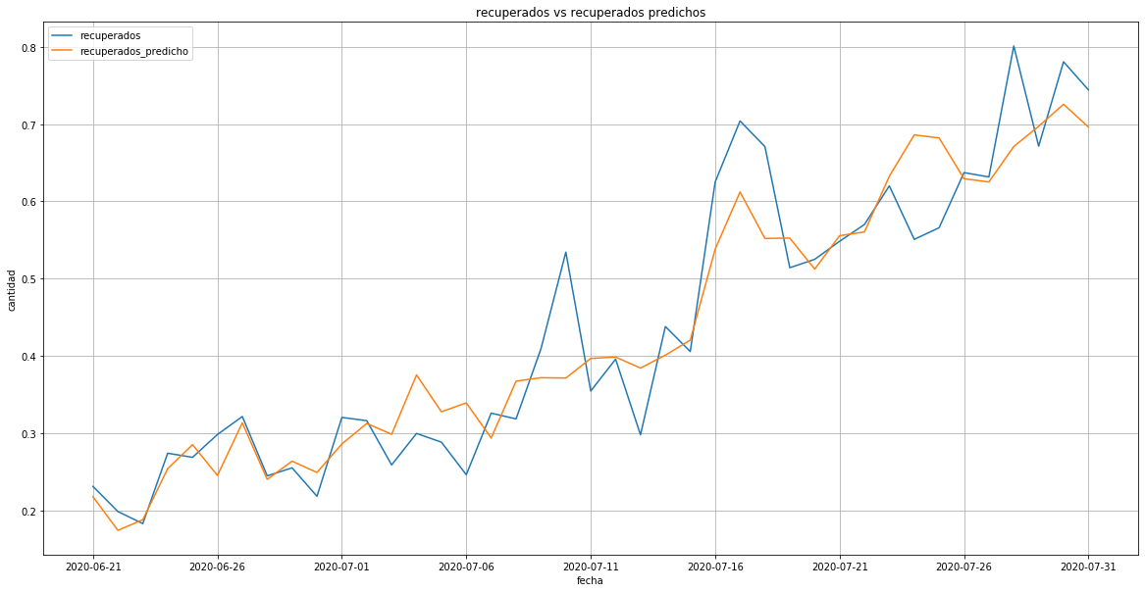
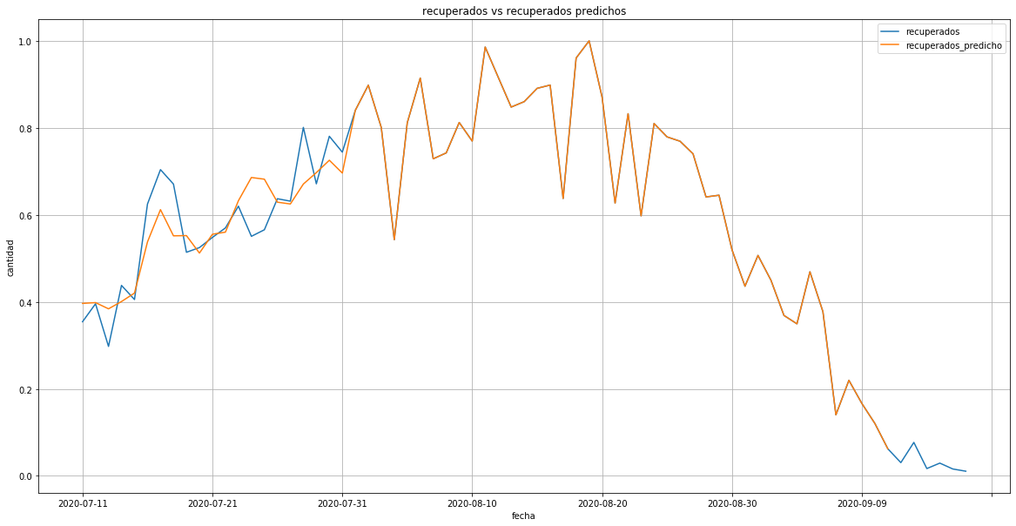

regression linear RL t-4 Recovered Incremental learnings linear t-4 Recovered

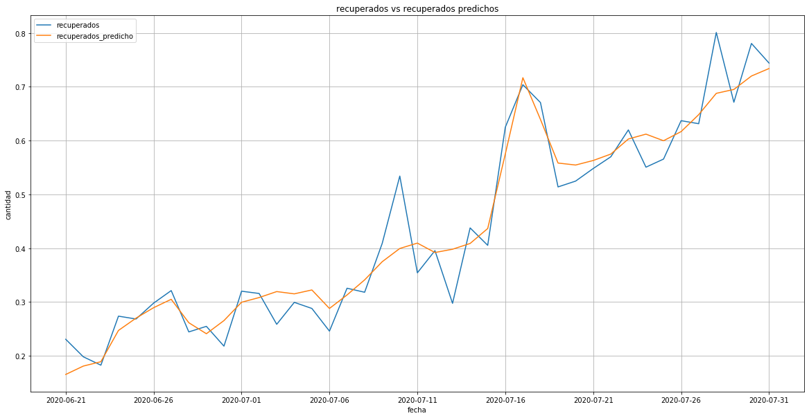
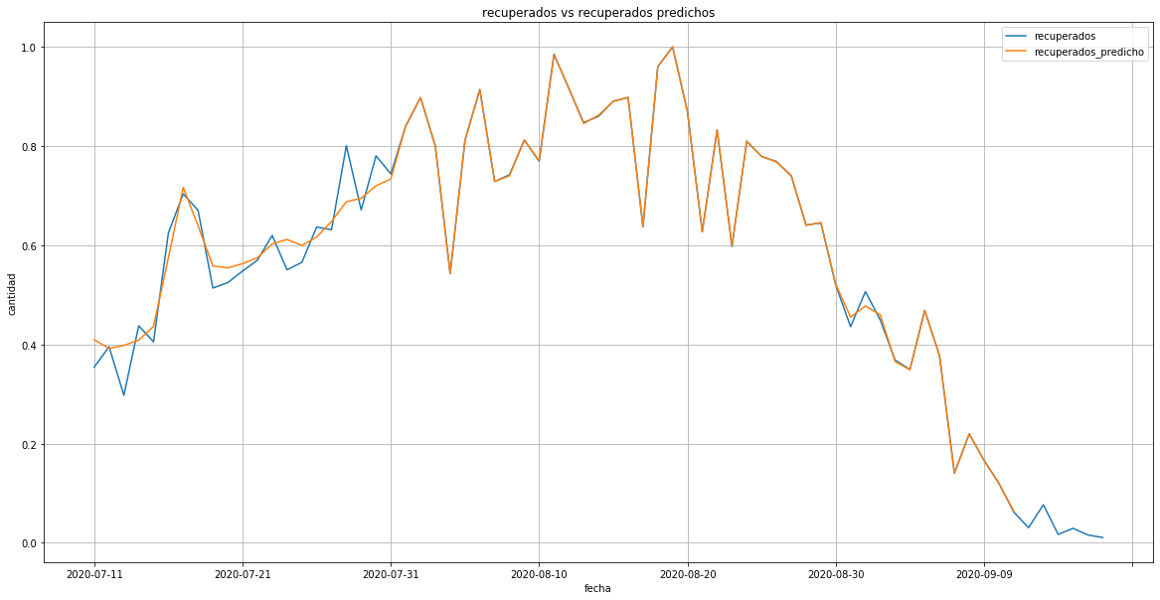

Neural Network t-4 Recovered Incremental learnings Neural Network t-4 Recovered
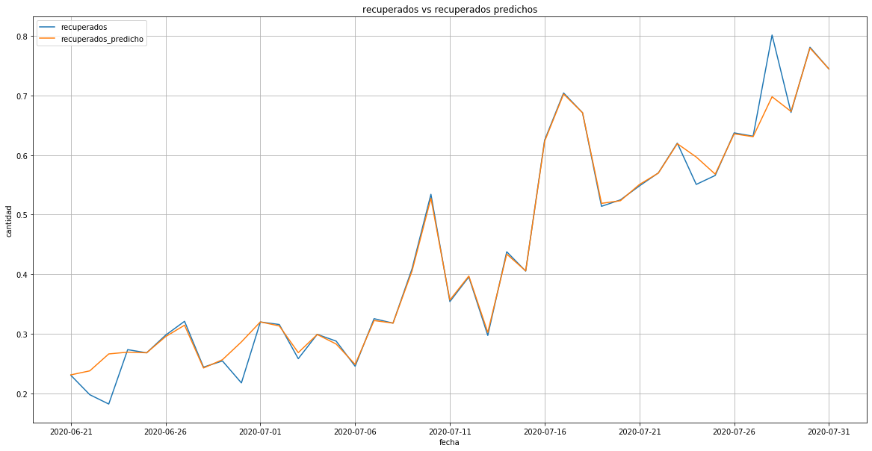
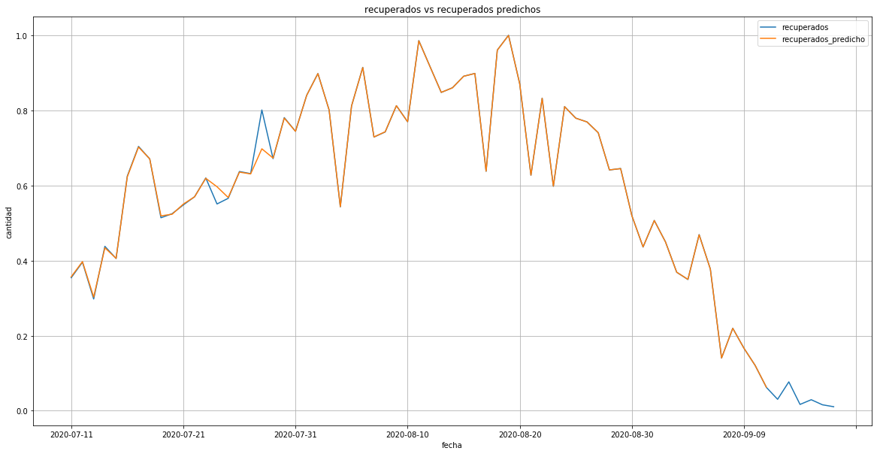

Modelo entrenado Gradient Boosting t-4 Recovered Incremental learnings Gradient Boosting t-4 Recovered
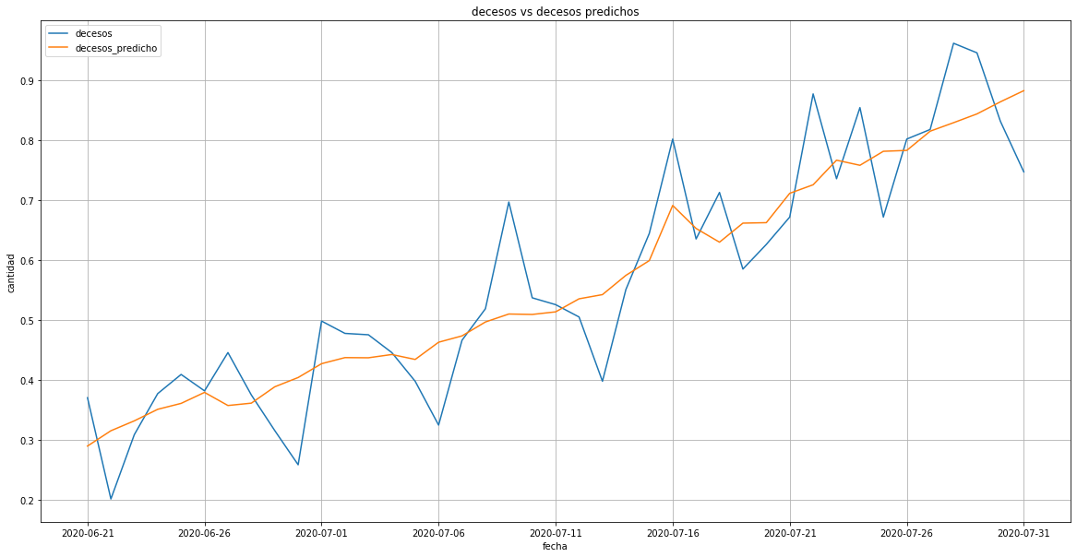
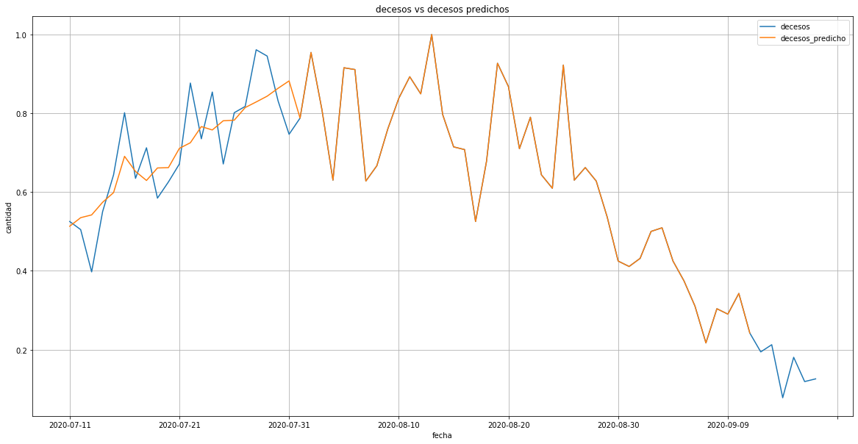

regression linear t-4 Dead Incremental learnings linear t-4 Dead

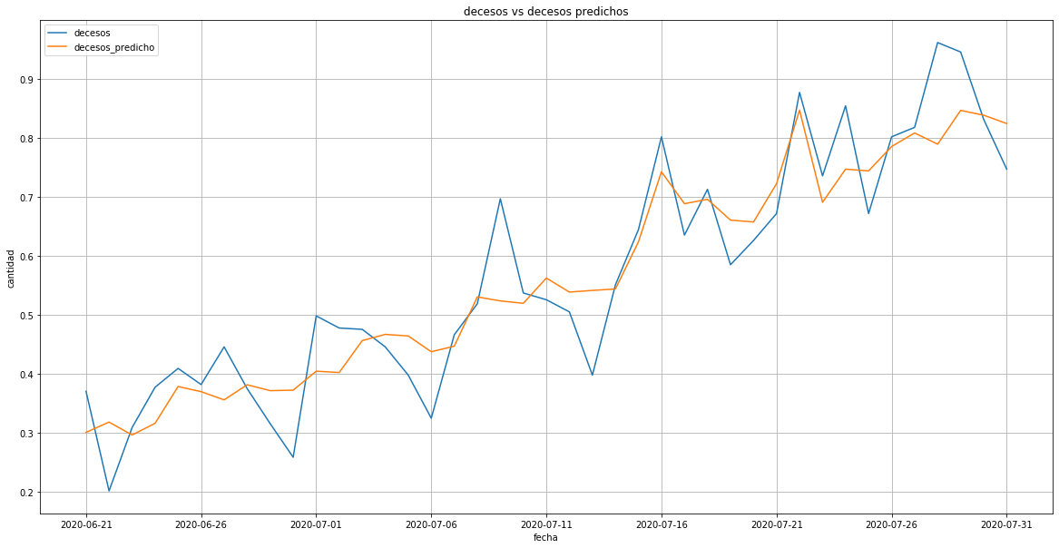
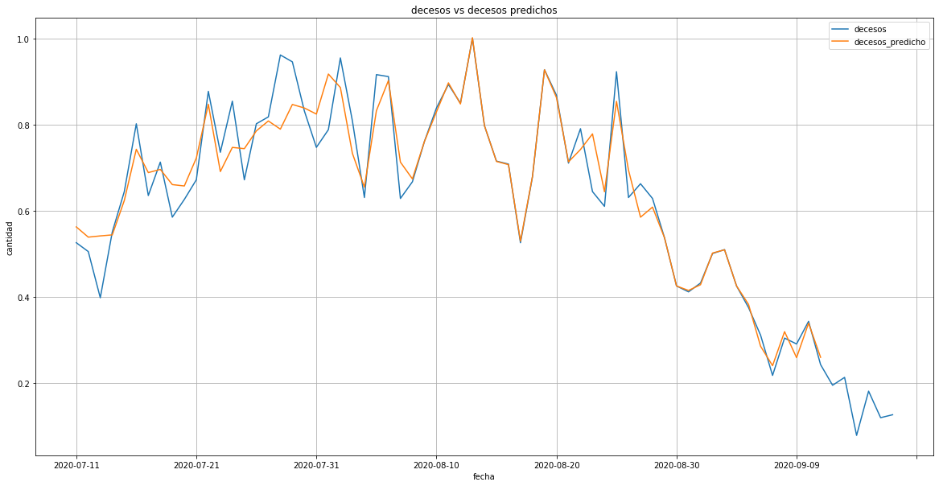

Neural Networkt-4 Dead Incremental learnings Neural Network t-4 Dead
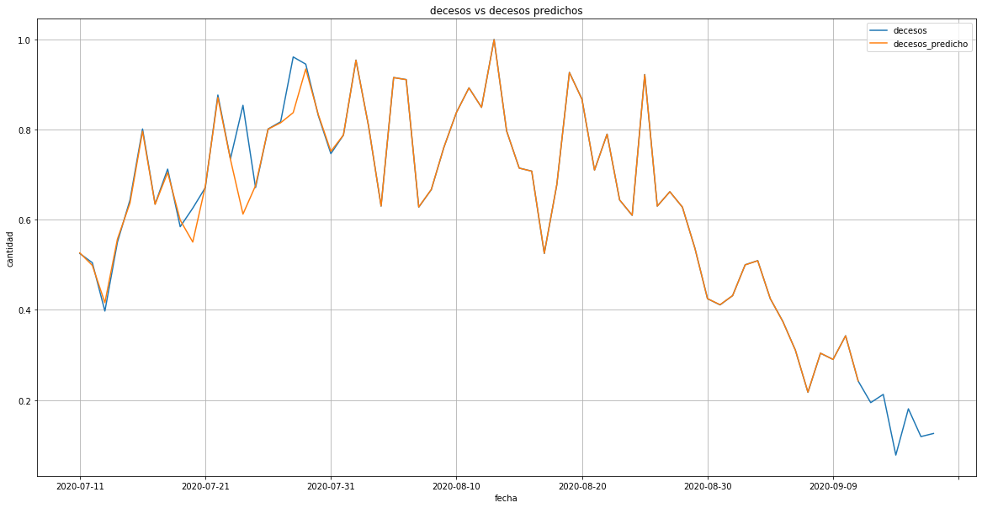
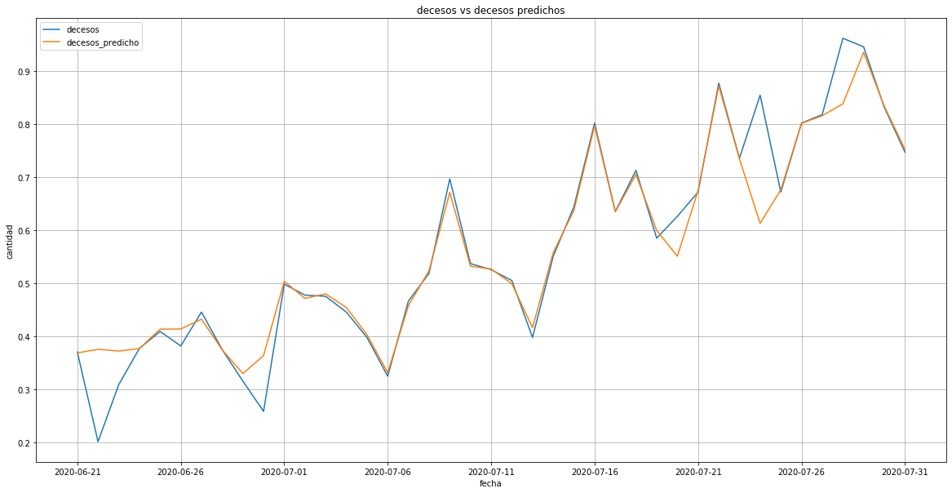

Modelo entrenado Gradient Boosting t-4 Dead Incremental learnings Gradient Boosting t-4 Dead

5.3 DISCUSSION OF RESULTS (Todos)

Target Variable | Regressor Model | Mean Squared Error | R² | Incremental Learnings | Mean Squared Error | R²
S | Gradient boosting | 0.990 | 0.0010 | Gradient boosting | 0,999 | 3,1e-05
S | Random forest |  |  | Random forest
S | Linear | 0,998 | 0.0010 | Linear | 0,9962 | 0.0001
S | Neural network | 0.9334 | 0.0006 | Neural network | 0,9941 | 0.0001
E | Gradient boosting | 0.788 | 0,0023 | Gradient boosting | 31.6654 | 0.9128
E | Random forest |  |  | Random forest
E | Linear | 0.788 | 0,0023 | Linear | 0,8991 | 0.0018
E | Neural network | 0.846 | 0.0003 | Neural network | 0,9274 | 0.0013
I | Gradient boosting | 0.9718 | 0.0007 | Gradient boosting | 0,0091 | 0.0001
I | Random forest |  |  | Random forest
I | Linear | 0.824 | 0.0043 | Linear | 0,8400 | 0.0029
I | Neural network | 0.833 | 0.0053 | Neural network | 0,8626 | 0.0025
R | Gradient boosting | 0.979 | 0.0001 | Gradient boosting | 0.9954 | 0.0002
R | Random forest |  |  | Random forest
R | Linear | 0.8839 | 0.0050 | Linear | 0.9804 | 0.0010
R | Neural network | 0.9384 | 0.0024 | Neural network | 0.9912 | 0.0004
D | Gradient boosting | 0.9185 | 0.0067 | Gradient boosting | 0.9681 | 0.0013
D | Random forest |  |  | Random forest
D | Linear | 0.829 | 0.0085 | Linear | 0.9591 | 0.0017
D | Neural network | 0.8625 | 0.006 | Neural network | 0.935 | 0.002

6. CONCLUSIONS AND FUTURE WORKS (jose)

REFERENCES

