EMDB

Requirements
- EMDB should allow admin users to ingest a movie/series/person from TMDB by its ID
- EMDB should allow users to retrieve specific movie/series/person details by its ID
- EMDB should allow users to retrieve all movies/series/people from the system
- EMDB should allow admin users to update specific movie/series/person details by its ID
- EMDB should allow admin users to delete specific movie/series/person details by its ID
- EMDB must have the capability to automatically ingest all changed movies/series/people from TMDB

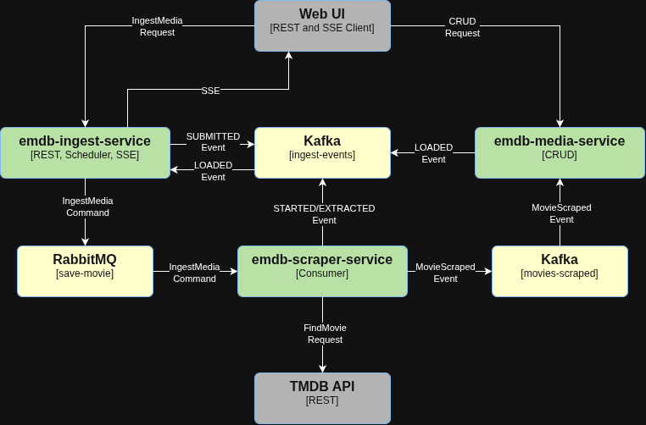
Workflow
- UI sends an IngestMediaRequest to emdb-ingest-service
  - writes the job to the ingest schema
  - publish the IngestMediaCommand to RabbitMQ
  - publish IngestEventMessage with type SUBMITTED to Kafka
- emdb--service consumes the IngestMediaCommand one at a time
  - publish IngestEventMessage with type STARTED to Kafka
  - fetch media details from TMDB under the 40 req/s limit
  - publish MovieScraped event, including full payload, to Kafka
  - publish IngestEventMessage with type EXTRACTED to Kafka
- emdb-media-service consumes the MovieScraped event
  - Upserts the movie into the media schema
  - publish IngestEventMessage with type LOADED to Kafka
- emdb-ingest-service persists every event and pushes it over SSE to the UI

Describe at a high level how to use event driven architecture to build an application using Quarkus that ingests movie data from TMDB and store it in my local Postgres database. The ingest process and the movie CRUD process need to be separated so that they can scale independently. The ingest process can be initiated by a synchronous REST request from a client or by a scheduler. Events like, SUBMITTED, STARTED, EXTRACTED, LOADED, COMPLETED, FAILED need to be streamed real time to my UI via SSE as well as being persisted in the database. I can use RabbitMQ, Kafka or both. The ingest process cant exceed TMDBs rate limit of 40 requests/second.

Show me the package structure using DDD + Hexagonal architecture for an Ingest service built on Quarkus, Jakarta Data, and RabbitMQ that ingests a movie from TMDB. The ingest process will be initiated by a synchronous REST request containing the TMDB id of the movie to ingest and converted to an IngestMediaCommand published to RabbitMQ. An ingest consumer will take the IngestMediaCommand message from the queue one at a time and extract the data from TMDB ensuring not to exceed TMDBs rate limit. Once extracted, a SaveMovieCommand will be sent to my Media service to store in my local database completing the ingest process. I need an audit log that contains each stage of the ingest process, SUBMITTED, STARTED, EXTRACTED, COMPLETED, FAILED.

Movie
- A movie, its credits, and person stubs will be saved in the same transaction. They either all commit or none of them do.
- A person stub will be created in the same transaction as the credit while the persons details will get filled in later using eventual consistency.
- Ingest from TMDB
  - Find the existing movie by TMDB id. If the movie doesn’t already exist by TMDB id, create a new movie.
  - Find all existing credits for the movie by movie id. The movie credit will have the id of the person the credit belongs to.
  - Match each incoming credit to existing credits by SourceId
  - Update matched credits
  - Insert any incoming credit that not in the list of existing credits
  - Remove any existing credit thats not in the list of incoming credits
- Updating a single credit from the UI
  - /api/movies/{id}/credits/{id}
  - find the existing credit by id
  - make the updates
  - return the updated credit version

Architecture Rules
- The credits can only be referenced through the Movie, Person, and Series root aggregates
- The Movie and Series aggregates define a transactional boundary such that credits and details are updated atomically. The person the credit belongs to will eventually be updated but is not immediate.
- The Series Seasons and Episodes will be updated

Buisness Rules
- The root aggregate must not be locked if its being persisted

emdb-ui
The emdb-ui is a Vue.js application that provides a User Interface frontend for EMDB with the following capabilites:
- View and edit movie/series data currently available in EMDB.
- Show the status of movie/series ingest jobs, both autonomous and manual. If the ingest job fails the extracted movie/series data from TMDB will be saved in a JSON format where it can be modified and uploaded into EMDB.
- Show user preferences such as favorites, watched movies and series episodes, personal scores, etc.

emdb-ingest-service
The Ingest service owns the ETL process for the root aggregates, Movie, Series, and Person.
- Extract movie, series, person details from TMDB
- Transform the TMDB entities into SaveCommands
- Load the EMDB root aggregates into the database
The ETL process runs automatically according to the Scheduler and can be manually triggered as well. The Ingest consumer pulls an IngestMedia command one at a time from the ingest-media queue and is rate limited according to TMDB specification.

emdb-media-service
The Media service manages the movie, series, and person root aggregates life cycle. The Media module ensures data consistency by persisting each root aggregate in a single transaction. It exposes GraphQL endpoints for querying root aggregates.

emdb-notification-service
The emdb-notification-service saves events to the database creating an event history that gets broadcast as sever sent events (SSE).

emdb-user-service

Release
- release/emdb/1.0.0 (Microservices refactor)
  - Create media schema
  - Create emdb-media-service
  - Create Movie aggregate
  - Created movie and movie edit pages in UI
  - Create ingest schema
  - Create emdb-ingest-service
  - Add Ingest aggregate
- release/emdb/1.1.0 (Person)
  - Create Person aggregate
  - Implement outbox pattern for making a person eventually consistent
  - Created person and person edit pages in UI
- release/emdb/1.2.0 (Movie Credits)
  - Create MovieCredit entity
  - Verify a person becomes eventually consistent
  - Create audit log for Media service
  - Create ArchUnit test for emdb-media-service
- release/emdb/v1.3.0 (Series)
  - Create Series aggregate
  - Create Season aggregate
  - Create Episode aggregate
- release/emdb/v1.4.0 (Ingest)
  - Add Ingest aggregate
  - Publish Ingest events
    - IngestSubmittedEvent
    - IngestStartedEvent
    - IngestProgressedEvent
    - IngestCompletedEvent
    - IngestFailedEvent
  - Persist the status changed events
  - Stream the status changed events as SSEs to the UI
  - Add Ingest page to the UI to start ingest process and monitor progress
  - Add ArchUnit test for emdb-ingest module
- release/emdb/v1.5.0 (Keycloak)
  - Secure the back-end
  - Secure the front-end
  - Restrict the /api/ingest endpoint to the ADMIN role
- release/emdb/v1.6.0 (Pessimistic Lock)
  - Add a locked and locked_by column to each aggregate that can be edited
  - Allow anyone with the ADMIN role to release the lock
  - Return 423 (Locked) if attempting to update a locked aggregate
- release/emdb/v1.7.0 (Resellinency)
  - Make the requests to the TMDB API fault tolerant
  - Rate limit the ingest process
  - Add Invalid command recovery path
- release/emdb/v1.8.0 (Scheduler)
  - Add movie/person/series scheduler
  - Add scheduler page to allow dynamic control of schedulers (Quartz)
- release/emdb/v1.9.0 (User Preferences)
  - Add emdb-user module
  - Add user favorites, watchlist, theme, ratings
- release/emdb/v1.10.0 (Observabillity)
  - Put the front-end and back-end into Docker
  - logging
  - metrics
- release/emdb/v1.11.0 (Caching/SSL/TLS)
  - Use Redis to cache data to prevent the client from hitting the Media module with multiple requests
  - Add SSL/TLS using NGINX
- release/emdb/v1.12.0 (Pagination, Filtering, Sorting)
  - Add POST /graphql/allMovies operation + pagination, sorting
  - Add POST /graphql/allPeople operation + pagination, sorting
  - Add POST /graphql/allSeries operation + pagination, sorting
  - Waiting on Jakarta Data 1.1 and the Restriction API for filtering

Ingest
- Each movie/series/person must be saved in a single transaction to prevent orphaned data. If the people are saved in a separate transaction than the movie and its credits, all the people will be orphaned if the movie and credits get rolled back. If the movie and credits never get corrected all those people will just be sitting in the database taking up space.
- TMDB does not provide a change key for Season/Episode vote_average and poster/still_path.
- The Series first air date and Season air date are derived from the air date of the first episode.
- The Series last air date is derived from the air date of the last episode to air.
- Every time we fetch the Series details we get the default Seasons but not the Episodes.

The best way to keep the Season/Episode vote_average and poster/still_path in sync with TMDB is to update the collection of Seasons in EMDB every time the top level Series object changes. This keeps the updates simple by watching for the Series ID in the Changes endpoint and sending the updated collection of Seasons and Episodes to EMDB.

Images
- TmdbMovieScraper extracts the movie data including backdrop and poster images from TMDB
- TmdbMovieScraper checks to see if the movie exists in EMDB
- If the movie exists and the backdrop/poster are not null, update the image with the existing image name
- Otherwise, generate a new image name

Seasons and Episodes:
- Sync the collection of Seasons in EMDB with TMDB
  - Perform a complete replacement of the collection of Seasons in EMDB with the one from TMDB.
    - If an existing Season in EMDB is not present in the updated Seasons from TMDB, it will be deleted.
    - If a Season from TMDB is not present in EMDB, it will be inserted.
    - If a Season from TMDB already exists in EMDB, it will be updated if changed
    - PUT http://127.0.0.1:60320/emdb/api/series/{id}/seasons
- Update the collection of Episodes in EMDB

Two sharp edges to plan for, and note how they split across the boundary. First, prefetch 1 is per consumer: run two instances of your app and you have two consumers, hence two ingestions in flight. If you need globally-one-at-a-time, declare the queue with RabbitMQ's single-active-consumer flag (x-single-active-consumer: true), which makes the broker deliver to only one consumer at a time and fail over automatically — again pure adapter/broker territory.
mp.messaging.incoming.ingestion-requests.connector=smallrye-rabbitmq
mp.messaging.incoming.ingestion-requests.queue.name=ingestion.requests
mp.messaging.incoming.ingestion-requests.max-outstanding-messages=1
mp.messaging.incoming.ingestion-requests.x-single-active-consumer=true

Two cross-cutting things now that this is a multi-writer edit page. First, full-replacement PUTs are lost-update machines — put a version on the movie (and credits, or version the aggregate as a whole), send it as ETag, require If-Match, return 412 on mismatch. Second, and this is the bigger landmine: your POST /api/movies ingestion path replaces credits and attributes wholesale, so the next TMDB re-sync will clobber every manual edit your users make. Decide that policy now — either track which fields/credits were manually edited and skip them during sync, or explicitly accept sync-wins semantics — because retrofitting it after users have curated data is painful.

Examples
- emdb/main: Movie/Series/Person credits
- erdouglass-emdb/erdouglass-emdb-web: UI

