After you've made the board and 3D printed the housing parts, you are ready to assemble. The picture below shows what you should have along with a few extra things you'll need.
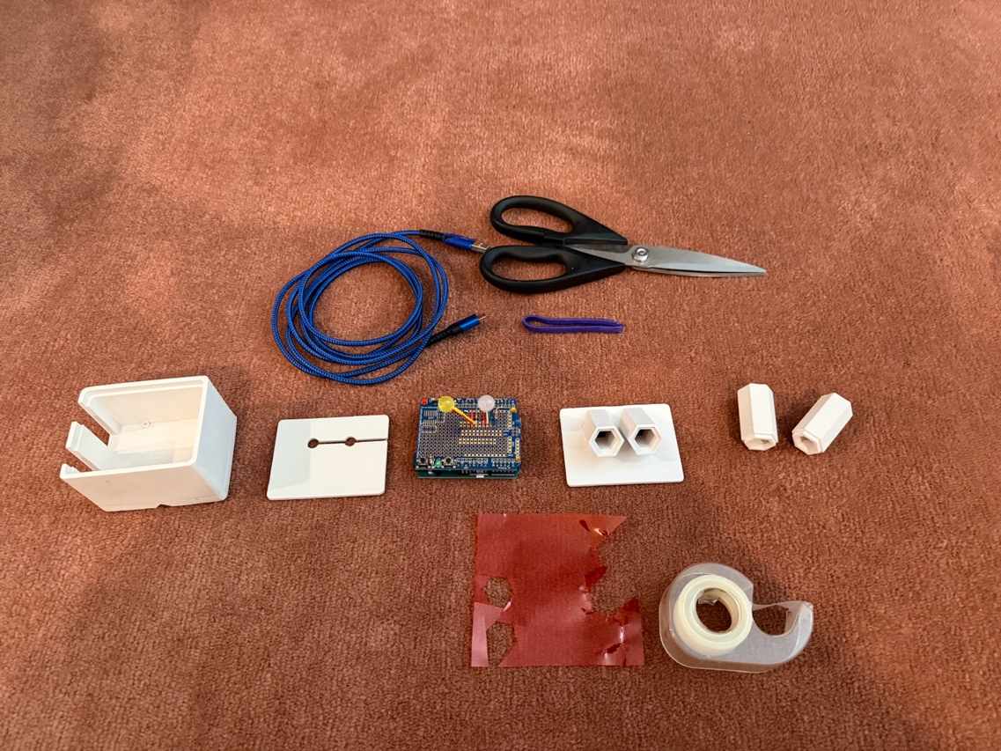
1) Put the Arduino in the main housing. Make sure the USB port is accessible through the slot on the side.
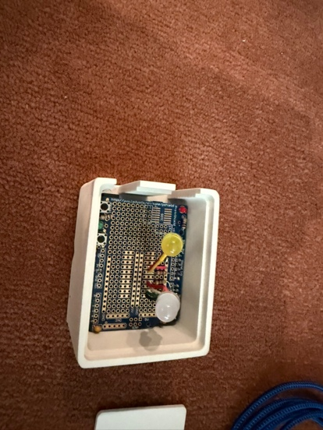
2) Put on the top plate. I try to get the LEDs so they are just sticking out a little. The LED leads are a little fragile so be gentle as you bend the wires to get them into place.
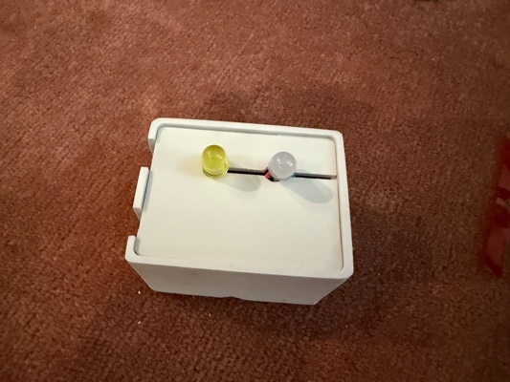
3) Pop on the lower part of the tubes. You can also put a rubber band or hair band around the top late to hold it on.
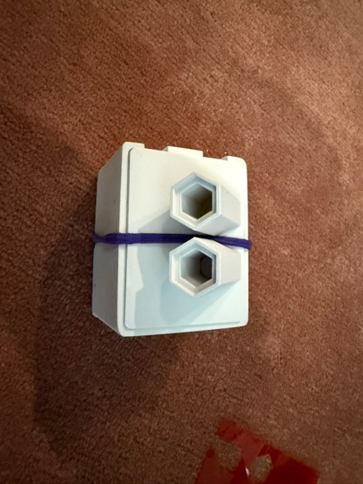

4) Get the right size for the filter insert. I jam a piece of filter between the two parts of the tube and press it down as shown. Then I remove which leaves a nice outline of the desired shape, that lets me cut the hexagonal filter piece to the right size. (You can also do this with the tubes, before you start assembling.)
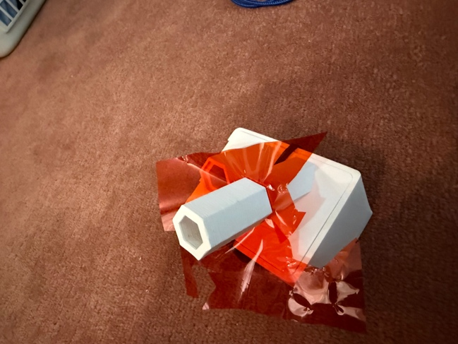

5) Insert the filters in the first part of the tubes.
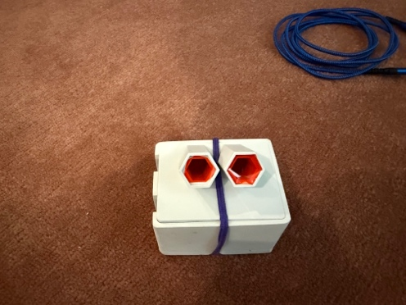

6) Pop on the top part of the tubes.
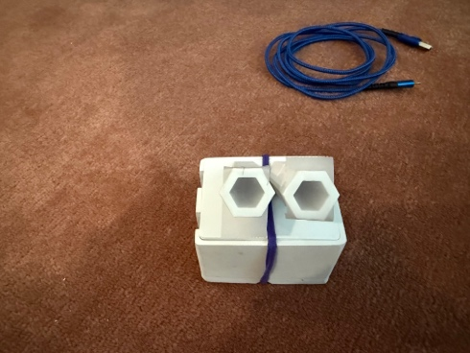
7) There are many ways to try to diffuse the light coming out of the tube. One is a bit of slightly opaque transparent tape. You can also get theater light diffusing material pretty cheap and try that.
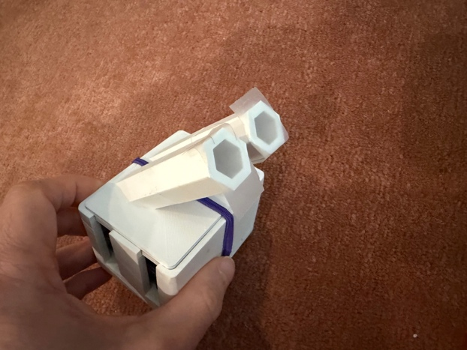
8) Plug in the USB cable and you're ready to go.
