Immediate tasks:
- State space plot
- Improve ecosystem plot

Paper writing plan

Tasks:
- Check Andelas conclusions
- Finalise Plan
- State space of veg vs fire
- Write abstract
- Methods section
- Write paper
- Emissions ecosystem trend
- Finialise figures#

Key message: We show trends in the controls in burnt area across the entire global. These trends are hard to pick up in most parts of the world outside tropical Savanna from burnt area alone as changes in controls impact on one-another, increaseing the noise with straight correltation with burnt area or even counter-acting one another to produce little overall trend in brunt area. We are able to seperate these out using our clever stuff. Trends are likely to have a big ecological/socio-economic impact

Title: Bayes on fire: hotpots of fire regime change via trends in burnt area controls machine learning.

Abstract (200-300 words)
We demonstrate that the controls on fire show dramatic shifts over the last 1 ½ decades over much of the world. The resultant trends in burnt area has a much smaller impact on global burnt area than the decine in tropical Savvanna ecostystems in recent studies 1. However, for ecosystems eveloved with infrequent, or sometime no fire, this is likely to have a dramatic impact. Far from being removed from the Earth system, fire is likley to have a prominent inlfuce on the worlds changing ecosystems <policy etc>>

Main

Introduction

The world has seen a decline in burnt area over the past two decades, attributed to increases in human suppression in fire-prone tropical savannas 1,2. Here, fire plays a vital role in maintaining ecosystem structure and function, favoring quick growing herbaceous over woody vegetation 3 and driving evolutionary adaptations to disturbance 4, maintaining biodiversity (<<ref - Toby>>) and altering plant carbon and nutrient allocation 5. This decline in burnt area is therefore likely have a significant impact on ecosystem function, resulting in woody encroachment and dramatically altering carbon cycling which will feedback to the wider Earth System 1,6. Tropical savannas account fo 78% of global burnt areas despite coving just 16% of the land surface 7, so it makes sense that changes in their fire regimes have a disproportionate impact of global burnt area trends. Conversely, non-fire prone ecosystems, with vegetation adapted to infrequent fires, only require a small change in burnt area to dramatically alter the landscape<<ref>>. Trends here would not be detected in a global signal, but could potentially impact a much more extensive land area and have a much greater impact on the earth system. Forest ecosystems are of particular concern due to the amount of carbon stored in none-fire adapted wood vegetation <<ref - Chantelle>>.

The assumption that changes in burnt area can be attributed to changes in one class of drive - in the case of tropical savanna, human manipulation of the fire regime - is harder to apply to vegetation types where bioclimatic controls play a significant role in limiting fire 8,9. To determine drivers in these areas instead requires a way of picking apart the complex interplay of different controls on burnt area. Changes in controls may also highlight potential shifts in fire regime not detectable via trend analysis of burnt area alone: e.g decreases in moisture and hence productivity and fuel loads is associated with fewer, larger less intense fires with potentially little change in burnt area 10,11. Several recent studies which aimed to determine the relative strength of the control of relevant human and bioclimatic variables have on burnt area could be exploited to unpick drivers of fire regime trends. Bistannis et al 9 represented each variable as a logistic curve (such as the curves shown in figure 1) and used generalised linear modelling (GLM) to identify plant available moisture (measured by the ratio of actual to potential evapotranspiration, hereby referred to as ), cropland area and population density as significant suppressive controls, and net primary production (NPP), vegetative cover, number of dry days, maximum temperature, grazing-land area and diurnal temperature range (as a proxy for relative humidity) as significant liberative controls of burnt area. This technique was simplified in Kelley et al 7 by selecting one key variable for fuel, moisture and ignitions and using GLM to map the relative limitation of each control on Australian fires, demonstrating that areas of high burnt area can be determined by the limitation imposed by fuel and moisture alone. Forkner et al (8) developed this by incorporating multiple variables into each of these three controls and by including a fourth control: human suppression.

Methods
We build on these previous studies by constructing burnt area as a combination of the limitations imposed by key variables identified in 8, or heavily relied upon by the global fire modelling community 12, split between the four controls: fuel (dis)continuity (referred hereafter as just “fuel”) by variables describing vegetation cover and maximum annual anomalie; fuel moisture (“moisture”) by and atmospheric drying potential, which combines dry days, maximum temperature and relative humidity 13; potential ignitions (“ignition”) by lightning strikes, population density and pasture cover; and anthropogenic suppression (suppression) by cropland and population density (see methods for data sources). Each control is expressed as a linear combination of their respective variables, and limitation imposed by each control is represented by a logistic function (figure 1, see methods). Burnt area is constructed by multiplying the maximum permitted fire by each control. By separating out controls in this way, we are able to: a) allow variables to contribute to both suppressive and liberative controls (i.e, by incorporating vegetation moisture content in fuel and moisture terms, and including population density for ignitions and suppression); b) represent the additive nature of variables to each control. Human contribution to ignitions, for examples, has a much smaller impact burnt area in the presence on natural ignitions compared to when no natural ignitions are present; and c) simplify trend analysis, as we can track the emergent trend of four controls rather than monitor that change in a multitude of variables

We optimized the contribution of each variable to their control, and the shape of the control curves against monthly GFED version 4 burnt area 14 incorporating small fires 15 (GFED4s) using an iterative Bayesian inference technique. Bayesian machine learning allows us to encode our prior understanding about the basic structure of our modelling framework, and express (un)certainty in resultant parameter combinations once our framework has been optimized against observations. We ran 10,000 iterations over 10% randomly sampled data points. Parameter uncertainty was determined by sampling 100 ensemble members from the last 1000 iterations. Burnt area constructed for all grid points using this framework reproduces the magnitude and spatial pattern of GFED4s annual burning (Figure S3), fire season timing and historical trends in burnt area, with relatively little spread between ensemble members (see methods and SI notebook 1 for full quantitative assessment).

Results

Fuel becomes limiting at relatively high vegetative fractions (figure 1), allowing 50% burning at 55 ± 0.01% fuel continuity (roughly 87% unmodulated total vegetative cover). Limitation only slowly increases with decreasing fuel, limiting monthly burnt area to 10% at fuel continuity of 27 ± 0.52% (73% cover). Moisture is 50% limiting at 22 +/- 0.26%, comparable to “moisture extinction” studies (e.g 16 but see SI for more.), with sharper transition, limiting burning to 10% by 29 +/- 0.15% (figure 1). Ignitions demonstrate very little control on fire, with 50% burning allowed from 1.54 +/- 0.01 monthly “potential” ignitions - well below the amount of lightning found in areas not controlled by fuel or moisture (figure SI1). Suppression rapidly affects fire at low values agricultural land covers and/or low population densities. Cropland landuse is the major supressent of fire, with cropland causing significant local reduction in burnt area, much more that it’s own extent, suggesting significant landscape fragmentation effects (Figure SI7). On the whole, people tend to reduce burnt area, completely suppressing fire at populations densities >1000 people/km2 . At low population densities, people tend to increase burnt area just a few areas with little natural ignitions and decreases fire when controlled by fuel or moisture, and with little other anthropogenic disturbance.

To determine the relative limitations of controls at different locations/times (figure 2), we assessed

- Most of the world's Savannas and other fire-prone transition zones are sensitive to ignitions and changes in anthropogenic suppression, something masked when just considering the absolute contribution of each control.

There 3 ways to look at limitation imposed on burnt area by these four controls which we refer to here as raw, potential and sensitivity. Raw is the one normally considered: how much fire would the control permit in otherwise perfect conditions. Potential is a more appropriate way of considering the relative contribution of each control on fire: how much extra burning would occur if the limitation by that control were lifted, given the limits imposed by other local controls. Sensitivity is perhaps the most relevant for looking at the transient change in burnt area and possible associated bgc and/or social impacts: how rapidly does fire change given marginal changes in the control in the presence of limitations imposed by all other controls. The latter is how we assess the drivers behind recent trends in burnt area.

- Sensitivity

Trends (include potential shifts in fire regime):
- How we determine trends
- Increases in cropland and population are the main cause of the decline in burnt areas in many of the world's Savannas. This is partly offset by increases in vegetation cover in fuel limited, more arid savanna ecosystems.#
- Globally, trends in fuel (abolute %) followed by moisture (%), although moisture shows more extreme variability with 25% of land surafce showing ?? trend, specially in tropical humid forest, generally showig increases in fire from decrease in moisture (although offset in places from increase in suppression) and boreal regions generally showing increase in fuel with burnt area counteracted by increase in fuel moisture.
- Changes in suppression and ignitions show little control over much of the world, although changes in suppression in dry troical and savvanah ecosystem …
- 75% of mediterranean ecosystems show increase in fire from increased fuel load, although in Northern Afrirca, this is offset by increased moisture. Shrublands almost always show an increase in trend in veg cover (SI), however, as areas such as Sahahar, Kalihari, parts of Australia are so fuel limited, 50% of areas show no icnrease in fire.
- Trend index
- Tropical wet and boreal forests atre the most subseptable to changes in fire regime from trend index, ostly driven by changes in moisture and fuel. They are closely followed by temerate forest ad woodland. All ecosystems except tropical Savvanna and shrubland show > 50% area with >5% trends index.
- Significant changes in drivers are affecting burnt area in less-fire prone areas of the world.
  - Tropica

====
Check its in here:

- Desert regions on the whole are seeing an increase in burnt area with an increase in vegetation cover
- Shifts in climate in temperate and boreal regions are having dramatic changes in burnt area.
- Areas in humid tropical rainforests that see an increase in burnt area are becoming more susceptible from drying.

=====

Conclusions

Senstivity to limiation for trends
Sensitivity vs limitation, showing what control => change, not just what is limiting
- Sensitivity to and limitation by controls are not always equivalent, with areas where fire is a key ecosystem process limited by the interplay of fuel and moisture, but more sensitive to changes in ignitions and suppression.

Identified trends in burnt area
We demonstrate that the controls on fire show dramatic shifts over the last 1 ½ decades over much of the world. The resultant trends in burnt area has a much smaller impact on global burnt area than the decline in tropical Savanna ecosystems in recent studies <<ref:Andelas>>.
Far from diminishing ther serious these previous analysis have demostrated, we changes in fire
is much more of an inportangt issue globally and therefore … fire is likely to have a prominent influence on the world's changing ecosystems <policy etc>>
- Small but significant increases in burnt area in arid and humid regions are being driven by bioclimatic changes rather than direct human impacts.
- Forest particularly susetbale
- Potential impact on eosystem function and earth system
- Future work meeded to address this
Burnt area has long been used as a proxy for fire regines in general in global fire modelling (ref). In reality, it emerges from other ecologically and socioeconomically import aspects of fire regimes: a product of number of fires and fire size which is itself dependant on fire intensity. Although xXxX shows no change in overall burnt area, the positive influence on burnt area trend by xXxX is likely to act through increasing number of fires (Hantson et el), while xxx is likely to mean a shift to smaller, less intense fires (xXxX). This would havr the ecological effect of ...., even though burnt area remains unchanged.

Although we can qualitatively describe changes in fore regime and infere ecological impacts as a whole via the changes in controls burnt area, to quantify these impacts requires similar studies for ecological important aspect of fire regime. Hantsin st am (xXxX) has studied fire size, but fire intensity remains an open and important question. On top of this, the modelling the impacts of fire on vegetation is largely untested, and would benefit with studies exploring fire-vegetation impact of coarse global scales.

Fiuture climate
Another interest would be to explore how the identified hotspots might evolve in the future, or indeed if other hotspots emerge. The 1.5 and 2 degree targets set by the Paris agreement are loosely based on perceived wide spread ecological and socio-economic thresholds. However, the impact of large scale fire regime change was not explicitly considered in their construction. The framework we developed here is ripe fpr applying to this question.

Novel use of model development techniques
New way of model development
CCDAS - complex process, our simple

Baysian model optimization - Perhaps more importantly, we have demonstated a novel hybrid methods for model development, applying machine learning tecniques which are qunatatiklivty by scientific expterise to described the relationships between our process (fire) and its controls and qunatativivly constructed by machine learning tecniques.

Things to thimk about addig in if space:
The observed large-scale decline of burned area in the world’s grasslands, savannas, and tropical land-use frontiers had broad consequences for vegetation dynamics, carbon cycling, air quality, and biodiversity.
- Interesting that areas shown to be most sensitivity to trend in hurnt area (Savvana - Andelas and Shrub/Desert) show lowest fire trend susceptibility.
- Possible impact on emission: Savanna emissions low compared to tropical
- Future, including future land use seniorios
- Socio-economic tradeoffs

Figures
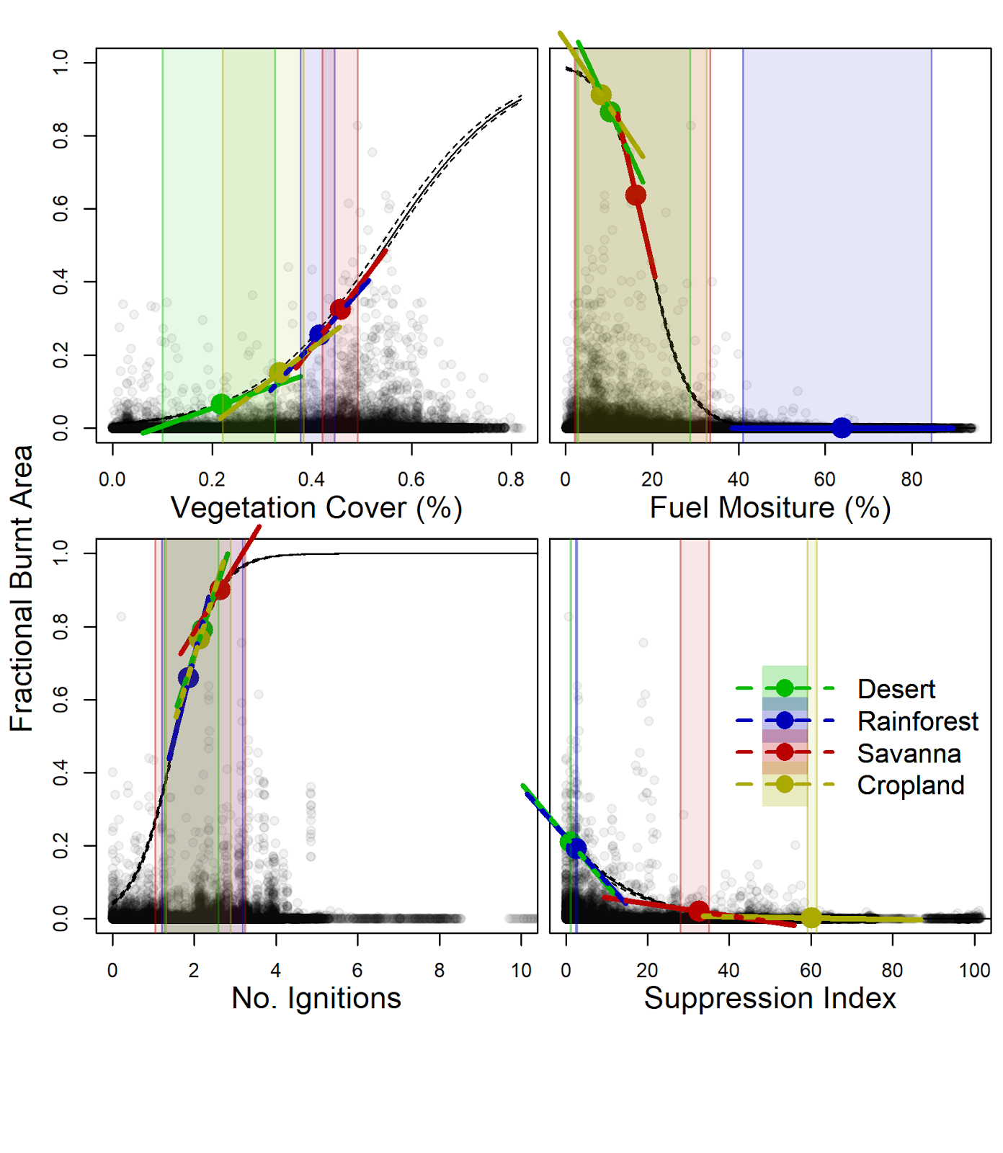
Figure 1:

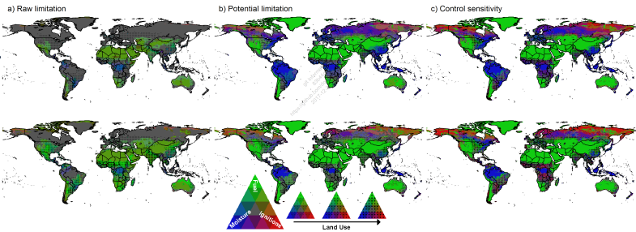
Figure 2

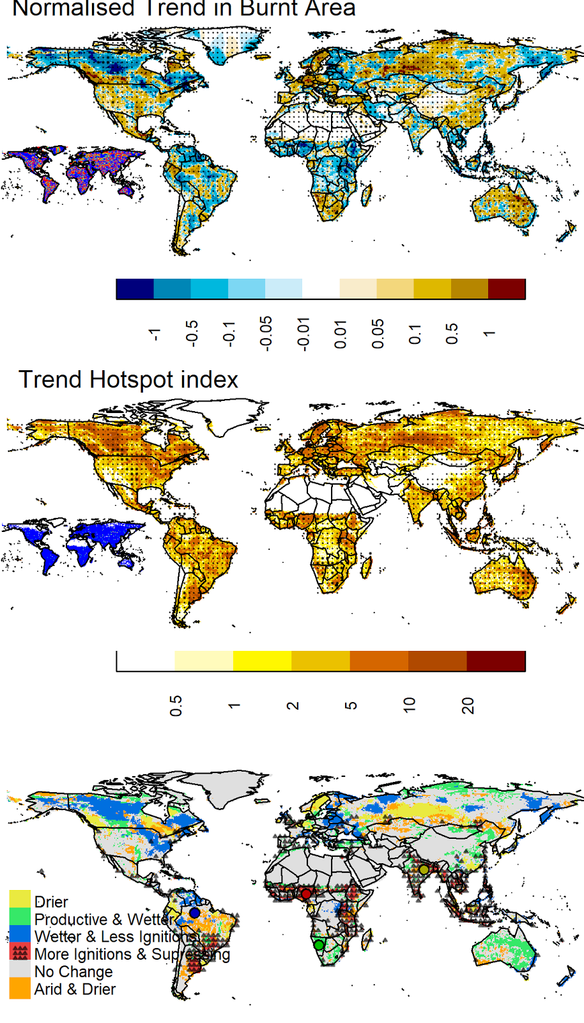
Figure 3

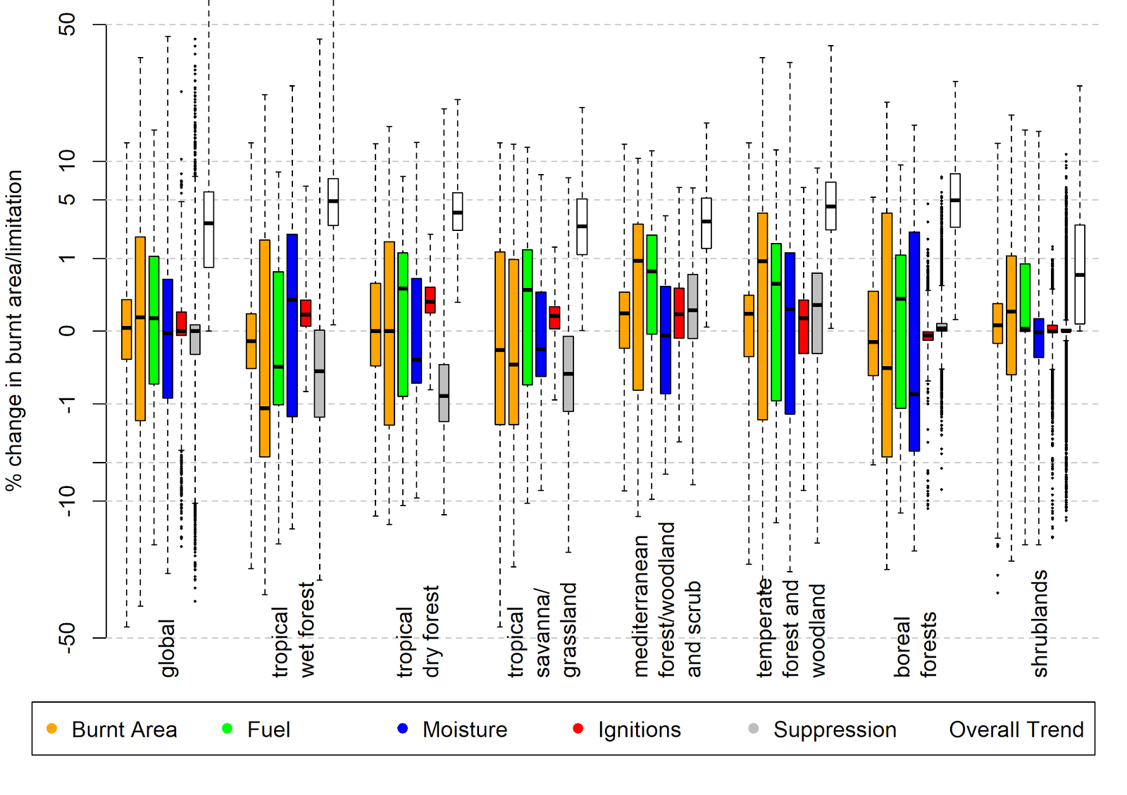

Figure 4

Methods
Modelling framework
Monthly burnt area (F) is calculated as a product of limitations imposed by four controls: fuel (dis)continuity (w), fuel moisture (), ignition availability (ig) and direct human suppression (s) each represented by a simple logistic curve (figure 1):
f(x) = 1 / (1 + e-k(x - xo))
F = Fmax f(x) (1)
Where f(x) is the limitation imposed by control, x =w, , ig, s and Fmax is a maximum permitted monthly burnt area used to aid model optimization. xois the value of control xwhen it imposes a limitation of 50% on burnt area (i.e,f(x) = 0.5), and k is the steepness of the logistic curve, equal to ¼ of the gradient at x = xo. For w and ig, where burnt area increases with the control, k > 0, whereas k < 0 for and s, for which burnt area decreases. Each control is represented by a combination of variables (xi) weighted by their respective influence (vi). Where possible, units are consistent across variables within each control, and as such the combined variables are normalised to maintain these units
x = ivi xi / ivi (2)

is a combination of “live” fuel, dead fuel drying potential, and impact of canopy on atmospheric moisture content. Live fuel is represented by the ratio of actual to potential evapotranspiration (), calculated from CRUTS3.23 cloud cover, temperature and precipitation 17 using the STASH model18 (SI…). Dead fuel drying potential follows 13 using CRU relative humidity, temperature, wet days and precipitation. VCF fractional tree cover 19 is used as a proxy of canopy effects on moisture.

w is represented by total fractional vegetation cover (C)19. C is only provided on a annual timestep. In order to capture the impact of seasonal variations of moisture on semi-arid ecosystem vegetation cover, we weight C by the maximum anomalie over the previous 12 months (max). Fractional cover was also raised to a power (p) in order to account for saturation for covers > ~ 80%:
w = Cp (V max/ - 1 + 1) (3)

igcombines natural ignitions from climatological LIS/OTD lightning flash counts20, with inter-cloud flashes removed using the technique described by 13, and human caused ignitions from HYDEv3.1 pasture cover and population density 21.

s combines HYDE population density, cropland or pasture 21

All variables where resampled to the coarsest (and most common) resolution of 0.5. Fractional cover and HYDE variables are interpolated from an annual to a monthly timestep. LIS lightning 12 month climatology was recycled each year.

Bayesian optimization
We optimized constructed burnt area from the above framework against GFED version 4 14 with small fires 15 (GFED4s) for 2000-2012 (common years among all datasets) using a Bayesian inference technique. In our case, Bayes theorem states that the likelihood of the values of our unexplained parameter set (i.e. all -k, x0 and Fmax in equation (1), vi in equation (2) and p, V in equation(3)), given a set of observations X, is proportional to the prior probability distribution of (P()) by the probability of X give . i.e

P(|X) P() P(X|) (4)

We set uninformed prior distribution for all parameters , i.e uniform with only physically plausible or generously large bounds (see SI <<notebook>>). For simplicity, we define model error to be normally distributed:
P(|X) = (F, ) = N2 expiNyi - Fii2 (5)
Where i represents an individual datapoint, yi is the GFED4s burnt area observation. Posterior distribution are inferred using the Metropolis-Hastings algorithm <<ref Rhys>> to minimise equation 5, which replaces the prior distributions for the next iteration. We ran 10,000 iterations over 10% randomly sampled data points on a 0.5͒, monthly time step for 12 year. This represents 2,314,512 data points. Our final posterior distribution is sampled from the last 100 iterations in order to construct the 100 model ensemble for analysis. Final parameter values and distributions are in SI noteboook 3

Framework assessment
Burnt area from the optimized framework constructed over all data points was assessed against GFED4s for annual average burnt area, seasonal timing and trends using a modified version the Kelley et al benchmarking framework 13 as used by the fire Model Intercomparison Project 12. The framework reproduced global burnt area estimates (?? vs GFEDv4s observed of ??). With an Normalised Mean Error score of 0.47 for annual average burnt area, it outperforms all fireMIP and benchmarking null models. Despite being an emergent property of fire reconstruction, the framework scores 0.91 for spatial trends in burnt area, better than null models (table SI1 - fireMIP model trend assessment have yet to be published).

Raw, potential and sensitivity to limitation
“Raw” limitation refers to the limitation imposed by each control under otherwise ideal burning conditions and is defined as 1 - f(x) (point on the curve in figure 1). “Potential” limitation (p(xi) for control xi) is the potential increase is burnt area if the limitation imposed by a control is removed, in the presence of other controls:
p(xi) =jN(i) f(xj) / F = (Fmax f(xi))-1 (6)
The sensitivity to limitation (Si) is the change in burnt area (G - gradient lines in figure 1) relative to the maximum rate of change in burnt area for that control (i.e when x = x0), weighted by the potential limitation for that cell:

G = f(x)/x f(x0)/x
Si = Gi F-i (7)

Where F-i = jN(i)f(xj) is the product of all fire controls excluding the one being considered.

Trend analysis
Trends for each control were calculated by fitting a simple linear regression model of the control for each month of the year through time. This trend was removed from that control, leaving behind just seasonal and interannual variability. The impact of the trend in a control on fire is the difference from reconstructed fire including the trend (i.e Fin equation 1) and reconstructed burnt area with the trend of that control removed:
Fdxi= F - f(xi - t xidt )F-i (8)

This is then normalised by mean constructed burnt area (F) to determine the relative impact of the controls trend on burnt area (d(xi))
d(xi) =Fdxi / F

And index for the impact of trend from all four controls is constructed by multiplying the absolute value of all impacts together:
D = id(xi)

References
1. Andela, N. et al. A human-driven decline in global burned area. Science 356, 1356–1362 (2017).
2. Knorr, W., Arneth, A. & Jiang, L. Demographic controls of future global fire risk. Nat. Clim. Chang. 6, 781–785 (2016).
3. Lasslop, G., Brovkin, V., Reick, C. H., Bathiany, S. & Kloster, S. Multiple stable states of tree cover in a global land surface model due to a fire-vegetation feedback. Geophys. Res. Lett. 43, 6324–6331 (2016).
4. Zeppel, M. J. B. et al. Drought and resprouting plants. New Phytol. 206, 583–589 (2015).
5. Clarke, P. J. et al. Resprouting as a key functional trait: how buds, protection and resources drive persistence after fire. New Phytol. 197, 19–35 (2013).
6. Kelley, D. I. & Harrison, S. P. Enhanced Australian carbon sink despite increased wildfire during the 21st century. Environ. Res. Lett. 9, 104015 (2014).
7. Kelley, D. I. Modelling Australian fire regimes. (Macquarie University, 2014).
8. Forkel, M. et al. A data-driven approach to identify controls on global fire activity from satellite and climate observations (SOFIA V1). Geoscientific Model Development 10, 4443–4476 (2017).
9. Bistinas, I., Harrison, S. P., Prentice, I. C. & Pereira, J. M. C. Causal relationships vs. emergent patterns in the global controls of fire frequency. Biogeosci. Discuss. 11, 3865–3892 (2014).
10. Archibald, S., Lehmann, C. E. R., Gómez-Dans, J. L. & Bradstock, R. A. Defining pyromes and global syndromes of fire regimes. Proc. Natl. Acad. Sci. U. S. A. 110, 6442–6447 (2013).
11. Murphy, B. P., Lawes, M. J. & Bowman, D. M. J. S. Pattern, prediction and parsimony in continental-scale synthesis of pyromes: a reply to Gosper et al. J. Biogeogr. 43, 636–638 (2015).
12. Rabin, S. S. et al. The Fire Modeling Intercomparison Project (FireMIP), phase 1: Experimental and analytical protocols. Geoscientific Model Development Discussions 1–31 (2016).
13. Kelley, D. I., Harrison, S. P. & Prentice, I. C. Improved simulation of fire-vegetation interactions in the Land surface Processes and eXchanges dynamic global vegetation model (LPX-Mv1). Geoscientific Model Development Discussions 7, 931–1000 (2014).
14. Giglio, L., Randerson, J. T. & van der Werf, G. R. Analysis of daily, monthly, and annual burned area using the fourth-generation global fire emissions database (GFED4). Journal of Geophysical Research: Biogeosciences 118, 317–328 (2013).
15. Randerson, J. T., Chen, Y., van der Werf, G. R., Rogers, B. M. & Morton, D. C. Global burned area and biomass burning emissions from small fires. Journal of Geophysical Research: Biogeosciences 117, (2012).
16. Albini, F. A. Estimating wildfire behaviour and effects. (U.S. Department of Agriculture, 1976).
17. Harris, I., Jones, P. D., Osborn, T. J. & Lister, D. H. Updated high-resolution grids of monthly climatic observations - the CRU TS3.10 Dataset. Int. J. Climatol. 34, 623–642 (2013).
18. Davis, T. W. et al. Simple process-led algorithms for simulating habitats (SPLASH v.1.0): robust indices of radiation, evapotranspiration and plant-available moisture. Geoscientific Model Development 10, 689–708 (2017).
19. Daac, N. L. P. Vegetation Continuous Fields : MOD44B. (2015). doi:10.5067/MODIS/MOD44B.006
20. Cecil, D. J., Buechler, D. E. & Blakeslee, R. J. Gridded lightning climatology from TRMM-LIS and OTD: Dataset description. Atmos. Res. 135-136, 404–414 (2014).
21. Klein Goldewijk, K., Goldewijk, K. K., Beusen, A., Van Drecht, G. & De Vos, M. The HYDE 3.1 spatially explicit database of human-induced global land-use change over the past 12,000 years. Glob. Ecol. Biogeogr. 20, 73–86 (2010).
SI information and figures:
https://github.com/rhyswhitley/fire_limitation/tree/master/notebooks
(to be converted to PDF when closer to being finished).

