I used <http://www.mathopenref.com/lawofsines.html> in order to come up with the test cases for this problem.

With the appropriate angles and side(s), one can use the Law of Sines to determine the remaining sides. The program asks for Angle A, Side a and Angle B and it solves for Side b, Angle C and Side C.

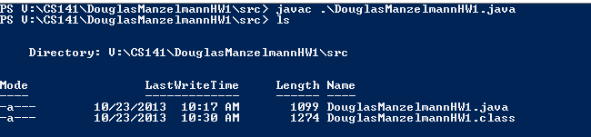

Angle Side

|  |  |
| --- | --- |
| A 89° | a 18.7 |
| B 59° | b 16 |
| C 32° | c 10 |

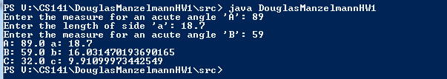

|  |  |
| --- | --- |
| A 66° | A 18.2 |
| B 79° | B 19.4 |
| C 35° | C 11.4 |

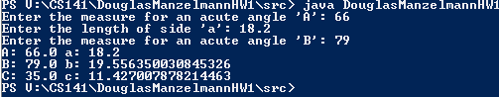

|  |  |
| --- | --- |
| A 60° | a 15.7 |
| B 54° | b 14.6 |
| C 66° | c 16.5 |

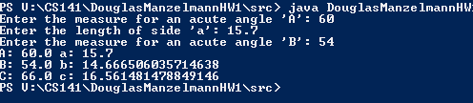

|  |  |
| --- | --- |
| A 45° | a 12 |
| B 32° | b 9.1 |
| C 103° | c 16.5 |

