Codebook for filteredData

Autogenerated data summary from dataMaid

2018-12-03 14:17:35

# Data report overview

The dataset examined has the following dimensions:

|  |  |
| --- | --- |
| Feature | Result |
| Number of observations | 10299 |
| Number of variables | 69 |

# Codebook summary table

|  |  |  |  |  |  |
| --- | --- | --- | --- | --- | --- |
| Label | Variable | Class | # unique values | Missing | Description |
|  | **Subject** | integer | 30 | 0.00 % |  |
|  | **V1100** | integer | 6 | 0.00 % |  |
|  | **tBodyAcc-mean()-X** | numeric | 10293 | 0.00 % |  |
|  | **tBodyAcc-mean()-Y** | numeric | 10295 | 0.00 % |  |
|  | **tBodyAcc-mean()-Z** | numeric | 10297 | 0.00 % |  |
|  | **tBodyAcc-std()-X** | numeric | 10297 | 0.00 % |  |
|  | **tBodyAcc-std()-Y** | numeric | 10291 | 0.00 % |  |
|  | **tBodyAcc-std()-Z** | numeric | 10298 | 0.00 % |  |
|  | **tGravityAcc-mean()-X** | numeric | 10299 | 0.00 % |  |
|  | **tGravityAcc-mean()-Y** | numeric | 10288 | 0.00 % |  |
|  | **tGravityAcc-mean()-Z** | numeric | 10293 | 0.00 % |  |
|  | **tGravityAcc-std()-X** | numeric | 10296 | 0.00 % |  |
|  | **tGravityAcc-std()-Y** | numeric | 10287 | 0.00 % |  |
|  | **tGravityAcc-std()-Z** | numeric | 10290 | 0.00 % |  |
|  | **tBodyAccJerk-mean()-X** | numeric | 10299 | 0.00 % |  |
|  | **tBodyAccJerk-mean()-Y** | numeric | 10290 | 0.00 % |  |
|  | **tBodyAccJerk-mean()-Z** | numeric | 10296 | 0.00 % |  |
|  | **tBodyAccJerk-std()-X** | numeric | 10293 | 0.00 % |  |
|  | **tBodyAccJerk-std()-Y** | numeric | 10290 | 0.00 % |  |
|  | **tBodyAccJerk-std()-Z** | numeric | 10298 | 0.00 % |  |
|  | **tBodyGyro-mean()-X** | numeric | 10297 | 0.00 % |  |
|  | **tBodyGyro-mean()-Y** | numeric | 10292 | 0.00 % |  |
|  | **tBodyGyro-mean()-Z** | numeric | 10296 | 0.00 % |  |
|  | **tBodyGyro-std()-X** | numeric | 10296 | 0.00 % |  |
|  | **tBodyGyro-std()-Y** | numeric | 10296 | 0.00 % |  |
|  | **tBodyGyro-std()-Z** | numeric | 10298 | 0.00 % |  |
|  | **tBodyGyroJerk-mean()-X** | numeric | 10298 | 0.00 % |  |
|  | **tBodyGyroJerk-mean()-Y** | numeric | 10292 | 0.00 % |  |
|  | **tBodyGyroJerk-mean()-Z** | numeric | 10295 | 0.00 % |  |
|  | **tBodyGyroJerk-std()-X** | numeric | 10291 | 0.00 % |  |
|  | **tBodyGyroJerk-std()-Y** | numeric | 10294 | 0.00 % |  |
|  | **tBodyGyroJerk-std()-Z** | numeric | 10292 | 0.00 % |  |
|  | **tBodyAccMag-mean()** | numeric | 10297 | 0.00 % |  |
|  | **tBodyAccMag-std()** | numeric | 7568 | 0.00 % |  |
|  | **tGravityAccMag-mean()** | numeric | 10297 | 0.00 % |  |
|  | **tGravityAccMag-std()** | numeric | 7568 | 0.00 % |  |
|  | **tBodyAccJerkMag-mean()** | numeric | 10291 | 0.00 % |  |
|  | **tBodyAccJerkMag-std()** | numeric | 7393 | 0.00 % |  |
|  | **tBodyGyroMag-mean()** | numeric | 10293 | 0.00 % |  |
|  | **tBodyGyroMag-std()** | numeric | 7730 | 0.00 % |  |
|  | **tBodyGyroJerkMag-mean()** | numeric | 10293 | 0.00 % |  |
|  | **tBodyGyroJerkMag-std()** | numeric | 7504 | 0.00 % |  |
|  | **fBodyAcc-mean()-X** | numeric | 10295 | 0.00 % |  |
|  | **fBodyAcc-mean()-Y** | numeric | 10294 | 0.00 % |  |
|  | **fBodyAcc-mean()-Z** | numeric | 10297 | 0.00 % |  |
|  | **fBodyAcc-std()-X** | numeric | 10296 | 0.00 % |  |
|  | **fBodyAcc-std()-Y** | numeric | 10294 | 0.00 % |  |
|  | **fBodyAcc-std()-Z** | numeric | 10298 | 0.00 % |  |
|  | **fBodyAccJerk-mean()-X** | numeric | 10294 | 0.00 % |  |
|  | **fBodyAccJerk-mean()-Y** | numeric | 10291 | 0.00 % |  |
|  | **fBodyAccJerk-mean()-Z** | numeric | 10294 | 0.00 % |  |
|  | **fBodyAccJerk-std()-X** | numeric | 10290 | 0.00 % |  |
|  | **fBodyAccJerk-std()-Y** | numeric | 10295 | 0.00 % |  |
|  | **fBodyAccJerk-std()-Z** | numeric | 10295 | 0.00 % |  |
|  | **fBodyGyro-mean()-X** | numeric | 10297 | 0.00 % |  |
|  | **fBodyGyro-mean()-Y** | numeric | 10297 | 0.00 % |  |
|  | **fBodyGyro-mean()-Z** | numeric | 10293 | 0.00 % |  |
|  | **fBodyGyro-std()-X** | numeric | 10295 | 0.00 % |  |
|  | **fBodyGyro-std()-Y** | numeric | 10295 | 0.00 % |  |
|  | **fBodyGyro-std()-Z** | numeric | 10298 | 0.00 % |  |
|  | **fBodyAccMag-mean()** | numeric | 10295 | 0.00 % |  |
|  | **fBodyAccMag-std()** | numeric | 10296 | 0.00 % |  |
|  | **fBodyBodyAccJerkMag-mean()** | numeric | 10293 | 0.00 % |  |
|  | **fBodyBodyAccJerkMag-std()** | numeric | 10293 | 0.00 % |  |
|  | **fBodyBodyGyroMag-mean()** | numeric | 10297 | 0.00 % |  |
|  | **fBodyBodyGyroMag-std()** | numeric | 10297 | 0.00 % |  |
|  | **fBodyBodyGyroJerkMag-mean()** | numeric | 10295 | 0.00 % |  |
|  | **fBodyBodyGyroJerkMag-std()** | numeric | 10293 | 0.00 % |  |
|  | **Activity** | factor | 6 | 0.00 % |  |

# Variable list

## Subject

|  |  |
| --- | --- |
| Feature | Result |
| Variable type | integer |
| Number of missing obs. | 0 (0 %) |
| Number of unique values | 30 |
| Median | 17 |
| 1st and 3rd quartiles | 9; 24 |
| Min. and max. | 1; 30 |

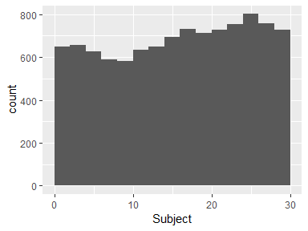

## V1100

|  |  |
| --- | --- |
| Feature | Result |
| Variable type | integer |
| Number of missing obs. | 0 (0 %) |
| Number of unique values | 6 |
| Median | 4 |
| 1st and 3rd quartiles | 2; 5 |
| Min. and max. | 1; 6 |

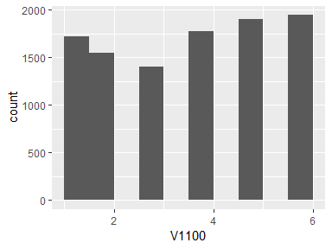

## tBodyAcc-mean()-X

|  |  |
| --- | --- |
| Feature | Result |
| Variable type | numeric |
| Number of missing obs. | 0 (0 %) |
| Number of unique values | 10293 |
| Median | -0.11 |
| 1st and 3rd quartiles | -0.12; -0.1 |
| Min. and max. | -1; 1 |

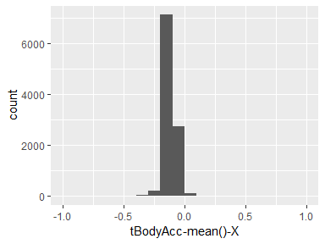

## tBodyAcc-mean()-Y

|  |  |
| --- | --- |
| Feature | Result |
| Variable type | numeric |
| Number of missing obs. | 0 (0 %) |
| Number of unique values | 10295 |
| Median | -0.94 |
| 1st and 3rd quartiles | -0.99; -0.25 |
| Min. and max. | -1; 1 |

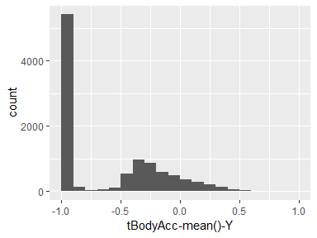

## tBodyAcc-mean()-Z

|  |  |
| --- | --- |
| Feature | Result |
| Variable type | numeric |
| Number of missing obs. | 0 (0 %) |
| Number of unique values | 10297 |
| Median | -0.84 |
| 1st and 3rd quartiles | -0.98; -0.06 |
| Min. and max. | -1; 1 |

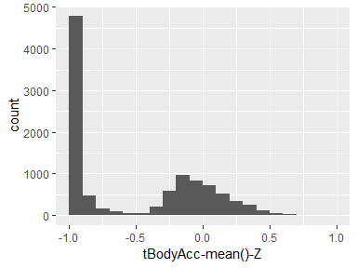

## tBodyAcc-std()-X

|  |  |
| --- | --- |
| Feature | Result |
| Variable type | numeric |
| Number of missing obs. | 0 (0 %) |
| Number of unique values | 10297 |
| Median | -0.85 |
| 1st and 3rd quartiles | -0.98; -0.28 |
| Min. and max. | -1; 1 |

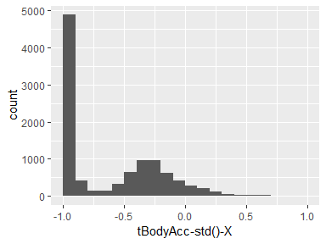

## tBodyAcc-std()-Y

|  |  |
| --- | --- |
| Feature | Result |
| Variable type | numeric |
| Number of missing obs. | 0 (0 %) |
| Number of unique values | 10291 |
| Median | -0.95 |
| 1st and 3rd quartiles | -0.99; -0.3 |
| Min. and max. | -1; 1 |

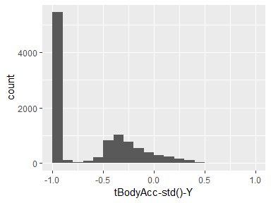

## tBodyAcc-std()-Z

|  |  |
| --- | --- |
| Feature | Result |
| Variable type | numeric |
| Number of missing obs. | 0 (0 %) |
| Number of unique values | 10298 |
| Median | -0.84 |
| 1st and 3rd quartiles | -0.98; -0.09 |
| Min. and max. | -1; 1 |

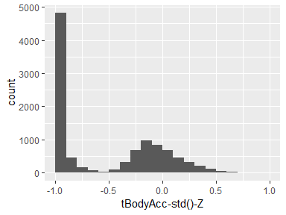

## tGravityAcc-mean()-X

|  |  |
| --- | --- |
| Feature | Result |
| Variable type | numeric |
| Number of missing obs. | 0 (0 %) |
| Number of unique values | 10299 |
| Median | 0.04 |
| 1st and 3rd quartiles | -0.12; 0.22 |
| Min. and max. | -1; 1 |

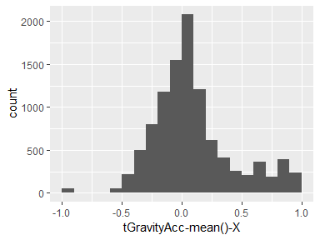

## tGravityAcc-mean()-Y

|  |  |
| --- | --- |
| Feature | Result |
| Variable type | numeric |
| Number of missing obs. | 0 (0 %) |
| Number of unique values | 10288 |
| Median | -0.98 |
| 1st and 3rd quartiles | -0.99; -0.96 |
| Min. and max. | -1; 1 |

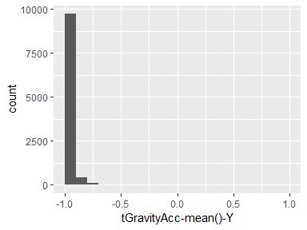

## tGravityAcc-mean()-Z

|  |  |
| --- | --- |
| Feature | Result |
| Variable type | numeric |
| Number of missing obs. | 0 (0 %) |
| Number of unique values | 10293 |
| Median | -0.98 |
| 1st and 3rd quartiles | -0.99; -0.95 |
| Min. and max. | -1; 1 |

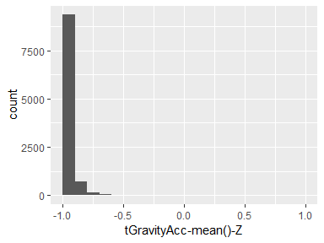

## tGravityAcc-std()-X

|  |  |
| --- | --- |
| Feature | Result |
| Variable type | numeric |
| Number of missing obs. | 0 (0 %) |
| Number of unique values | 10296 |
| Median | -0.97 |
| 1st and 3rd quartiles | -0.99; -0.93 |
| Min. and max. | -1; 1 |

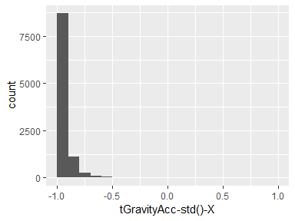

## tGravityAcc-std()-Y

|  |  |
| --- | --- |
| Feature | Result |
| Variable type | numeric |
| Number of missing obs. | 0 (0 %) |
| Number of unique values | 10287 |
| Median | -0.98 |
| 1st and 3rd quartiles | -0.99; -0.96 |
| Min. and max. | -1; 1 |

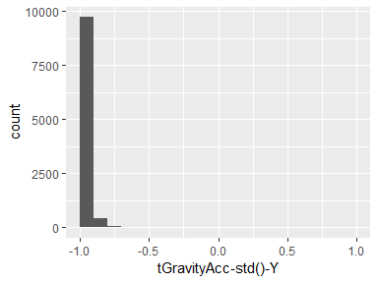

## tGravityAcc-std()-Z

|  |  |
| --- | --- |
| Feature | Result |
| Variable type | numeric |
| Number of missing obs. | 0 (0 %) |
| Number of unique values | 10290 |
| Median | -0.98 |
| 1st and 3rd quartiles | -0.99; -0.95 |
| Min. and max. | -1; 1 |

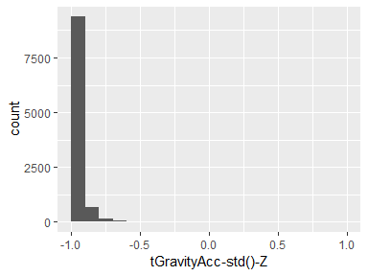

## tBodyAccJerk-mean()-X

|  |  |
| --- | --- |
| Feature | Result |
| Variable type | numeric |
| Number of missing obs. | 0 (0 %) |
| Number of unique values | 10299 |
| Median | 0 |
| 1st and 3rd quartiles | -0.03; 0.02 |
| Min. and max. | -1; 1 |

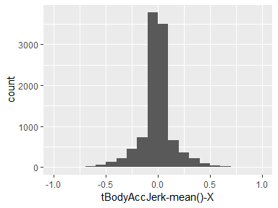

## tBodyAccJerk-mean()-Y

|  |  |
| --- | --- |
| Feature | Result |
| Variable type | numeric |
| Number of missing obs. | 0 (0 %) |
| Number of unique values | 10290 |
| Median | -0.95 |
| 1st and 3rd quartiles | -0.99; -0.29 |
| Min. and max. | -1; 1 |

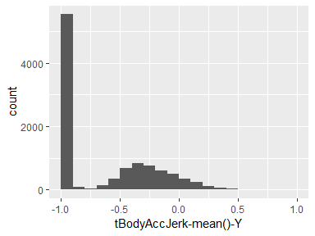

## tBodyAccJerk-mean()-Z

|  |  |
| --- | --- |
| Feature | Result |
| Variable type | numeric |
| Number of missing obs. | 0 (0 %) |
| Number of unique values | 10296 |
| Median | -0.93 |
| 1st and 3rd quartiles | -0.99; -0.22 |
| Min. and max. | -1; 1 |

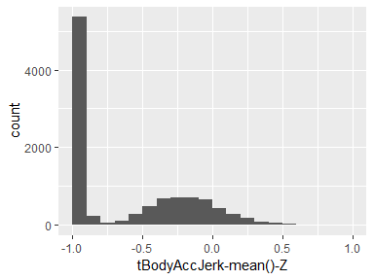

## tBodyAccJerk-std()-X

|  |  |
| --- | --- |
| Feature | Result |
| Variable type | numeric |
| Number of missing obs. | 0 (0 %) |
| Number of unique values | 10293 |
| Median | -0.95 |
| 1st and 3rd quartiles | -0.99; -0.55 |
| Min. and max. | -1; 1 |

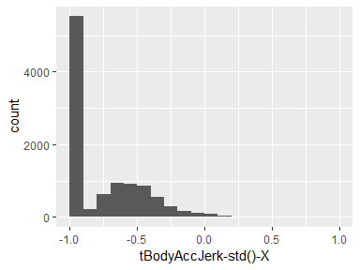

## tBodyAccJerk-std()-Y

|  |  |
| --- | --- |
| Feature | Result |
| Variable type | numeric |
| Number of missing obs. | 0 (0 %) |
| Number of unique values | 10290 |
| Median | -0.96 |
| 1st and 3rd quartiles | -0.99; -0.28 |
| Min. and max. | -1; 1 |

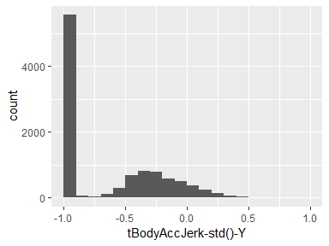

## tBodyAccJerk-std()-Z

|  |  |
| --- | --- |
| Feature | Result |
| Variable type | numeric |
| Number of missing obs. | 0 (0 %) |
| Number of unique values | 10298 |
| Median | -0.93 |
| 1st and 3rd quartiles | -0.98; -0.19 |
| Min. and max. | -1; 1 |

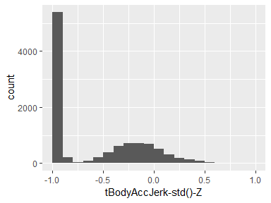

## tBodyGyro-mean()-X

|  |  |
| --- | --- |
| Feature | Result |
| Variable type | numeric |
| Number of missing obs. | 0 (0 %) |
| Number of unique values | 10297 |
| Median | 0.09 |
| 1st and 3rd quartiles | 0.06; 0.11 |
| Min. and max. | -1; 1 |

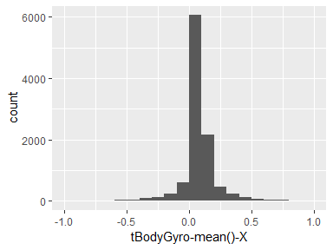

## tBodyGyro-mean()-Y

|  |  |
| --- | --- |
| Feature | Result |
| Variable type | numeric |
| Number of missing obs. | 0 (0 %) |
| Number of unique values | 10292 |
| Median | -0.9 |
| 1st and 3rd quartiles | -0.99; -0.48 |
| Min. and max. | -1; 1 |

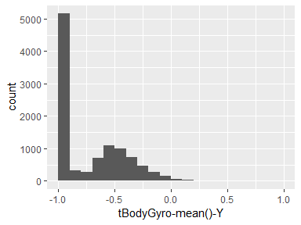

## tBodyGyro-mean()-Z

|  |  |
| --- | --- |
| Feature | Result |
| Variable type | numeric |
| Number of missing obs. | 0 (0 %) |
| Number of unique values | 10296 |
| Median | -0.91 |
| 1st and 3rd quartiles | -0.98; -0.45 |
| Min. and max. | -1; 1 |

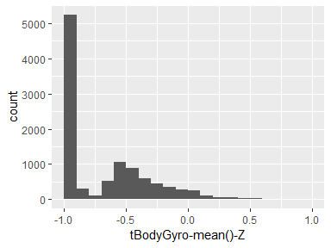

## tBodyGyro-std()-X

|  |  |
| --- | --- |
| Feature | Result |
| Variable type | numeric |
| Number of missing obs. | 0 (0 %) |
| Number of unique values | 10296 |
| Median | -0.88 |
| 1st and 3rd quartiles | -0.99; -0.34 |
| Min. and max. | -1; 1 |

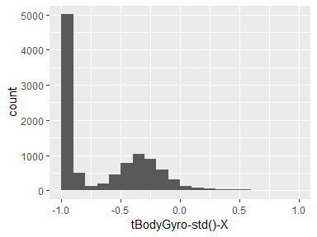

## tBodyGyro-std()-Y

|  |  |
| --- | --- |
| Feature | Result |
| Variable type | numeric |
| Number of missing obs. | 0 (0 %) |
| Number of unique values | 10296 |
| Median | -0.91 |
| 1st and 3rd quartiles | -0.99; -0.49 |
| Min. and max. | -1; 1 |

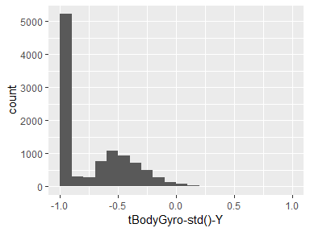

## tBodyGyro-std()-Z

|  |  |
| --- | --- |
| Feature | Result |
| Variable type | numeric |
| Number of missing obs. | 0 (0 %) |
| Number of unique values | 10298 |
| Median | -0.92 |
| 1st and 3rd quartiles | -0.98; -0.46 |
| Min. and max. | -1; 1 |

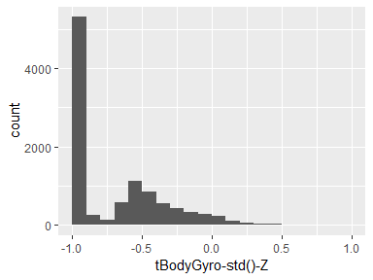

## tBodyGyroJerk-mean()-X

|  |  |
| --- | --- |
| Feature | Result |
| Variable type | numeric |
| Number of missing obs. | 0 (0 %) |
| Number of unique values | 10298 |
| Median | -0.05 |
| 1st and 3rd quartiles | -0.08; -0.03 |
| Min. and max. | -1; 1 |

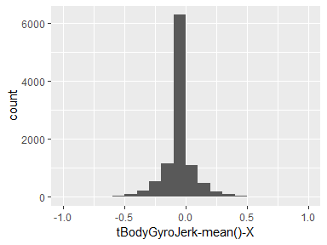

## tBodyGyroJerk-mean()-Y

|  |  |
| --- | --- |
| Feature | Result |
| Variable type | numeric |
| Number of missing obs. | 0 (0 %) |
| Number of unique values | 10292 |
| Median | -0.93 |
| 1st and 3rd quartiles | -0.99; -0.49 |
| Min. and max. | -1; 1 |

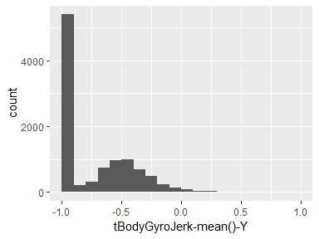

## tBodyGyroJerk-mean()-Z

|  |  |
| --- | --- |
| Feature | Result |
| Variable type | numeric |
| Number of missing obs. | 0 (0 %) |
| Number of unique values | 10295 |
| Median | -0.95 |
| 1st and 3rd quartiles | -0.99; -0.63 |
| Min. and max. | -1; 1 |

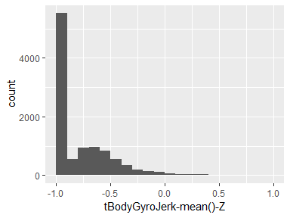

## tBodyGyroJerk-std()-X

|  |  |
| --- | --- |
| Feature | Result |
| Variable type | numeric |
| Number of missing obs. | 0 (0 %) |
| Number of unique values | 10291 |
| Median | -0.95 |
| 1st and 3rd quartiles | -0.99; -0.51 |
| Min. and max. | -1; 1 |

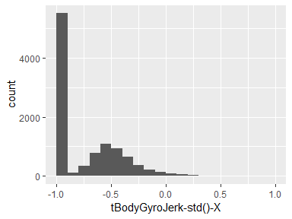

## tBodyGyroJerk-std()-Y

|  |  |
| --- | --- |
| Feature | Result |
| Variable type | numeric |
| Number of missing obs. | 0 (0 %) |
| Number of unique values | 10294 |
| Median | -0.94 |
| 1st and 3rd quartiles | -0.99; -0.48 |
| Min. and max. | -1; 1 |

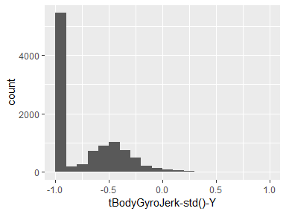

## tBodyGyroJerk-std()-Z

|  |  |
| --- | --- |
| Feature | Result |
| Variable type | numeric |
| Number of missing obs. | 0 (0 %) |
| Number of unique values | 10292 |
| Median | -0.96 |
| 1st and 3rd quartiles | -0.99; -0.64 |
| Min. and max. | -1; 1 |

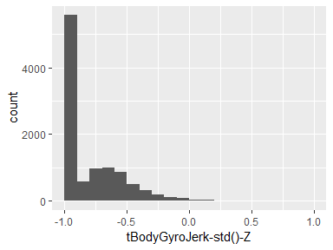

## tBodyAccMag-mean()

|  |  |
| --- | --- |
| Feature | Result |
| Variable type | numeric |
| Number of missing obs. | 0 (0 %) |
| Number of unique values | 10297 |
| Median | -0.86 |
| 1st and 3rd quartiles | -0.98; -0.34 |
| Min. and max. | -1; 1 |

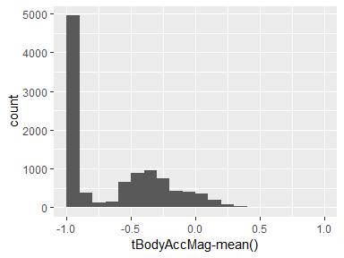

## tBodyAccMag-std()

|  |  |
| --- | --- |
| Feature | Result |
| Variable type | numeric |
| Number of missing obs. | 0 (0 %) |
| Number of unique values | 7568 |
| Median | -0.85 |
| 1st and 3rd quartiles | -0.98; -0.17 |
| Min. and max. | -1; 1 |

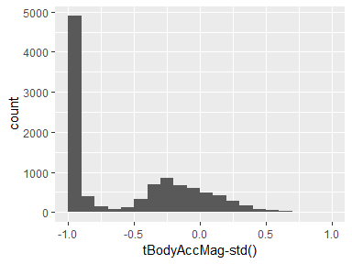

## tGravityAccMag-mean()

|  |  |
| --- | --- |
| Feature | Result |
| Variable type | numeric |
| Number of missing obs. | 0 (0 %) |
| Number of unique values | 10297 |
| Median | -0.86 |
| 1st and 3rd quartiles | -0.98; -0.34 |
| Min. and max. | -1; 1 |

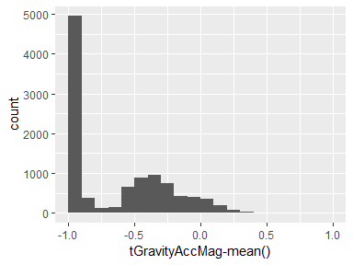

## tGravityAccMag-std()

|  |  |
| --- | --- |
| Feature | Result |
| Variable type | numeric |
| Number of missing obs. | 0 (0 %) |
| Number of unique values | 7568 |
| Median | -0.85 |
| 1st and 3rd quartiles | -0.98; -0.17 |
| Min. and max. | -1; 1 |

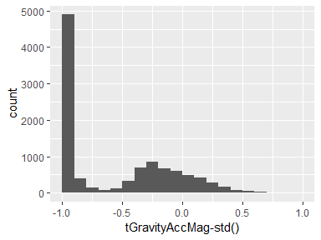

## tBodyAccJerkMag-mean()

|  |  |
| --- | --- |
| Feature | Result |
| Variable type | numeric |
| Number of missing obs. | 0 (0 %) |
| Number of unique values | 10291 |
| Median | -0.94 |
| 1st and 3rd quartiles | -0.99; -0.31 |
| Min. and max. | -1; 1 |

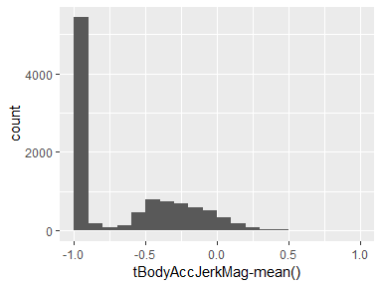

## tBodyAccJerkMag-std()

|  |  |
| --- | --- |
| Feature | Result |
| Variable type | numeric |
| Number of missing obs. | 0 (0 %) |
| Number of unique values | 7393 |
| Median | -0.93 |
| 1st and 3rd quartiles | -0.99; -0.3 |
| Min. and max. | -1; 1 |

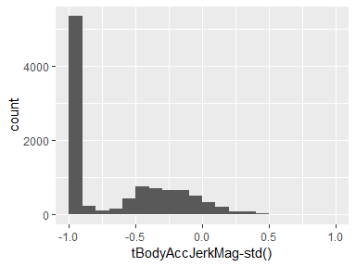

## tBodyGyroMag-mean()

|  |  |
| --- | --- |
| Feature | Result |
| Variable type | numeric |
| Number of missing obs. | 0 (0 %) |
| Number of unique values | 10293 |
| Median | -0.81 |
| 1st and 3rd quartiles | -0.98; -0.33 |
| Min. and max. | -1; 1 |

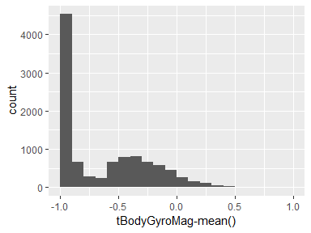

## tBodyGyroMag-std()

|  |  |
| --- | --- |
| Feature | Result |
| Variable type | numeric |
| Number of missing obs. | 0 (0 %) |
| Number of unique values | 7730 |
| Median | -0.85 |
| 1st and 3rd quartiles | -0.98; -0.45 |
| Min. and max. | -1; 1 |

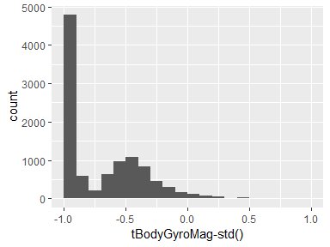

## tBodyGyroJerkMag-mean()

|  |  |
| --- | --- |
| Feature | Result |
| Variable type | numeric |
| Number of missing obs. | 0 (0 %) |
| Number of unique values | 10293 |
| Median | -0.95 |
| 1st and 3rd quartiles | -0.99; -0.63 |
| Min. and max. | -1; 1 |

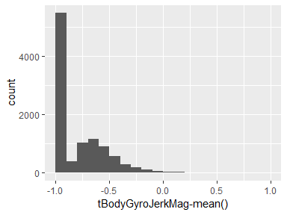

## tBodyGyroJerkMag-std()

|  |  |
| --- | --- |
| Feature | Result |
| Variable type | numeric |
| Number of missing obs. | 0 (0 %) |
| Number of unique values | 7504 |
| Median | -0.94 |
| 1st and 3rd quartiles | -0.99; -0.63 |
| Min. and max. | -1; 1 |

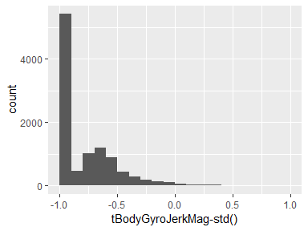

## fBodyAcc-mean()-X

|  |  |
| --- | --- |
| Feature | Result |
| Variable type | numeric |
| Number of missing obs. | 0 (0 %) |
| Number of unique values | 10295 |
| Median | -0.9 |
| 1st and 3rd quartiles | -0.98; -0.37 |
| Min. and max. | -1; 1 |

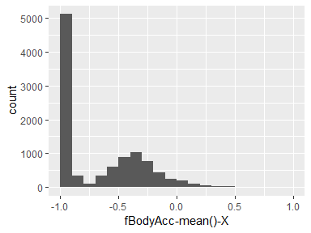

## fBodyAcc-mean()-Y

|  |  |
| --- | --- |
| Feature | Result |
| Variable type | numeric |
| Number of missing obs. | 0 (0 %) |
| Number of unique values | 10294 |
| Median | -0.94 |
| 1st and 3rd quartiles | -0.99; -0.25 |
| Min. and max. | -1; 1 |

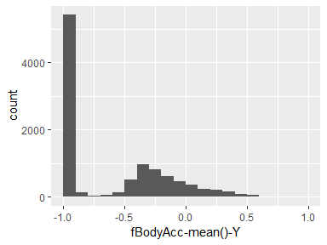

## fBodyAcc-mean()-Z

|  |  |
| --- | --- |
| Feature | Result |
| Variable type | numeric |
| Number of missing obs. | 0 (0 %) |
| Number of unique values | 10297 |
| Median | -0.83 |
| 1st and 3rd quartiles | -0.98; -0.09 |
| Min. and max. | -1; 1 |

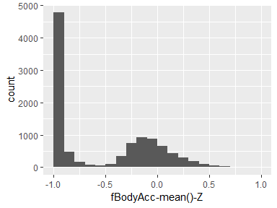

## fBodyAcc-std()-X

|  |  |
| --- | --- |
| Feature | Result |
| Variable type | numeric |
| Number of missing obs. | 0 (0 %) |
| Number of unique values | 10296 |
| Median | -0.84 |
| 1st and 3rd quartiles | -0.98; -0.3 |
| Min. and max. | -1; 1 |

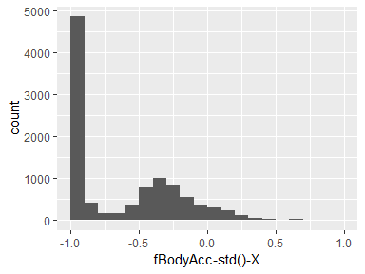

## fBodyAcc-std()-Y

|  |  |
| --- | --- |
| Feature | Result |
| Variable type | numeric |
| Number of missing obs. | 0 (0 %) |
| Number of unique values | 10294 |
| Median | -0.94 |
| 1st and 3rd quartiles | -0.99; -0.2 |
| Min. and max. | -1; 1 |

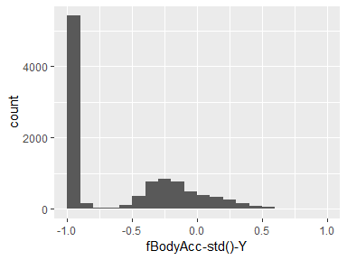

## fBodyAcc-std()-Z

|  |  |
| --- | --- |
| Feature | Result |
| Variable type | numeric |
| Number of missing obs. | 0 (0 %) |
| Number of unique values | 10298 |
| Median | -0.86 |
| 1st and 3rd quartiles | -0.98; -0.08 |
| Min. and max. | -1; 1 |

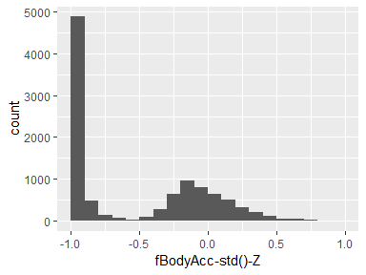

## fBodyAccJerk-mean()-X

|  |  |
| --- | --- |
| Feature | Result |
| Variable type | numeric |
| Number of missing obs. | 0 (0 %) |
| Number of unique values | 10294 |
| Median | -0.95 |
| 1st and 3rd quartiles | -0.99; -0.51 |
| Min. and max. | -1; 1 |

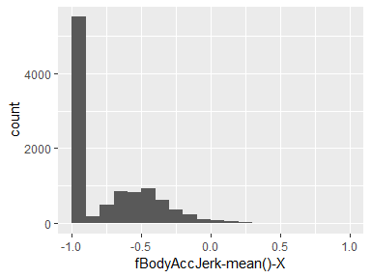

## fBodyAccJerk-mean()-Y

|  |  |
| --- | --- |
| Feature | Result |
| Variable type | numeric |
| Number of missing obs. | 0 (0 %) |
| Number of unique values | 10291 |
| Median | -0.96 |
| 1st and 3rd quartiles | -0.99; -0.32 |
| Min. and max. | -1; 1 |

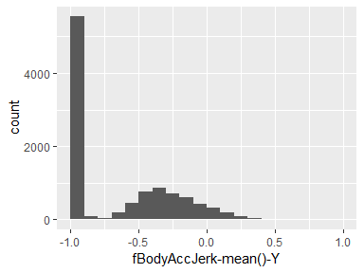

## fBodyAccJerk-mean()-Z

|  |  |
| --- | --- |
| Feature | Result |
| Variable type | numeric |
| Number of missing obs. | 0 (0 %) |
| Number of unique values | 10294 |
| Median | -0.93 |
| 1st and 3rd quartiles | -0.99; -0.24 |
| Min. and max. | -1; 1 |

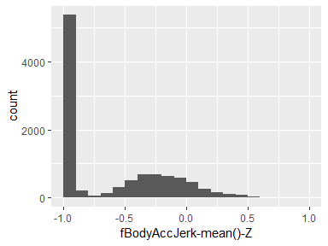

## fBodyAccJerk-std()-X

|  |  |
| --- | --- |
| Feature | Result |
| Variable type | numeric |
| Number of missing obs. | 0 (0 %) |
| Number of unique values | 10290 |
| Median | -0.96 |
| 1st and 3rd quartiles | -0.99; -0.59 |
| Min. and max. | -1; 1 |

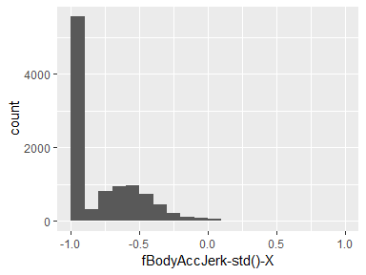

## fBodyAccJerk-std()-Y

|  |  |
| --- | --- |
| Feature | Result |
| Variable type | numeric |
| Number of missing obs. | 0 (0 %) |
| Number of unique values | 10295 |
| Median | -0.95 |
| 1st and 3rd quartiles | -0.99; -0.2 |
| Min. and max. | -1; 1 |

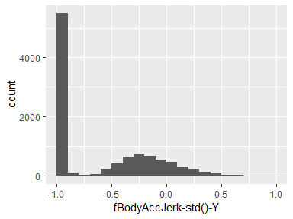

## fBodyAccJerk-std()-Z

|  |  |
| --- | --- |
| Feature | Result |
| Variable type | numeric |
| Number of missing obs. | 0 (0 %) |
| Number of unique values | 10295 |
| Median | -0.93 |
| 1st and 3rd quartiles | -0.99; -0.26 |
| Min. and max. | -1; 1 |

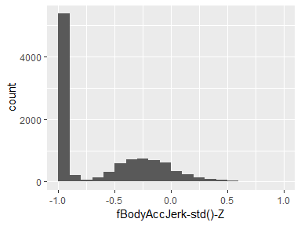

## fBodyGyro-mean()-X

|  |  |
| --- | --- |
| Feature | Result |
| Variable type | numeric |
| Number of missing obs. | 0 (0 %) |
| Number of unique values | 10297 |
| Median | -0.89 |
| 1st and 3rd quartiles | -0.99; -0.32 |
| Min. and max. | -1; 1 |

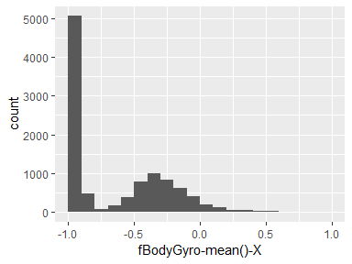

## fBodyGyro-mean()-Y

|  |  |
| --- | --- |
| Feature | Result |
| Variable type | numeric |
| Number of missing obs. | 0 (0 %) |
| Number of unique values | 10297 |
| Median | -0.91 |
| 1st and 3rd quartiles | -0.99; -0.52 |
| Min. and max. | -1; 1 |

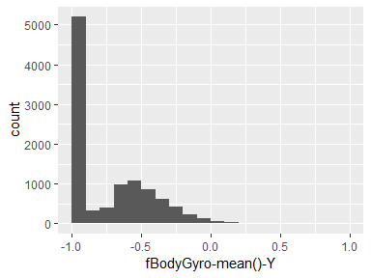

## fBodyGyro-mean()-Z

|  |  |
| --- | --- |
| Feature | Result |
| Variable type | numeric |
| Number of missing obs. | 0 (0 %) |
| Number of unique values | 10293 |
| Median | -0.91 |
| 1st and 3rd quartiles | -0.98; -0.44 |
| Min. and max. | -1; 1 |

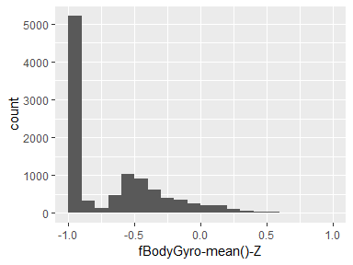

## fBodyGyro-std()-X

|  |  |
| --- | --- |
| Feature | Result |
| Variable type | numeric |
| Number of missing obs. | 0 (0 %) |
| Number of unique values | 10295 |
| Median | -0.89 |
| 1st and 3rd quartiles | -0.99; -0.42 |
| Min. and max. | -1; 1 |

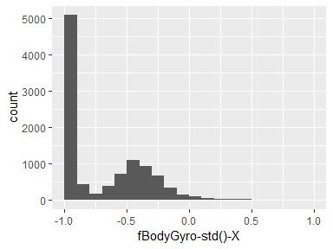

## fBodyGyro-std()-Y

|  |  |
| --- | --- |
| Feature | Result |
| Variable type | numeric |
| Number of missing obs. | 0 (0 %) |
| Number of unique values | 10295 |
| Median | -0.89 |
| 1st and 3rd quartiles | -0.99; -0.41 |
| Min. and max. | -1; 1 |

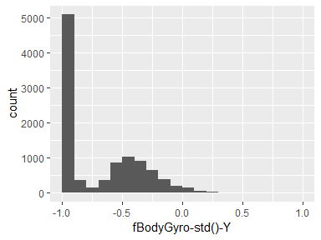

## fBodyGyro-std()-Z

|  |  |
| --- | --- |
| Feature | Result |
| Variable type | numeric |
| Number of missing obs. | 0 (0 %) |
| Number of unique values | 10298 |
| Median | -0.92 |
| 1st and 3rd quartiles | -0.98; -0.5 |
| Min. and max. | -1; 1 |

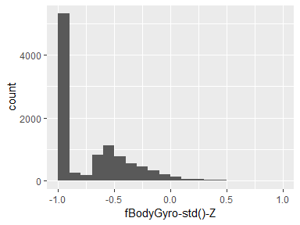

## fBodyAccMag-mean()

|  |  |
| --- | --- |
| Feature | Result |
| Variable type | numeric |
| Number of missing obs. | 0 (0 %) |
| Number of unique values | 10295 |
| Median | -0.85 |
| 1st and 3rd quartiles | -0.98; -0.25 |
| Min. and max. | -1; 1 |

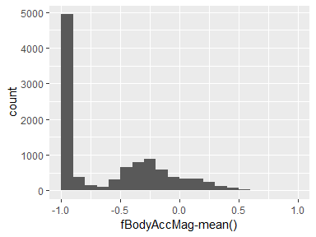

## fBodyAccMag-std()

|  |  |
| --- | --- |
| Feature | Result |
| Variable type | numeric |
| Number of missing obs. | 0 (0 %) |
| Number of unique values | 10296 |
| Median | -0.88 |
| 1st and 3rd quartiles | -0.99; -0.57 |
| Min. and max. | -1; 1 |

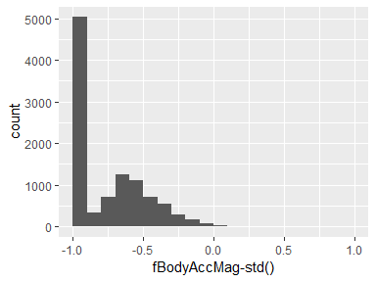

## fBodyBodyAccJerkMag-mean()

|  |  |
| --- | --- |
| Feature | Result |
| Variable type | numeric |
| Number of missing obs. | 0 (0 %) |
| Number of unique values | 10293 |
| Median | -0.92 |
| 1st and 3rd quartiles | -0.99; -0.25 |
| Min. and max. | -1; 1 |

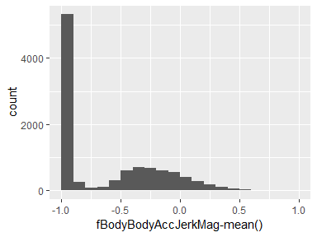

## fBodyBodyAccJerkMag-std()

|  |  |
| --- | --- |
| Feature | Result |
| Variable type | numeric |
| Number of missing obs. | 0 (0 %) |
| Number of unique values | 10293 |
| Median | -0.94 |
| 1st and 3rd quartiles | -0.99; -0.4 |
| Min. and max. | -1; 1 |

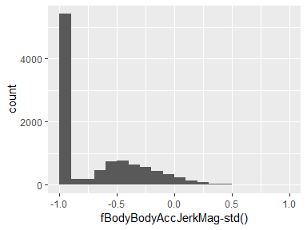

## fBodyBodyGyroMag-mean()

|  |  |
| --- | --- |
| Feature | Result |
| Variable type | numeric |
| Number of missing obs. | 0 (0 %) |
| Number of unique values | 10297 |
| Median | -0.85 |
| 1st and 3rd quartiles | -0.98; -0.42 |
| Min. and max. | -1; 1 |

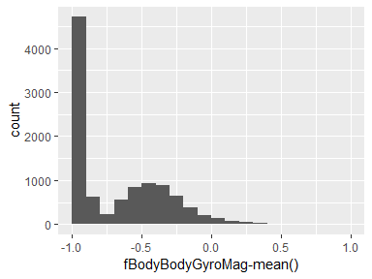

## fBodyBodyGyroMag-std()

|  |  |
| --- | --- |
| Feature | Result |
| Variable type | numeric |
| Number of missing obs. | 0 (0 %) |
| Number of unique values | 10297 |
| Median | -0.83 |
| 1st and 3rd quartiles | -0.98; -0.56 |
| Min. and max. | -1; 1 |

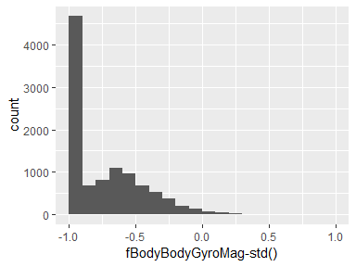

## fBodyBodyGyroJerkMag-mean()

|  |  |
| --- | --- |
| Feature | Result |
| Variable type | numeric |
| Number of missing obs. | 0 (0 %) |
| Number of unique values | 10295 |
| Median | -0.94 |
| 1st and 3rd quartiles | -0.99; -0.61 |
| Min. and max. | -1; 1 |

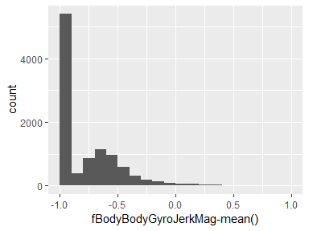

## fBodyBodyGyroJerkMag-std()

|  |  |
| --- | --- |
| Feature | Result |
| Variable type | numeric |
| Number of missing obs. | 0 (0 %) |
| Number of unique values | 10293 |
| Median | -0.94 |
| 1st and 3rd quartiles | -0.99; -0.68 |
| Min. and max. | -1; 1 |

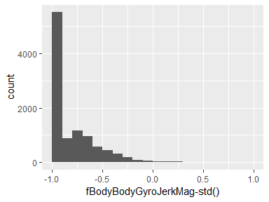

## Activity

|  |  |
| --- | --- |
| Feature | Result |
| Variable type | factor |
| Number of missing obs. | 0 (0 %) |
| Number of unique values | 6 |
| Mode | “LAYING” |
| Reference category | LAYING |

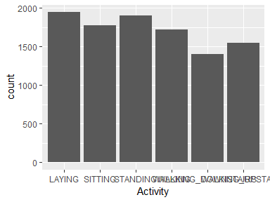

* Observed factor levels: "LAYING", "SITTING", "STANDING", "WALKING", "WALKING_DOWNSTAIRS", "WALKING_UPSTAIRS".

Report generation information:

* Created by Doug McClung  
  McClung, Doug (username: doug.mcclung).
* Report creation time: Mon Dec 03 2018 14:17:39
* Report was run from directory: c:/Users/doug.mcclung/Documents/UCI HAR Dataset
* dataMaid v1.2.0 [Pkg: 2018-10-03 from CRAN (R 3.5.1)]
* R version 3.5.1 (2018-07-02).
* Platform: x86_64-w64-mingw32/x64 (64-bit)(Windows >= 8 x64 (build 9200)).
* Function call: makeDataReport(data = filteredData, mode = c("summarize", "visualize", "check"), smartNum = FALSE, file = "codebook_filteredData.Rmd", replace = TRUE, checks = list(character = "showAllFactorLevels", factor = "showAllFactorLevels", labelled = "showAllFactorLevels", haven_labelled = "showAllFactorLevels", numeric = NULL, integer = NULL, logical = NULL, Date = NULL), listChecks = FALSE, maxProbVals = Inf, codebook = TRUE, reportTitle = "Codebook for filteredData")