Codebook for summarizedData

Autogenerated data summary from dataMaid

2018-12-03 14:18:05

# Data report overview

The dataset examined has the following dimensions:

|  |  |
| --- | --- |
| Feature | Result |
| Number of observations | 180 |
| Number of variables | 136 |

# Codebook summary table

|  |  |  |  |  |  |
| --- | --- | --- | --- | --- | --- |
| Label | Variable | Class | # unique values | Missing | Description |
|  | **Subject** | integer | 30 | 0.00 % |  |
|  | **Activity** | factor | 6 | 0.00 % |  |
|  | **V1100_mean** | numeric | 6 | 0.00 % |  |
|  | **tBodyAcc-mean()-X_mean** | numeric | 180 | 0.00 % |  |
|  | **tBodyAcc-mean()-Y_mean** | numeric | 180 | 0.00 % |  |
|  | **tBodyAcc-mean()-Z_mean** | numeric | 180 | 0.00 % |  |
|  | **tBodyAcc-std()-X_mean** | numeric | 180 | 0.00 % |  |
|  | **tBodyAcc-std()-Y_mean** | numeric | 180 | 0.00 % |  |
|  | **tBodyAcc-std()-Z_mean** | numeric | 180 | 0.00 % |  |
|  | **tGravityAcc-mean()-X_mean** | numeric | 180 | 0.00 % |  |
|  | **tGravityAcc-mean()-Y_mean** | numeric | 180 | 0.00 % |  |
|  | **tGravityAcc-mean()-Z_mean** | numeric | 180 | 0.00 % |  |
|  | **tGravityAcc-std()-X_mean** | numeric | 180 | 0.00 % |  |
|  | **tGravityAcc-std()-Y_mean** | numeric | 180 | 0.00 % |  |
|  | **tGravityAcc-std()-Z_mean** | numeric | 180 | 0.00 % |  |
|  | **tBodyAccJerk-mean()-X_mean** | numeric | 180 | 0.00 % |  |
|  | **tBodyAccJerk-mean()-Y_mean** | numeric | 180 | 0.00 % |  |
|  | **tBodyAccJerk-mean()-Z_mean** | numeric | 180 | 0.00 % |  |
|  | **tBodyAccJerk-std()-X_mean** | numeric | 180 | 0.00 % |  |
|  | **tBodyAccJerk-std()-Y_mean** | numeric | 180 | 0.00 % |  |
|  | **tBodyAccJerk-std()-Z_mean** | numeric | 180 | 0.00 % |  |
|  | **tBodyGyro-mean()-X_mean** | numeric | 180 | 0.00 % |  |
|  | **tBodyGyro-mean()-Y_mean** | numeric | 180 | 0.00 % |  |
|  | **tBodyGyro-mean()-Z_mean** | numeric | 180 | 0.00 % |  |
|  | **tBodyGyro-std()-X_mean** | numeric | 180 | 0.00 % |  |
|  | **tBodyGyro-std()-Y_mean** | numeric | 180 | 0.00 % |  |
|  | **tBodyGyro-std()-Z_mean** | numeric | 180 | 0.00 % |  |
|  | **tBodyGyroJerk-mean()-X_mean** | numeric | 180 | 0.00 % |  |
|  | **tBodyGyroJerk-mean()-Y_mean** | numeric | 180 | 0.00 % |  |
|  | **tBodyGyroJerk-mean()-Z_mean** | numeric | 180 | 0.00 % |  |
|  | **tBodyGyroJerk-std()-X_mean** | numeric | 180 | 0.00 % |  |
|  | **tBodyGyroJerk-std()-Y_mean** | numeric | 180 | 0.00 % |  |
|  | **tBodyGyroJerk-std()-Z_mean** | numeric | 180 | 0.00 % |  |
|  | **tBodyAccMag-mean()_mean** | numeric | 180 | 0.00 % |  |
|  | **tBodyAccMag-std()_mean** | numeric | 180 | 0.00 % |  |
|  | **tGravityAccMag-mean()_mean** | numeric | 180 | 0.00 % |  |
|  | **tGravityAccMag-std()_mean** | numeric | 180 | 0.00 % |  |
|  | **tBodyAccJerkMag-mean()_mean** | numeric | 180 | 0.00 % |  |
|  | **tBodyAccJerkMag-std()_mean** | numeric | 180 | 0.00 % |  |
|  | **tBodyGyroMag-mean()_mean** | numeric | 180 | 0.00 % |  |
|  | **tBodyGyroMag-std()_mean** | numeric | 180 | 0.00 % |  |
|  | **tBodyGyroJerkMag-mean()_mean** | numeric | 180 | 0.00 % |  |
|  | **tBodyGyroJerkMag-std()_mean** | numeric | 180 | 0.00 % |  |
|  | **fBodyAcc-mean()-X_mean** | numeric | 180 | 0.00 % |  |
|  | **fBodyAcc-mean()-Y_mean** | numeric | 180 | 0.00 % |  |
|  | **fBodyAcc-mean()-Z_mean** | numeric | 180 | 0.00 % |  |
|  | **fBodyAcc-std()-X_mean** | numeric | 180 | 0.00 % |  |
|  | **fBodyAcc-std()-Y_mean** | numeric | 180 | 0.00 % |  |
|  | **fBodyAcc-std()-Z_mean** | numeric | 180 | 0.00 % |  |
|  | **fBodyAccJerk-mean()-X_mean** | numeric | 180 | 0.00 % |  |
|  | **fBodyAccJerk-mean()-Y_mean** | numeric | 180 | 0.00 % |  |
|  | **fBodyAccJerk-mean()-Z_mean** | numeric | 180 | 0.00 % |  |
|  | **fBodyAccJerk-std()-X_mean** | numeric | 180 | 0.00 % |  |
|  | **fBodyAccJerk-std()-Y_mean** | numeric | 180 | 0.00 % |  |
|  | **fBodyAccJerk-std()-Z_mean** | numeric | 180 | 0.00 % |  |
|  | **fBodyGyro-mean()-X_mean** | numeric | 180 | 0.00 % |  |
|  | **fBodyGyro-mean()-Y_mean** | numeric | 180 | 0.00 % |  |
|  | **fBodyGyro-mean()-Z_mean** | numeric | 180 | 0.00 % |  |
|  | **fBodyGyro-std()-X_mean** | numeric | 180 | 0.00 % |  |
|  | **fBodyGyro-std()-Y_mean** | numeric | 180 | 0.00 % |  |
|  | **fBodyGyro-std()-Z_mean** | numeric | 180 | 0.00 % |  |
|  | **fBodyAccMag-mean()_mean** | numeric | 180 | 0.00 % |  |
|  | **fBodyAccMag-std()_mean** | numeric | 180 | 0.00 % |  |
|  | **fBodyBodyAccJerkMag-mean()_mean** | numeric | 180 | 0.00 % |  |
|  | **fBodyBodyAccJerkMag-std()_mean** | numeric | 180 | 0.00 % |  |
|  | **fBodyBodyGyroMag-mean()_mean** | numeric | 180 | 0.00 % |  |
|  | **fBodyBodyGyroMag-std()_mean** | numeric | 180 | 0.00 % |  |
|  | **fBodyBodyGyroJerkMag-mean()_mean** | numeric | 180 | 0.00 % |  |
|  | **fBodyBodyGyroJerkMag-std()_mean** | numeric | 180 | 0.00 % |  |
|  | **V1100_sd** | numeric | 1 | 0.00 % |  |
|  | **tBodyAcc-mean()-X_sd** | numeric | 180 | 0.00 % |  |
|  | **tBodyAcc-mean()-Y_sd** | numeric | 180 | 0.00 % |  |
|  | **tBodyAcc-mean()-Z_sd** | numeric | 180 | 0.00 % |  |
|  | **tBodyAcc-std()-X_sd** | numeric | 180 | 0.00 % |  |
|  | **tBodyAcc-std()-Y_sd** | numeric | 180 | 0.00 % |  |
|  | **tBodyAcc-std()-Z_sd** | numeric | 180 | 0.00 % |  |
|  | **tGravityAcc-mean()-X_sd** | numeric | 180 | 0.00 % |  |
|  | **tGravityAcc-mean()-Y_sd** | numeric | 180 | 0.00 % |  |
|  | **tGravityAcc-mean()-Z_sd** | numeric | 180 | 0.00 % |  |
|  | **tGravityAcc-std()-X_sd** | numeric | 180 | 0.00 % |  |
|  | **tGravityAcc-std()-Y_sd** | numeric | 180 | 0.00 % |  |
|  | **tGravityAcc-std()-Z_sd** | numeric | 180 | 0.00 % |  |
|  | **tBodyAccJerk-mean()-X_sd** | numeric | 180 | 0.00 % |  |
|  | **tBodyAccJerk-mean()-Y_sd** | numeric | 180 | 0.00 % |  |
|  | **tBodyAccJerk-mean()-Z_sd** | numeric | 180 | 0.00 % |  |
|  | **tBodyAccJerk-std()-X_sd** | numeric | 180 | 0.00 % |  |
|  | **tBodyAccJerk-std()-Y_sd** | numeric | 180 | 0.00 % |  |
|  | **tBodyAccJerk-std()-Z_sd** | numeric | 180 | 0.00 % |  |
|  | **tBodyGyro-mean()-X_sd** | numeric | 180 | 0.00 % |  |
|  | **tBodyGyro-mean()-Y_sd** | numeric | 180 | 0.00 % |  |
|  | **tBodyGyro-mean()-Z_sd** | numeric | 180 | 0.00 % |  |
|  | **tBodyGyro-std()-X_sd** | numeric | 180 | 0.00 % |  |
|  | **tBodyGyro-std()-Y_sd** | numeric | 180 | 0.00 % |  |
|  | **tBodyGyro-std()-Z_sd** | numeric | 180 | 0.00 % |  |
|  | **tBodyGyroJerk-mean()-X_sd** | numeric | 180 | 0.00 % |  |
|  | **tBodyGyroJerk-mean()-Y_sd** | numeric | 180 | 0.00 % |  |
|  | **tBodyGyroJerk-mean()-Z_sd** | numeric | 180 | 0.00 % |  |
|  | **tBodyGyroJerk-std()-X_sd** | numeric | 180 | 0.00 % |  |
|  | **tBodyGyroJerk-std()-Y_sd** | numeric | 180 | 0.00 % |  |
|  | **tBodyGyroJerk-std()-Z_sd** | numeric | 180 | 0.00 % |  |
|  | **tBodyAccMag-mean()_sd** | numeric | 180 | 0.00 % |  |
|  | **tBodyAccMag-std()_sd** | numeric | 180 | 0.00 % |  |
|  | **tGravityAccMag-mean()_sd** | numeric | 180 | 0.00 % |  |
|  | **tGravityAccMag-std()_sd** | numeric | 180 | 0.00 % |  |
|  | **tBodyAccJerkMag-mean()_sd** | numeric | 180 | 0.00 % |  |
|  | **tBodyAccJerkMag-std()_sd** | numeric | 180 | 0.00 % |  |
|  | **tBodyGyroMag-mean()_sd** | numeric | 180 | 0.00 % |  |
|  | **tBodyGyroMag-std()_sd** | numeric | 180 | 0.00 % |  |
|  | **tBodyGyroJerkMag-mean()_sd** | numeric | 180 | 0.00 % |  |
|  | **tBodyGyroJerkMag-std()_sd** | numeric | 180 | 0.00 % |  |
|  | **fBodyAcc-mean()-X_sd** | numeric | 180 | 0.00 % |  |
|  | **fBodyAcc-mean()-Y_sd** | numeric | 180 | 0.00 % |  |
|  | **fBodyAcc-mean()-Z_sd** | numeric | 180 | 0.00 % |  |
|  | **fBodyAcc-std()-X_sd** | numeric | 180 | 0.00 % |  |
|  | **fBodyAcc-std()-Y_sd** | numeric | 180 | 0.00 % |  |
|  | **fBodyAcc-std()-Z_sd** | numeric | 180 | 0.00 % |  |
|  | **fBodyAccJerk-mean()-X_sd** | numeric | 180 | 0.00 % |  |
|  | **fBodyAccJerk-mean()-Y_sd** | numeric | 180 | 0.00 % |  |
|  | **fBodyAccJerk-mean()-Z_sd** | numeric | 180 | 0.00 % |  |
|  | **fBodyAccJerk-std()-X_sd** | numeric | 180 | 0.00 % |  |
|  | **fBodyAccJerk-std()-Y_sd** | numeric | 180 | 0.00 % |  |
|  | **fBodyAccJerk-std()-Z_sd** | numeric | 180 | 0.00 % |  |
|  | **fBodyGyro-mean()-X_sd** | numeric | 180 | 0.00 % |  |
|  | **fBodyGyro-mean()-Y_sd** | numeric | 180 | 0.00 % |  |
|  | **fBodyGyro-mean()-Z_sd** | numeric | 180 | 0.00 % |  |
|  | **fBodyGyro-std()-X_sd** | numeric | 180 | 0.00 % |  |
|  | **fBodyGyro-std()-Y_sd** | numeric | 180 | 0.00 % |  |
|  | **fBodyGyro-std()-Z_sd** | numeric | 180 | 0.00 % |  |
|  | **fBodyAccMag-mean()_sd** | numeric | 180 | 0.00 % |  |
|  | **fBodyAccMag-std()_sd** | numeric | 180 | 0.00 % |  |
|  | **fBodyBodyAccJerkMag-mean()_sd** | numeric | 180 | 0.00 % |  |
|  | **fBodyBodyAccJerkMag-std()_sd** | numeric | 180 | 0.00 % |  |
|  | **fBodyBodyGyroMag-mean()_sd** | numeric | 180 | 0.00 % |  |
|  | **fBodyBodyGyroMag-std()_sd** | numeric | 180 | 0.00 % |  |
|  | **fBodyBodyGyroJerkMag-mean()_sd** | numeric | 180 | 0.00 % |  |
|  | **fBodyBodyGyroJerkMag-std()_sd** | numeric | 180 | 0.00 % |  |

# Variable list

## Subject

|  |  |
| --- | --- |
| Feature | Result |
| Variable type | integer |
| Number of missing obs. | 0 (0 %) |
| Number of unique values | 30 |
| Median | 15.5 |
| 1st and 3rd quartiles | 8; 23 |
| Min. and max. | 1; 30 |

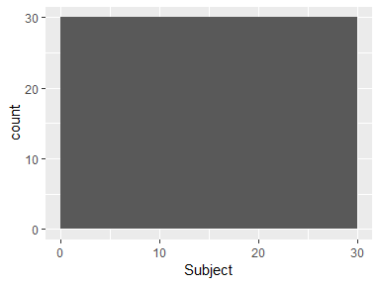

## Activity

|  |  |
| --- | --- |
| Feature | Result |
| Variable type | factor |
| Number of missing obs. | 0 (0 %) |
| Number of unique values | 6 |
| Mode | “LAYING” |
| Reference category | LAYING |

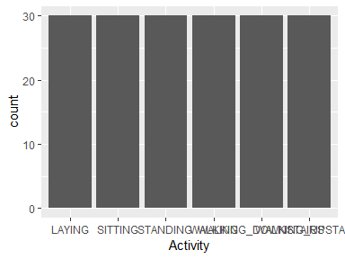

* Observed factor levels: "LAYING", "SITTING", "STANDING", "WALKING", "WALKING_DOWNSTAIRS", "WALKING_UPSTAIRS".

## V1100_mean

|  |  |
| --- | --- |
| Feature | Result |
| Variable type | numeric |
| Number of missing obs. | 0 (0 %) |
| Number of unique values | 6 |
| Median | 3.5 |
| 1st and 3rd quartiles | 2; 5 |
| Min. and max. | 1; 6 |

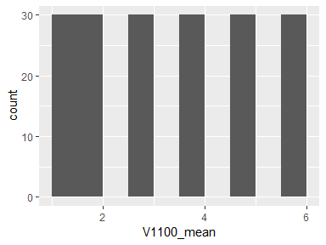

## tBodyAcc-mean()-X_mean

|  |  |
| --- | --- |
| Feature | Result |
| Variable type | numeric |
| Number of missing obs. | 0 (0 %) |
| Number of unique values | 180 |
| Median | -0.11 |
| 1st and 3rd quartiles | -0.11; -0.1 |
| Min. and max. | -0.15; -0.08 |

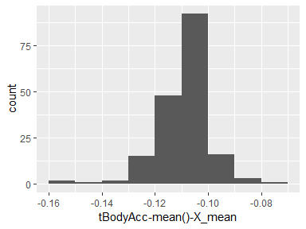

## tBodyAcc-mean()-Y_mean

|  |  |
| --- | --- |
| Feature | Result |
| Variable type | numeric |
| Number of missing obs. | 0 (0 %) |
| Number of unique values | 180 |
| Median | -0.75 |
| 1st and 3rd quartiles | -0.98; -0.2 |
| Min. and max. | -1; 0.63 |

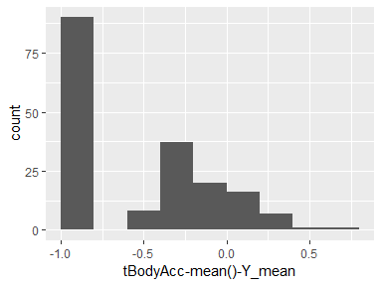

## tBodyAcc-mean()-Z_mean

|  |  |
| --- | --- |
| Feature | Result |
| Variable type | numeric |
| Number of missing obs. | 0 (0 %) |
| Number of unique values | 180 |
| Median | -0.51 |
| 1st and 3rd quartiles | -0.94; -0.03 |
| Min. and max. | -0.99; 0.62 |

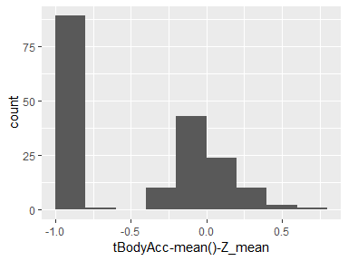

## tBodyAcc-std()-X_mean

|  |  |
| --- | --- |
| Feature | Result |
| Variable type | numeric |
| Number of missing obs. | 0 (0 %) |
| Number of unique values | 180 |
| Median | -0.65 |
| 1st and 3rd quartiles | -0.95; -0.23 |
| Min. and max. | -0.99; 0.61 |

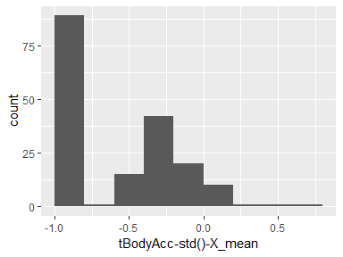

## tBodyAcc-std()-Y_mean

|  |  |
| --- | --- |
| Feature | Result |
| Variable type | numeric |
| Number of missing obs. | 0 (0 %) |
| Number of unique values | 180 |
| Median | -0.77 |
| 1st and 3rd quartiles | -0.98; -0.27 |
| Min. and max. | -1; 0.61 |

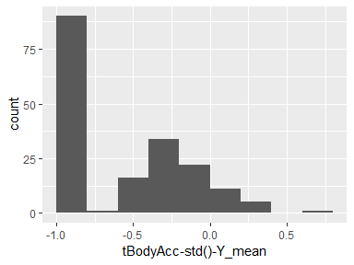

## tBodyAcc-std()-Z_mean

|  |  |
| --- | --- |
| Feature | Result |
| Variable type | numeric |
| Number of missing obs. | 0 (0 %) |
| Number of unique values | 180 |
| Median | -0.51 |
| 1st and 3rd quartiles | -0.94; -0.07 |
| Min. and max. | -0.99; 0.52 |

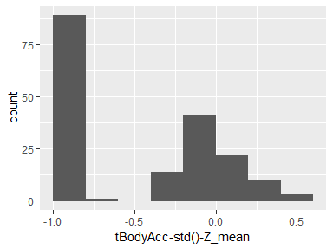

## tGravityAcc-mean()-X_mean

|  |  |
| --- | --- |
| Feature | Result |
| Variable type | numeric |
| Number of missing obs. | 0 (0 %) |
| Number of unique values | 180 |
| Median | 0.02 |
| 1st and 3rd quartiles | -0.12; 0.15 |
| Min. and max. | -0.5; 0.96 |

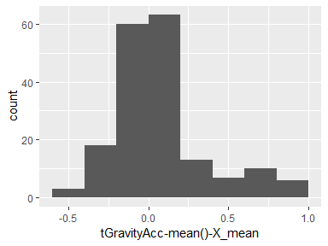

## tGravityAcc-mean()-Y_mean

|  |  |
| --- | --- |
| Feature | Result |
| Variable type | numeric |
| Number of missing obs. | 0 (0 %) |
| Number of unique values | 180 |
| Median | -0.97 |
| 1st and 3rd quartiles | -0.98; -0.95 |
| Min. and max. | -1; -0.83 |

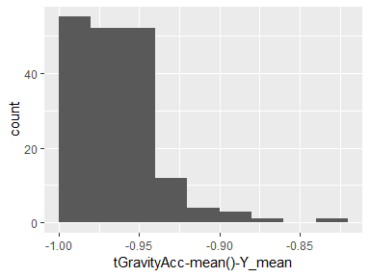

## tGravityAcc-mean()-Z_mean

|  |  |
| --- | --- |
| Feature | Result |
| Variable type | numeric |
| Number of missing obs. | 0 (0 %) |
| Number of unique values | 180 |
| Median | -0.96 |
| 1st and 3rd quartiles | -0.97; -0.94 |
| Min. and max. | -0.99; -0.64 |

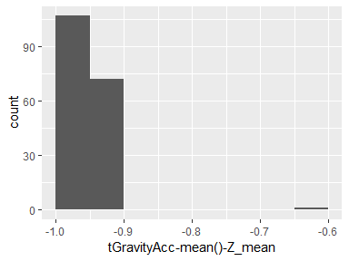

## tGravityAcc-std()-X_mean

|  |  |
| --- | --- |
| Feature | Result |
| Variable type | numeric |
| Number of missing obs. | 0 (0 %) |
| Number of unique values | 180 |
| Median | -0.95 |
| 1st and 3rd quartiles | -0.96; -0.92 |
| Min. and max. | -0.99; -0.61 |

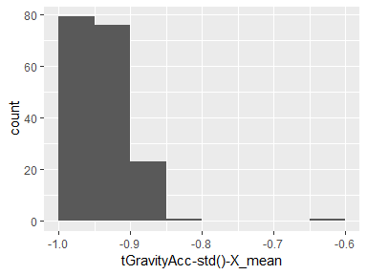

## tGravityAcc-std()-Y_mean

|  |  |
| --- | --- |
| Feature | Result |
| Variable type | numeric |
| Number of missing obs. | 0 (0 %) |
| Number of unique values | 180 |
| Median | -0.97 |
| 1st and 3rd quartiles | -0.98; -0.95 |
| Min. and max. | -1; -0.83 |

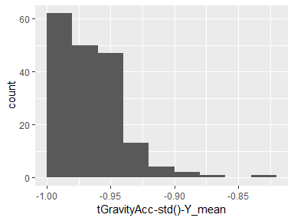

## tGravityAcc-std()-Z_mean

|  |  |
| --- | --- |
| Feature | Result |
| Variable type | numeric |
| Number of missing obs. | 0 (0 %) |
| Number of unique values | 180 |
| Median | -0.96 |
| 1st and 3rd quartiles | -0.97; -0.94 |
| Min. and max. | -0.99; -0.65 |

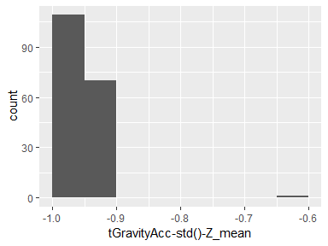

## tBodyAccJerk-mean()-X_mean

|  |  |
| --- | --- |
| Feature | Result |
| Variable type | numeric |
| Number of missing obs. | 0 (0 %) |
| Number of unique values | 180 |
| Median | 0 |
| 1st and 3rd quartiles | -0.01; 0 |
| Min. and max. | -0.07; 0.04 |

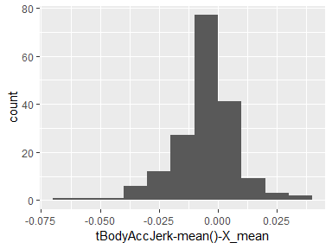

## tBodyAccJerk-mean()-Y_mean

|  |  |
| --- | --- |
| Feature | Result |
| Variable type | numeric |
| Number of missing obs. | 0 (0 %) |
| Number of unique values | 180 |
| Median | -0.81 |
| 1st and 3rd quartiles | -0.98; -0.22 |
| Min. and max. | -0.99; 0.54 |

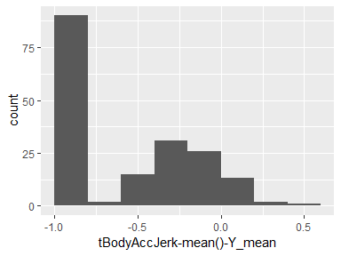

## tBodyAccJerk-mean()-Z_mean

|  |  |
| --- | --- |
| Feature | Result |
| Variable type | numeric |
| Number of missing obs. | 0 (0 %) |
| Number of unique values | 180 |
| Median | -0.78 |
| 1st and 3rd quartiles | -0.97; -0.15 |
| Min. and max. | -0.99; 0.36 |

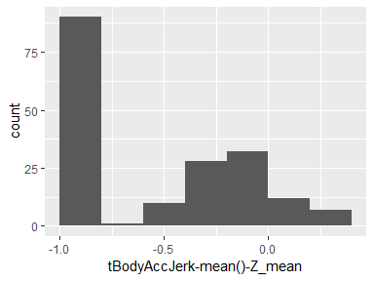

## tBodyAccJerk-std()-X_mean

|  |  |
| --- | --- |
| Feature | Result |
| Variable type | numeric |
| Number of missing obs. | 0 (0 %) |
| Number of unique values | 180 |
| Median | -0.88 |
| 1st and 3rd quartiles | -0.98; -0.51 |
| Min. and max. | -0.99; 0.03 |

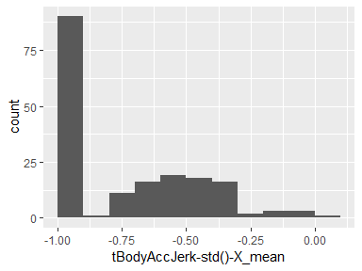

## tBodyAccJerk-std()-Y_mean

|  |  |
| --- | --- |
| Feature | Result |
| Variable type | numeric |
| Number of missing obs. | 0 (0 %) |
| Number of unique values | 180 |
| Median | -0.81 |
| 1st and 3rd quartiles | -0.98; -0.2 |
| Min. and max. | -1; 0.55 |

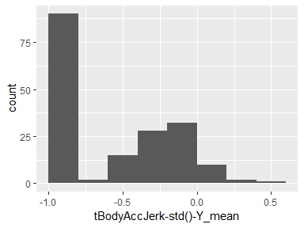

## tBodyAccJerk-std()-Z_mean

|  |  |
| --- | --- |
| Feature | Result |
| Variable type | numeric |
| Number of missing obs. | 0 (0 %) |
| Number of unique values | 180 |
| Median | -0.76 |
| 1st and 3rd quartiles | -0.97; -0.12 |
| Min. and max. | -0.99; 0.47 |

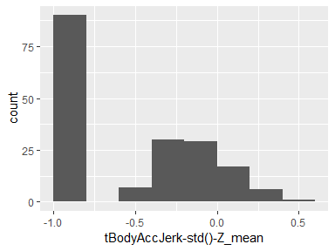

## tBodyGyro-mean()-X_mean

|  |  |
| --- | --- |
| Feature | Result |
| Variable type | numeric |
| Number of missing obs. | 0 (0 %) |
| Number of unique values | 180 |
| Median | 0.09 |
| 1st and 3rd quartiles | 0.07; 0.1 |
| Min. and max. | -0.07; 0.18 |

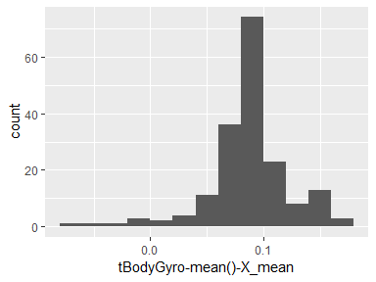

## tBodyGyro-mean()-Y_mean

|  |  |
| --- | --- |
| Feature | Result |
| Variable type | numeric |
| Number of missing obs. | 0 (0 %) |
| Number of unique values | 180 |
| Median | -0.79 |
| 1st and 3rd quartiles | -0.97; -0.44 |
| Min. and max. | -0.99; 0.27 |

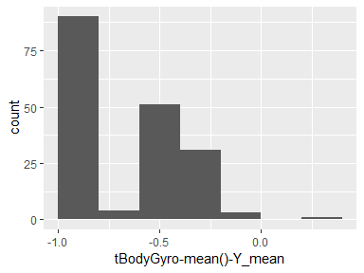

## tBodyGyro-mean()-Z_mean

|  |  |
| --- | --- |
| Feature | Result |
| Variable type | numeric |
| Number of missing obs. | 0 (0 %) |
| Number of unique values | 180 |
| Median | -0.8 |
| 1st and 3rd quartiles | -0.96; -0.42 |
| Min. and max. | -0.99; 0.48 |

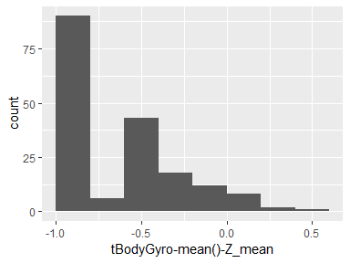

## tBodyGyro-std()-X_mean

|  |  |
| --- | --- |
| Feature | Result |
| Variable type | numeric |
| Number of missing obs. | 0 (0 %) |
| Number of unique values | 180 |
| Median | -0.8 |
| 1st and 3rd quartiles | -0.96; -0.31 |
| Min. and max. | -0.99; 0.56 |

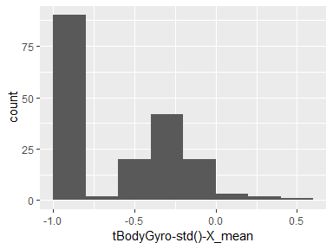

## tBodyGyro-std()-Y_mean

|  |  |
| --- | --- |
| Feature | Result |
| Variable type | numeric |
| Number of missing obs. | 0 (0 %) |
| Number of unique values | 180 |
| Median | -0.8 |
| 1st and 3rd quartiles | -0.98; -0.45 |
| Min. and max. | -0.99; 0.26 |

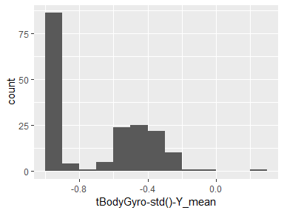

## tBodyGyro-std()-Z_mean

|  |  |
| --- | --- |
| Feature | Result |
| Variable type | numeric |
| Number of missing obs. | 0 (0 %) |
| Number of unique values | 180 |
| Median | -0.81 |
| 1st and 3rd quartiles | -0.97; -0.44 |
| Min. and max. | -0.99; 0.4 |

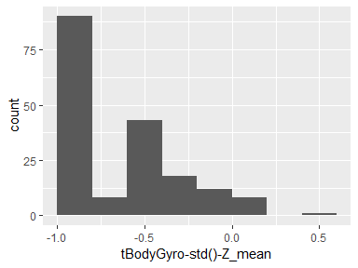

## tBodyGyroJerk-mean()-X_mean

|  |  |
| --- | --- |
| Feature | Result |
| Variable type | numeric |
| Number of missing obs. | 0 (0 %) |
| Number of unique values | 180 |
| Median | -0.05 |
| 1st and 3rd quartiles | -0.06; -0.05 |
| Min. and max. | -0.09; -0.01 |

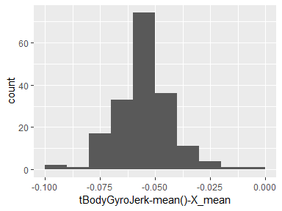

## tBodyGyroJerk-mean()-Y_mean

|  |  |
| --- | --- |
| Feature | Result |
| Variable type | numeric |
| Number of missing obs. | 0 (0 %) |
| Number of unique values | 180 |
| Median | -0.84 |
| 1st and 3rd quartiles | -0.98; -0.46 |
| Min. and max. | -1; 0.18 |

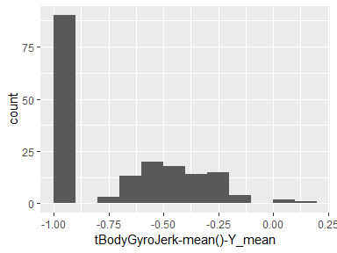

## tBodyGyroJerk-mean()-Z_mean

|  |  |
| --- | --- |
| Feature | Result |
| Variable type | numeric |
| Number of missing obs. | 0 (0 %) |
| Number of unique values | 180 |
| Median | -0.89 |
| 1st and 3rd quartiles | -0.98; -0.59 |
| Min. and max. | -1; 0.3 |

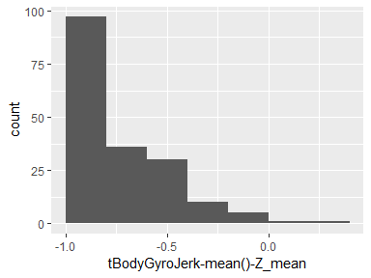

## tBodyGyroJerk-std()-X_mean

|  |  |
| --- | --- |
| Feature | Result |
| Variable type | numeric |
| Number of missing obs. | 0 (0 %) |
| Number of unique values | 180 |
| Median | -0.86 |
| 1st and 3rd quartiles | -0.98; -0.47 |
| Min. and max. | -1; 0.19 |

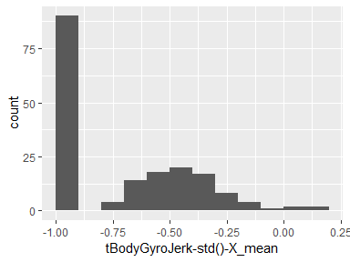

## tBodyGyroJerk-std()-Y_mean

|  |  |
| --- | --- |
| Feature | Result |
| Variable type | numeric |
| Number of missing obs. | 0 (0 %) |
| Number of unique values | 180 |
| Median | -0.84 |
| 1st and 3rd quartiles | -0.98; -0.46 |
| Min. and max. | -1; 0.21 |

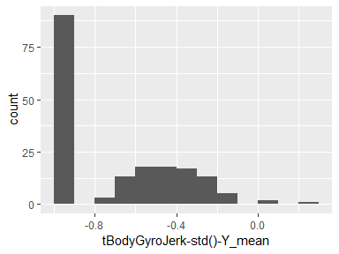

## tBodyGyroJerk-std()-Z_mean

|  |  |
| --- | --- |
| Feature | Result |
| Variable type | numeric |
| Number of missing obs. | 0 (0 %) |
| Number of unique values | 180 |
| Median | -0.9 |
| 1st and 3rd quartiles | -0.99; -0.6 |
| Min. and max. | -1; 0.17 |

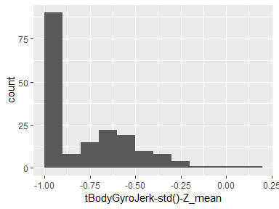

## tBodyAccMag-mean()_mean

|  |  |
| --- | --- |
| Feature | Result |
| Variable type | numeric |
| Number of missing obs. | 0 (0 %) |
| Number of unique values | 180 |
| Median | -0.64 |
| 1st and 3rd quartiles | -0.95; -0.3 |
| Min. and max. | -0.99; 0.27 |

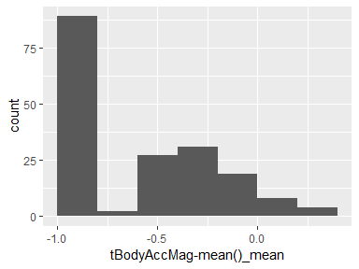

## tBodyAccMag-std()_mean

|  |  |
| --- | --- |
| Feature | Result |
| Variable type | numeric |
| Number of missing obs. | 0 (0 %) |
| Number of unique values | 180 |
| Median | -0.6 |
| 1st and 3rd quartiles | -0.95; -0.12 |
| Min. and max. | -0.98; 0.5 |

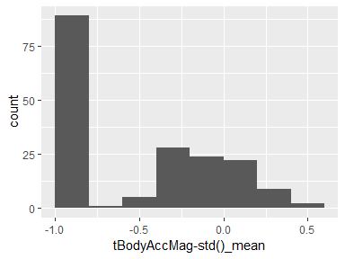

## tGravityAccMag-mean()_mean

|  |  |
| --- | --- |
| Feature | Result |
| Variable type | numeric |
| Number of missing obs. | 0 (0 %) |
| Number of unique values | 180 |
| Median | -0.64 |
| 1st and 3rd quartiles | -0.95; -0.3 |
| Min. and max. | -0.99; 0.27 |

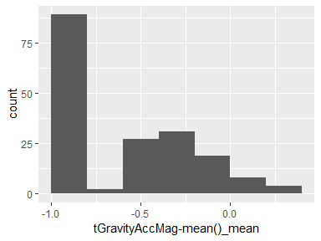

## tGravityAccMag-std()_mean

|  |  |
| --- | --- |
| Feature | Result |
| Variable type | numeric |
| Number of missing obs. | 0 (0 %) |
| Number of unique values | 180 |
| Median | -0.6 |
| 1st and 3rd quartiles | -0.95; -0.12 |
| Min. and max. | -0.98; 0.5 |

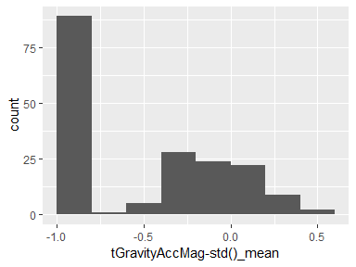

## tBodyAccJerkMag-mean()_mean

|  |  |
| --- | --- |
| Feature | Result |
| Variable type | numeric |
| Number of missing obs. | 0 (0 %) |
| Number of unique values | 180 |
| Median | -0.82 |
| 1st and 3rd quartiles | -0.98; -0.27 |
| Min. and max. | -0.99; 0.4 |

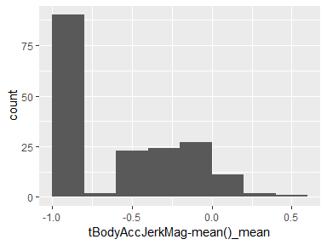

## tBodyAccJerkMag-std()_mean

|  |  |
| --- | --- |
| Feature | Result |
| Variable type | numeric |
| Number of missing obs. | 0 (0 %) |
| Number of unique values | 180 |
| Median | -0.8 |
| 1st and 3rd quartiles | -0.97; -0.2 |
| Min. and max. | -0.99; 0.35 |

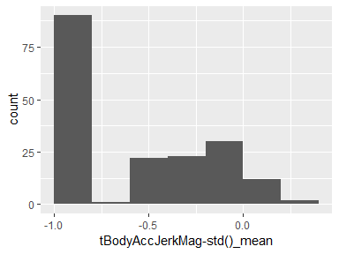

## tBodyGyroMag-mean()_mean

|  |  |
| --- | --- |
| Feature | Result |
| Variable type | numeric |
| Number of missing obs. | 0 (0 %) |
| Number of unique values | 180 |
| Median | -0.73 |
| 1st and 3rd quartiles | -0.94; -0.29 |
| Min. and max. | -0.98; 0.38 |

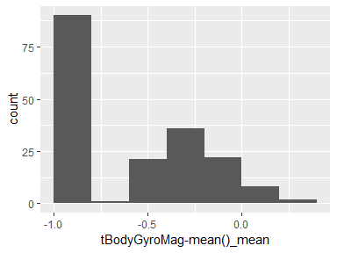

## tBodyGyroMag-std()_mean

|  |  |
| --- | --- |
| Feature | Result |
| Variable type | numeric |
| Number of missing obs. | 0 (0 %) |
| Number of unique values | 180 |
| Median | -0.76 |
| 1st and 3rd quartiles | -0.96; -0.41 |
| Min. and max. | -0.98; 0.22 |

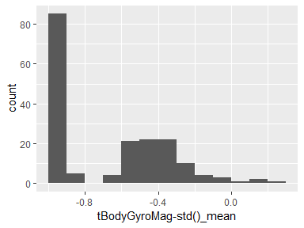

## tBodyGyroJerkMag-mean()_mean

|  |  |
| --- | --- |
| Feature | Result |
| Variable type | numeric |
| Number of missing obs. | 0 (0 %) |
| Number of unique values | 180 |
| Median | -0.89 |
| 1st and 3rd quartiles | -0.98; -0.59 |
| Min. and max. | -1; 0.11 |

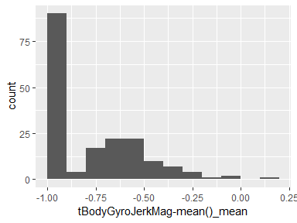

## tBodyGyroJerkMag-std()_mean

|  |  |
| --- | --- |
| Feature | Result |
| Variable type | numeric |
| Number of missing obs. | 0 (0 %) |
| Number of unique values | 180 |
| Median | -0.88 |
| 1st and 3rd quartiles | -0.98; -0.6 |
| Min. and max. | -1; 0.18 |

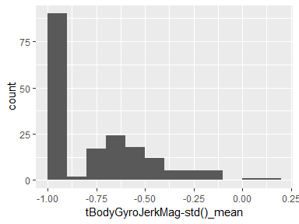

## fBodyAcc-mean()-X_mean

|  |  |
| --- | --- |
| Feature | Result |
| Variable type | numeric |
| Number of missing obs. | 0 (0 %) |
| Number of unique values | 180 |
| Median | -0.72 |
| 1st and 3rd quartiles | -0.96; -0.32 |
| Min. and max. | -0.99; 0.28 |

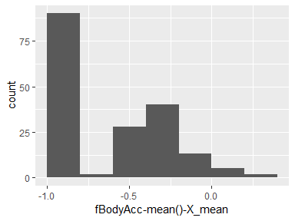

## fBodyAcc-mean()-Y_mean

|  |  |
| --- | --- |
| Feature | Result |
| Variable type | numeric |
| Number of missing obs. | 0 (0 %) |
| Number of unique values | 180 |
| Median | -0.75 |
| 1st and 3rd quartiles | -0.98; -0.2 |
| Min. and max. | -1; 0.66 |

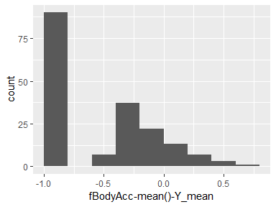

## fBodyAcc-mean()-Z_mean

|  |  |
| --- | --- |
| Feature | Result |
| Variable type | numeric |
| Number of missing obs. | 0 (0 %) |
| Number of unique values | 180 |
| Median | -0.51 |
| 1st and 3rd quartiles | -0.94; -0.08 |
| Min. and max. | -0.99; 0.56 |

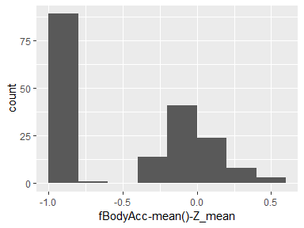

## fBodyAcc-std()-X_mean

|  |  |
| --- | --- |
| Feature | Result |
| Variable type | numeric |
| Number of missing obs. | 0 (0 %) |
| Number of unique values | 180 |
| Median | -0.64 |
| 1st and 3rd quartiles | -0.95; -0.27 |
| Min. and max. | -0.99; 0.69 |

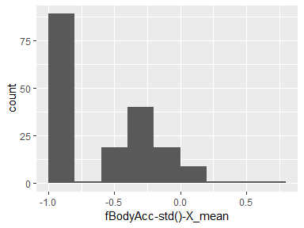

## fBodyAcc-std()-Y_mean

|  |  |
| --- | --- |
| Feature | Result |
| Variable type | numeric |
| Number of missing obs. | 0 (0 %) |
| Number of unique values | 180 |
| Median | -0.75 |
| 1st and 3rd quartiles | -0.98; -0.17 |
| Min. and max. | -1; 0.63 |

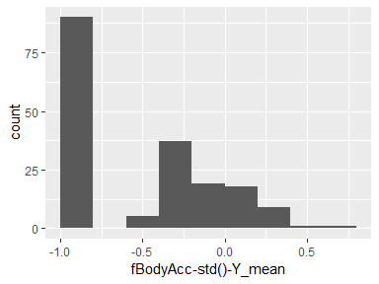

## fBodyAcc-std()-Z_mean

|  |  |
| --- | --- |
| Feature | Result |
| Variable type | numeric |
| Number of missing obs. | 0 (0 %) |
| Number of unique values | 180 |
| Median | -0.56 |
| 1st and 3rd quartiles | -0.95; -0.03 |
| Min. and max. | -0.99; 0.63 |

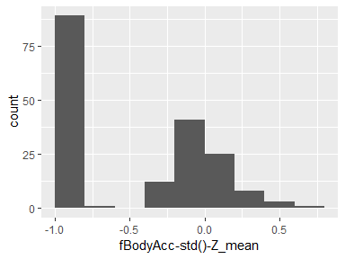

## fBodyAccJerk-mean()-X_mean

|  |  |
| --- | --- |
| Feature | Result |
| Variable type | numeric |
| Number of missing obs. | 0 (0 %) |
| Number of unique values | 180 |
| Median | -0.87 |
| 1st and 3rd quartiles | -0.98; -0.47 |
| Min. and max. | -0.99; 0.16 |

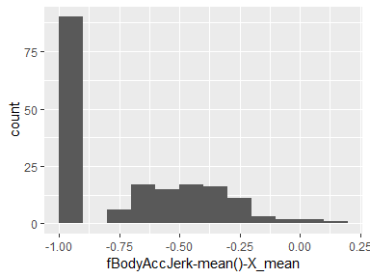

## fBodyAccJerk-mean()-Y_mean

|  |  |
| --- | --- |
| Feature | Result |
| Variable type | numeric |
| Number of missing obs. | 0 (0 %) |
| Number of unique values | 180 |
| Median | -0.83 |
| 1st and 3rd quartiles | -0.98; -0.25 |
| Min. and max. | -1; 0.48 |

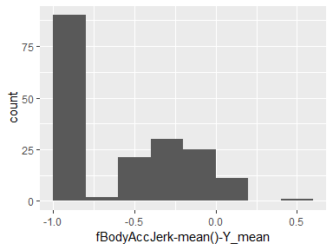

## fBodyAccJerk-mean()-Z_mean

|  |  |
| --- | --- |
| Feature | Result |
| Variable type | numeric |
| Number of missing obs. | 0 (0 %) |
| Number of unique values | 180 |
| Median | -0.79 |
| 1st and 3rd quartiles | -0.97; -0.17 |
| Min. and max. | -0.99; 0.35 |

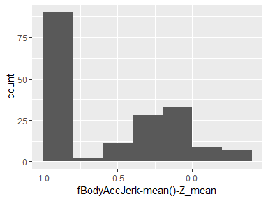

## fBodyAccJerk-std()-X_mean

|  |  |
| --- | --- |
| Feature | Result |
| Variable type | numeric |
| Number of missing obs. | 0 (0 %) |
| Number of unique values | 180 |
| Median | -0.9 |
| 1st and 3rd quartiles | -0.98; -0.54 |
| Min. and max. | -0.99; -0.01 |

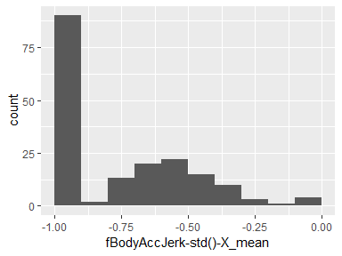

## fBodyAccJerk-std()-Y_mean

|  |  |
| --- | --- |
| Feature | Result |
| Variable type | numeric |
| Number of missing obs. | 0 (0 %) |
| Number of unique values | 180 |
| Median | -0.79 |
| 1st and 3rd quartiles | -0.98; -0.13 |
| Min. and max. | -0.99; 0.66 |

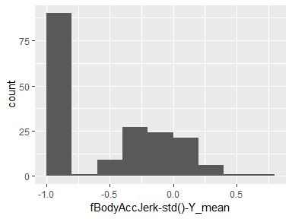

## fBodyAccJerk-std()-Z_mean

|  |  |
| --- | --- |
| Feature | Result |
| Variable type | numeric |
| Number of missing obs. | 0 (0 %) |
| Number of unique values | 180 |
| Median | -0.79 |
| 1st and 3rd quartiles | -0.97; -0.18 |
| Min. and max. | -0.99; 0.29 |

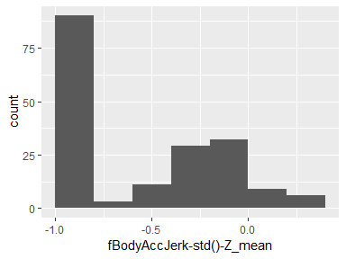

## fBodyGyro-mean()-X_mean

|  |  |
| --- | --- |
| Feature | Result |
| Variable type | numeric |
| Number of missing obs. | 0 (0 %) |
| Number of unique values | 180 |
| Median | -0.79 |
| 1st and 3rd quartiles | -0.96; -0.26 |
| Min. and max. | -0.99; 0.49 |

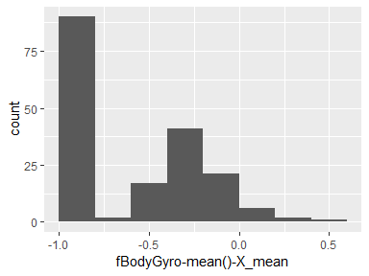

## fBodyGyro-mean()-Y_mean

|  |  |
| --- | --- |
| Feature | Result |
| Variable type | numeric |
| Number of missing obs. | 0 (0 %) |
| Number of unique values | 180 |
| Median | -0.81 |
| 1st and 3rd quartiles | -0.98; -0.48 |
| Min. and max. | -0.99; 0.2 |

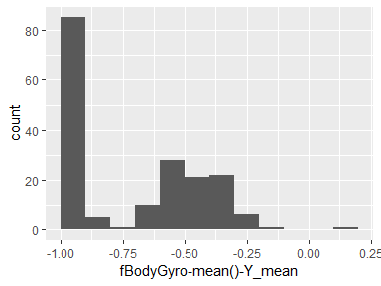

## fBodyGyro-mean()-Z_mean

|  |  |
| --- | --- |
| Feature | Result |
| Variable type | numeric |
| Number of missing obs. | 0 (0 %) |
| Number of unique values | 180 |
| Median | -0.8 |
| 1st and 3rd quartiles | -0.96; -0.42 |
| Min. and max. | -0.99; 0.65 |

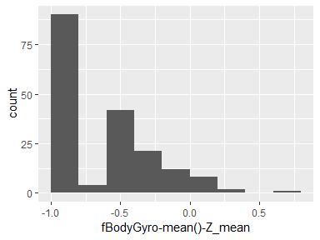

## fBodyGyro-std()-X_mean

|  |  |
| --- | --- |
| Feature | Result |
| Variable type | numeric |
| Number of missing obs. | 0 (0 %) |
| Number of unique values | 180 |
| Median | -0.82 |
| 1st and 3rd quartiles | -0.96; -0.39 |
| Min. and max. | -0.99; 0.52 |

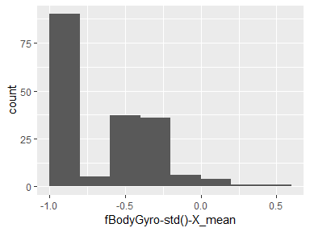

## fBodyGyro-std()-Y_mean

|  |  |
| --- | --- |
| Feature | Result |
| Variable type | numeric |
| Number of missing obs. | 0 (0 %) |
| Number of unique values | 180 |
| Median | -0.75 |
| 1st and 3rd quartiles | -0.97; -0.38 |
| Min. and max. | -0.99; 0.38 |

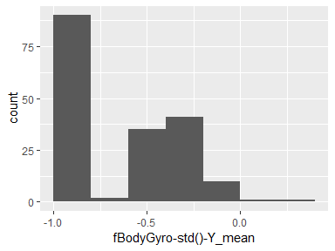

## fBodyGyro-std()-Z_mean

|  |  |
| --- | --- |
| Feature | Result |
| Variable type | numeric |
| Number of missing obs. | 0 (0 %) |
| Number of unique values | 180 |
| Median | -0.82 |
| 1st and 3rd quartiles | -0.97; -0.48 |
| Min. and max. | -0.99; 0.27 |

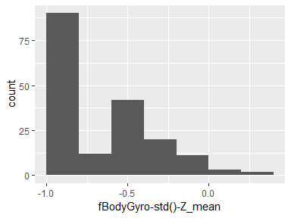

## fBodyAccMag-mean()_mean

|  |  |
| --- | --- |
| Feature | Result |
| Variable type | numeric |
| Number of missing obs. | 0 (0 %) |
| Number of unique values | 180 |
| Median | -0.65 |
| 1st and 3rd quartiles | -0.95; -0.22 |
| Min. and max. | -0.99; 0.49 |

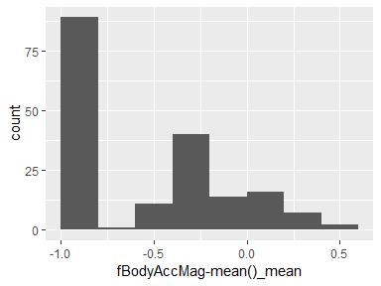

## fBodyAccMag-std()_mean

|  |  |
| --- | --- |
| Feature | Result |
| Variable type | numeric |
| Number of missing obs. | 0 (0 %) |
| Number of unique values | 180 |
| Median | -0.75 |
| 1st and 3rd quartiles | -0.95; -0.56 |
| Min. and max. | -0.99; -0.09 |

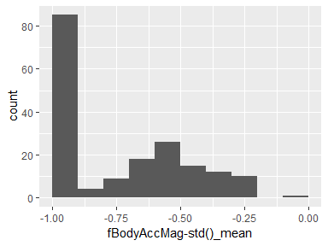

## fBodyBodyAccJerkMag-mean()_mean

|  |  |
| --- | --- |
| Feature | Result |
| Variable type | numeric |
| Number of missing obs. | 0 (0 %) |
| Number of unique values | 180 |
| Median | -0.79 |
| 1st and 3rd quartiles | -0.97; -0.18 |
| Min. and max. | -0.99; 0.48 |

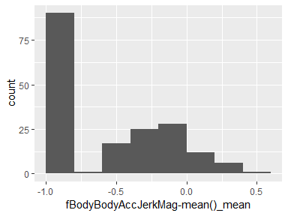

## fBodyBodyAccJerkMag-std()_mean

|  |  |
| --- | --- |
| Feature | Result |
| Variable type | numeric |
| Number of missing obs. | 0 (0 %) |
| Number of unique values | 180 |
| Median | -0.84 |
| 1st and 3rd quartiles | -0.98; -0.34 |
| Min. and max. | -1; 0.18 |

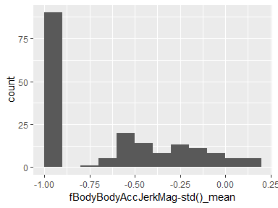

## fBodyBodyGyroMag-mean()_mean

|  |  |
| --- | --- |
| Feature | Result |
| Variable type | numeric |
| Number of missing obs. | 0 (0 %) |
| Number of unique values | 180 |
| Median | -0.75 |
| 1st and 3rd quartiles | -0.95; -0.38 |
| Min. and max. | -0.98; 0.36 |

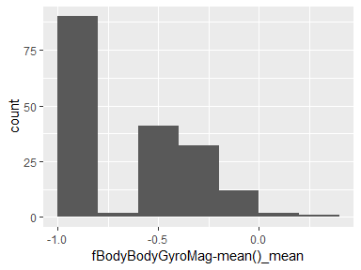

## fBodyBodyGyroMag-std()_mean

|  |  |
| --- | --- |
| Feature | Result |
| Variable type | numeric |
| Number of missing obs. | 0 (0 %) |
| Number of unique values | 180 |
| Median | -0.81 |
| 1st and 3rd quartiles | -0.95; -0.51 |
| Min. and max. | -0.98; 0.08 |

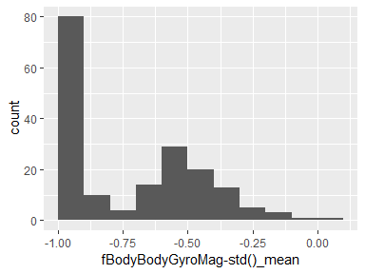

## fBodyBodyGyroJerkMag-mean()_mean

|  |  |
| --- | --- |
| Feature | Result |
| Variable type | numeric |
| Number of missing obs. | 0 (0 %) |
| Number of unique values | 180 |
| Median | -0.88 |
| 1st and 3rd quartiles | -0.98; -0.57 |
| Min. and max. | -1; 0.35 |

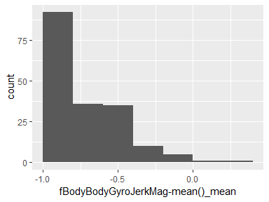

## fBodyBodyGyroJerkMag-std()_mean

|  |  |
| --- | --- |
| Feature | Result |
| Variable type | numeric |
| Number of missing obs. | 0 (0 %) |
| Number of unique values | 180 |
| Median | -0.91 |
| 1st and 3rd quartiles | -0.98; -0.66 |
| Min. and max. | -1; 0.14 |

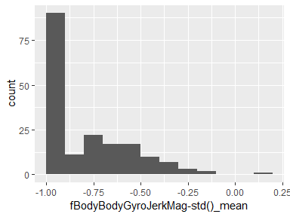

## V1100_sd

* The variable only takes one (non-missing) value: "0". The variable contains 0 % missing observations.

## tBodyAcc-mean()-X_sd

|  |  |
| --- | --- |
| Feature | Result |
| Variable type | numeric |
| Number of missing obs. | 0 (0 %) |
| Number of unique values | 180 |
| Median | 0.04 |
| 1st and 3rd quartiles | 0.03; 0.05 |
| Min. and max. | 0; 0.34 |

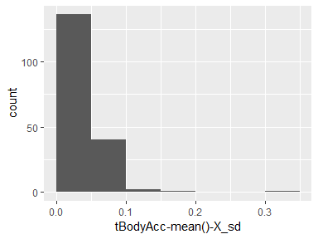

## tBodyAcc-mean()-Y_sd

|  |  |
| --- | --- |
| Feature | Result |
| Variable type | numeric |
| Number of missing obs. | 0 (0 %) |
| Number of unique values | 180 |
| Median | 0.06 |
| 1st and 3rd quartiles | 0.03; 0.09 |
| Min. and max. | 0.01; 0.19 |

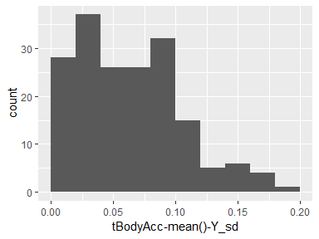

## tBodyAcc-mean()-Z_sd

|  |  |
| --- | --- |
| Feature | Result |
| Variable type | numeric |
| Number of missing obs. | 0 (0 %) |
| Number of unique values | 180 |
| Median | 0.1 |
| 1st and 3rd quartiles | 0.07; 0.14 |
| Min. and max. | 0.01; 0.36 |

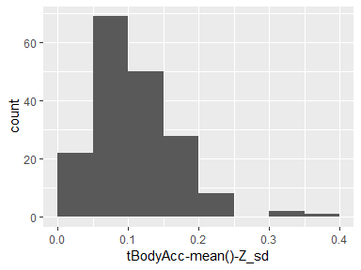

## tBodyAcc-std()-X_sd

|  |  |
| --- | --- |
| Feature | Result |
| Variable type | numeric |
| Number of missing obs. | 0 (0 %) |
| Number of unique values | 180 |
| Median | 0.08 |
| 1st and 3rd quartiles | 0.06; 0.13 |
| Min. and max. | 0.01; 0.33 |

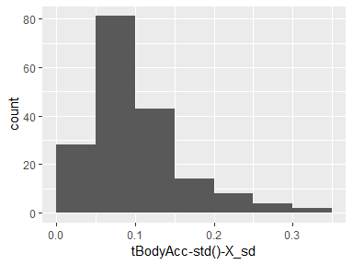

## tBodyAcc-std()-Y_sd

|  |  |
| --- | --- |
| Feature | Result |
| Variable type | numeric |
| Number of missing obs. | 0 (0 %) |
| Number of unique values | 180 |
| Median | 0.06 |
| 1st and 3rd quartiles | 0.02; 0.09 |
| Min. and max. | 0; 0.2 |

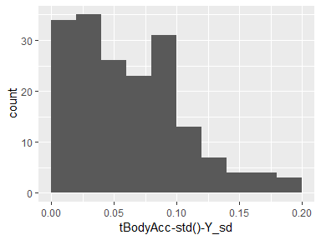

## tBodyAcc-std()-Z_sd

|  |  |
| --- | --- |
| Feature | Result |
| Variable type | numeric |
| Number of missing obs. | 0 (0 %) |
| Number of unique values | 180 |
| Median | 0.1 |
| 1st and 3rd quartiles | 0.06; 0.14 |
| Min. and max. | 0.01; 0.41 |

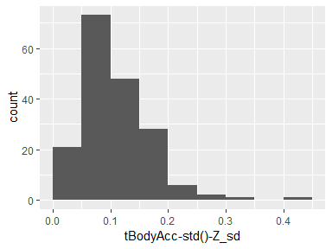

## tGravityAcc-mean()-X_sd

|  |  |
| --- | --- |
| Feature | Result |
| Variable type | numeric |
| Number of missing obs. | 0 (0 %) |
| Number of unique values | 180 |
| Median | 0.07 |
| 1st and 3rd quartiles | 0.03; 0.14 |
| Min. and max. | 0.01; 0.91 |

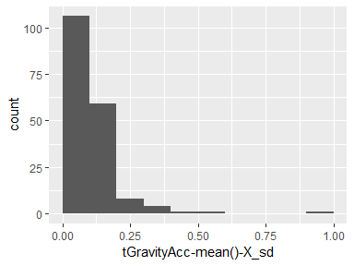

## tGravityAcc-mean()-Y_sd

|  |  |
| --- | --- |
| Feature | Result |
| Variable type | numeric |
| Number of missing obs. | 0 (0 %) |
| Number of unique values | 180 |
| Median | 0.03 |
| 1st and 3rd quartiles | 0.02; 0.05 |
| Min. and max. | 0; 0.37 |

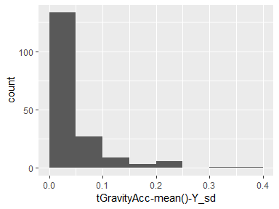

## tGravityAcc-mean()-Z_sd

|  |  |
| --- | --- |
| Feature | Result |
| Variable type | numeric |
| Number of missing obs. | 0 (0 %) |
| Number of unique values | 180 |
| Median | 0.04 |
| 1st and 3rd quartiles | 0.03; 0.06 |
| Min. and max. | 0.01; 0.49 |

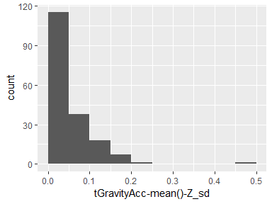

## tGravityAcc-std()-X_sd

|  |  |
| --- | --- |
| Feature | Result |
| Variable type | numeric |
| Number of missing obs. | 0 (0 %) |
| Number of unique values | 180 |
| Median | 0.06 |
| 1st and 3rd quartiles | 0.04; 0.09 |
| Min. and max. | 0.01; 0.46 |

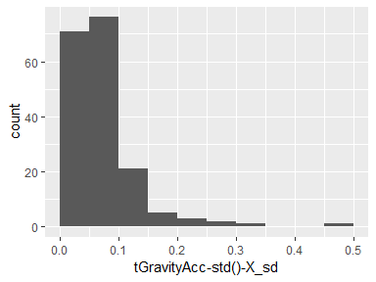

## tGravityAcc-std()-Y_sd

|  |  |
| --- | --- |
| Feature | Result |
| Variable type | numeric |
| Number of missing obs. | 0 (0 %) |
| Number of unique values | 180 |
| Median | 0.03 |
| 1st and 3rd quartiles | 0.02; 0.05 |
| Min. and max. | 0; 0.38 |

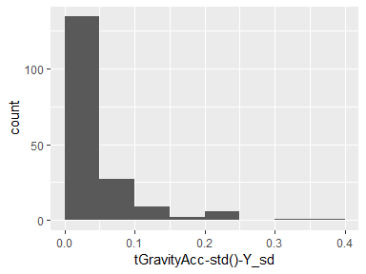

## tGravityAcc-std()-Z_sd

|  |  |
| --- | --- |
| Feature | Result |
| Variable type | numeric |
| Number of missing obs. | 0 (0 %) |
| Number of unique values | 180 |
| Median | 0.04 |
| 1st and 3rd quartiles | 0.03; 0.06 |
| Min. and max. | 0.01; 0.49 |

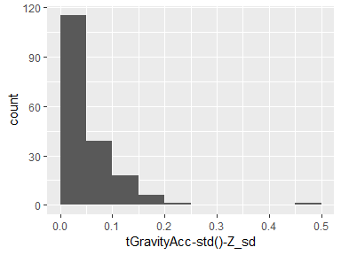

## tBodyAccJerk-mean()-X_sd

|  |  |
| --- | --- |
| Feature | Result |
| Variable type | numeric |
| Number of missing obs. | 0 (0 %) |
| Number of unique values | 180 |
| Median | 0.12 |
| 1st and 3rd quartiles | 0.04; 0.22 |
| Min. and max. | 0.01; 0.38 |

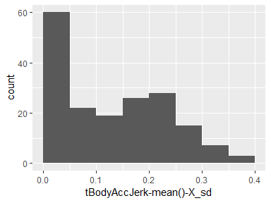

## tBodyAccJerk-mean()-Y_sd

|  |  |
| --- | --- |
| Feature | Result |
| Variable type | numeric |
| Number of missing obs. | 0 (0 %) |
| Number of unique values | 180 |
| Median | 0.05 |
| 1st and 3rd quartiles | 0.02; 0.09 |
| Min. and max. | 0; 0.21 |

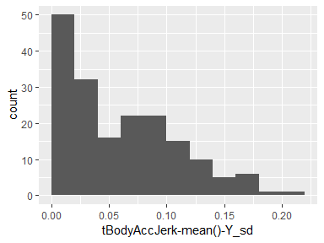

## tBodyAccJerk-mean()-Z_sd

|  |  |
| --- | --- |
| Feature | Result |
| Variable type | numeric |
| Number of missing obs. | 0 (0 %) |
| Number of unique values | 180 |
| Median | 0.06 |
| 1st and 3rd quartiles | 0.03; 0.12 |
| Min. and max. | 0; 0.32 |

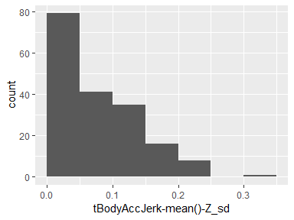

## tBodyAccJerk-std()-X_sd

|  |  |
| --- | --- |
| Feature | Result |
| Variable type | numeric |
| Number of missing obs. | 0 (0 %) |
| Number of unique values | 180 |
| Median | 0.04 |
| 1st and 3rd quartiles | 0.02; 0.08 |
| Min. and max. | 0; 0.41 |

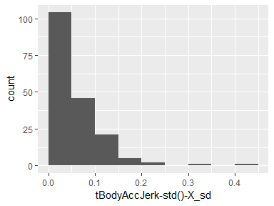

## tBodyAccJerk-std()-Y_sd

|  |  |
| --- | --- |
| Feature | Result |
| Variable type | numeric |
| Number of missing obs. | 0 (0 %) |
| Number of unique values | 180 |
| Median | 0.04 |
| 1st and 3rd quartiles | 0.02; 0.09 |
| Min. and max. | 0; 0.23 |

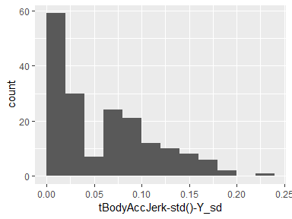

## tBodyAccJerk-std()-Z_sd

|  |  |
| --- | --- |
| Feature | Result |
| Variable type | numeric |
| Number of missing obs. | 0 (0 %) |
| Number of unique values | 180 |
| Median | 0.06 |
| 1st and 3rd quartiles | 0.03; 0.12 |
| Min. and max. | 0; 0.31 |

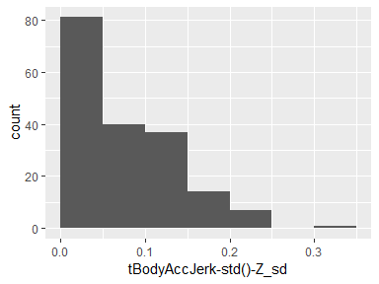

## tBodyGyro-mean()-X_sd

|  |  |
| --- | --- |
| Feature | Result |
| Variable type | numeric |
| Number of missing obs. | 0 (0 %) |
| Number of unique values | 180 |
| Median | 0.1 |
| 1st and 3rd quartiles | 0.06; 0.16 |
| Min. and max. | 0.01; 0.44 |

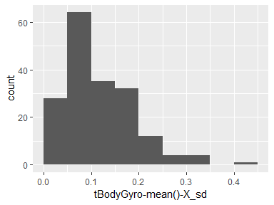

## tBodyGyro-mean()-Y_sd

|  |  |
| --- | --- |
| Feature | Result |
| Variable type | numeric |
| Number of missing obs. | 0 (0 %) |
| Number of unique values | 180 |
| Median | 0.07 |
| 1st and 3rd quartiles | 0.03; 0.14 |
| Min. and max. | 0.01; 0.29 |

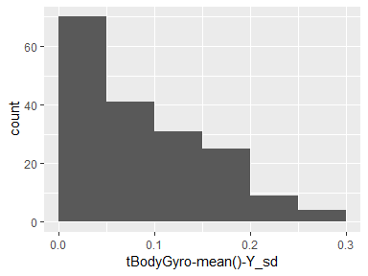

## tBodyGyro-mean()-Z_sd

|  |  |
| --- | --- |
| Feature | Result |
| Variable type | numeric |
| Number of missing obs. | 0 (0 %) |
| Number of unique values | 180 |
| Median | 0.06 |
| 1st and 3rd quartiles | 0.04; 0.09 |
| Min. and max. | 0.01; 0.42 |

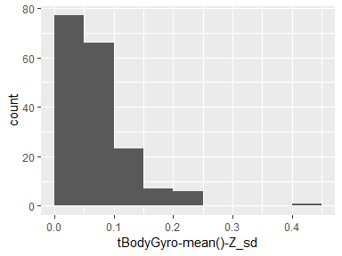

## tBodyGyro-std()-X_sd

|  |  |
| --- | --- |
| Feature | Result |
| Variable type | numeric |
| Number of missing obs. | 0 (0 %) |
| Number of unique values | 180 |
| Median | 0.06 |
| 1st and 3rd quartiles | 0.04; 0.09 |
| Min. and max. | 0.02; 0.35 |

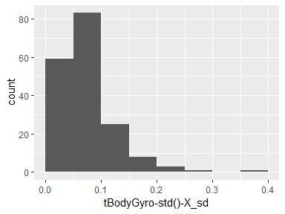

## tBodyGyro-std()-Y_sd

|  |  |
| --- | --- |
| Feature | Result |
| Variable type | numeric |
| Number of missing obs. | 0 (0 %) |
| Number of unique values | 180 |
| Median | 0.07 |
| 1st and 3rd quartiles | 0.03; 0.14 |
| Min. and max. | 0.01; 0.29 |

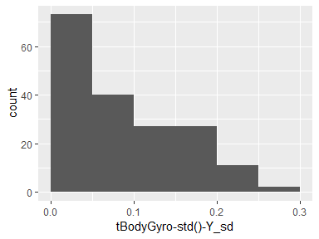

## tBodyGyro-std()-Z_sd

|  |  |
| --- | --- |
| Feature | Result |
| Variable type | numeric |
| Number of missing obs. | 0 (0 %) |
| Number of unique values | 180 |
| Median | 0.05 |
| 1st and 3rd quartiles | 0.03; 0.08 |
| Min. and max. | 0; 0.42 |

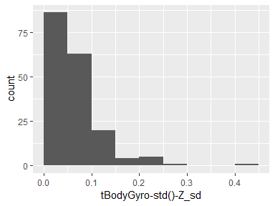

## tBodyGyroJerk-mean()-X_sd

|  |  |
| --- | --- |
| Feature | Result |
| Variable type | numeric |
| Number of missing obs. | 0 (0 %) |
| Number of unique values | 180 |
| Median | 0.07 |
| 1st and 3rd quartiles | 0.03; 0.18 |
| Min. and max. | 0.01; 0.47 |

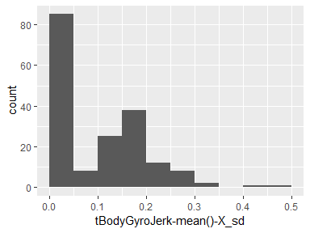

## tBodyGyroJerk-mean()-Y_sd

|  |  |
| --- | --- |
| Feature | Result |
| Variable type | numeric |
| Number of missing obs. | 0 (0 %) |
| Number of unique values | 180 |
| Median | 0.05 |
| 1st and 3rd quartiles | 0.02; 0.08 |
| Min. and max. | 0; 0.34 |

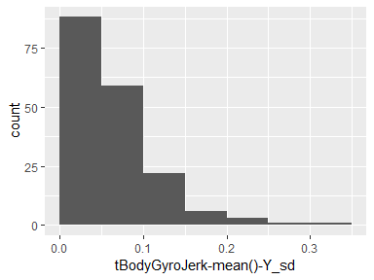

## tBodyGyroJerk-mean()-Z_sd

|  |  |
| --- | --- |
| Feature | Result |
| Variable type | numeric |
| Number of missing obs. | 0 (0 %) |
| Number of unique values | 180 |
| Median | 0.04 |
| 1st and 3rd quartiles | 0.02; 0.08 |
| Min. and max. | 0; 0.51 |

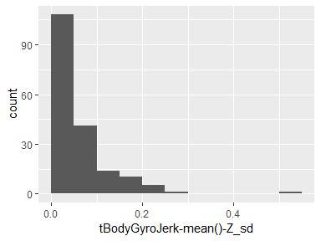

## tBodyGyroJerk-std()-X_sd

|  |  |
| --- | --- |
| Feature | Result |
| Variable type | numeric |
| Number of missing obs. | 0 (0 %) |
| Number of unique values | 180 |
| Median | 0.05 |
| 1st and 3rd quartiles | 0.02; 0.07 |
| Min. and max. | 0; 0.26 |

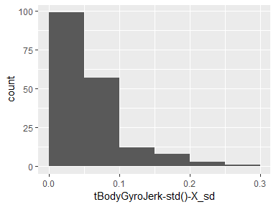

## tBodyGyroJerk-std()-Y_sd

|  |  |
| --- | --- |
| Feature | Result |
| Variable type | numeric |
| Number of missing obs. | 0 (0 %) |
| Number of unique values | 180 |
| Median | 0.05 |
| 1st and 3rd quartiles | 0.02; 0.08 |
| Min. and max. | 0; 0.33 |

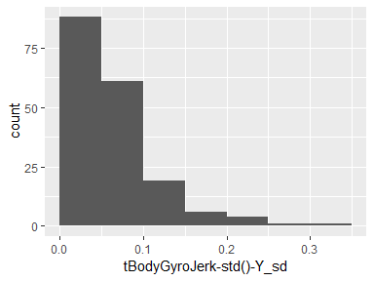

## tBodyGyroJerk-std()-Z_sd

|  |  |
| --- | --- |
| Feature | Result |
| Variable type | numeric |
| Number of missing obs. | 0 (0 %) |
| Number of unique values | 180 |
| Median | 0.03 |
| 1st and 3rd quartiles | 0.02; 0.07 |
| Min. and max. | 0; 0.49 |

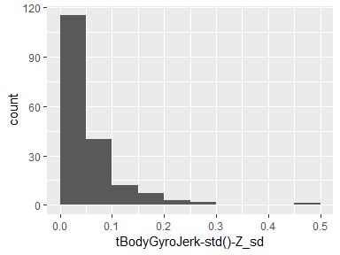

## tBodyAccMag-mean()_sd

|  |  |
| --- | --- |
| Feature | Result |
| Variable type | numeric |
| Number of missing obs. | 0 (0 %) |
| Number of unique values | 180 |
| Median | 0.08 |
| 1st and 3rd quartiles | 0.06; 0.11 |
| Min. and max. | 0.01; 0.37 |

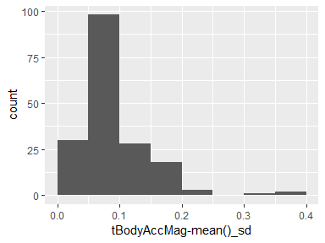

## tBodyAccMag-std()_sd

|  |  |
| --- | --- |
| Feature | Result |
| Variable type | numeric |
| Number of missing obs. | 0 (0 %) |
| Number of unique values | 180 |
| Median | 0.09 |
| 1st and 3rd quartiles | 0.06; 0.12 |
| Min. and max. | 0.02; 0.29 |

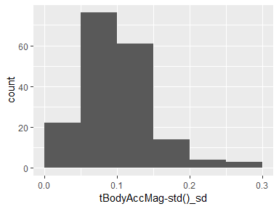

## tGravityAccMag-mean()_sd

|  |  |
| --- | --- |
| Feature | Result |
| Variable type | numeric |
| Number of missing obs. | 0 (0 %) |
| Number of unique values | 180 |
| Median | 0.08 |
| 1st and 3rd quartiles | 0.06; 0.11 |
| Min. and max. | 0.01; 0.37 |

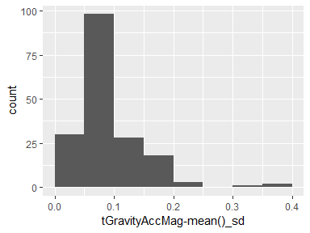

## tGravityAccMag-std()_sd

|  |  |
| --- | --- |
| Feature | Result |
| Variable type | numeric |
| Number of missing obs. | 0 (0 %) |
| Number of unique values | 180 |
| Median | 0.09 |
| 1st and 3rd quartiles | 0.06; 0.12 |
| Min. and max. | 0.02; 0.29 |

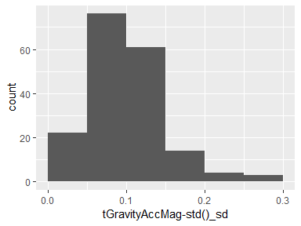

## tBodyAccJerkMag-mean()_sd

|  |  |
| --- | --- |
| Feature | Result |
| Variable type | numeric |
| Number of missing obs. | 0 (0 %) |
| Number of unique values | 180 |
| Median | 0.05 |
| 1st and 3rd quartiles | 0.02; 0.09 |
| Min. and max. | 0; 0.24 |

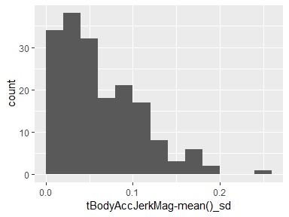

## tBodyAccJerkMag-std()_sd

|  |  |
| --- | --- |
| Feature | Result |
| Variable type | numeric |
| Number of missing obs. | 0 (0 %) |
| Number of unique values | 180 |
| Median | 0.07 |
| 1st and 3rd quartiles | 0.03; 0.13 |
| Min. and max. | 0.01; 0.27 |

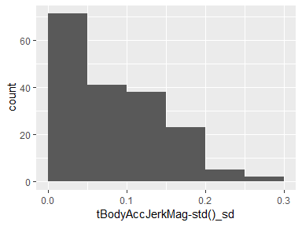

## tBodyGyroMag-mean()_sd

|  |  |
| --- | --- |
| Feature | Result |
| Variable type | numeric |
| Number of missing obs. | 0 (0 %) |
| Number of unique values | 180 |
| Median | 0.1 |
| 1st and 3rd quartiles | 0.06; 0.15 |
| Min. and max. | 0.03; 0.32 |

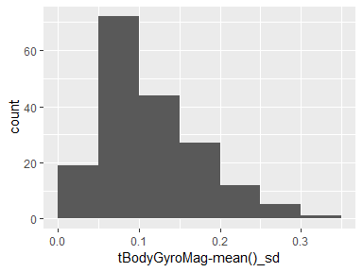

## tBodyGyroMag-std()_sd

|  |  |
| --- | --- |
| Feature | Result |
| Variable type | numeric |
| Number of missing obs. | 0 (0 %) |
| Number of unique values | 180 |
| Median | 0.08 |
| 1st and 3rd quartiles | 0.05; 0.11 |
| Min. and max. | 0.02; 0.31 |

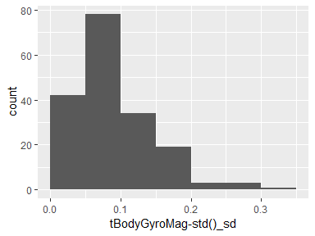

## tBodyGyroJerkMag-mean()_sd

|  |  |
| --- | --- |
| Feature | Result |
| Variable type | numeric |
| Number of missing obs. | 0 (0 %) |
| Number of unique values | 180 |
| Median | 0.04 |
| 1st and 3rd quartiles | 0.02; 0.07 |
| Min. and max. | 0; 0.41 |

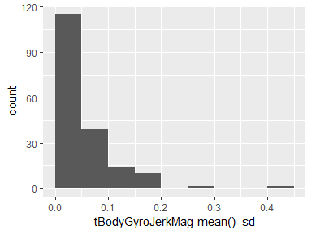

## tBodyGyroJerkMag-std()_sd

|  |  |
| --- | --- |
| Feature | Result |
| Variable type | numeric |
| Number of missing obs. | 0 (0 %) |
| Number of unique values | 180 |
| Median | 0.05 |
| 1st and 3rd quartiles | 0.03; 0.09 |
| Min. and max. | 0; 0.42 |

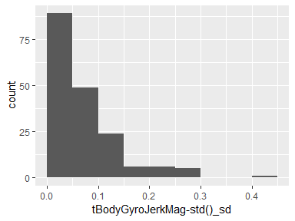

## fBodyAcc-mean()-X_sd

|  |  |
| --- | --- |
| Feature | Result |
| Variable type | numeric |
| Number of missing obs. | 0 (0 %) |
| Number of unique values | 180 |
| Median | 0.07 |
| 1st and 3rd quartiles | 0.05; 0.11 |
| Min. and max. | 0.01; 0.36 |

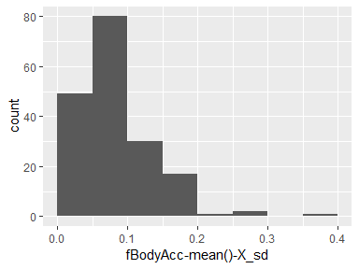

## fBodyAcc-mean()-Y_sd

|  |  |
| --- | --- |
| Feature | Result |
| Variable type | numeric |
| Number of missing obs. | 0 (0 %) |
| Number of unique values | 180 |
| Median | 0.06 |
| 1st and 3rd quartiles | 0.03; 0.1 |
| Min. and max. | 0; 0.2 |

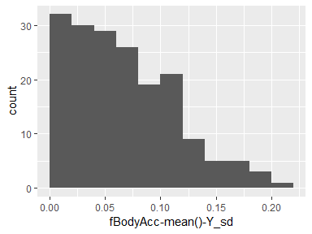

## fBodyAcc-mean()-Z_sd

|  |  |
| --- | --- |
| Feature | Result |
| Variable type | numeric |
| Number of missing obs. | 0 (0 %) |
| Number of unique values | 180 |
| Median | 0.1 |
| 1st and 3rd quartiles | 0.07; 0.14 |
| Min. and max. | 0.01; 0.4 |

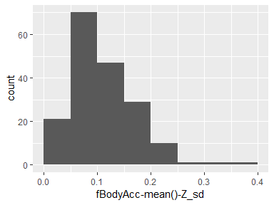

## fBodyAcc-std()-X_sd

|  |  |
| --- | --- |
| Feature | Result |
| Variable type | numeric |
| Number of missing obs. | 0 (0 %) |
| Number of unique values | 180 |
| Median | 0.08 |
| 1st and 3rd quartiles | 0.06; 0.13 |
| Min. and max. | 0.01; 0.33 |

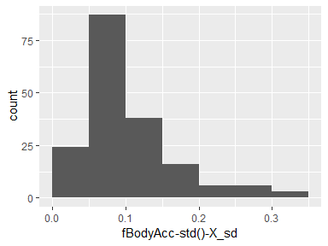

## fBodyAcc-std()-Y_sd

|  |  |
| --- | --- |
| Feature | Result |
| Variable type | numeric |
| Number of missing obs. | 0 (0 %) |
| Number of unique values | 180 |
| Median | 0.06 |
| 1st and 3rd quartiles | 0.03; 0.1 |
| Min. and max. | 0; 0.2 |

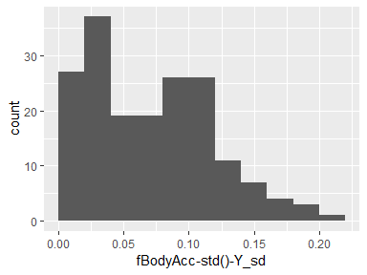

## fBodyAcc-std()-Z_sd

|  |  |
| --- | --- |
| Feature | Result |
| Variable type | numeric |
| Number of missing obs. | 0 (0 %) |
| Number of unique values | 180 |
| Median | 0.1 |
| 1st and 3rd quartiles | 0.06; 0.13 |
| Min. and max. | 0.01; 0.33 |

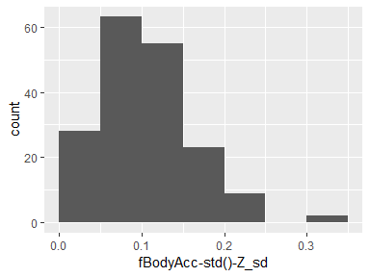

## fBodyAccJerk-mean()-X_sd

|  |  |
| --- | --- |
| Feature | Result |
| Variable type | numeric |
| Number of missing obs. | 0 (0 %) |
| Number of unique values | 180 |
| Median | 0.04 |
| 1st and 3rd quartiles | 0.02; 0.08 |
| Min. and max. | 0; 0.43 |

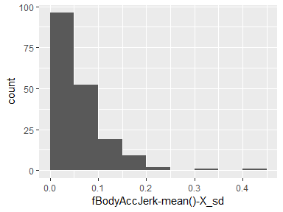

## fBodyAccJerk-mean()-Y_sd

|  |  |
| --- | --- |
| Feature | Result |
| Variable type | numeric |
| Number of missing obs. | 0 (0 %) |
| Number of unique values | 180 |
| Median | 0.05 |
| 1st and 3rd quartiles | 0.02; 0.1 |
| Min. and max. | 0; 0.22 |

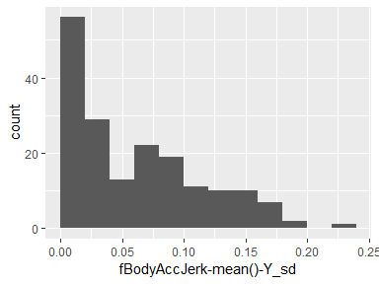

## fBodyAccJerk-mean()-Z_sd

|  |  |
| --- | --- |
| Feature | Result |
| Variable type | numeric |
| Number of missing obs. | 0 (0 %) |
| Number of unique values | 180 |
| Median | 0.06 |
| 1st and 3rd quartiles | 0.03; 0.13 |
| Min. and max. | 0; 0.33 |

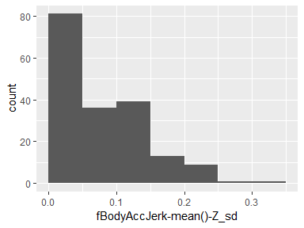

## fBodyAccJerk-std()-X_sd

|  |  |
| --- | --- |
| Feature | Result |
| Variable type | numeric |
| Number of missing obs. | 0 (0 %) |
| Number of unique values | 180 |
| Median | 0.04 |
| 1st and 3rd quartiles | 0.02; 0.08 |
| Min. and max. | 0; 0.4 |

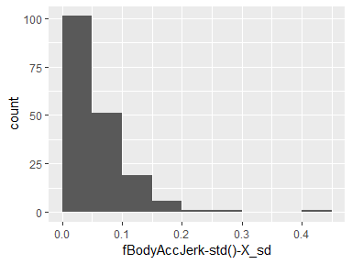

## fBodyAccJerk-std()-Y_sd

|  |  |
| --- | --- |
| Feature | Result |
| Variable type | numeric |
| Number of missing obs. | 0 (0 %) |
| Number of unique values | 180 |
| Median | 0.06 |
| 1st and 3rd quartiles | 0.02; 0.12 |
| Min. and max. | 0; 0.23 |

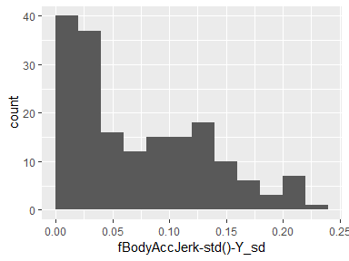

## fBodyAccJerk-std()-Z_sd

|  |  |
| --- | --- |
| Feature | Result |
| Variable type | numeric |
| Number of missing obs. | 0 (0 %) |
| Number of unique values | 180 |
| Median | 0.06 |
| 1st and 3rd quartiles | 0.03; 0.12 |
| Min. and max. | 0; 0.35 |

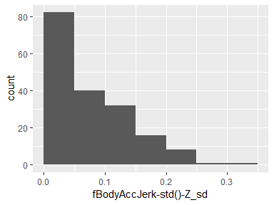

## fBodyGyro-mean()-X_sd

|  |  |
| --- | --- |
| Feature | Result |
| Variable type | numeric |
| Number of missing obs. | 0 (0 %) |
| Number of unique values | 180 |
| Median | 0.07 |
| 1st and 3rd quartiles | 0.04; 0.1 |
| Min. and max. | 0.01; 0.28 |

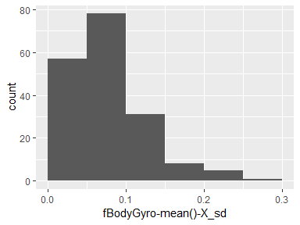

## fBodyGyro-mean()-Y_sd

|  |  |
| --- | --- |
| Feature | Result |
| Variable type | numeric |
| Number of missing obs. | 0 (0 %) |
| Number of unique values | 180 |
| Median | 0.07 |
| 1st and 3rd quartiles | 0.03; 0.15 |
| Min. and max. | 0.01; 0.31 |

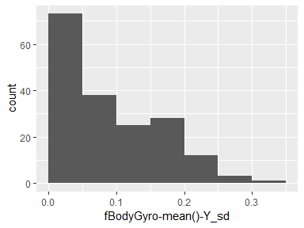

## fBodyGyro-mean()-Z_sd

|  |  |
| --- | --- |
| Feature | Result |
| Variable type | numeric |
| Number of missing obs. | 0 (0 %) |
| Number of unique values | 180 |
| Median | 0.06 |
| 1st and 3rd quartiles | 0.04; 0.09 |
| Min. and max. | 0.01; 0.38 |

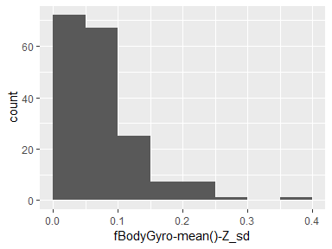

## fBodyGyro-std()-X_sd

|  |  |
| --- | --- |
| Feature | Result |
| Variable type | numeric |
| Number of missing obs. | 0 (0 %) |
| Number of unique values | 180 |
| Median | 0.06 |
| 1st and 3rd quartiles | 0.04; 0.09 |
| Min. and max. | 0.01; 0.35 |

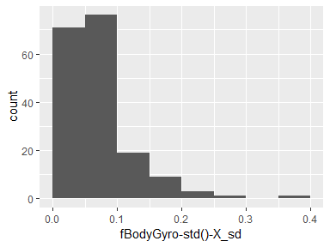

## fBodyGyro-std()-Y_sd

|  |  |
| --- | --- |
| Feature | Result |
| Variable type | numeric |
| Number of missing obs. | 0 (0 %) |
| Number of unique values | 180 |
| Median | 0.08 |
| 1st and 3rd quartiles | 0.04; 0.13 |
| Min. and max. | 0.01; 0.29 |

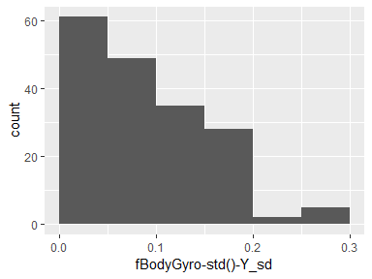

## fBodyGyro-std()-Z_sd

|  |  |
| --- | --- |
| Feature | Result |
| Variable type | numeric |
| Number of missing obs. | 0 (0 %) |
| Number of unique values | 180 |
| Median | 0.05 |
| 1st and 3rd quartiles | 0.03; 0.08 |
| Min. and max. | 0.01; 0.37 |

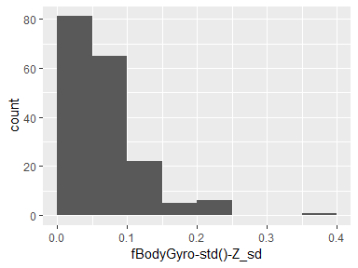

## fBodyAccMag-mean()_sd

|  |  |
| --- | --- |
| Feature | Result |
| Variable type | numeric |
| Number of missing obs. | 0 (0 %) |
| Number of unique values | 180 |
| Median | 0.09 |
| 1st and 3rd quartiles | 0.06; 0.12 |
| Min. and max. | 0.01; 0.3 |

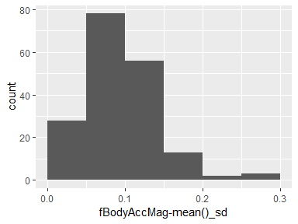

## fBodyAccMag-std()_sd

|  |  |
| --- | --- |
| Feature | Result |
| Variable type | numeric |
| Number of missing obs. | 0 (0 %) |
| Number of unique values | 180 |
| Median | 0.08 |
| 1st and 3rd quartiles | 0.05; 0.12 |
| Min. and max. | 0.01; 0.37 |

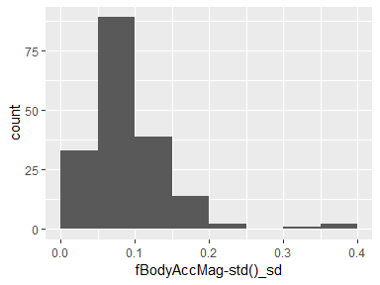

## fBodyBodyAccJerkMag-mean()_sd

|  |  |
| --- | --- |
| Feature | Result |
| Variable type | numeric |
| Number of missing obs. | 0 (0 %) |
| Number of unique values | 180 |
| Median | 0.06 |
| 1st and 3rd quartiles | 0.03; 0.12 |
| Min. and max. | 0; 0.25 |

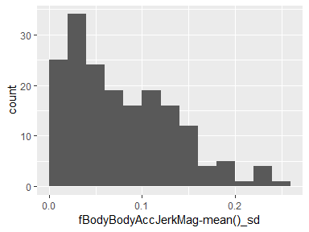

## fBodyBodyAccJerkMag-std()_sd

|  |  |
| --- | --- |
| Feature | Result |
| Variable type | numeric |
| Number of missing obs. | 0 (0 %) |
| Number of unique values | 180 |
| Median | 0.07 |
| 1st and 3rd quartiles | 0.03; 0.12 |
| Min. and max. | 0; 0.35 |

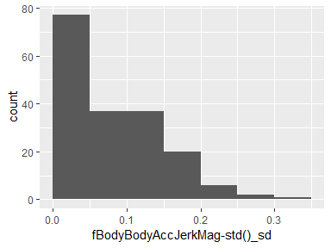

## fBodyBodyGyroMag-mean()_sd

|  |  |
| --- | --- |
| Feature | Result |
| Variable type | numeric |
| Number of missing obs. | 0 (0 %) |
| Number of unique values | 180 |
| Median | 0.09 |
| 1st and 3rd quartiles | 0.05; 0.13 |
| Min. and max. | 0.02; 0.33 |

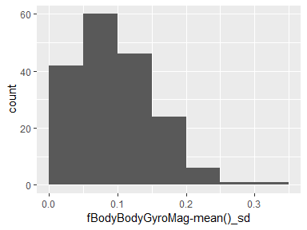

## fBodyBodyGyroMag-std()_sd

|  |  |
| --- | --- |
| Feature | Result |
| Variable type | numeric |
| Number of missing obs. | 0 (0 %) |
| Number of unique values | 180 |
| Median | 0.09 |
| 1st and 3rd quartiles | 0.06; 0.16 |
| Min. and max. | 0.02; 0.34 |

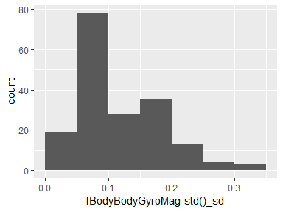

## fBodyBodyGyroJerkMag-mean()_sd

|  |  |
| --- | --- |
| Feature | Result |
| Variable type | numeric |
| Number of missing obs. | 0 (0 %) |
| Number of unique values | 180 |
| Median | 0.05 |
| 1st and 3rd quartiles | 0.03; 0.09 |
| Min. and max. | 0; 0.44 |

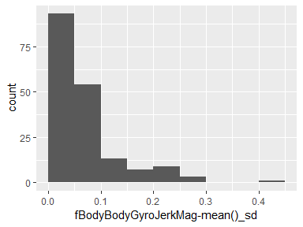

## fBodyBodyGyroJerkMag-std()_sd

|  |  |
| --- | --- |
| Feature | Result |
| Variable type | numeric |
| Number of missing obs. | 0 (0 %) |
| Number of unique values | 180 |
| Median | 0.05 |
| 1st and 3rd quartiles | 0.03; 0.09 |
| Min. and max. | 0; 0.43 |

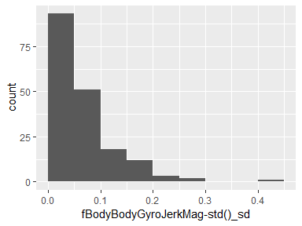

Report generation information:

* Created by Doug McClung  
  McClung, Doug (username: doug.mcclung).
* Report creation time: Mon Dec 03 2018 14:18:10
* Report was run from directory: c:/Users/doug.mcclung/Documents/UCI HAR Dataset
* dataMaid v1.2.0 [Pkg: 2018-10-03 from CRAN (R 3.5.1)]
* R version 3.5.1 (2018-07-02).
* Platform: x86_64-w64-mingw32/x64 (64-bit)(Windows >= 8 x64 (build 9200)).
* Function call: makeDataReport(data = summarizedData, mode = c("summarize", "visualize", "check"), smartNum = FALSE, file = "codebook_summarizedData.Rmd", replace = TRUE, checks = list(character = "showAllFactorLevels", factor = "showAllFactorLevels", labelled = "showAllFactorLevels", haven_labelled = "showAllFactorLevels", numeric = NULL, integer = NULL, logical = NULL, Date = NULL), listChecks = FALSE, maxProbVals = Inf, codebook = TRUE, reportTitle = "Codebook for summarizedData")