
When the user enters the site, this screen will be displayed, but the user cannot access any function until he is logged in. Once he logs in successfully al functions will be available (see next screen) In this phase any entered text for user ID will be sufficient.

Screen 2

Now all the functions are operational. On the left and picture supplied by Microsys will show, simulating future dynamic insertion of Ads.
The user will now select one tab which relates to a discipline. Then he will have the following options:
1 Type a question in the box and press the Get an Answer button
2. Press the Go To the Q&A page without entering a question
Either selection will open the next screen (see Screen 3)

Note: there should also be a button to log out. In that case the first screen will appear.
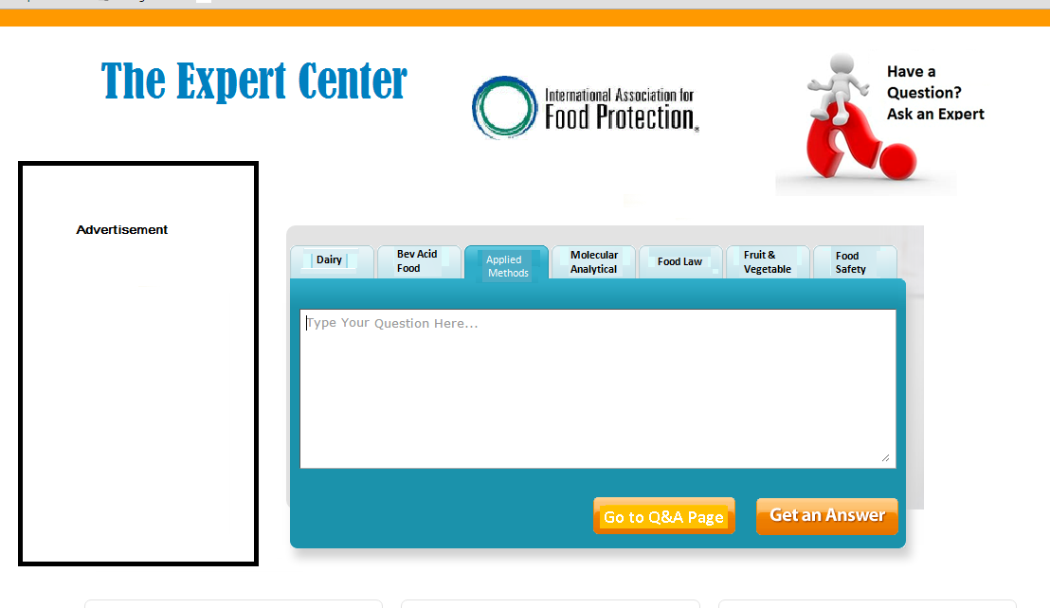

Screen 3
Once the user chose a discipline tab and chose one of the options this Q&A screen will show. Note that for each tab there will be a different screen showing different questions. If the user chose to enter a question, his question will appear on first in the list. This list may be large and a scroll button will enable to see all the questions.
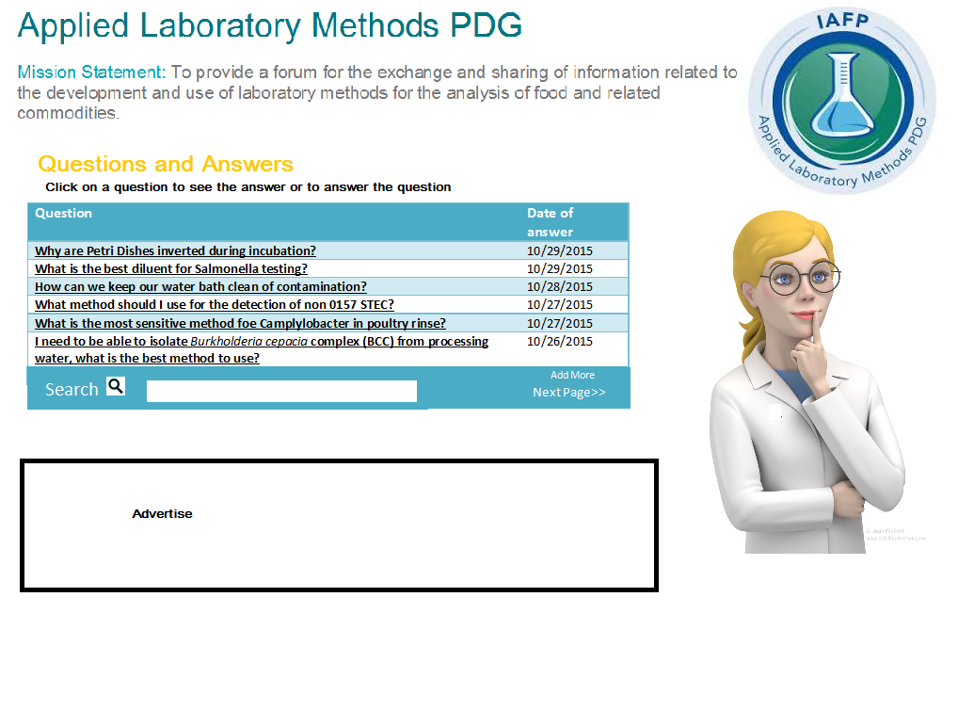
Once the user clicks on a specific question the next screen (see screen 4 below) will show.
Note: There should be also a button to go back to the second screen in order to choose another discipline or to log out.

Screen 4
Once the user clicks on a question the history is displayed. The user can scroll down to view all previous answers of replies. He can also post his reply filling the box and pressing Post Your Answer. Once pressed his response will appear first in the list. He can also go back to the questions page by pressing the See More Questions button

