0.395 
O. 385 
0.375 
0.365 
0.355 
0.345 
o 
IOk 20k 30k 40k 50k 60k 70k 80k gok 

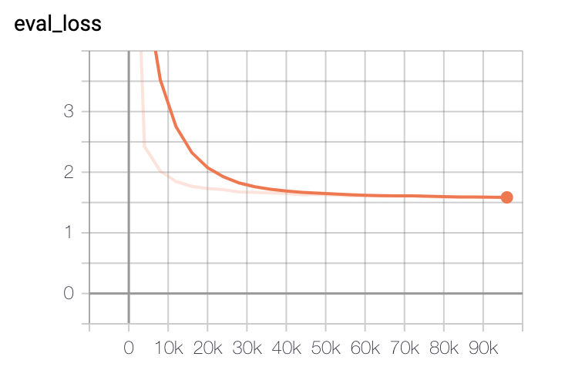

爿 00 L 相 日 
当 爿 0 レ : ℃ こ 
e 」 一 旧 」 e 

Please submit the nohup.out file along with screenshots of your Tensorboard indicating training progress (Blue score, eval loss) over time. Also, answer the following (simple) questions:

* How long does it take to complete the training run? (hint: this session is on distributed training, so it *will* take a while)

Answer: it took 48 hours to reach 100k steps

* Do you think your model is fully trained? How can you tell?

Answer: it is not, both the training loss and evaluation loss are still going down

* Were you overfitting?

Answer: not yet, the evaluation loss is not yet going up.

* Were your GPUs fully utilized?

NVIDIA-SMI 
418.67 
Perf 
PID 
Driver Version 
I GPI] 
Fan 
N/A 
1 
I N/A 
Name 
T emp 
Tesla 
z,ec 
Tesla 
z,ec 
Persistence—MI 
Pwr:lJsage/Capl 
Bus-Id 
: 418.67 
Disp.A 
Memory—usage 
CUDA Version: 10.1 
I Volatile Uncorr. ECC I 
I GPIJ—lJti1 Compute M. I 
Vieø-PCIE. 
124W 
Vieø-PCIE. .. 
131W 
Type 
Off 
25ew I 
Off 
25ew I 
Process 
python 
python 
Off I 
15422MiB / 
1613eMiB I 
Off I 
15424MiB / 
1613eMiB I 
name 
lee% 
Processes: 
GPU 
e 
1 
71298 
71299 
c 
c 
Default I 
Default I 
GPO Memory 
Usage 
154Ø9MiB I 
154Ø9MiB I 

This is one the utilization results for VM1, it is fully utilized

* Did you monitor network traffic (hint: apt install nmon ) ? Was network the bottleneck?

Answer: It does not seem like it, the 1G bandwidth is not fully utilized

nmon—14g 
Network 
1/F Name 
10 
e.e 
e.e 
e.e 
e.e 
ethl 
7.5 
1.1 
dockere 
e.e 
e.a 
e.e 
e.e 
e.a 
e.e 
ethe 
88.1 
76.3 
98.3 
[H for 
1/0 
Recv=KB/s Trans=KB/s packin packout 
Refresh= 2secs 
insize 
—22 : 34.11 
Trans 
98 
6 
outsize 
186.4 
184.2 
1181.5 
1181.5 
e.a 
12.4 
e.a 
3881614 . 5 
e.e 
92.3 
3675695.8 
.8 
8 

* Take a look at the plot of the learning rate and then check the config file. Can you explain this setting?

Answer: It takes a 8000 step ramp to grow from learning rate=0 to a high value, and then gradually reduce the learning rate to the target value. This setting allows the algorithm to test a range of gradually changing learning rate, but start from zero to avoid overshoot.

* How big was your training set (mb)? How many training lines did it contain?

Answer: the training data has train.en and train.de; train.de has 4562102 lines and the size is 678 MB; train.en has the same lines (obviously), and the size is 607 MB

* What are the files that a TF checkpoint is comprised of?

Answer: each checkpoint is comprised of:

* A .meta file
* A .index file
* A .data file
* How big is your resulting model checkpoint (mb)?

Answer: The size of the resulting model checkpoint is 827 MB

* Remember the definition of a "step". How long did an average step take?

Answer: It takes about 1.7 seconds for each step

* How does that correlate with the observed network utilization between nodes?

Answer: the network utilization is negatively correlated with the time for each step. With longer time spent on communication between the nodes, more time is needed for each step.