Optimizing Decay and Rehearsal in a
Computational Model of the Phonological Loop
Group Member: Yuze Song, Dao Zhou, Wen-Shuo Chao
Summer, 2025

- Background Information
Research on working memory has produced numerous theoretical models, among which Baddeley’s framework (e.g., 1986; Baddeley & Hitch, 1974) has been particularly influential. This model proposes several interacting components, most notably a visuospatial sketchpad for handling visual information and a phonological loop for maintaining verbal information, alongside a central executive and, more recently, an episodic buffer.

The phonological loop is based on two core ideas: verbal information in memory fades quickly over time, and this loss cannot be halted, but the contents can be refreshed through either overt or silent articulatory rehearsal. These mechanisms explain key empirical findings. For instance, the word length effect (WLE) shows that long words (e.g., fire engine, helicopter) are recalled less accurately than short words (e.g., egg, car) because fewer long words can be rehearsed before they decay beyond retrieval.

Hulme and Tordoff (1989) were interested in the development of the phonological loop in children, focusing here on 7- and 10-year-olds. Each child heard lists of five words, presented one per second, and immediately recalled them in order, saying “blank” for omissions. Lists differed in pronunciation duration — short (egg, pig, bus, car, fish), medium (rocket, monkey, tiger, apple, Indian), or long (elephant, umbrella, helicopter, banana, kangaroo) — corresponding to high, medium, and low speech rates. Speech rates were measured after recall by timing 10 spoken repetitions of word triplets for each duration, then averaging and converting to rates.

The general modeling logic is as follows (Fig.1): each word’s activation is initially set to 1 and decays continuously over time. When a word is selected for rehearsal based on its speech rate and its activation meets or exceeds the rehearsal threshold, its activation is reset to 1, indicating a successful rehearsal. If the activation falls below the threshold, the word is skipped and the process advances to the next word, following the rehearsal order specified in the model.

In the present work, we’d like to optimize the oversimplified WLE computational model described in Computational Modeling in Cognition: Principles and Practice (adapted from Hulme & Tordoff, 1989), which captures the essential decay and rehearsal processes while omitting some aspects of cognitive detail. The original model uses a linear decay function, assumes uniform encoding strength across list positions, does not include associative retrieval, and employs a head-to-tail rehearsal order.
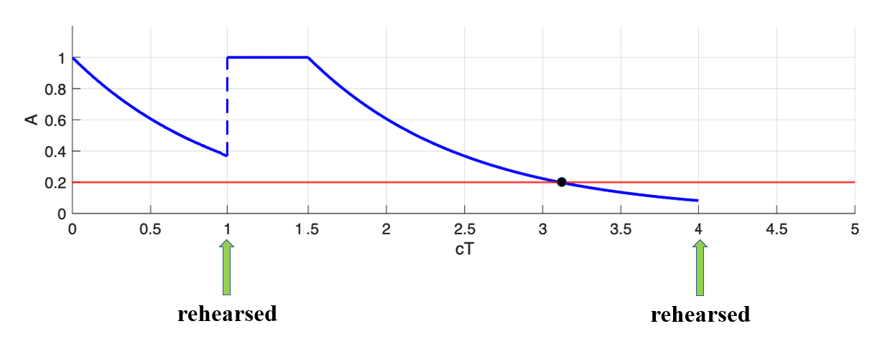
Fig.1 An example of the process of a word “egg”
The blue plot represents the fluctuating activation of “egg,” while the red plot indicates the rehearsal threshold. The initial activation is set to 1. Assuming “egg” is rehearsed at 1 s, its activation will return to 1 because it is still above the threshold. However, at 4 s, it can no longer be successfully rehearsed, as its activation has fallen below the threshold.

- Methods
For decay, we replace the original linear function with an exponential decay function. Sufficient evidence exists showing that the decay function is exponential rather than linear, no matter in simplified models like the primacy model (Page & Norris, 1998; Lewandowsky & Stephan, 2011), but also collective cognitive model like ACT-R (Anderson & Lebiere, 1998). Unlike linear decay, exponential decay remains strictly positive and may more accurately capture the natural decline of memory strength over time. The ideal function that we applied in the experiment is as followed,
$$\text{A(t) = }{\text{A}}_{\text{0}}\text{ × }{\text{e}}^{\text{-d ∙ t}}$$

where A₀ represents initial activation value (1 in this experiment), d represents decay rate, and t represents time elapsed since the last rehearsal. If A(t) is smaller than the threshold, the word cannot be rehearsed again and forever until the next trial.

For rehearsal, we introduce several enhancements. First, we examine the effect of item ordering during rehearsal by comparing random-order rehearsal with the standard forward serial rehearsal. We also take into account differences in encoding strength across list positions, assuming that earlier items are typically encoded more strongly than later ones. Additionally, we propose a novel mechanism incorporating semantic associations: when a word is rehearsed, semantically related words receive a boost in activation. For instance, rehearsing “bus” may increase the activation of “car” but not “egg.” Word embeddings from GloVe (Mannings, 2014), are used to quantify semantic similarity between all pairs of items in the list.

To automatically define and evaluate the model parameters, we employed a systematic search strategy over four core variables: DecRate, corresponding to the slope in the linear decay function y = −bx + a or the rate in the exponential function y = e^{−ax}; MinAct, the threshold below which items can no longer be rehearsed; ActDec, capturing the decline in encoding strength across list positions; and AssocStrength, representing activation of semantically related items during rehearsal. DecRate spans 0 – 1 for linear decay and 0.2 – 0.8 for non-linear decay, with MinAct fixed at 0 for linear decay and following the same 0.2 – 0.8 range for non-linear decay. When actDiff is on, ActDec ranges from 0.01 to 0.19, otherwise it is 0; similarly, AssocStrength ranges from 0.01 to 0.19 if assocRetrieval is on, and 0 otherwise.

The goal of evaluating a “good” model is to maximize the alignment between the model’s predictions and the raw data. Root mean squared deviation (RMSD) is a popular and simple discrepancy function expresses the deviation between the two sets of numbers (Lewandowsky & Stephan, 2011).
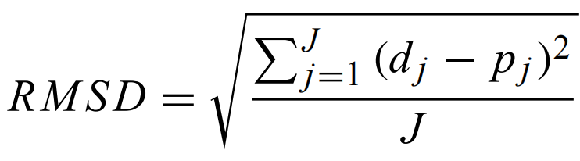

where J is the number of data points (6 in the experiments), and d and p represent data and predictions, respectively. In other words, smaller RMSD means smaller deviation between data and model predictions, representing better model estimation.

- Results
  - A replication of the original model
Firstly, we replicated Lewandowsky & Stephan’s model. However, after correcting an explicit mistake they made, it came out that the model is not as good as believed in the book. The minimum RMSD is above 0.1, and an example of modeling can be seen in Fig.2.

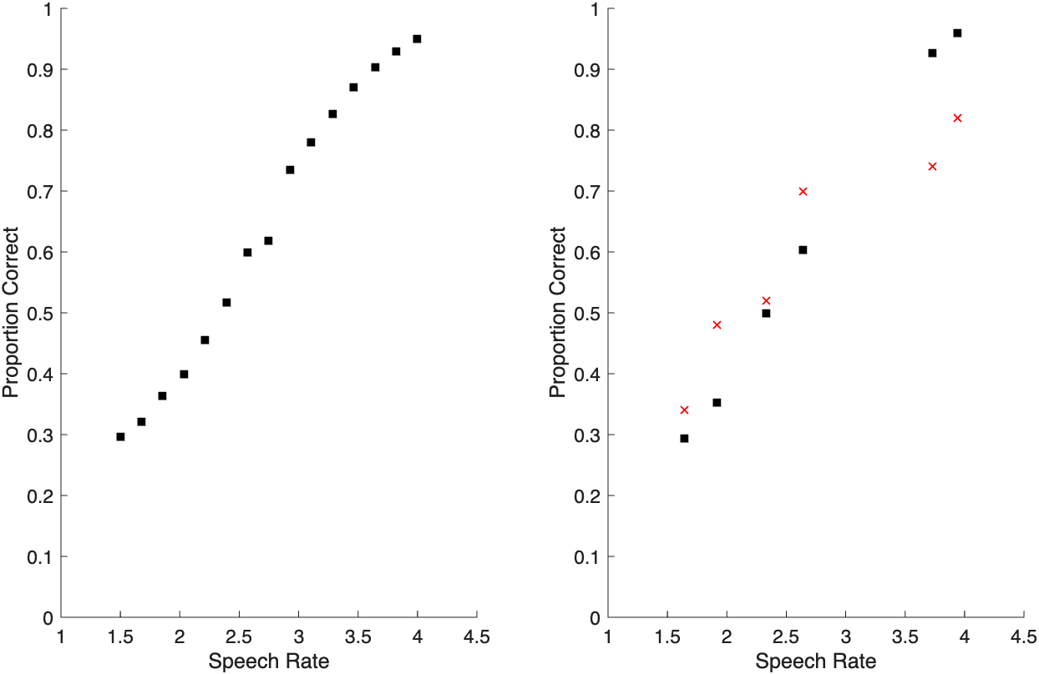
Fig.2 Replication of Lewandowsky & Stephan’s simplified phonological loop model
The left plot shows the model fit with the smallest RMSD across all speech rate conditions, with each point representing a speech rate. The right plot is result of the simulation of the original experimental data using the parameter set from the best-fit model in the left panel, where red crosses indicate empirical results and black dots indicate model predictions.

  - Exponential decay function
In this step, we only replaced the original linear decay function with an exponential decay function to test whether this improved the model fit. To visualize the modeling error, we use a heat map (Fig.3a), where blue regions indicate lower RMSD values compared to red regions. The red point marks the parameter combination that yields the minimum RMSD respectively. Fig.3b shows the results from this parameter combination. However, the minimum RMSD (~0.1) did not decrease significantly.
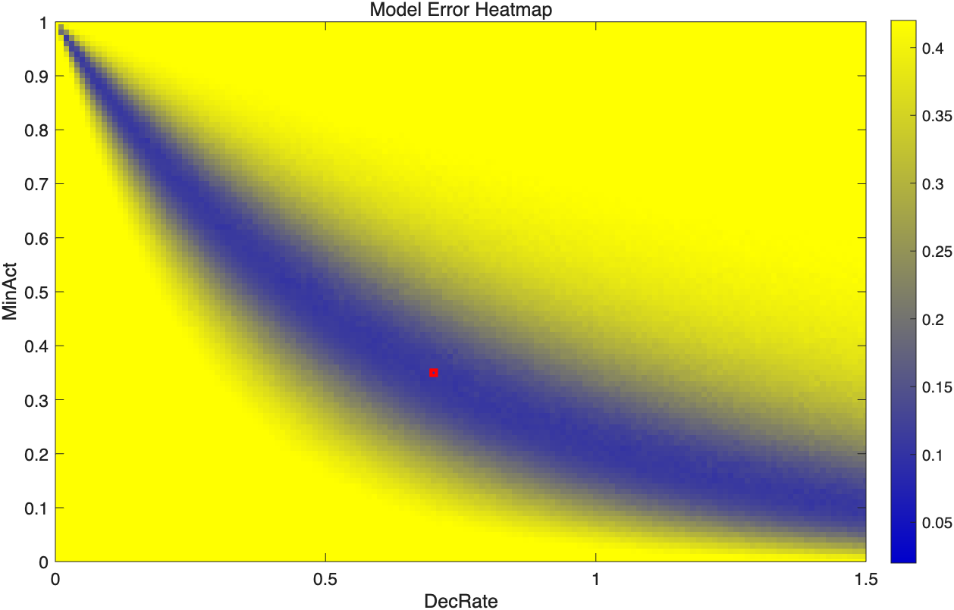 | 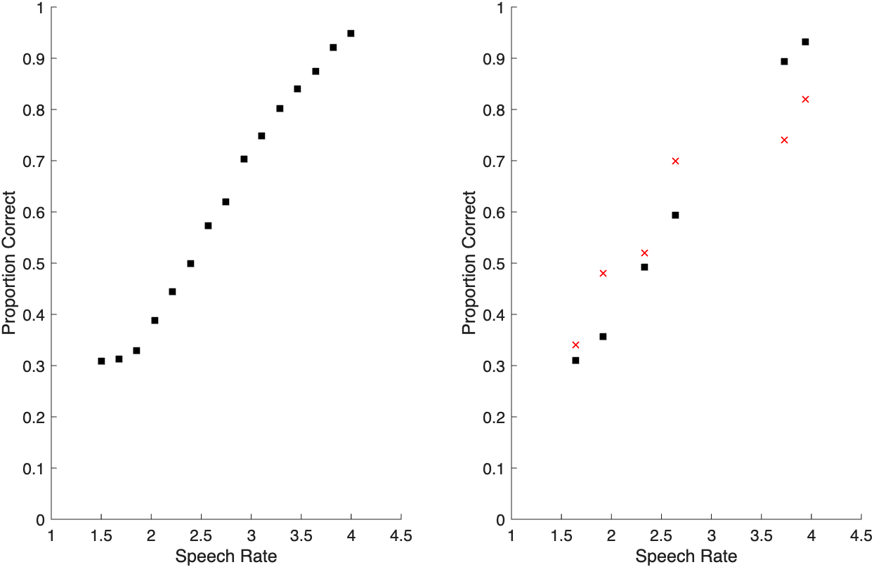
(a) | (b)
Fig.3 Model fit after replacing linear decay with exponential decay
Panel (a) is a heat map of RMSD across decay rate and threshold. Blue areas indicate lower RMSD values. Red point marks the minimum RMSD (~0.1). Panel (b) is model predictions of the minimum RMSD after replacing linear decay with exponential decay, similar to Fig.1.

  - Exponential decay function + differences in encoding strength
Next, we examined the role of encoding strength in the model. Results from the model evaluation indicate that encoding strength serves as an improvement factor, with the minimum RMSD decreasing to around 0.05 (Fig. 4, right). For each level of encoding strength, there is a corresponding set of decay rate and threshold parameters. Figure 5 presents heat maps across multiple encoding strength levels.

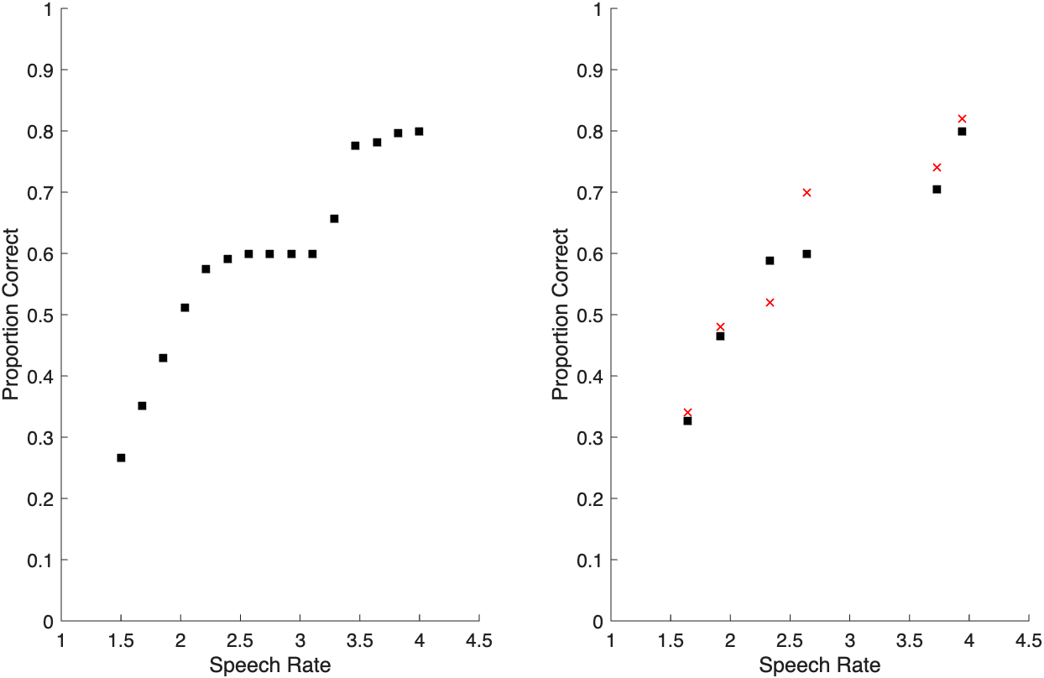
Fig.4 Improvement from incorporating differences in encoding strength
The result of model predictions of the minimum RMSD after adding position-dependent encoding strength, similar to Fig.1. Minimum RMSD decreases to ~0.05.

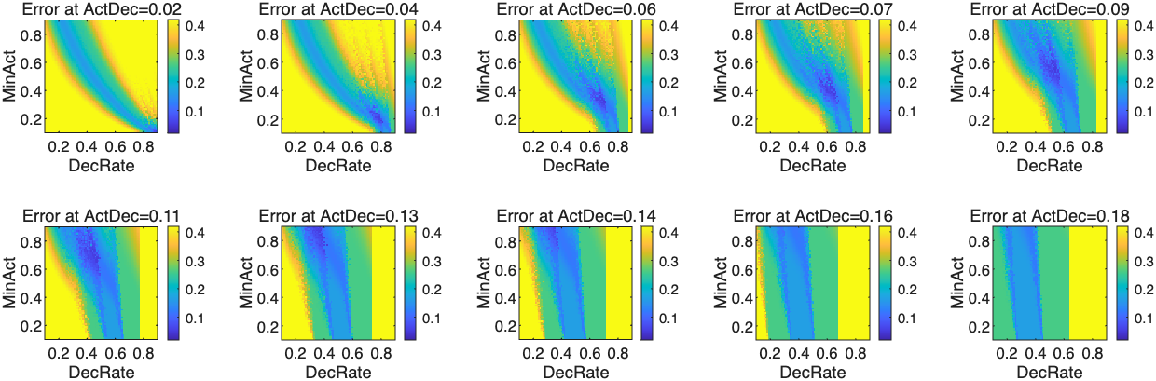
Fig.5 Heat maps of RMSD for models with varying encoding strengths
Each panel shows RMSD across decay rate and threshold under different encoding strengths, with blue indicating better fits.

  - Exponential decay function + differences in encoding strength + associative retrieval
We then incorporated associative retrieval into the model. However, the minimum RMSD (~0.05) showed no notable improvement compared to the previous version. The following parameter combinations emerged as feasible candidates for the best-fit final model: (DecRate = 0.46, MinAct = 0.60, ActDec = 0.08, AssocStrength = 0.12) and (DecRate = 0.54, MinAct = 0.54, ActDec = 0.09, AssocStrength = 0.03).

  - Random order does not show great results compared to head-to-tail order
In the original model, forward rehearsal involves recalling the next available word in sequence. In contrast, the random-order condition rehearses any other available word—avoiding immediate repetition of the same word whenever possible. The results clearly show that rehearsing in order is the most effective strategy for maximizing recall. When the random-order feature is introduced, all scores above 0.4 drop noticeably. With sufficiently long delays, all results above 0.4 converge to 0.4 for SpeedRate > 2, reflecting the recall of only two words out of five. This is far from the real data the experimenters obtained, so we won’t adopt random order in our final model.

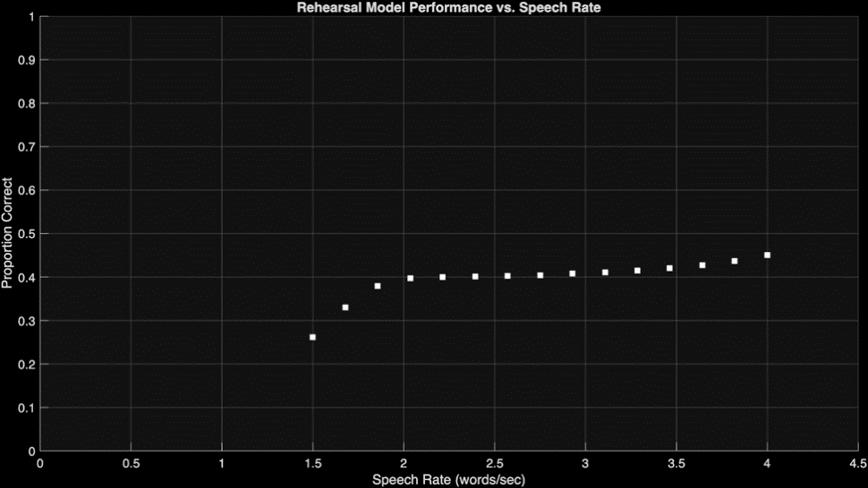
Fig.6 Model fit of random-order rehearsal
Random-order rehearsal consistently yields poorer recall than forward serial rehearsal.

- Conclusions
Our study extended Lewandowsky & Stephan’s simplified computational model of the phonological loop by systematically evaluating modifications to its decay and rehearsal mechanisms. Replacing the original linear decay function with an exponential decay function did not substantially improve model fit, suggesting that decay form alone is insufficient to capture the observed data. Incorporating position-dependent encoding strength yielded a marked reduction in RMSD, indicating that stronger encoding of earlier list items is a critical factor in the model. Adding associative retrieval based on semantic similarity, however, did not produce further improvements, implying that semantic associations may play a limited role under the present task conditions.

Overall, our findings suggest a path toward richer models of working memory that integrate both decay and rehearsal, especially variability in encoding strength across serial positions. The precise mechanisms through which encoding strength influences model behavior remain to be fully understood, and future work could integrate computational modeling with neuroimaging techniques to identify the neural correlates of these effects.

- Code availability
Matlab and Python are used in coding. The project is publicly available on Github. Feel free to explore if you’re interested in getting a closer look!
https://github.com/taochou-cogsci/CogSci-Final-Project-A-Computational-Model-of-the-Phonological-Loop

- References
Baddeley, A. D. (1986). Working memory. The psychology of learning and motivation: Advances in research and theory/Academic Press.

Hulme, C., & Tordoff, V. (1989). Working memory development: The effects of speech rate, word length, and acoustic similarity on serial recall. Journal of Experimental Child Psychology, 47(1), 72-87.

Lewandowsky, Stephan, and Simon Farrell. Computational Modeling in Cognition : Principles and Practice. Sage Publications, 2011.

Page, M., & Norris, D. (1998). The primacy model: a new model of immediate serial recall. Psychological review, 105(4), 761.

Anderson, J. R., Bothell, D., Lebiere, C., & Matessa, M. (1998). An integrated theory of list memory. Journal of Memory and Language, 38(4), 341-380.

Pennington, J., Socher, R., & Manning, C. D. (2014, October). Glove: Global vectors for word representation. In Proceedings of the 2014 conference on empirical methods in natural language processing (EMNLP) (pp. 1532-1543).

