Composing Crosscutting Concerns
using Composition Filters
Lodewijk Bergmans & Mehmet Aksit
TRESE project, Department of Computer Science, University of Twente,
P.O. Box 217, 7500 AE, Enschede, The Netherlands.
email: {bergmans|aksit}@cs.utwente.nl
http://trese.cs.utwente.nl

Introduction
A number of publications have shown that certain design concerns, such as access-control, synchronization, and object interactions cannot be expressed in current object-oriented languages as a separate software module [4, 7]. These so-called crosscutting concerns generally result in scattered implementations over multiple operations. If a crosscutting concern cannot be treated as a single module, its adaptability and reusability are likely to be reduced. A number of programming techniques have been proposed to express crosscutting concerns, for example Adaptive Programming [9], AspectJ [8], Hyperspaces [10], and Composition Filters [1]. This article presents the Composition Filters (CF) model and illustrates how it addresses evolving crosscutting concerns.
The filters in the CF model can express crosscutting concerns by modular and orthogonal enhancements to objects. Here, modularity means that filters have well-defined interfaces and are conceptually independent of the implementation –language– of the object. Orthogonality means that filter specifications do not refer to –the specification of– other filters. These two properties increase adaptability and reusability of concerns because filters can be applied to different languages and can be combined easily. Previous publications on the CF model focused on concerns that crosscut a single object [4]. This article presents a generalization of the CF model for expressing concerns that crosscut multiple objects.
In the following section, an example application is explained, which is used to introduce the CF model. Next, two evolution steps for the application are described, where each step introduces a new crosscutting aspect to the system and an appropriate solution using CFs is shown. Finally, the CF model is evaluated with respect to its effectiveness in coping with this evolution.

An Example: Office Automation for Social Security Services
The objective of the example application is to support the activities of a government-funded agency that is responsible for the implementation of disablement insurance laws. The core activity of the agency can be represented by five tasks, which are shown in Figure 1.
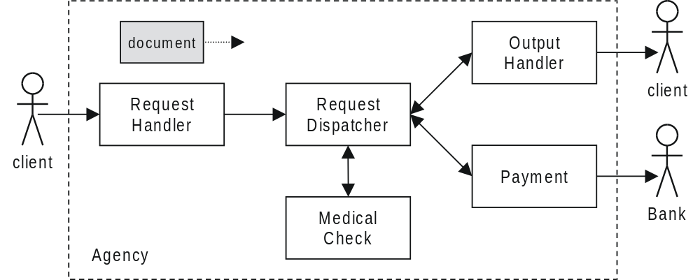
Figure 1. Tasks in the example system.
Task RequestHandler processes incoming requests and initializes a new document. Task RequestDispatcher implements the evaluation and distribution of the requests to the other tasks: MedicalCheck, Payment or OutputHandler. MedicalCheck is responsible for evaluating the client's disablement. Payment is responsible for issuing bank orders. OutputHandler is responsible for the interaction with clients.

Software Design of the Example Application
In this article, we ignore (user) interfacing issues and concentrate on the core application classes, which are shown in Figure 2. One major concern in the application is to model the documents that represent requests and another is to model tasks that process the requests. The operation of the system mainly consists of creating and editing documents, and forwarding the documents to other tasks as defined by office procedures.
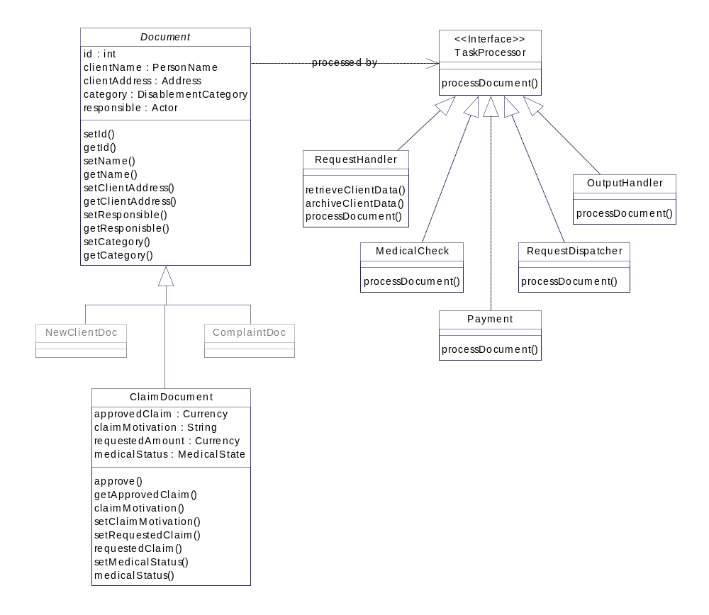
Figure 2. An overview of the core application classes in the example application.
For presentation purposes we reveal only a subset of the attributes and methods in Figure 2. Class Document is the common superclass of all document classes and defines the attributes id, clientName, and clientAddress, which are used for storing information about the client. The attribute category specifies the classification of the client with respect to the disablement laws. The attribute responsible represents the clerk who is responsible for processing the request. Class Document has ten methods, which are used to read and write the attributes. Class ClaimDocument is a specialization of Document and is used to represent the claims of clients. This class declares a number of attributes and methods regarding the motivation and size of a claim, the medical status and the approved claim amount.
All the task classes in the system implement the interface TaskProcessor. Here only the method processDocument is shown, which accepts a document as an argument and opens a dedicated editor for it.

Implementing the System Using Composition Filters
All current object-oriented languages and systems share a similar message-passing model. To specify filters independent of a specific programming language, filters are defined as functions, which manipulate messages that are received and sent by objects. Since an object's observable behavior is determined by messages it receives and sends, filters are capable of expressing a large category of concerns such as inheritance and delegation, synchronization, real-time constraints, and inter-object protocols. Because of the modularity of filter specifications, these concerns can be attached to objects as enhancements.
We will now explain how the CF model can be used to define class ClaimDocument, which was introduced in the previous section.
A CF class aggregates zero or more internal classes and composes their behavior using one or more filters. An internal class may be again a CF class or it may be a class expressed in any object-oriented language, for example Java. In Figure 3, the yellow rectangle with the UML stereotype “<<CF class>>”, represents a CF implementation of class ClaimDocument. We will refer to this class as CF-ClaimDocument. Class CF-ClaimDocument aggregates two other classes. Here, CF-Document –shown as an orange rectangle– is a CF representation of class Document. The implementation part, represented by class ClaimDocument –shown as a white rectangle–, defines an implementation of the (non-crosscutting) concerns of class ClaimDocument, for instance in a language such as Java or C++.
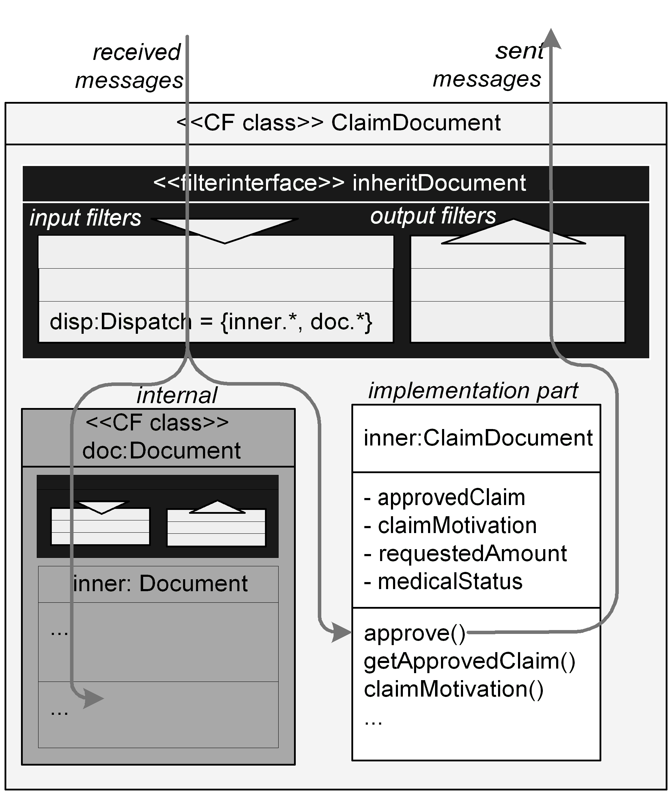
Figure 3. A UML-based representation of a CF instance of class ClaimDocument.
The blue boxes with arrows pointing in and out correspond to so-called input filters and output filters, respectively. Each message that is received must first be processed –one by one– by all filters in the input filter set. Eventually, the received message may be dispatched to one of the methods of the aggregated objects. During the execution of a method, all messages that are sent to other objects must first pass the output filters.
Here, class CF-ClaimDocument has only one filter named disp, which is an instance of the filter type named Dispatch. This example of a dispatch filter effectively implements inheritance from class Document. The dispatch filter is initialized with the filter expression between curly brackets. In this example, the filter expression “{inner.*, doc.*}” consists of two filter elements, separated by the comma. Whenever a message arrives at the filter, an attempt is made to match the message with each of the elements, from left to right. The matching process primarily involves the target and the selector of the message. If the matching process succeeds, the message is said to be 'accepted' by the filter, if not, the message is said to be 'rejected'. The type of the filter determines the semantics of acceptance or rejection.
The first filter element of the dispatch filter in the example consists of a target defined as "inner", and the wildcard "*" as the selector. The pseudovariable inner refers to the implementation part of the object. The wildcard "*" will match if the selector of the message is in the signature of the target (i.e. inner). The second filter element is similar, but with doc as the target. This filter element will cause the selector of a message to match all the method names that are in the signature of class CF-Document. In case of rejection by a dispatch filter, the message will proceed to the next filter. If there is no subsequent filter available in the filterset an exception will be raised. In case of acceptance, the dispatch filter causes the message to be dispatched to the object that corresponds to the target of the (first) matching element.
In Figure 3, two possible message flows are shown. One message is dispatched to the internal object doc of class CF-Document, and the other is dispatched to the implementation object. Since CF-Document is a CF class, the messages dispatched to doc have to pass the input filters defined by CF-Document as well. The Dispatch filter type can also be used to express multiple inheritance, dynamic inheritance, delegation, or a combination thereof, through appropriate filter expressions. Every filter is declared and initialized using the same syntax.
A number of filter types have been introduced to express certain crosscutting behavior. Some commonly used filter types are shown in Table 1.
(156)
Filter Type | Accept Action | Reject Action | Publications
Dispatch | dispatch message to the target of the message | Continue to the next filter in the set | [1, 6]
Error | continue to the next filter in the set | An exception is raised | [1, 6]
Wait | continue to the next filter in the set | The message is queued as long as the evaluation of the filter expression results in a rejection | [5]
Meta | The reified message is sent as a parameter of another –meta– message to a named object. The object that receives the meta message can observe and manipulate the message, then re-activate its execution | continue to the next filter in the set | [2]
RealTime | Adjust RT properties of the message (thread) | continue to the next filter in the set | [3, 4]

Evolution Step 1: Protecting Documents
In the initial system, the methods of the document classes are available for all task objects. This means that for example a clerk who is responsible for registering requests would be able to modify medical or financial information. To avoid this, methods should be extended with a code that verifies the identity of the caller. This type of selective behavior is referred to as multiple views [1]. To implement the views, we introduce a subclass of ClaimDocument called ProtClaimDocument.
Figure 4 represents class CF-ProtClaimDocument and its components. The class consists of one filterinterface named protectDocument, one internal object named cdoc, an instance of class ClaimDocument that has been described before, and an implementation, or inner part represented as class ProtClaimDocument. The filterinterface defines two inputfilters, called docProt and disp.
In the CF model, the message manipulation process can be affected at run-time through side-effect free Boolean expressions called conditions. In this example, class ProtClaimDocument declares two conditions called FinancialResp and MedicalResp, which evaluate to true if the responsibility of the sender of a message is financial or medical, respectively. These conditions are used within the filters, but defined in the implementation part.
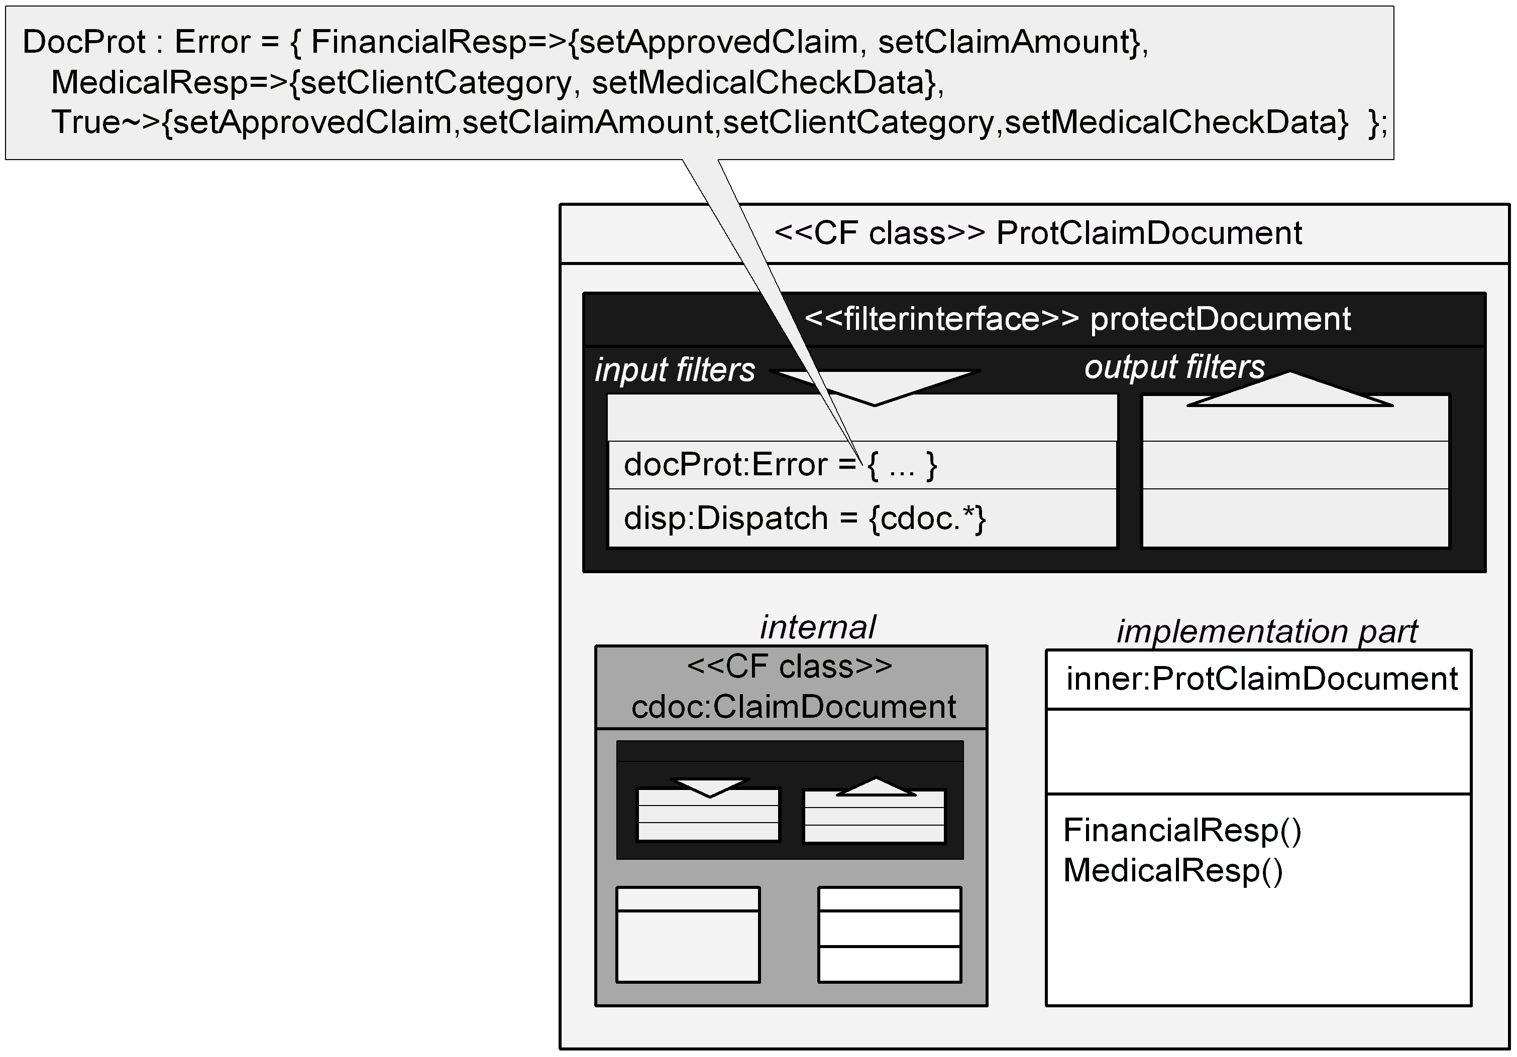
Figure 4. A UML-based visualization of CF class ProtClaimDocument with 2 input filters
In Figure 4, class CF-ProtClaimDocument illustrates how an Error filter can be used to enforce the required multiple views on the documents. As shown in the blue rectangle, this class declares two filters: docProt of type Error and disp of type Dispatch. The Error filter specification is shown in the gray call-out box. The first line of this specification states that the messages setApprovedClaim() and setClaimAmount() match the filter expression if the condition FinancialResp evaluates to true. If FinancialResp is false or the received message is not setApprovedClaim() or setClaimAmount, the second line of the filter expression is evaluated. If the condition MedicalResp evaluates to true, and the received message is setClientCategory() or setMedicalCheckData(), the message is accepted, otherwise the last element of the filter expression is evaluated. Here, the condition is True, followed by the exclusion operator, which is denoted by the characters "~>". This operator specifies that if the condition is true, all messages match, except the ones that are specified on the right hand side of the operator.

concern: error check  methods | FinancialResp | MedicalResp | any (true)
setApprovedClaim | 
setClaimAmount | 
setClientCategory |  | 
setMedicalCheckData |  | 
other (*) |  |  | 

Table 2 depicts the relation between the crosscutting concerns and methods. Here the rows show a selected set of methods of class ProtClaimDocument and the columns represent the crosscutting concerns. In a conventional object-oriented language such as Java, these concerns have to be repeatedly implemented in the corresponding methods. In the CF implementation, these concerns are expressed in filters separate from the methods of the document class.

Evolution Step 2: Document Queues
In the example office system, tasks are executed in parallel. When documents are forwarded, it may not be possible to start processing the next task immediately. To avoid blocking the execution of the preceding task, a document queue is to be defined for each task processor. In addition, the task processors must provide mutual exclusion; while an object is busy executing a task, every incoming message is queued until the object has finished the execution of the previous task. We will assume that the synchronization code that implements mutual exclusion can use an operation, say noActiveThreads(), which returns true if there is no active thread in the context of operation. This synchronization code must apply to every task processor class, and it is repeated within the implementation of several methods of the same task processor class: a typical example of a crosscutting behavior.
The CF model can express various synchronization mechanisms in a modular manner. To avoid that the synchronization code is replicated in all task classes, the CF model provides the so-called superimposition mechanism to impose filterinterfaces onto one or more objects. Figure 5 illustrates the superimposition mechanism for concurrent processing of tasks.
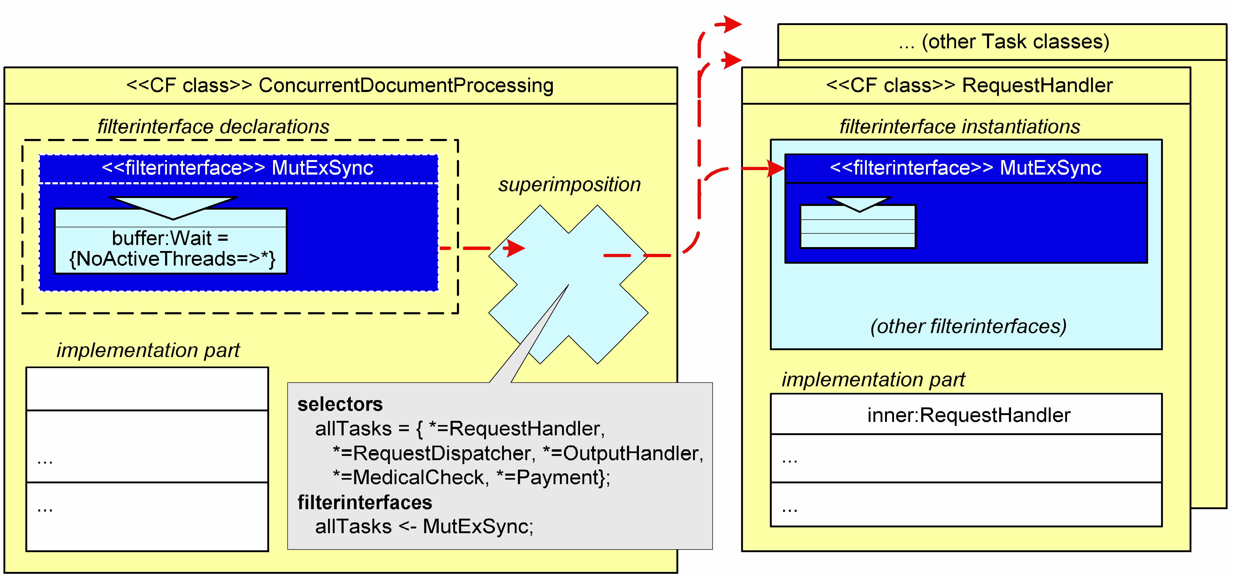
Figure 5. An example of a CF object with superimposition.
In the figure, the yellow rectangle on the left represents a CF implementation of class ConcurrentDocumentProcessing, which is used to model the crosscutting queuing concern. The yellow boxes on the right symbolize all the task processor classes that are to be extended with a document queue.
The blue rectangle in ConcurrentDocumentProcessing represents the filterinterface MutExSync of this class. The callout in the upper-left corner shows the filter expression in more detail. MutExSync declares a single inputfilter named buffer of type Wait. For this filter type the expression "{NoActiveThreads=>*}" means that if the condition NoActiveThreads is true, all messages can pass this filter. Otherwise, incoming messages will be blocked, until the condition becomes true, i.e. no more threads are active in the corresponding object.
The white rectangle in ConcurrentDocumentProcessing represents the implementation of the condition NoActiveThreads. The blue cross in ConcurrentDocumentProcessing symbolizes the superimposition specification, which denotes a set of objects where the filter MutExSync is inserted. Incoming and outgoing messages of the designated objects have to pass through this filter interface. The dashed, red lines indicate the process of superimposition. Note that the inserted filter MutExSync is shown on the right as the input filter of the task classes.
The definition of the superimposition that maps this filterinterface to the task classes is shown in the bottom center callout of Figure 4. In this definition, first a selector named allTasks is declared, which is an expression (query) for selecting a set of concern instances. In this particular case, the expression specifies that all the instances of classes RequestHandler, RequestDispatcher, and so on are selected. The superimposition specification continues by specifying how filterinterfaces are superimposed: e.g. "allTasks<-mutExSync" in the 'interface' clause means that the filterinterface MutExSync is to be superimposed upon all instances that are defined by selector allTasks of the same class. The result of this specification is thus that all the task instances are enhanced by superimposing the implementation of condition NoActiveThreads, and the filterinterface MutExSync.

Conclusion
We conclude with a discussion of the important characteristics of the CF model and evaluate these with respect to the example and some of the related work.
Declarative: concerns are specified declaratively using a simple message manipulation language. This specification allows for various implementation strategies. For example, ComposeJ is a compiler, which in-lines filter code within the appropriate methods. The Sina language compiler implements filters as meta objects. Approaches such as Adaptive Programming [9] and AspectJ [8] typically adopt a dedicated declarative specification to express the crosscut and a general-purpose language to express concerns.
High-level semantics: filter types encapsulate the 'accept' and 'reject' semantics of filters. The semantics of filter types are well defined and highly expressive within the domain of the concern [Error: Reference source not found, 4]. As shown in the example application, Error, Dispatch, Meta, and Wait filters could effectively express multiple views, inheritance, message reflection, and synchronization, respectively. Most related work adopts general-purpose programming languages for specifying concerns, in which case little or no reasoning about the semantics of the –composed– concerns is possible.
Open ended: The CF model is open-ended in at least three ways:
- New filter types can be introduced; for example, in [3] we introduced the filter type RealTime, which can be used to express timing constraints on message executions
- Filter expressions may contain wildcards to designate an open-ended set of messages. For example, to implement mutual exclusion for all messages, the filter expression "{NoActiveThreads=>*}" was used.
- Various kinds of composition operators have been defined and new operators can be added. For example, in Figure 4, to compose different views at the interface of the protected claim documents, the Conditional-OR operator ‘,’ and the exclusion operator ‘~>’ are used. To compose the error and dispatch filters, the Conditional-AND operator ‘;’ is used. Similar to the CF model, HyperJ [10] also supports an open-ended set of composition operators.
Strong encapsulation: in the CF model, superimposition of filter-interfaces, objects, methods, and conditions is restricted to the interface level. Therefore superimposed concerns do not rely on the details of the implementation, as such even the implementation language is encapsulated.
Modular: The CF model unifies object-oriented programming with aspect-oriented programming. Adding document queues to task objects, is an example of this modular extension. In Figure 2, task classes are specified independent of the queuing concern using a conventional object-oriented notation. The queuing concern is specified using a filter. The superimposition specification is used to integrate the queuing concern with the tasks.
Composable: All filters are specified using the same message manipulation language. Filters can be composed as desired through the application of several composition operators. For example, filters can be declared sequentially so that concerns can be enforced on messages in a particular order. In Figure 5, for instance, first mutual exclusion and then the message dispatching concerns are enforced; the messages are only accepted for execution if the corresponding object is idle. In Figure 4, various alternative views are enforced on the claim documents. Each filter has specific, well-defined semantics, determined by the filter type. This supports reasoning about the –feasibility of– compositions of filters. The dispatch filter also illustrates composition of the signatures of objects.
In this paper, we have presented the Composition Filters Model, a modular and orthogonal extension to the object-oriented model that supports both intra-class and inter-class crosscutting. Important characteristics of this model are: declarative, high-level semantics, open-ended, strong encapsulation, modular and composable. Within the limited space of this paper, lots of detail has been omitted, for more information, including worked out versions of the examples in this paper with the full code, we refer to [11].

References
- M. Aksit, L. Bergmans & S. Vural. An Object-Oriented Language-Database Integration Model: The Composition-Filters Approach, Proceedings of ECOOP '92, LNCS 615, Springer-Verlag, 1992, pp. 372-395
- M. Aksit, K. Wakita, J. Bosch, L. Bergmans & A. Yonezawa. Abstracting Object-Interactions Using Composition-Filters, In Object-based Distributed Processing, R. Guerraoui, O. Nierstrasz & M. Riveill (eds), LNCS 791, Springer-Verlag, 1993, pp 152-184
- M. Aksit, J. Bosch, W. v.d. Sterren & L. Bergmans. Real-Time Specification Inheritance Anomalies and Real-Time Filters, Proceedings of ECOOP '94, LNCS 821, Springer Verlag, July 1994, pp. 386-407
- M. Aksit and L. Bergmans, Guidelines for Identifying Obstacles when Composing Distributed Systems from Components, to be published in Software Architectures and Component Technology: The State of the Art in Research and Practice, M. Aksit (Ed.), Kluwer Academic Publishers, 2001
- L. Bergmans & M. Aksit, Composing Synchronization and Real-Time Constraints, Journal of Parallel and Distributed Programming, September 1996
- L. Bergmans & M. Aksit, Constructing Reusable Components with Multiple Concerns Using Composition Filters, to be published in Software Architectures and Component Technology: The State of the Art in Research and Practice, M. Aksit (Ed.), Kluwer Academic Publishers, 2001
- G. Kiczales, J. Lamping, A. Mendhekar, C. Maeda, C. Lopes, J.-M. Loingtier, J. Irwin, Aspect-Oriented Programming. In proceedings of ECOOP '97, Springer-Verlag LNCS 1241. June 1997.
- G. Kiczales, E. Hilsdale, J. Hugunin, M. Kersten, J. Palm & W. Griswold, An Overview of AspectJ, whitepaper at http://aspectj.org, 2001
- M. Mezini & K. Lieberherr, Adaptive Plug-and-Play Components for Evolutionary Software Development, OOPSLA '98, October 1998
- H. Ossher & P. Tarr, Multi-Dimensional Separation Ofconcerns And The Hyperspace Approach, to be published in Software Architectures and Component Technology: The State of the Art in Research and Practice, M. Aksit (Ed.), Kluwer Academic Publishers, 2001
- TRESE website, http://trese.cs.utwente.nl/composition_filters

i.e. the set of messages that an object supports on its interface.
The filter interfaces are arranged sequentially in the order of instantiation.

