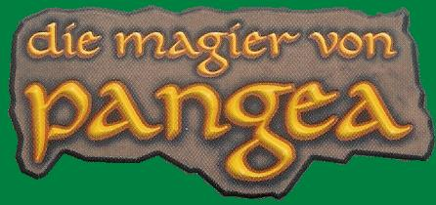

Game Components
- 1 Game Board – contains 26 square water fields of which 15 of them are numbered from 1-15. The land tiles are placed on this board.
- 5 Player Tablets – 1 Tablet for each player. The remaining 5th material is for the neutral mage.
Example: “2 x forest” means that player has 2 minions which are at home in the forest.
On the tablet is noted how many of each type of minion there is for that player. | 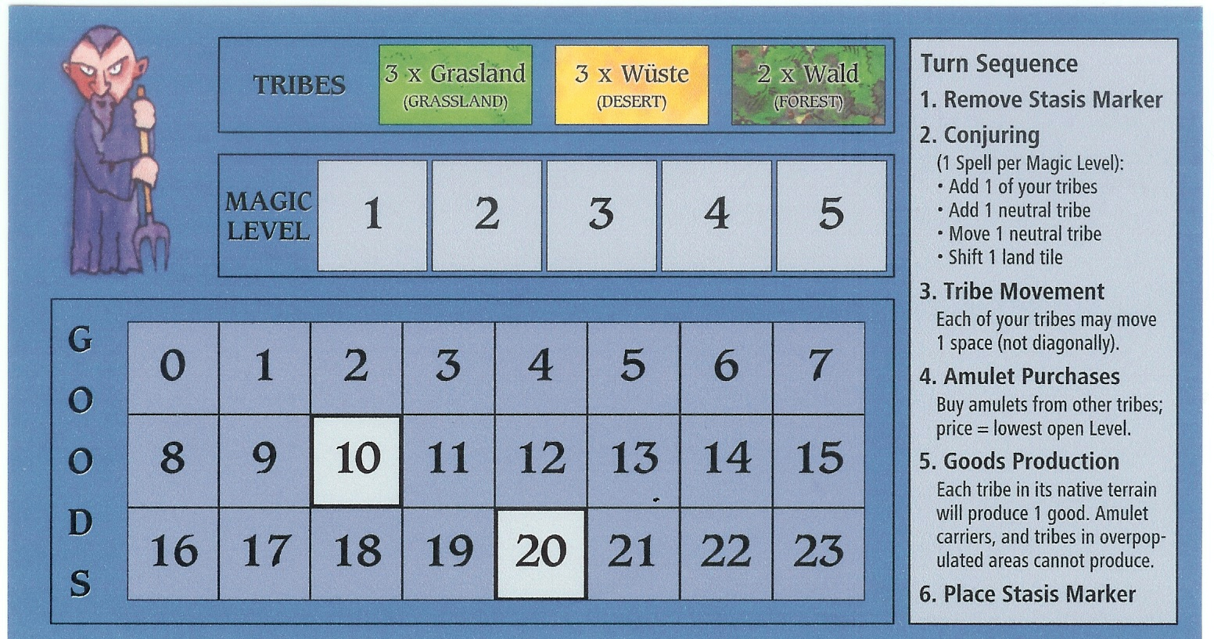
The middle table indicates what level magic the player is currently at.
The lower table is used to keep track of the number of goods a player has.
On the right of the tablet is a turn summary chart.
Author: Ralf Burkert © Copyright 2001
Artist: Elena Obermüller Queen Games
Realisation: Bernd Dietrich D-53842 Troisdorf, Germany
English translation by Scott Alden
Redone layout by Adam Tall
-1-
- 40 Master Markers
There are 5 players in the game, 1set of 8 markers is
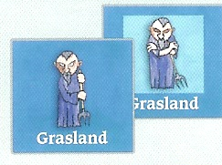
A minion marker showing the front and the back. It belongs to the blue player and its home is the grass tile.
used for each player. Each minion is characterised by
colour and picture which states to whom it belongs.
The type of land tile in which the minion is “at home”
is also specified on the tile. The front side is full colour,
while the back side has a lighter coloured frame.

As soon as a minion is in its own land tile, it
is turned to the front side (showing that it has
the capability to manufacture goods).

When the marker is in a different land
tile than what is specified on it, the
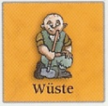
The minion is in the desert and will manufacture, so it is flipped to its front side.
minion should be flipped to its back
side.
  - If the minion is on its full
colour side (front side), then it
will manufacture goods.
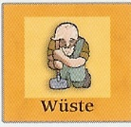
On all other tiles this minion will not manufacture, so it is flipped to its back side.
  - If the minion is on its side
with the frame (back side), then
it will not manufacture goods.

- 5 Magic Towers
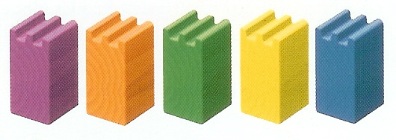
The magic tower signifies the place
Where a mage keeps their goods and
Magic amulets. The tower is also the
“place of birth” for all the minions of
this player. Whenever a player or neutral
mage brings in a new minion it is placed
on the tile where the tower is located.
- 15 Land Tiles
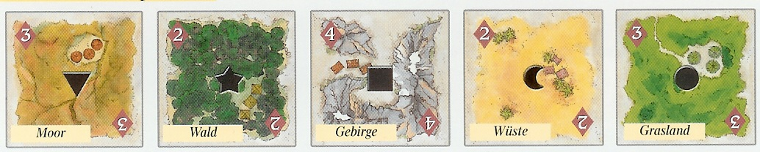

The 15 large square tiles show landscapes. There are 5 different landscapes: Moor, forest, mountains, desert, and grass. Each land tile occurs 3 times in the game. The number shown on each land tile indicates the maximum population of this tile. If the number of minions on the tile exceeds the number, then no manufacturing takes place on that tile.
-2-
Example: Landscape “Moor” with 2 minions. A minion is domestic and will manufacture goods (full-colored side up); the other minion is not domestic and does not manufacture goods (side with the farme up). The population limit of 2 is not exceeded.
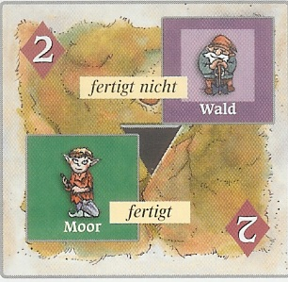
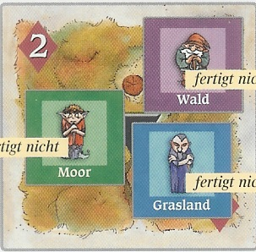
Example: The same landscape with 3 minions. Although a minion is domestic, it does not manufacture, because the landscape is over-populated. The population limit of 2 is exceeded.
- 5 marking stones – these marking stones are used to keep track of the number of goods a player has in their tower.
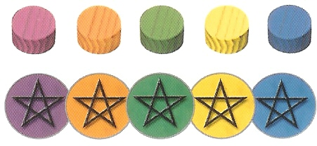
- 5 spell markers – one spell marker is used by each player to mark the affected tile of their spell.
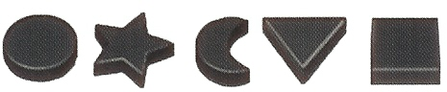

Object of the Game
Victory Conditions
- Collect 5 different amulets in your tower (highest victory condition), or
- Collect 4 different amulets in your tower and at least 10 goods (2nd highest victory condition), or
- Collect 3 different amulets in your tower and have at least 20 goods (3rd highest victory condition).

When a player fulfils one of these victory conditions, then the round is played to the end. The player to the right of the first player will be the last player. Thus all players will have the same chance in that turn to win. Whoever achieves the higher victory condition at the end of this last round, wins. If two players at the end of the last round fulfil the same victory condition, then the player with the highest number of goods wins.
-3-
- 25 amulets in 5 types – there are 5 types of amulet: circle, star, half moon, triangle, and square. Each type of amulet is associated with a different land type.

Play Preparation
Place the game board in the centre of the table. Each player selects a people (colour), taking the tablet, marking stone, spell marker, and bag of minions. Each player puts their marking stone on the “0” space of the goods table.
Mix up the land tiles face down and place them face up in sequence on the numbered water spaces on the board. Each game will develop a new continent layout.

The remaining people (colour) are considered neutral. The tower of the neutral player is placed on the specified field below. Also draw 3 minions from the bag and place them on the same land tile. Use these tiles depending on the colour of the neutral player:
- Purple – place on the mountain tile with the number 4.
- Green – place on the moor tile with the number 4.
- Orange - place on the desert tile with the number 4.
- Blue – place on the grass tile with the number 4.
- Yellow – place on the forest tile with the number 4.
Thus there are always 5 players in play.
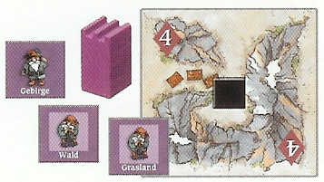
Example: Purple is neutral. The tower and 3 randomly drawn minions are placed on the mountain tile with the number 4.

Playing the Game
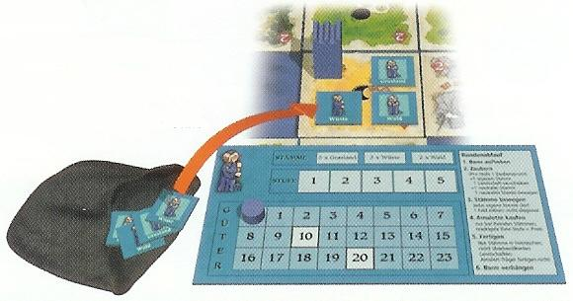
Each player now draws 3 minions from their bag. The youngest player begins and play continues in a clockwise direction.
The first player selects any land tile and places
her tower and 3 drawn minions on it. The minions
are turned to their correct side.
Example: The blue player selected the free desert tile with the number 4. She places the tower and 3 randonly drawn minions on the tile. One of the minions is not domestic and is flipped to its back-side (framed).
Note for the First Time Player: One should note the domestic locations on which your dominions are. You should not set the tower on a land tile in which your own minions will not be domestic. The tower is the “place of birth” of all new minions. This land tile should no exhibit too small a number, since it will quickly be over-populated. However you should not stray too far away from other players since this is the only way to receive magic amulets.
The first player sets the tower and 3 minions in the land tile, then the 2nd player, and so on…
There may only be one tower on a land tile.
-4-
Each player performs all 6 phases of a round one after the other, then the next player goes, and so on…

- Spell Removal

If the player cast a spell in the preceding round, then that spell must now be removed from the board. (See Phase 6: Spell Casting)

- Magic
The number of magic actions a player may take is based on their current amulet level. Players ma always perform at least one action (even if they don’t have an amulet). The following magic actions are possible:
- Pull one new minion out of your own bag
and place it on the land tower where your tower
resides.
- Shift a land tile. The tile may be pushed onto
a free, adjacent water space. Diagonal shifting
is not possible. You may push a tile off one side
of the board, and it will “wrap around” to the
other side as long as there is an empty water space.
(see also “movements beyond the edge of the board”, Page 8)
- Pull a new minion from a neutral player’s bag. Place the minion on the tower where that player’s tower resides.
- Move a neutral player’s minion to an adjacent tile. Diagonal movement is not possible. Minions may not enter water spaces.

The possibilities described above each represent one action. If a player has e.g. 3 amulets, then she can implement 3 actions.

Explanation of a Round
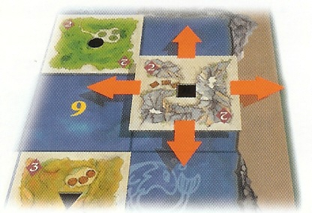
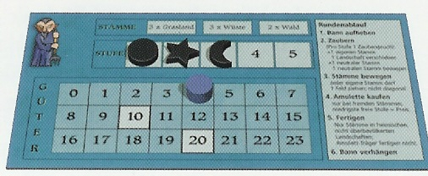
Example: Player blue has reached stage 3, so she may perform 3 magic actions each round.
-5-
At the beginning of the game all players can carry out a magic action. Later in the game, one may accomplish a magic action for each amulet which has been returned to that player’s tower. Thus, a player with 2 amulets may perform 2 actions, etc…

The selection of magic actions is arbitrary. A player may perform the same action several times.

- Movement
- All of a player’s minions may be moved 1 space.
- Diagonal movement is not possible.
- Water spaces may not be entered.
- Minions may “wrap around” the edge of the board
as long as there is a valid land tile on the opposite
side of the board.
- Only at the end of the movement phase may an
amulet be delivered to the player’s tower.
- Minions that are carrying amulets move like all
other minions.

- Amulet Purchase

Players may only possess amulets through a purchase.
- Amulets are acquired from foreign manufacturing minions (i.e. colour of another player or neutral player). Note: Minions that are currently carrying amulets may not be bought from since they are not currently manufacturing.
- When buying an amulet you must have one
of your own minions in the land tile in which
the amulet is to be bought. It doesn’t matter
whether or not that minion can manufacture.
- The price of the amulet depends on the current
stage of the purchasing player. If a player is
currently on stage 2, then each amulet costs 3
goods. If a player doesn’t have a amulet, then
the cost is 1 good. Amulets which are not yet in
the tower do not count.
- Remove the necessary number of goods from
the buying player’s table.
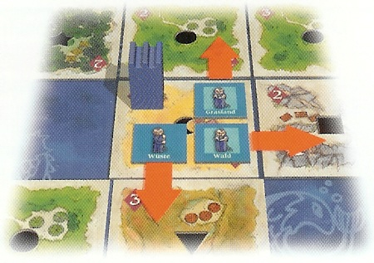
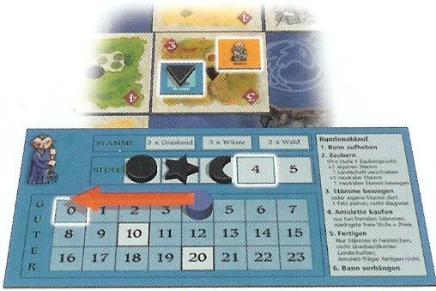
-6-
- The player then receives an amulet of the type specified on the land tile. The amulet is placed on the minion that is on the land tile for the purchase.
- The player who is the seller, receives 1 good (no matter what the cost of the amulet was). The good is marked on the player’s goods table.

- Manufacturing Phase

- After all movement and amulet sales are conducted, the minions of the current player manufacture goods.
- For each minion that is able to manufacture, the player receives 1 good. Note this good on the player’s goods table.
- Minions only manufacture in domestic tiles and non-overpopulated land tiles.
- Minions that carry amulets do not manufacture.

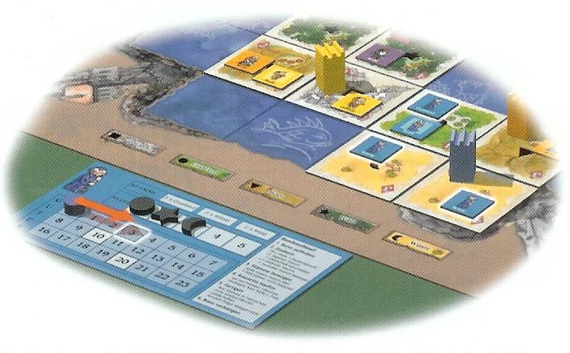
Example: There are 4 minions of the blue player in the figure.
3 of the minions manufacture
and one does not. The
player should mark 3 goods
on her table.
6. Cast a Spell

Casting a spell is used to prevent changes in the position of the landscape.
- A spell marker may be placed on a land tile or water tile, and remains lying there until the player’s next turn (phase 1).
- A landscape that has a spell marker on it may not be
shifted.
- A water space with a spell marker may not have a land tile
shifted over it.
- The player does not have to use her spell marker.
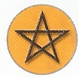
-7-

Notes on Magic
At the beginning of the game the player doesn’t have any magical amulets. Nevertheless, the players may perform a magic action as described in phase 2. In order to achieve higher stages, the player must acquire amulets and bring them to their home tower.
- A minion may only carry 1 amulet at a time.
- A minion that is carrying an amulet never manufactures goods.
- When a minion reaches the home tower, the amulet is placed on the player’s table on the lowest number space. This amulet is now in the tower.
- If the player has a 2nd amulet in the tower, then the player attains the stage 2 magic immediately. If a 3rd amulet is added, then she attains stage 3, etc… The number of amulets is marked on the player’s table.
- Players must acquire different amulets. You may not purchase an amulet that you have already bought (even if it is not already in the tower).

Movement Beyond the Edge of the Board
Both minions and land tiles can be moved beyond the edge of the playing field. The earth is formed in a sphere. The tile or minion moves into the space on the opposite side of the board (“wrap around”).
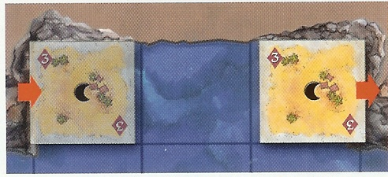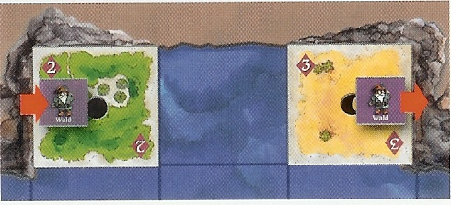
A land tile may be shifted into an empty water space. The minion may only be moved beyond the edge of the board if there is a land tile on the other side. A minion may not enter a water space.

Game End
If a player fulfils one of the victory conditions (see play goal on pg. 3), then the round is played to the end. Whoever achieves a higher victory condition wins the game.
-8-

