Trip Date | May 26 | What to bring
Meet & Unload boat | 9:15 AM | - Canoe or Kayak  - Paddle (recommended to also have a backup paddle)  - Life Jacket, Spray skirt for kayaks  - Lunch in a water tight bag (lunch is along the river on the river bank)  - Water  - Eye glasses band  - Change of clothing to pack on boat in case you get wet in a dry bag  - Sunscreen
Trip Review Meeting | 9:30 AM
Car Shuttle | Leave at  9:40 AM  Drop cars at takeout and return drivers to put-in with as few return cars as possible. Return drivers will be brought back to their car at end of paddle.

Trip Leader: Laura Huberty lhubes@gmail.com Cell 612-810-9588
Trip Description: The Kinni (for short) is a fun river to paddle, but it comes with some U-shaped turns, snags to avoid and some rapid features up to class 1.5 depending on the water level. I often refer to this river as technical, because you must pay attention and quickly decide which way to go. The scenery is fantastic with plenty of wild life. You should know how to quickly maneuver your boat and handle a current that might likely pull you into a snag. Often when I ask someone “What is your favorite river” the answer is the Kinni.
We will paddle about 13-16 miles and be on the river approximately 3.5-4hrs with a lunch stop. If we have a large group, it may take a little longer due to the takeout detour described below. We will take an extra break if needed.
From the Twin Cities, it takes about 60-75 minutes to reach River Falls.
To Put-in (Glen Park in River Falls)  From the Twin Cities metro area:  - Take I-94E  - After crossing the St. Croix River take Wisconsin 35 south  - Exit to Hwy 29 (River Falls) and proceed through town  - Turn right on West Park Street – the sign is hard to see coming from the south, but it will come up after you cross a bridge with water below. You can only turn to the right.  - Proceed to the end of the street where you will see the park.  - Please allow yourself enough time to unload, mingle and be ready to go by 9:30am. This put-in has a trail up to many steps down a hill requiring more time up front to unload and move the boat to the landing – PLEASE PLAN ACCORDINGLY.  - There is a restroom at the Put-in | To Takeout  The takeout is at the bridge at Cty F at the north Kinni State park landing. Most vehicles park on the shoulder on Cty Rd FF so they do not have to pay the State Park fee of $10 for the day, the non-resident fee.
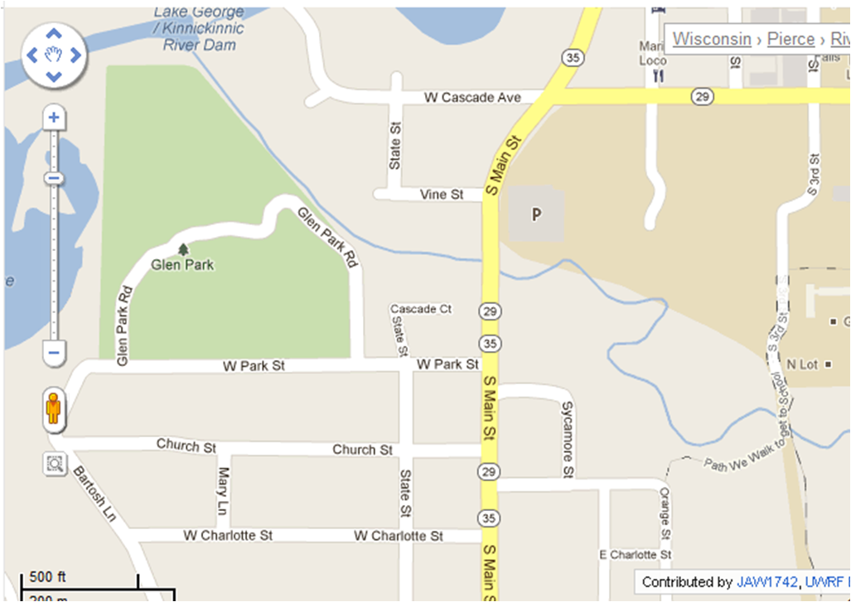
Map of put-in location in River Falls, WI
Landing

