**Create Ubuntu VPN Server**

Step #1: login to your AWS console at <https://aws.amazon.com/console/>

2: Click on EC2, then the launch instance button 

3: Select the following free Ubuntu instance   
4: By default, the t2.micro free tier instance should be chosen. Defaults are your friend.



5: Click Next 

6: Defaults are your friend.

7: Defaults are your friend. Click 

8: Defaults are your friend.

10: Create a new custom UDP rule for port 1194 and open it to the internet



11: Click on Review and Launch button 

12: Click on Launch 

13: On the *Select an existing key pair or create a new key pair*, choose create a new key pair from the drop down; select RSA for the Key pair type; then give your key pair a name. Click on the Download Key Pair button (leave it in your downloads folder), then click on the Launch Instance button.

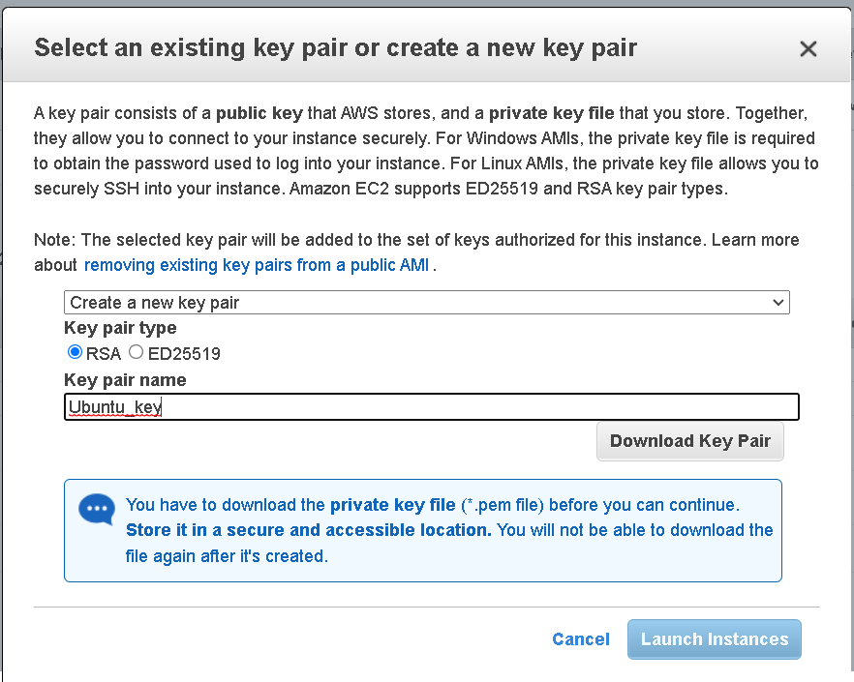

**Create EC2 Web Server**

Step #1: login to your AWS console at <https://aws.amazon.com/console/>

2: Click on EC2, then the launch instance button 

3: Select the following free Amazon Linux instance   
4: By default, the t2.micro free tier instance should be chosen. Defaults are your friend.



5: Click Next 

6: Defaults are your friend.

7: Defaults are your friend. Click 

8: Defaults are your friend.

10: Create a new custom UDP rule for port 1194 and open it to the internet. Do the same for TCP Ports 80 and 443



13: On the *Select an existing key pair or create a new key pair*, choose create a new key pair from the drop down; select RSA for the Key pair type; then give your key pair a name. Click on the Download Key Pair button (leave it in your downloads folder), then click on the Launch Instance button.

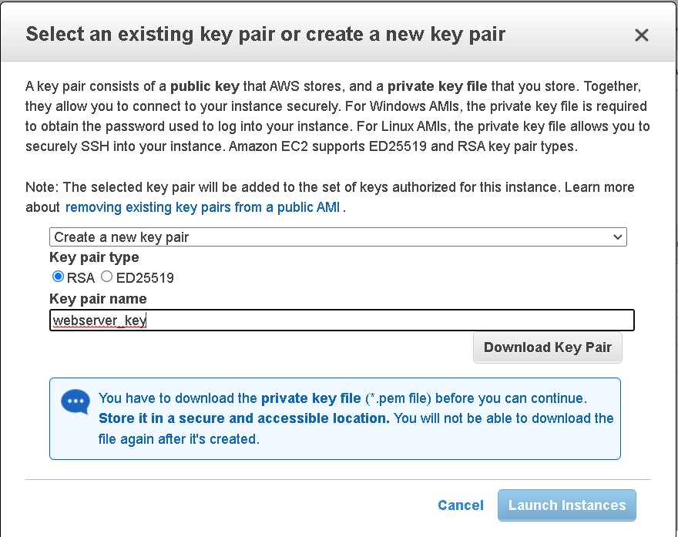

**Create Jumpbox Server**

Step #1: login to your AWS console at <https://aws.amazon.com/console/>

2: Click on EC2, then the launch instance button 

3: Select the following free Amazon Linux instance   
4: By default, the t2.micro free tier instance should be chosen. Defaults are your friend.



5: Click Next 

6: Defaults are your friend.

7: Defaults are your friend. Click 

8: Defaults are your friend.

10: Create a new custom UDP rule for TCP Ports 80 and 443



13: On the *Select an existing key pair or create a new key pair*, choose create a new key pair from the drop down; select RSA for the Key pair type; then give your key pair a name. Click on the Download Key Pair button (leave it in your downloads folder), then click on the Launch Instance button.

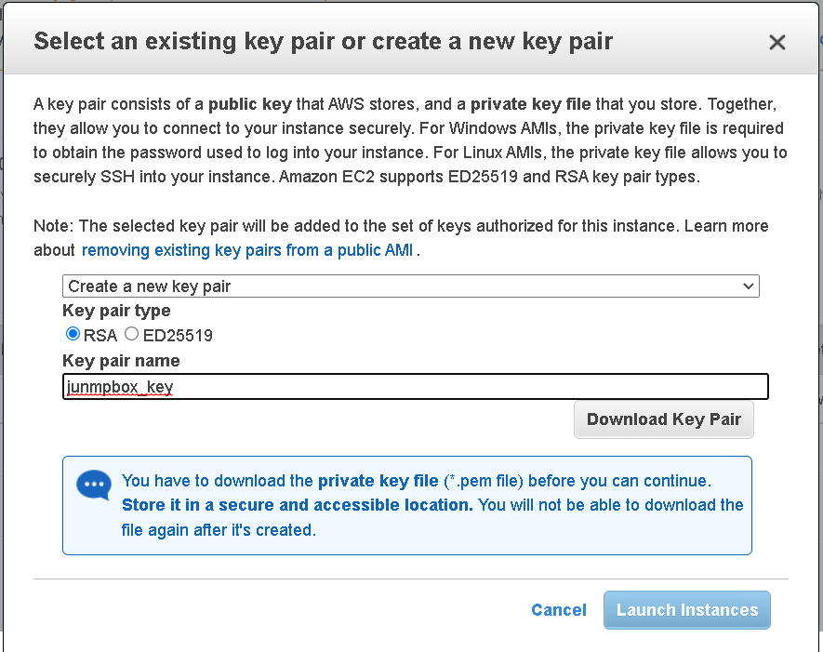

**Setup Jumpbox**

1: Using the software/program of your choice (we recommend Visual Studio Code), ssh into your Jumpbox server and run these commands in sequence:

2: sudo yum update

3. sudo yum install upgrade

4: sudo yum install python-pip

5: pip install ansible

6: sudo mkdir /etc/ansible

7: sudo nano /etc/ansible/ansible.cfg

8: sudo reboot