

**Installation & Users Guide**

Last Updated: November 27, 2014

logo.png

Table of Contents

1 Introduction 3

2 Open Source Licensing 3

2.1 License 3

2.2 Source Code 3

3 System Architecture 4

4 Installing Open Waters 5

4.1 Prerequisites 5

4.2 Installation Instructions 5

5 Using Open Waters 7

5.1 Organizations 7

5.2 Monitoring Locations 9

5.3 Projects 11

5.4 Activities (Chemical & Biological Samples) 12

5.5 Data Import of Biological Data 13

5.6 Data Analysis 14

5.6.1 Maps 14

5.6.2 Graphs 15

6 Administering Open Waters 16

6.1 General Application Settings 16

6.2 Managing Users & Roles 17

6.3 Synchronizing Reference Data from EPA 19

# Introduction

Open Waters is a web-based water quality data management system that allows you to manage water quality monitoring locations, samples, results, and projects. Some high-level features of the application are:

* **Water Quality Data Management:** Manage your water quality samples & results, monitoring locations, projects, and organizations
* **Automatic WQX Submission:** Data is automatically submitted to EPA’s WQX program (<http://www.epa.gov/storet/wqx/>) as it is entered (if data is flagged for submission to EPA)
* **Reference Data Synchronization:** Reference data (e.g. Pollutant names, Taxonomic names, analytical methods, etc) are fully synchronized with EPA’s reference data, ensuring that submissions will not fail due to mismatches in reference values.
* **Bulk Data Import:** Data can be bulk imported from Excel, saving time on data entry.
* **Application Customization:** Application can be customized to show or hide various data elements, allowing application administrator to streamline the application screens to only include the data elements of interest to the Agency staff.
* **Security:** Role-based application security and additional layered security measured to ensure security of data
* **Multi-Agency Support:** Allows multiple agencies (called Organizations) to share the application; all data and data security is segmented by Agency.
* **Open Source:** Application is free to use, free to share, and free to modify

# Open Source Licensing

## License

Open Waters is free software: you can redistribute it and/or modify it under the terms of the GNU General Public License v3 as published by the Free Software Foundation, either version 3 or (at your option) any later version.

This program is distributed in the hope that it will be useful, but without any warranty; without even the implied warranty of merchantability or fitness for a particular purpose. See the GNU General Public License for more details. See here for a complete text of the license terms: <http://www.gnu.org/licenses/gpl.txt>

## Source Code

Source Code for Open Waters is available at: <http://code.google.com/p/open-waters/>.

* **Obtaining the Installation Package:** To download a copy of the installation package, click on the Download tab (<http://code.google.com/p/open-waters/downloads/list>).
* **Obtaining the Source Code:** To download a copy of the source code, click on the Source tab (<http://code.google.com/p/open-waters/source/checkout>) and use a tool such as Subversion to synchronize with the project repository.
* **Contributing Source Code:** Developers are encouraged to join the Open Waters development team. If you are a developer who wishes to contribute to the Open Waters development, contact a team member listed at (<http://code.google.com/p/open-waters/>). A team member will add you to the project team.

# System Architecture

The following diagram depicts the Open Waters application architecture:

**Open Waters**

**EPA**

**Open Waters Web Application**

**WQX Reference Data**

**WQX Warehouse**

**Windows Service**

**CDX Node**

**Open Waters Database**

**WQX Submission**

***Figure 4.1: Open Waters System Architecture***

The overall solution is divided into the following major components:

**Open Waters Database:** A Water Quality Database that closely mimics the EPA-WQX data structure.

**Water Quality Data Management System:** A variety of data management screens are provided to allow staff to insert/update/delete water quality data (i.e. projects, monitoring locations, samples, and results).

**WQX Reference Data Synchronization:** The Open Water web application interfaces directly with EPA’s WQX Domain services (<http://www.epa.gov/storet/wqx/wqx_getdomainvalueswebservice.html>) to pull the latest set of valid WQX reference data. These reference values are then used by the data management system to populate relevant drop-downs during the data entry process.

**Open Waters Windows Service:** A Windows Service is also installed on the Web Server. This Windows Service controls the scheduling of the submission of WQX data to EPA.

# Installing Open Waters

## Prerequisites

Before installing Open Waters, your hosting environment must meet the following requirements:

* **Web Server:** 
  + Windows Server 2003 or later (IIS 6 or later)
  + .NET Framework 4.0
  + Microsoft WSE 2.0
  + Microsoft WSE 3.0
  + Web server can communicate with Internet
  + Web server can communicate with Database Server
* **Database Server:** 
  + SQL Server 2008 or later

## Installation Instructions

To install Open Waters, follow these steps:

1. Make sure all prerequisites from the previous section have been installed
2. **Database Installation:**
   1. Login to SQL Server Management Studio and run the script called **Create_DB.sql**. This will create a new database called OpenEnvironment, and create several database tables and stored procedures.
   2. *(Optional)* It is then recommended that you change the password for the **oe_login** user from the default in the provided script.
   3. *(Optional)* If you have been given an additional script to populate the database with your agency’s water quality data, then run this (note: this is not provided by default).
3. **Application Installation:** 
   1. Unzip the provided OpenWaters.zip to a directory on the Web Server where you would like to host the application.
   2. Open up the Web.config file - find the following block:

<connectionStrings>

<add name="OpenEnvironmentEntities" connectionString="*** />

</connectionStrings>

Change the values of the data source, username, and password to match the database installed in Step 2 above.

* 1. Change the dir value of the following block:  
     <add key="ChartImageHandler" value="storage=file;timeout=20;dir=c:\TempImageFiles\;" />
  2. Open up IIS 6 or 7. Create a new Virtual Directory called “OpenWaters”, pointing to the location where you unzipped the application files
  3. Restart IIS
  4. Browse to the following directory to confirm that the application is working: <http://localhost/OpenWaters>

1. **Install Windows Service:** Open Waters includes a Windows Service that will periodically submit data to EPA as a background process.
   1. Unzip the OpenWatersSvc.zip to a directory on the server
   2. Open up the OpenWatersSvc.exe.config file - find the following block:

<connectionStrings>

<add name="OpenEnvironmentEntities" connectionString="*** />

</connectionStrings>

Change the values of the data source, username, and password to match the database installed in Step 2 above.

* 1. Open the **Install.bat** file and change the directory to match the location where you have copied the service files (Step 4a above).
  2. Run the **Install.bat** file, by clicking Start🡪Run🡪type in cmd🡪 then type in <path>\OpenWatersSvc.bat **(you must run as Administrator)**
  3. Confirm the service is running by going to Control Panel🡪Administrative Tools🡪Services. A service entitled “Open Waters Service” should be listed.

1. **Application Configuration:** After the application has been installed, there are some initial configuration steps that will improve system behavior:
   1. General Application Settings: Set the following general application settings (follow the instruction in Section 5.1):
      1. Default ORG ID: This will be the default organization that appears in the drop-down in the application’s top menu.
      2. NAAS Username: This is the default NAAS account that will be used to submit data to EPA. You can also override that value by specifying an Organiation-specific NAAS account at the Organization edit page.
      3. NAAS Password
      4. CDX Submission URL: The web service web page of EPA’s CDX Node to which WQX submissions will be made (this will be set but may need to be changed depending on whether you will be submitting to EPA’s test or production environment)
      5. CDX Ref Data URL: The web service web page of EPA’s domain service from which Open Waters will retrieve reference data
   2. Synchronize Reference Data: by default, Open Waters does not have any reference data populated. To populate reference data, an initial synchronization must be performed. Follow instructions in Section 5.3
   3. Add users: you may wish to add more application users or administrators. Follow instructions in Section 5.2.
   4. Configure which columns to display in application: Open Waters allows the administrator to configure which columns will be displayed in the application for the following screens:
      1. Monitoring Location
      2. Activity
      3. Result

To specify which columns to include in the application, open up the web.config file on the web server, in the root folder in which the application is deployed. Find the application settings section of the file and change the setting to “true” or “false” for each field.

1. **Start the Windows Service:**
   1. Go to Control Panel 🡪 Admin Tools 🡪 Services.
   2. Click the Start button to start the Open Waters service

# Using Open Waters

## Organizations

**Site Navigation:** Water Quality 🡪 Organizations

An organization describes the agency managing the water quality data. Having at least 1 organization record in the database is essential before any water quality data can be transferred to EPA-WQX.

**Your Organization ID will be assigned to you from EPA. Please contact EPA if you do not have a WQX Organization ID or are unsure of its value. The ID used in Open Waters must match the ID assigned by EPA.**

The Organization webpage lists all organizations in a datagrid, as shown here:

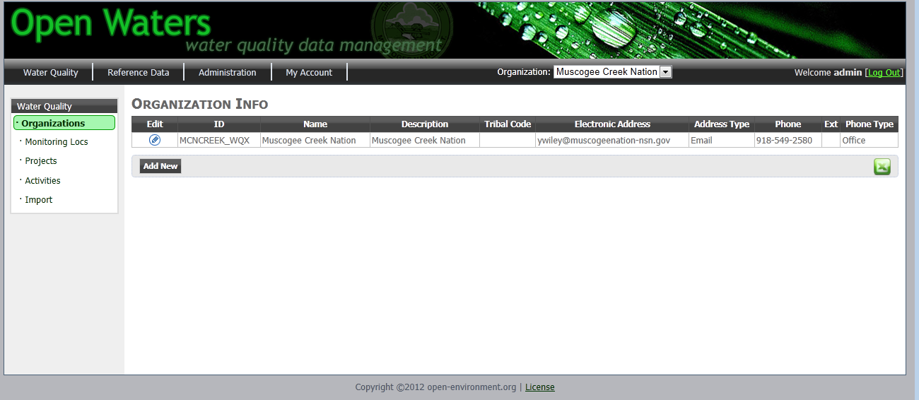

***Figure 5‑1 Organization Listing Page***

Open Waters support the management of multiple Organizations.

**Edit an Existing Organization:** To edit an organization, click the pencil icon in the first column for the monitoring location you wish to edit. This will display the Edit Organization screen, as shown here:

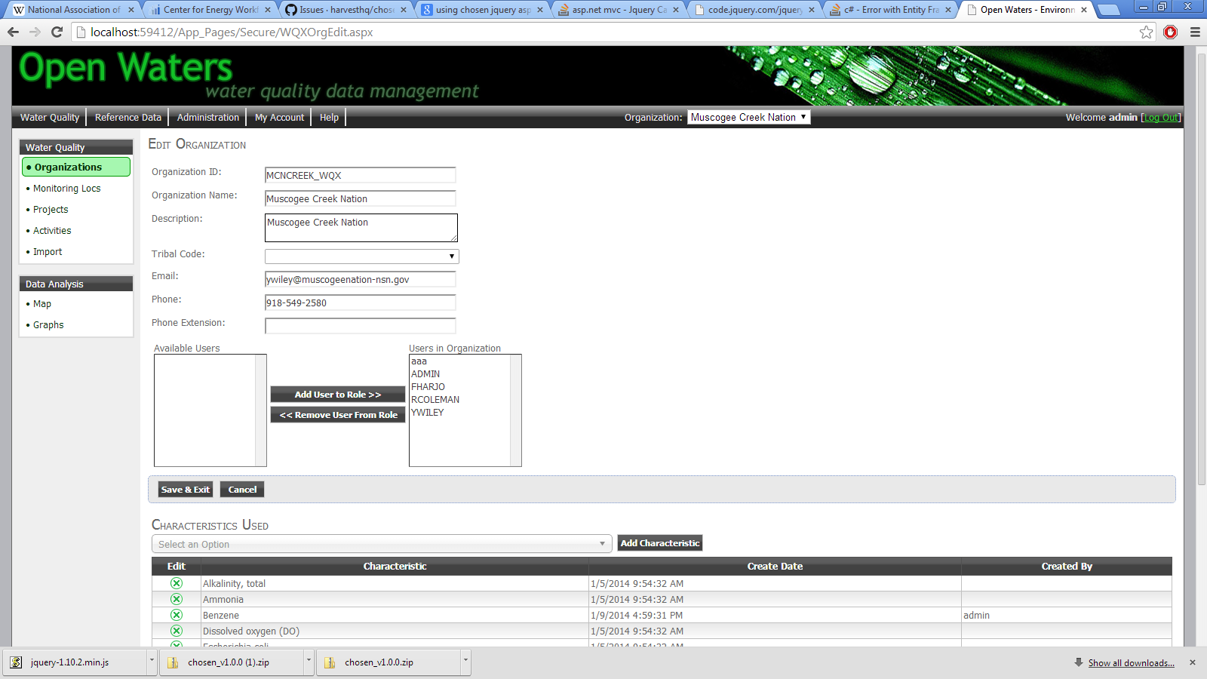

***Figure 5‑2 Organization Edit Page***

On the Organization Edit page, you can modify the following information:

* General organization details
* Which Open Waters users can access and edit data for this organization
* CDX Submitter: specify the NAAS account to be used to submit this organization’s data to EPA/CDX.
* Specify which characteristics the organization will sample for: By Default, EPA provides 1000s of chemical characteristics. To speed up data entry of samples, you can define a subset of these 1000+ chemicals that may actually be sampled by your organization.

Make your changes and click the Save button.

*Note: your changes will not be transferred to EPA until another piece of data has been updated (i.e. Monitoring Location, Project, or Activity).*

**Add an Organization:** Only users that have ADMINS role can add a new Organization. Click the button and a new Organization will be created.

**Export to Excel:** Click the Excel icon ( xls.png ) to export the listing of Organizations to Excel.

## Monitoring Locations

**Site Navigation:** Water Quality 🡪 Monitoring Locations

Monitoring Locations identify the specific places at which water quality sampling or other activities (i.e. habitat assessments) are performed.

The Monitoring Locations page lists all monitoring locations in a datagrid, as shown here:

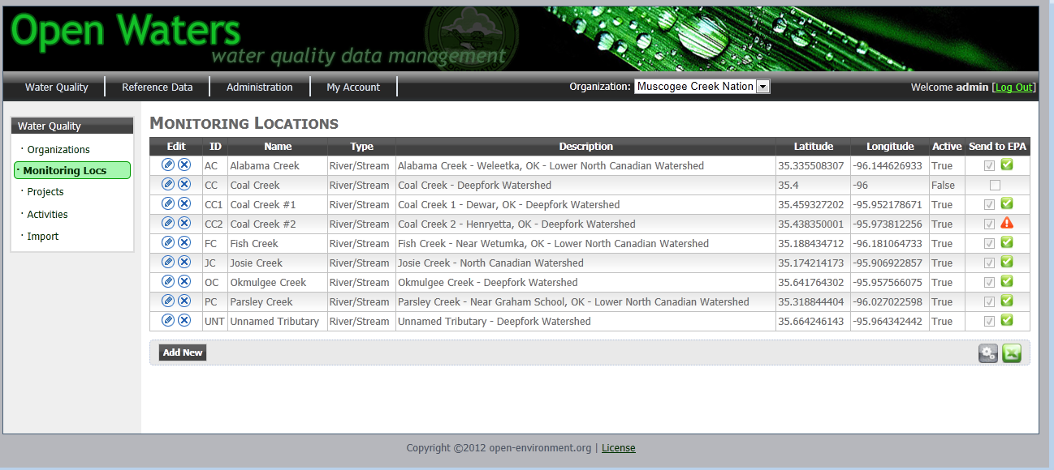

***Figure 5‑3 Monitoring Location Listing Page***

**Deleting a Monitoring Location:** To delete a monitoring location, click the “X” icon in the first column of the datagrid for the monitoring you wish to delete. Note: this will not completely remove the record, but will instead mark as inactive and trigger a submission of a delete file to EPA.

**Adding a New Monitoring Location:** To add a new monitoring location, click the **Add New** button at the bottom of the page.

**Edit an Existing Monitoring Location:** To edit a monitoring location, click the pencil icon in the first column for the monitoring location you wish to edit. This will load the Edit Monitoring Location page, as shown here:

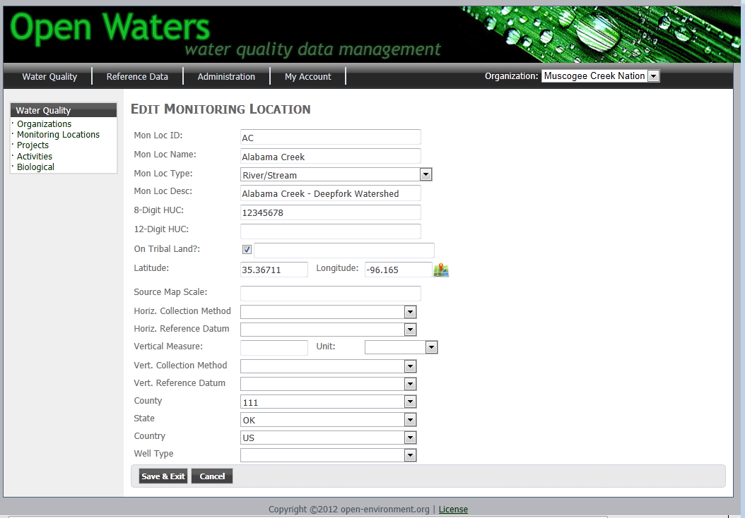

***Figure 5.4: Monitoring Location Edit Record Page***

**WQX Submission of Monitoring Locations:** You can select which monitoring locations are submitted to EPA by clicking the “Send to EPA” checkbox. When a monitoring location is modified and is marked to submit to EPA, it will be flagged with a WQX_IND=”U” in the database. The next time the Open Waters service runs, it will query all records from the database with a WQX_IND=”U” and attempt to submit them to EPA-WQX. The record will be flagged according to the following:

: Record failed in its most recent submission attempt to EPA.



: Record successfully submitted to EPA is most recent submission attempt.



progress.gif: Changes have been made to the record and the record has either (A) not yet been submitted to EPA, or (2) submission has been made, but feedback from EPA on submission success/failure has not yet been received.

**View WQX Submission History:** To view a history of submissions made to EPA for the particular record, click the status icon in the last column, which will display the following screen:

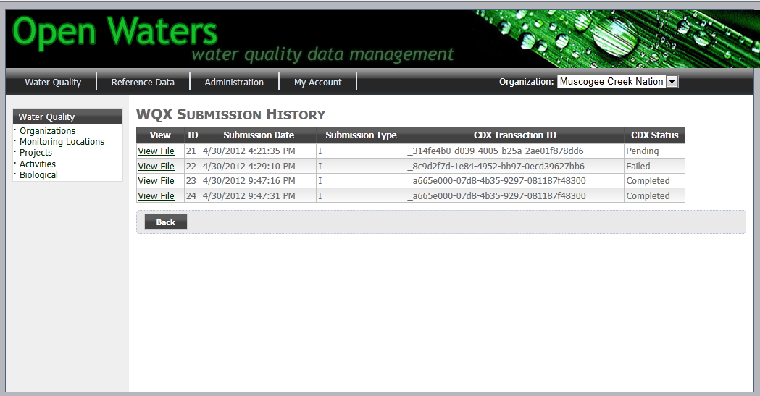

***Figure 5.5: WQX Submission History Page***

**Export to Excel:** Click the Excel icon ( xls.png ) to export the listing of Monitoring Locations to Excel.

## Projects

**Site Navigation:** Water Quality 🡪 Projects

Projects are a way of logically grouping Sampling Activities.

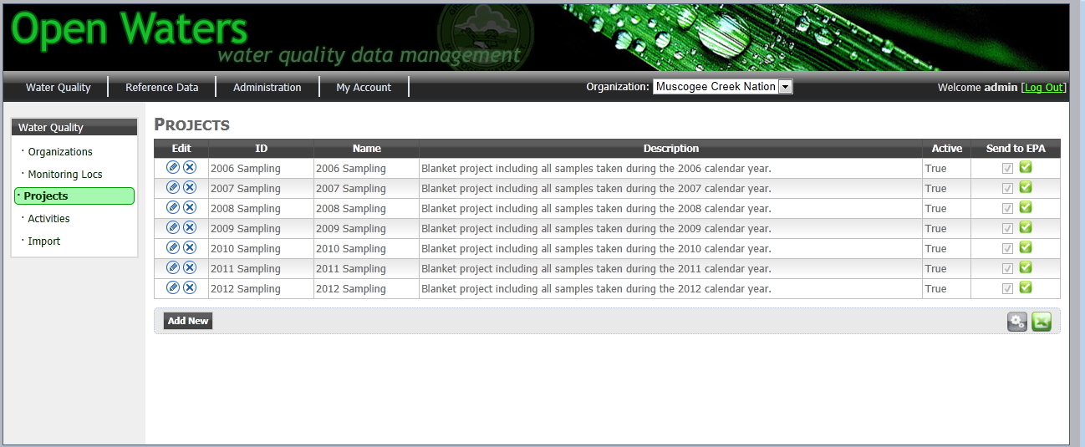

***Figure 5.6: Project Data Management Page***

Management of Projects (i.e. Insert/Update/Delete as well as WQX Submission history tracking) are similar to that of Monitoring Locations covered in the previous section.

**Export to Excel:** Click the Excel icon ( xls.png ) to export the listing of Projects to Excel.

## Activities (Chemical & Biological Samples)

**Site Navigation:** Water Quality 🡪 Activities

The Activities page allows you to track all sampling activities, including samples and results. This includes both chemical samples and biological samples.

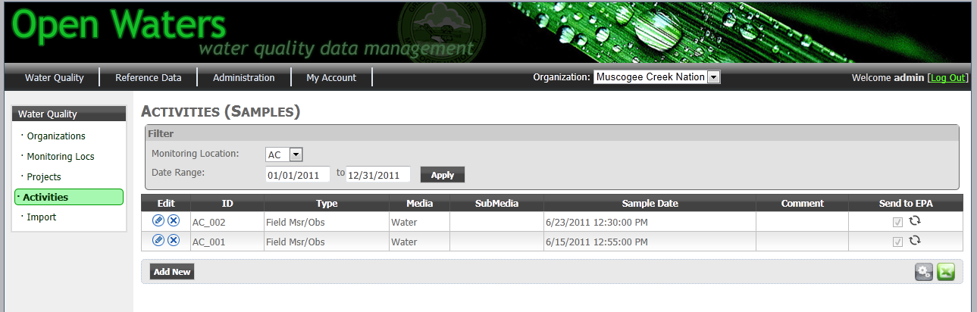

***Figure 5.7: Activities Data Management Page***

**Data Filters:** You can filter the display of Activities by Monitoring Location and sample date range.

**Management of Activities** (i.e. Insert/Update/Delete as well as WQX Submission history tracking) are similar to that of Monitoring Locations covered in the previous section.

**Results Editing:** When on the Activity edit page, you can also add or edit the sampling results for each characteristic sampled, as shown here:

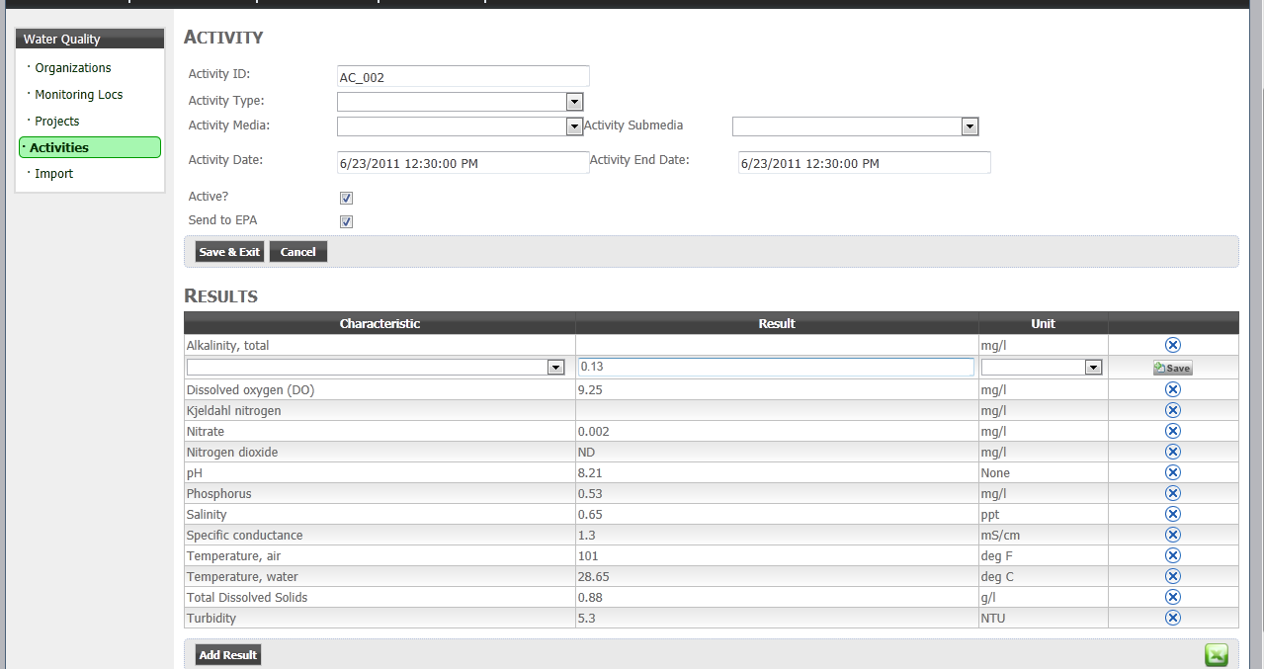

***Figure 5.8: Activity Details/Result Data Management Page***

By default, the drop-down of characteristics will be limited to only those characteristics associated with your organization. To modify this list, please go to the Organization Edit page (see section 5.1).

**Data Validation of Results:** OpenWaters will perform the following data validation on results as they are entered:

* **Valid Results Values:** The following values are allowed for results:
  + Any numeric value
  + ND: Non-Detect
  + NR: Not reported
  + PAQL: Present above quantitation limit
  + PBQL: Present below quantitation limit
  + DNQ: Did not quantify
* **Result Range Checking:** When results are entered, Open Waters may check that the result falls within a valid range. This check will only be performed if a record exists in the T_WQX_REF_CHAR_LIMIT table for the Characteristic/Unit combination that is being entered.

## Data Import of Biological Data

**Site Navigation:** Water Quality 🡪 Import

The data import screen lets you import biological data from Excel into the database. After data is imported, it can be submitted to EPA-WQX.

To import data, follow these steps:

1. Open Biological Data spreadsheet
2. Highlight the range of cells on the Metric page, including the column and row headers, then select “Copy”, as shown here:

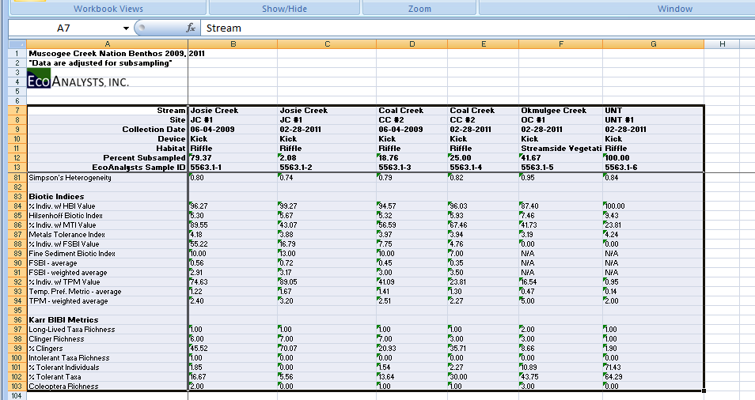

***Figure 5.9: Data Import – Copy Data from Excel***

1. In Open Waters, paste the data into the large Textbox, as shown here:

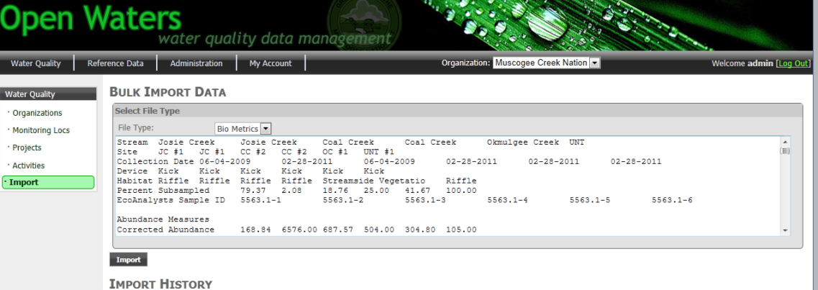

***Figure 5.10: Data Import – Paste Data into Open Waters Textbox***

1. Specify which Project you would like to import the data into.
2. Then click the Import button. This will import data to the Open Waters database.

## Data Analysis

### Maps

**Site Navigation:** Water Quality 🡪 Map

The Maps screen allows you to view monitoring locations and results geospatially.

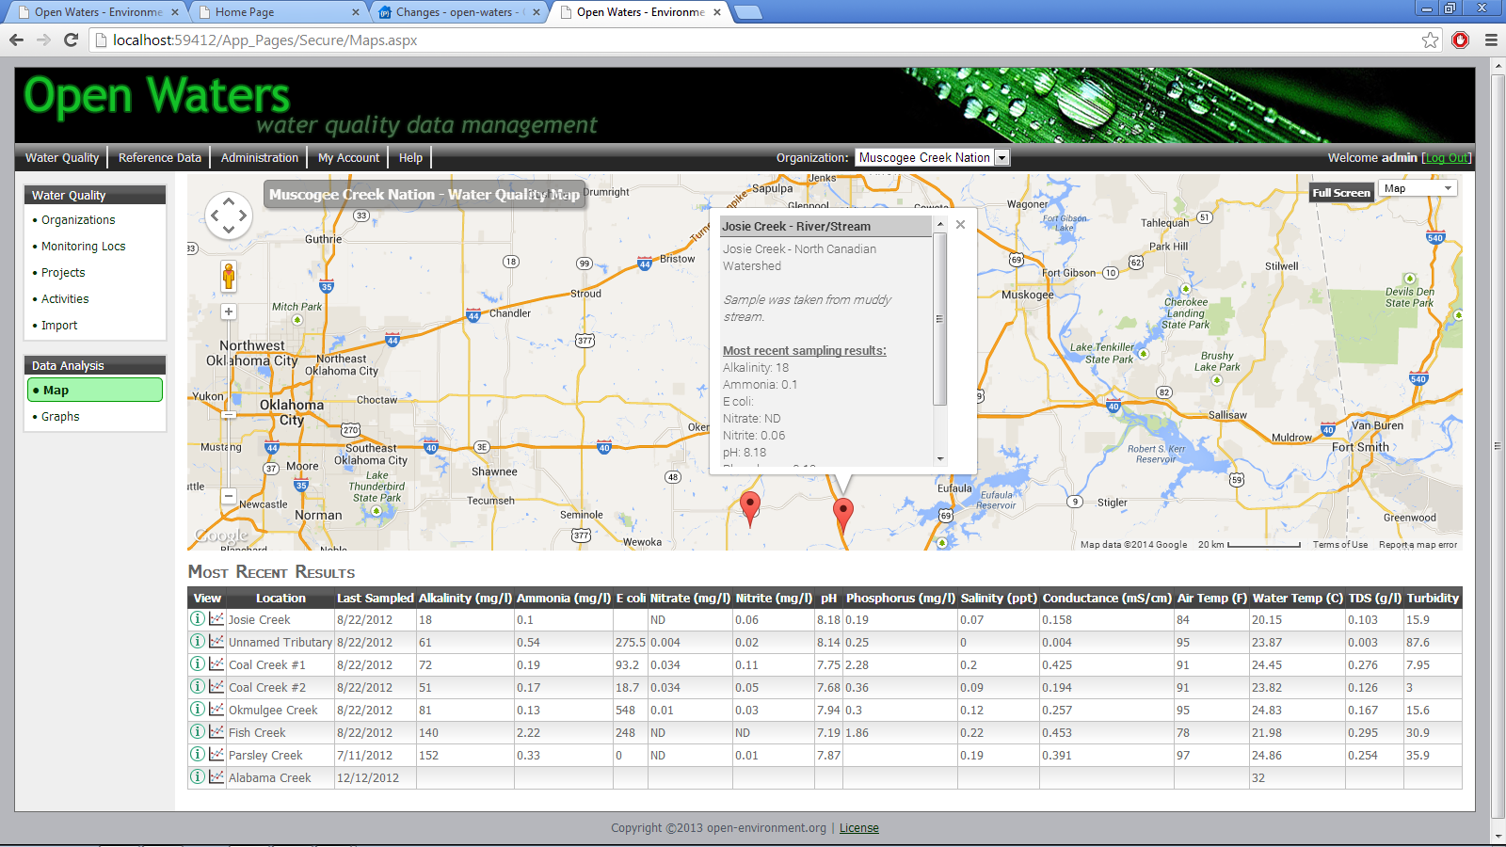

***Figure 5.11: Data Analysis - Map***

The map will display the monitoring locations for your organization. To view additional details for a particular monitoring location, you can click the icon on the map.

The datagrid below the map will display the most recent sample taken at each location. Two icons appear in the 1st column of the datagrid. This allows you to view all sample results taken at the particular location, or view graphs for the data at this location (see next section for graphing details).

### Graphs

**Site Navigation:** Water Quality 🡪 Graphs

The Graphs page allows you to view data for a particular monitoring location and characteristic in a time-series graph.

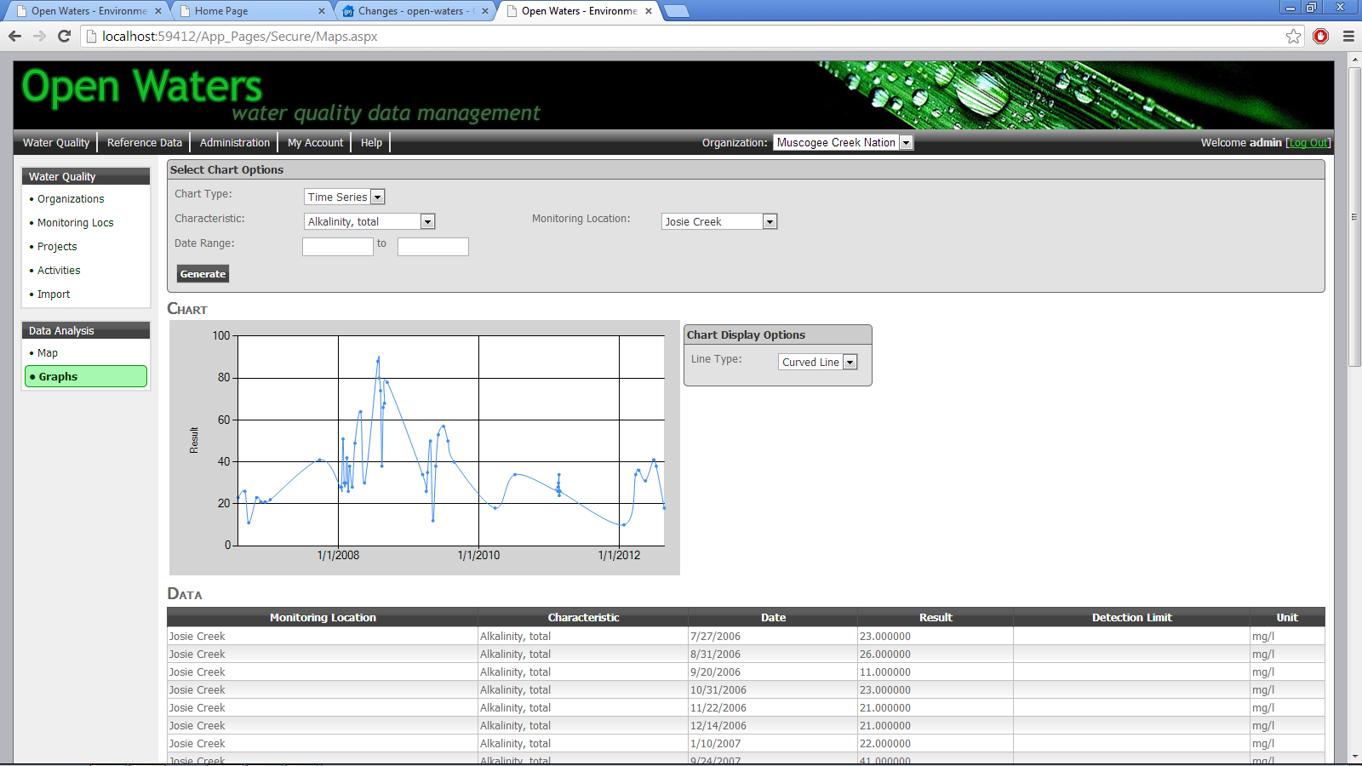

***Figure 5.12: Data Analysis - Graphs***

# Administering Open Waters

This section describes several tasks for administering the Open Waters application.

## General Application Settings

**Site Navigation:** Administration 🡪 App Settings

The General Application Settings page lets Administrators configure several important global application settings.

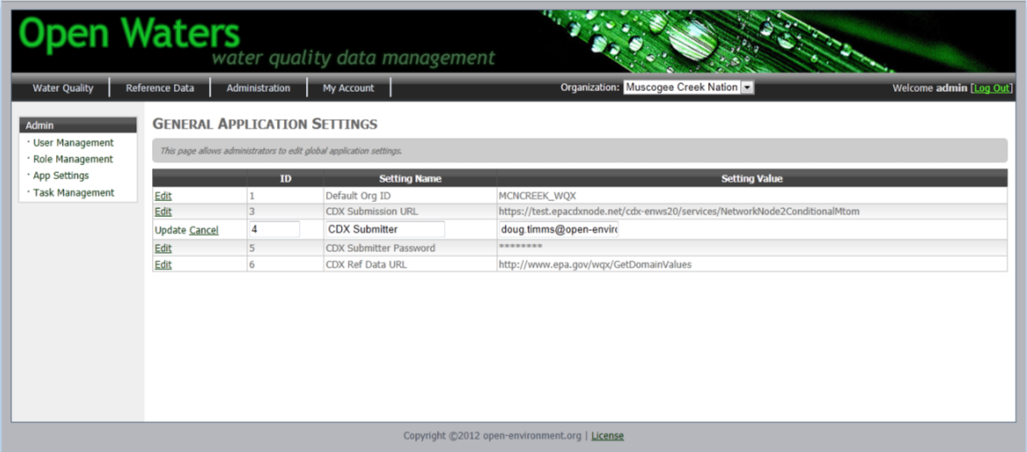

***Figure 6.1: General Application Settings Page***

To edit a record, click the Edit link in the first column, change the value, then click the Update link. These changes are stored in the database. The following table lists the various application settings and their meanings:

|  |  |
| --- | --- |
| **Setting** | **Description** |
| CDX Submission URL | The URL to which WQX XML submissions will be made. |
| CDX Ref Data URL | The URL from which Open Waters will retrieve WQX reference data. |
| CDX Submitter | The NAAS account used when submitting data to EPA. |
| CDX Submitter Password | The NAAS account password used when submitting data to EPA. |
| Log Level | When set to “DEBUG”, Open Waters will save a copy of the XML file used when submitting data to EPA. |
| EMAIL FROM | Open Waters sends out emails to people when they register a new account. Emails will originate from this account. |
| EMAIL SERVER | The email server (IP address) used by Open Waters to send emails out. |

## Managing Users & Roles

**Site Navigation:** Administration 🡪 User Management

Administrators can manage users and user access rights in the application. At the User Management screen Administrators can view a listing of current users.

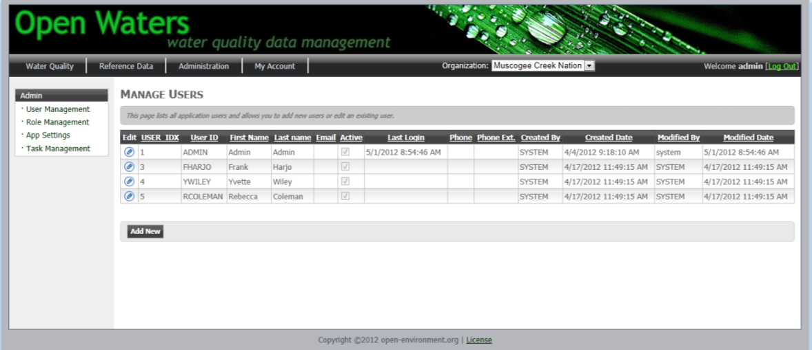

***Figure 6.2: User Management***

* **Change a User’s Password:** To edit a user, click the pencil icon.
* **Add a new User:** Click the Add New button at the bottom of the screen.
* **Delete a User:** First click the Pencil icon to edit the user, then deselect the “Active” checkbox to Inactivate the user. (To completely delete a user’s record, you must remove it directly in SQL Server)

**Role Management:** Roles define which screens in the application a user can access. Open Waters includes two roles as defined here:

|  |  |
| --- | --- |
| **Role** | **Access Rights** |
| ADMIN | Unrestricted |
| USERS | All screens except:   * Admin🡪User Management * Admin🡪Role Management * Admin🡪App Settings * Admin🡪WQX Management * Water Quality 🡪 Organizations 🡪 Add New Org button |
| READONLY | Cannot add, edit, or delete activities |

To add or remove a user from a role, click on the **Role Management** screen:

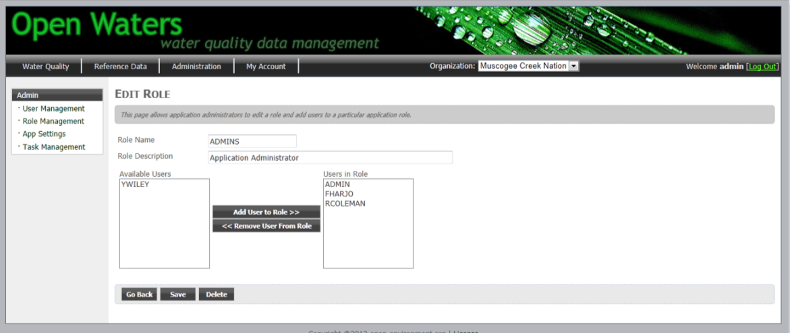

***Figure 6.3: Role Management***

Click the Add User to Role or Remove User From Role buttons.

## Synchronizing Reference Data from EPA

**Site Navigation:** Reference Data

The Reference Data screen allows you to view the reference data in Open Waters and also retrieve the latest reference data from EPA.

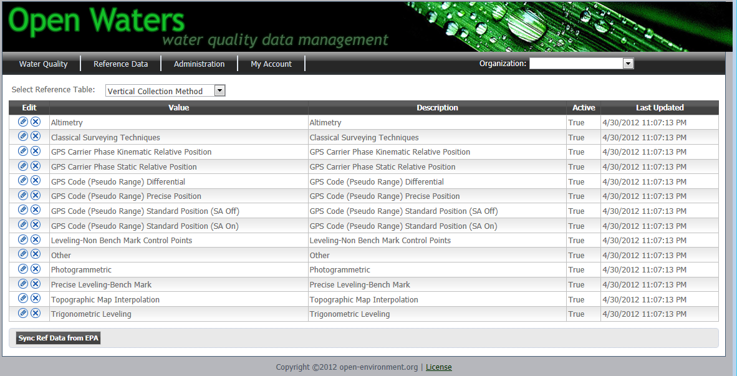

***Figure 6.4: Reference Data Management***

When you click the **Sync Ref Data from EPA** button, Open Waters will import the following sets of reference data from EPA:

* **Organization Level:**
  + Tribes
* **Project Level:** 
  + Sampling Design Type Code
* **Monitoring Location Level:**
  + County
  + Country
  + Horizontal Collection Method
  + Horizontal Reference Datum
  + Monitoring Location Type
  + State
  + Vertical Collection Method
  + Vertical Reference Datum
  + Well Formation Type
  + Well Type
* **Activity (Sample) Level:**
  + Activity Media
  + Activity Media Subdivision
  + Activity Type
  + Relative Depth
  + Analytical Method
  + Characteristic
  + Measure Unit
  + Net Type
  + Sample Collection Equipment
  + Sample Container Color
  + Sample Container Type
  + Sample Tissue Anatomy
* **Results Level**
  + Result Detection Condition
  + Result Laboratory Comment
  + Result Measure Qualifier
  + Result Sample Fraction
  + Result Status
  + Result Temperature Basis
  + Result Time Basis
  + Result Value Type
  + Result Weight Basis
  + Taxonomy
  + Time Zones

**Configure Data Import URL:** Data will be retrieved from the EPA website which can be configured by changing the “CDX Ref Data URL” setting found on the Admin 🡪 App Settings page.

**Data Import Logic:** All data will be matched based on value – if new values are added from EPA they will be added in Open Waters. If a description for an existing value is updated, it will be updated in Open Waters. If a value is removed from EPA, it will not be removed from Open Waters.