SUPPLEMENTAL INFORMATION LEGENDS
Supplemental Table 1. Descriptive Statistics
Supplemental Table 2. Agreement statistics by dementia status
Supplemental Figure 1. Derivation of 954 Paired Ratings for Inter-Rater Reliability Analysis. The BASIL II study enrolled n=488 participants into the full cohort. From the full cohort, a sample of n=46 participants were selected to create a reliability sample. Cases were selected sequentially to ensure representation of both delirium positive and negative cases across all study sites, with an intended sample size of 25-50 to assure statistical stability. Seven clinical assessors rated delirium severity in each of the participants in the reliability sample. For the analysis, this resulted in 21 unique rater pairs [(7 assessors x 6 pairs)/2], with a total number of possible pairs 21 rater pairs x 46 participants = 966 paired ratings. Because one assessor had missing ratings for two participants, there was a total of 12 missing paired ratings. Thus, the analysis sample was 954 paired ratings.
Supplemental Figure 2. Flow Diagram of Clinical Assessor Process. AD8 = 8-item Informant Interview to Differentiate Aging and Dementia; ADLs = Activities of Daily Living; CAM = Confusion Assessment Method; CAM-S = Confusion Assessment Method – Severity Scale; DSI = Abbreviated Delirium Symptom Interview; DSRS = Dementia Severity Rating Scale; FAM-CAM = Family Confusion Assessment Method; IADLs = Instrumental Activities of Daily Living; MoCA = Montreal Cognitive Assessment; PHQ-9 = 9-item Patient Health Questionnaire; SIB-8 = 8-item Severe Impairment Battery.

Supplemental Table 1. Descriptive Statistics
 |  | Overall  N=46 | BIDMC  N=10 | UF  N=14 | TNJH  N=22
Age, mean years (SD) |  | 80 (6.2) | 80 (7.2) | 74 (3.9) | 81(6.7)
Female, n (%) |  | 27 (59) | 6 (60) | 7 (50) | 14 (64)
Race and ethnicity, n (%) |  | 15 (33) | 2 (20) | 1 (7.1) | 12 (55)
White, n (%) |  | 31 (67) | 8 (80) | 13 (93) | 10 (45)
Black or African-American, n (%) |  | 13(28) | 2(20) | 1 (7.1) | 10(45)
Asian, n (%) |  | 0 (0) | 0 (0) | 0 (0) | 0 (0)
Hispanic, n (%) |  | 0 (0) | 0 (0) | 0 (0) | 0 (0)
Not reported, n (%) |  | 2 (4.3) | 0 (0) | 0 (0) | 2 (9.1)
Education, mean years (SD) |  | 14.3 (3.2) | 14.5 (2.7) | 14.7 (2.6) | 14.0 (3.7)
English as a second language, n (%) |  | 1 (2.2) | 0 (0) | 0 (0) | 1 (4.5)
Married, n (%) |  | 15 (33) | 2 (20) | 10 (71) | 3 (14)
Lives alone, n (%) |  | 9 (20) | 5 (50) | 4 (29) | 0 (0)
Lives in nursing home, n (%) |  | 22 (48) | 0 (0) | 0 (0) | 22 (100)
Charlson score (0-7), mean (SD)
0, n (%) |  | 11 (24) | 2 (20) | 4 (31) | 5 (23)
1, n (%) |  | 3 (6.7) | 1 (10) | 2 (15) | 0 (0)
≥ 2, n (%) |  | 31 (45.9) | 7 (70) | 7 (60) | 17 (78.1)
Hearing impairment, n (%) |  | 14 (30) | 2 (20) | 4 (29) | 8 (36)
Vision impairment, n (%) |  | 16 (39) | 2 (20) | 3 (21) | 11 (65)
Dementia, n (%) |  | 27 (59) | 3 (30) | 3 (21) | 21 (95)
Mild Cognitive Impairment, n (%) |  | 9 (20) | 5 (50) | 3 (21) | 1 (4.5)
Delirium, n (%) |  | 21(46) | 6 (60) | 6 (43) | 9 (41)
Delirium Severity (0-10), mean (SD) |  | 2.4 (2.6) | 2.7 (2.3) | 2.0 (2.6) | 2.5 (2.9)

Missing data: Education, n=1; Charlson score, n=2; Vision impairment, n=5.

Supplemental Table 2. Agreement statistics by dementia status
Status | N | N pairs | Kappa (Pre) | Kappa (Post) | Percent agreement (Pre) | Percent agreement (Post) | Mean absolute difference (Pre) | Mean absolute difference (Post)
No dementia | 19 | 393 | 0.85 (0.82, 0.88) | 0.94 (0.93, 0.95) | 90 | 100 | 0.84 | 0.52
Dementia | 27 | 561 | 0.84 (0.81, 0.86) | 0.93 (0.92, 0.94) | 87 | 100 | 1.20 | 0.77
Overall | 46 | 954 | 0.84 (0.82, 0.86) | 0.93 (0.92, 0.94) | 88 | 100 | 1.05 | 0.67

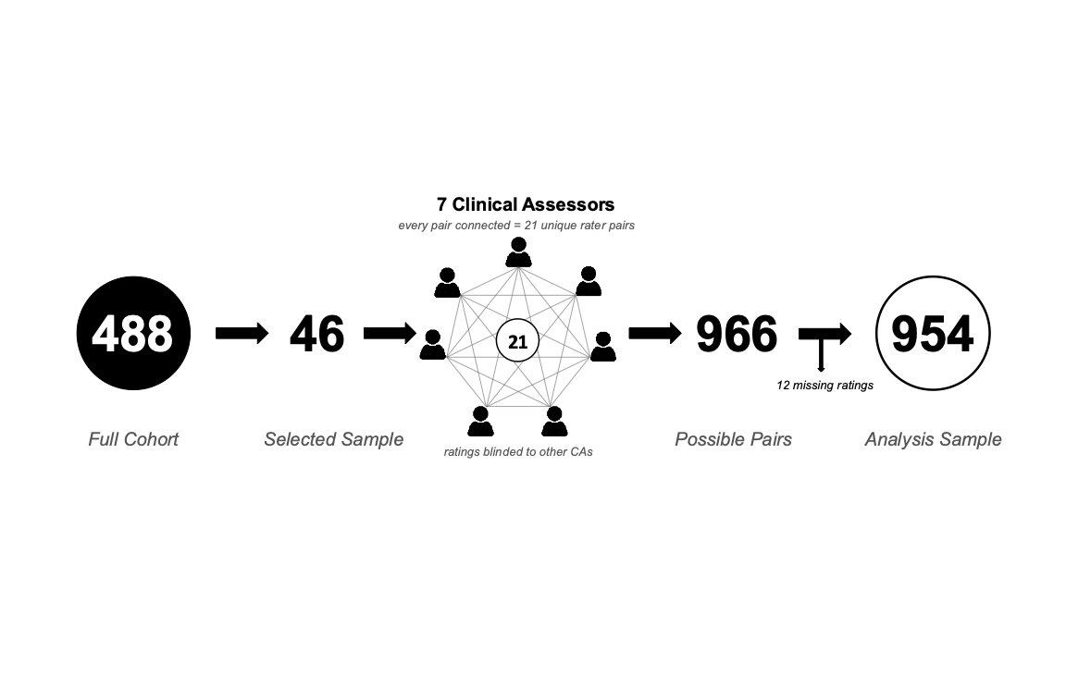
Supplemental Figure 1. Derivation of 954 Paired Ratings for Inter-Rater Reliability Analysis. The BASIL II study enrolled n=488 participants into the full cohort. From the full cohort, a sample of n=46 participants were selected to create a reliability sample. Cases were selected sequentially to ensure representation of both delirium positive and negative cases across all study sites, with an intended sample size of 25-50 to assure statistical stability. Seven clinical assessors rated delirium severity in each of the participants in the reliability sample. For the analysis, this resulted in 21 unique rater pairs [(7 assessors x 6 pairs)/2], with a total number of possible pairs 21 rater pairs x 46 participants = 966 paired ratings. Because one assessor had missing ratings for two participants, there was a total of 12 missing paired ratings. Thus, the analysis sample was 954 paired ratings.



Independent Review
yes
no
Data Available to Clinical Assessor:
Demographics
Age
Gender
Education
English as first language
Vision Impairment
Hearing Impairment
Baseline Instruments
MoCA
SIB-8 (Site 3)
DSI
CAM
CAM-S
Acute Instruments
MoCA
CAM
CAM-S
Functional Measures (self-report)
ADLs
IADLs
Estimated DSRS
PHQ-9
Proxy Measures
FAM-CAM
AD8
Open Chart Review – including history of delirium, dementia, or depression; newly started on antipsychotic
Nurse Interview – acute change; newly started antipsychotic or behavioral management
Consensus
(5 of 7)
Group Discussion

Inter-rater Agreement?
Supplemental Figure 2. Flow Diagram of Clinical Assessor Process. AD8 = 8-item Informant Interview to Differentiate Aging and Dementia; ADLs = Activities of Daily Living; CAM = Confusion Assessment Method; CAM-S = Confusion Assessment Method – Severity Scale; DSI = Abbreviated Delirium Symptom Interview; DSRS = Dementia Severity Rating Scale; FAM-CAM = Family Confusion Assessment Method; IADLs = Instrumental Activities of Daily Living; MoCA = Montreal Cognitive Assessment; PHQ-9 = 9-item Patient Health Questionnaire; SIB-8 = 8-item Severe Impairment Battery.

