Analysis2: agreement among independent packet reviewers
2026-10-10
Table of contents

Purpose and design
This is a re-analysis of agreement of delirium severity among 7 BASIL reference standard clinical raters as described in the draft manuscript Inter-rater reliability of delirium severity ratings using a standardized clinical assessment of delirium in at-risk patients (AMGP-26-510). The main analytic criticism was lack of clarity among statistical methods and failure to use standard methods for multiple rater reliability assessment, and reporting Pearson’s correlations when kappa statistics are more standard. The new analysis extends Conger’s kappa to incorporate entropy-balanced participant weights. These estimates are the primary results. We retain the all-pairs data structure only for preparing graphical displays of agreement. We no longer report correlation coefficients, only kappas and absolute deviations (differences).
Conger’s kappa is a chance-corrected agreement statistic that accommodates category weights (providing partial credit for close severity ratings). Category weights and participant weights serve different purposes. The primary analysis uses entropy balancing to match the reliability sample to the full BASIL cohort on mean reference-standard delirium severity and site proportions. Equal-participant-weight results are retained only in the technical report for comparison and implementation validation. Conger’s kappa and pooled all-pairs Cohen’s kappa may be numerically similar, but they are not algebraically equivalent.
A potential point of confusion is that weights enter the reliability assessment in the agreement cells. Weights also enter the analysis at the individual participant level to account for differences in the sampled persons from the overall basal sample. This has to be described carefully.
This analysis report does four main things:
- We describe the new analyses in technical and computational detail, and high-level statistical results that are not ready for manuscript presentation.
- We describe the statistical results.
- We identify text in the submitted manuscript, reprint it as struck out text, and replace it with new text that reflects the new analyses.
- We present a new set of tables and figures to replace the original tables and figures in the submitted manuscript.
Technical tables are labelled Table TA, Table TB, and so on: “T” denotes “Technical output,” and the letters index tables in report order. After Table TZ, the sequence continues with Table TAA, Table TAB, and so on. Tables prepared for the revised manuscript retain their manuscript labels (Table 1, Supplemental Table 1, and Supplemental Table 2), so they can be distinguished from the technical output.
References to original manuscript passages use page numbers in the current PDF, counting from its title page as page 1. These refer to pages in the source manuscript, not pages in this analysis report.
This analysis report is not a point-by-point response of reviewer critiques, and it is not a comprehensive revision of the submitted manuscript. Nevertheless, it is informative of those end products. In this report, we refer to “analysis1” that is the analysis done for the submitted manuscript. This analysis is referred to as “analysis2.”

Inputs and missing ratings
The import and participant-level harmonization were adapted from Analysis1’s 030, 040, and 045 scripts. The local workbook is SourceData/FINAL RS IRR Ratings.xlsx; the parent-cohort inputs are BASILIIMainStudy_Derived.dta and n488.dta in the relative folder specified in this control file. As in Analysis1, Tamara’s rows are excluded, participant identifiers are trimmed before joining, and a rating without an arrow is carried forward as its post-discussion rating. Those carried-forward ratings do not establish that a case was discussed.
Available ratings are used without imputing absent reviewer scores. Each outcome is checked separately. Participants with fewer than 2 ratings or a reviewer with no ratings cause the run to stop. A complete-participant sensitivity estimate drops participants missing any of the 7 ratings for that outcome and stage.
Table TA. Availability of reviewer ratings by outcome and rating stage
outcome_stage | participants | observed | missing | complete_participants | graphic_comparisons
severity_initial | 46 | 320 | 2 | 44 | 954
severity_consensus | 46 | 320 | 2 | 44 | 954
presence_initial | 46 | 320 | 2 | 44 | 954
presence_consensus | 46 | 320 | 2 | 44 | 954
NOTES. outcome_stage: Outcome and rating stage; consensus denotes post-discussion ratings. participants: Number of participants in the rating matrix. observed: Number of nonmissing participant-reviewer ratings. missing: Number of absent ratings among the possible participant-reviewer ratings. complete_participants: Number of participants with all 7 reviewer ratings. graphic_comparisons: Number of observed unique reviewer pairs, summed across participants.
Table TB. Available ratings by anonymous reviewer
reviewer | severity_initial | severity_consensus | presence_initial | presence_consensus
Reviewer1 | 46 | 46 | 46 | 46
Reviewer2 | 46 | 46 | 46 | 46
Reviewer3 | 46 | 46 | 46 | 46
Reviewer4 | 46 | 46 | 46 | 46
Reviewer5 | 46 | 46 | 46 | 46
Reviewer6 | 44 | 44 | 44 | 44
Reviewer7 | 46 | 46 | 46 | 46
NOTES. reviewer: Anonymous identifier for a fixed member of the 7-reviewer panel. severity_initial: Number of available initial severity ratings. severity_consensus: Number of available post-discussion severity ratings. presence_initial: Number of available initial presence ratings. presence_consensus: Number of available post-discussion presence ratings.
Table TC. Reliability sample and reference-standard dementia status
measure | count
Reliability participants | 46
Reference-standard dementia present | 27
Reference-standard dementia absent | 19
NOTES. measure: Sample count or reference-standard dementia category. count: Number of participants in the named category.
Table TD. Reference-standard delirium severity distribution in the reliability sample
reference_standard_severity | participants
0 | 21
1 | 4
3 | 2
4 | 7
5 | 4
6 | 5
7 | 2
8 | 1
NOTES. reference_standard_severity: Reference-standard delirium severity score, on the 0-10 scale. participants: Number of participants with the score shown.
Table TE. Distribution of reviewer-assigned delirium severity scores
outcome_stage | severity | ratings | denominator
severity_initial | 0 | 109 | 320
severity_initial | 1 | 43 | 320
severity_initial | 2 | 17 | 320
severity_initial | 3 | 18 | 320
severity_initial | 4 | 30 | 320
severity_initial | 5 | 39 | 320
severity_initial | 6 | 30 | 320
severity_initial | 7 | 20 | 320
severity_initial | 8 | 7 | 320
severity_initial | 9 | 7 | 320
severity_initial | 10 | 0 | 320
severity_consensus | 0 | 98 | 320
severity_consensus | 1 | 48 | 320
severity_consensus | 2 | 30 | 320
severity_consensus | 3 | 12 | 320
severity_consensus | 4 | 23 | 320
severity_consensus | 5 | 40 | 320
severity_consensus | 6 | 40 | 320
severity_consensus | 7 | 17 | 320
severity_consensus | 8 | 7 | 320
severity_consensus | 9 | 5 | 320
severity_consensus | 10 | 0 | 320
NOTES. outcome_stage: Initial or post-discussion severity ratings. severity: Reviewer-assigned delirium severity score, on the 0-10 scale. ratings: Number of observed ratings equal to the score shown. denominator: Total number of nonmissing ratings at that stage.

Agreement and uncertainty
The primary estimate is calculated with our participant-weighted extension of Conger’s kappa. We adapted the irrCAC implementation so that entropy-balanced participant weights enter both observed agreement and each reviewer’s category proportions. This is our extension, rather than a participant-weighting option in the package. With every participant weight set to 1, our code is checked against irrCAC::conger.kappa.raw for each estimable outcome, stage, and dementia group; the technical tables report the differences, and the run stops if any exceed 0.00001. Installed irrCAC version: 1.4; R version: 4.6.1.
Cohen’s kappa summarizes agreement between 2 reviewers, whereas Conger’s kappa extends the calculation to a panel of reviewers. Both compare observed agreement ($P_{o}$) with the agreement expected from reviewers’ separate use of the rating categories ($P_{e}$):
$$κ=\frac{P_{o}−P_{e}}{1−P_{e}}.$$
A value of 1 indicates perfect agreement; 0 indicates agreement equal to that expected under this chance model; negative values indicate less agreement than expected. This chance model assumes independent ratings with each reviewer’s observed category proportions.
For Cohen’s kappa, expected agreement is calculated from the category proportions of the 2 reviewers:
PeCohen=a​b​wab p1a p2b.
Here, $p_{ja}$ is the proportion of reviewer $j$’s available ratings in category $a$, and $w_{ab}$ is the agreement credit for ratings $a$ and $b$. Traditional, unweighted Cohen’s kappa gives credit only to identical ratings ($w_{ab}=1$ if $a=b$, and 0 otherwise). Weighted kappa also gives partial credit to close ratings.
Conger’s kappa averages expected agreement across all distinct reviewer pairs, retaining each reviewer’s own category proportions. For our 7 reviewers, there are 21 pairs:
PeConger=121j<k​a​b​wab pja pkb.
For standard Conger’s kappa, observed agreement is calculated by averaging agreement credit across available reviewer pairs within each participant, then across participants. Conger’s kappa combines observed and expected agreement into a single panel estimate, rather than averaging 21 separately calculated kappas. With only 2 reviewers, it reduces to Cohen’s kappa using the same agreement weights. For severity scores on our 0-10 scale, $w_{ab}=1−{\left(a−b\right)}^{2}/100$; for delirium presence, only identical ratings receive credit.

Participant-weighted extension
Our extension retains the same kappa formula and distinct-reviewer-pair calculation of expected agreement. We replace equal-participant averages with entropy-weighted averages. If $v_{i}$ is participant $i$’s entropy weight, $R_{ij}$ is reviewer $j$’s rating, and $A_{i}$ is the average agreement credit across available reviewer pairs for that participant, then
Po=i​viAii​vi, pja=i: Rij observed​vi 1Rij=ai: Rij observed​vi.
The indicator $1\left(R_{ij}=a\right)$ is 1 when the rating equals category $a$ and 0 otherwise. These weighted category proportions are substituted into $P_{e}^{Conger}$. Setting every $v_{i}=1$ recovers the standard equal-participant-weight calculation. The primary estimates use the entropy weights; the equal-weight special case is used for validation and technical comparison.
Uncertainty is summarized by percentile 95% confidence intervals from 2000 bootstrap samples of participants. All reviewer columns and the observed missingness pattern travel together. The same participant sample is used for initial and post-discussion κ when estimating their paired change. Reviewers are treated as a fixed panel, so these intervals describe uncertainty across participants conditional on the 7 reviewers; they do not quantify variation over a population of reviewers.
Table TF. Primary agreement with entropy-balanced participant weights: Delirium severity, initial ratings
group | participants | metric | estimate | lower | upper | valid_bootstrap | attempted
Overall | 46 | Kappa | 0.821 | 0.736 | 0.877 | 2000 | 2000
Overall | 46 | exact | 0.441 | 0.343 | 0.549 | 2000 | 2000
Overall | 46 | within2 | 0.888 | 0.842 | 0.934 | 2000 | 2000
Overall | 46 | MAD | 0.941 | 0.732 | 1.158 | 2000 | 2000
No dementia | 19 | Kappa | 0.832 | 0.691 | 0.910 | 2000 | 2000
No dementia | 19 | exact | 0.526 | 0.367 | 0.685 | 2000 | 2000
No dementia | 19 | within2 | 0.904 | 0.832 | 0.964 | 2000 | 2000
No dementia | 19 | MAD | 0.789 | 0.473 | 1.132 | 2000 | 2000
Dementia | 27 | Kappa | 0.799 | 0.655 | 0.866 | 2000 | 2000
Dementia | 27 | exact | 0.313 | 0.261 | 0.361 | 2000 | 2000
Dementia | 27 | within2 | 0.865 | 0.802 | 0.926 | 2000 | 2000
Dementia | 27 | MAD | 1.169 | 1.024 | 1.354 | 2000 | 2000
NOTES. group: Overall sample or stratum defined by reference-standard dementia status. participants: Number of participants contributing ratings to the group. metric: Kappa: Conger’s generalized kappa (quadratic category weights for severity, identity weights for presence); exact: proportion of reviewer pairs with identical ratings; within2: proportion differing by at most 2 severity points; MAD: mean absolute severity difference in points. Descriptive measures are first calculated within participant, then averaged across participants. estimate: Point estimate of the measure named in metric; exact and within2 are on a 0-1 scale. lower: Lower limit of the percentile 95% participant-bootstrap confidence interval. upper: Upper limit of the percentile 95% participant-bootstrap confidence interval. valid_bootstrap: Number of bootstrap replicates with a finite estimate. attempted: Total number of bootstrap replicates attempted. Entropy-balanced participant weights enter observed agreement and reviewer category proportions. Severity uses quadratic agreement weights; presence gives credit only to identical ratings. Bootstrap intervals hold participant weights fixed, omit weight-estimation uncertainty, and condition on the fixed reviewer panel.
Table TG. Primary agreement with entropy-balanced participant weights: Delirium severity, post-discussion ratings
group | participants | metric | estimate | lower | upper | valid_bootstrap | attempted
Overall | 46 | Kappa | 0.927 | 0.892 | 0.946 | 2000 | 2000
Overall | 46 | exact | 0.532 | 0.449 | 0.620 | 2000 | 2000
Overall | 46 | within2 | 1.000 | 1.000 | 1.000 | 2000 | 2000
Overall | 46 | MAD | 0.589 | 0.473 | 0.707 | 2000 | 2000
No dementia | 19 | Kappa | 0.941 | 0.894 | 0.962 | 2000 | 2000
No dementia | 19 | exact | 0.616 | 0.500 | 0.738 | 2000 | 2000
No dementia | 19 | within2 | 1.000 | 1.000 | 1.000 | 2000 | 2000
No dementia | 19 | MAD | 0.463 | 0.314 | 0.620 | 2000 | 2000
Dementia | 27 | Kappa | 0.905 | 0.840 | 0.930 | 2000 | 2000
Dementia | 27 | exact | 0.405 | 0.352 | 0.478 | 2000 | 2000
Dementia | 27 | within2 | 1.000 | 1.000 | 1.000 | 2000 | 2000
Dementia | 27 | MAD | 0.778 | 0.672 | 0.862 | 2000 | 2000
NOTES. group: Overall sample or stratum defined by reference-standard dementia status. participants: Number of participants contributing ratings to the group. metric: Kappa: Conger’s generalized kappa (quadratic category weights for severity, identity weights for presence); exact: proportion of reviewer pairs with identical ratings; within2: proportion differing by at most 2 severity points; MAD: mean absolute severity difference in points. Descriptive measures are first calculated within participant, then averaged across participants. estimate: Point estimate of the measure named in metric; exact and within2 are on a 0-1 scale. lower: Lower limit of the percentile 95% participant-bootstrap confidence interval. upper: Upper limit of the percentile 95% participant-bootstrap confidence interval. valid_bootstrap: Number of bootstrap replicates with a finite estimate. attempted: Total number of bootstrap replicates attempted. Entropy-balanced participant weights enter observed agreement and reviewer category proportions. Severity uses quadratic agreement weights; presence gives credit only to identical ratings. Bootstrap intervals hold participant weights fixed, omit weight-estimation uncertainty, and condition on the fixed reviewer panel.
Table TH. Primary agreement with entropy-balanced participant weights: Delirium presence, initial ratings
group | participants | metric | estimate | lower | upper | valid_bootstrap | attempted
Overall | 46 | Kappa | 0.745 | 0.619 | 0.850 | 2000 | 2000
Overall | 46 | exact | 0.885 | 0.831 | 0.936 | 2000 | 2000
No dementia | 19 | Kappa | 0.753 | 0.567 | 0.894 | 2000 | 2000
No dementia | 19 | exact | 0.890 | 0.815 | 0.959 | 2000 | 2000
Dementia | 27 | Kappa | 0.734 | 0.534 | 0.883 | 2000 | 2000
Dementia | 27 | exact | 0.878 | 0.797 | 0.952 | 2000 | 2000
NOTES. group: Overall sample or stratum defined by reference-standard dementia status. participants: Number of participants contributing ratings to the group. metric: Kappa: Conger’s generalized kappa (quadratic category weights for severity, identity weights for presence); exact: proportion of reviewer pairs with identical ratings; within2: proportion differing by at most 2 severity points; MAD: mean absolute severity difference in points. Descriptive measures are first calculated within participant, then averaged across participants. estimate: Point estimate of the measure named in metric; exact and within2 are on a 0-1 scale. lower: Lower limit of the percentile 95% participant-bootstrap confidence interval. upper: Upper limit of the percentile 95% participant-bootstrap confidence interval. valid_bootstrap: Number of bootstrap replicates with a finite estimate. attempted: Total number of bootstrap replicates attempted. Entropy-balanced participant weights enter observed agreement and reviewer category proportions. Severity uses quadratic agreement weights; presence gives credit only to identical ratings. Bootstrap intervals hold participant weights fixed, omit weight-estimation uncertainty, and condition on the fixed reviewer panel.
Table TI. Primary agreement with entropy-balanced participant weights: Delirium presence, post-discussion ratings
group | participants | metric | estimate | lower | upper | valid_bootstrap | attempted
Overall | 46 | Kappa | 0.790 | 0.665 | 0.887 | 2000 | 2000
Overall | 46 | exact | 0.903 | 0.849 | 0.951 | 2000 | 2000
No dementia | 19 | Kappa | 0.768 | 0.586 | 0.902 | 2000 | 2000
No dementia | 19 | exact | 0.895 | 0.824 | 0.962 | 2000 | 2000
Dementia | 27 | Kappa | 0.822 | 0.640 | 0.947 | 2000 | 2000
Dementia | 27 | exact | 0.916 | 0.844 | 0.977 | 2000 | 2000
NOTES. group: Overall sample or stratum defined by reference-standard dementia status. participants: Number of participants contributing ratings to the group. metric: Kappa: Conger’s generalized kappa (quadratic category weights for severity, identity weights for presence); exact: proportion of reviewer pairs with identical ratings; within2: proportion differing by at most 2 severity points; MAD: mean absolute severity difference in points. Descriptive measures are first calculated within participant, then averaged across participants. estimate: Point estimate of the measure named in metric; exact and within2 are on a 0-1 scale. lower: Lower limit of the percentile 95% participant-bootstrap confidence interval. upper: Upper limit of the percentile 95% participant-bootstrap confidence interval. valid_bootstrap: Number of bootstrap replicates with a finite estimate. attempted: Total number of bootstrap replicates attempted. Entropy-balanced participant weights enter observed agreement and reviewer category proportions. Severity uses quadratic agreement weights; presence gives credit only to identical ratings. Bootstrap intervals hold participant weights fixed, omit weight-estimation uncertainty, and condition on the fixed reviewer panel.
Table TJ. Paired change in overall kappa following discussion
outcome | weighting | estimate | lower | upper | valid_bootstrap | attempted
severity | Equal participant weights | 0.088 | 0.057 | 0.133 | 2000 | 2000
presence | Equal participant weights | 0.039 | 0.005 | 0.083 | 2000 | 2000
severity | Entropy balanced | 0.106 | 0.063 | 0.174 | 2000 | 2000
presence | Entropy balanced | 0.045 | 0.007 | 0.102 | 2000 | 2000
NOTES. outcome: Delirium severity or delirium presence. weighting: Entropy balanced: primary analysis; Equal participant weights: technical comparison. estimate: Post-discussion kappa minus initial kappa; positive values indicate higher post-discussion agreement. lower: Lower limit of the percentile 95% participant-bootstrap confidence interval. upper: Upper limit of the percentile 95% participant-bootstrap confidence interval. valid_bootstrap: Number of bootstrap replicates with a finite estimate. attempted: Total number of bootstrap replicates attempted. Each bootstrap draw uses the same participants and their fixed weights for both rating stages. Entropy-balanced intervals omit weight-estimation uncertainty. The change is descriptive and does not identify a causal effect of discussion.
Table TK. Technical sensitivity analysis among participants with complete reviewer ratings: Delirium severity, initial ratings
group | weighting | n | kappa
Overall | Equal participant weights | 44 | 0.843
Overall | Entropy balanced | 44 | 0.818
No dementia | Equal participant weights | 18 | 0.843
No dementia | Entropy balanced | 18 | 0.825
Dementia | Equal participant weights | 26 | 0.834
Dementia | Entropy balanced | 26 | 0.798
NOTES. group: Overall sample or stratum defined by reference-standard dementia status. weighting: Entropy balanced: original full-cohort participant weights retained; Equal participant weights: no entropy weights. n: Number of participants with all 7 reviewer ratings for the outcome and stage. kappa: Participant-weighted extension of Conger’s kappa, using quadratic agreement weights for severity and identity weights for presence.
Table TL. Technical sensitivity analysis among participants with complete reviewer ratings: Delirium severity, post-discussion ratings
group | weighting | n | kappa
Overall | Equal participant weights | 44 | 0.934
Overall | Entropy balanced | 44 | 0.928
No dementia | Equal participant weights | 18 | 0.939
No dementia | Entropy balanced | 18 | 0.942
Dementia | Equal participant weights | 26 | 0.926
Dementia | Entropy balanced | 26 | 0.906
NOTES. group: Overall sample or stratum defined by reference-standard dementia status. weighting: Entropy balanced: original full-cohort participant weights retained; Equal participant weights: no entropy weights. n: Number of participants with all 7 reviewer ratings for the outcome and stage. kappa: Participant-weighted extension of Conger’s kappa, using quadratic agreement weights for severity and identity weights for presence.
Table TM. Technical sensitivity analysis among participants with complete reviewer ratings: Delirium presence, initial ratings
group | weighting | n | kappa
Overall | Equal participant weights | 44 | 0.776
Overall | Entropy balanced | 44 | 0.758
No dementia | Equal participant weights | 18 | 0.776
No dementia | Entropy balanced | 18 | 0.779
Dementia | Equal participant weights | 26 | 0.773
Dementia | Entropy balanced | 26 | 0.729
NOTES. group: Overall sample or stratum defined by reference-standard dementia status. weighting: Entropy balanced: original full-cohort participant weights retained; Equal participant weights: no entropy weights. n: Number of participants with all 7 reviewer ratings for the outcome and stage. kappa: Participant-weighted extension of Conger’s kappa, using quadratic agreement weights for severity and identity weights for presence.
Table TN. Technical sensitivity analysis among participants with complete reviewer ratings: Delirium presence, post-discussion ratings
group | weighting | n | kappa
Overall | Equal participant weights | 44 | 0.817
Overall | Entropy balanced | 44 | 0.807
No dementia | Equal participant weights | 18 | 0.800
No dementia | Entropy balanced | 18 | 0.795
Dementia | Equal participant weights | 26 | 0.824
Dementia | Entropy balanced | 26 | 0.818
NOTES. group: Overall sample or stratum defined by reference-standard dementia status. weighting: Entropy balanced: original full-cohort participant weights retained; Equal participant weights: no entropy weights. n: Number of participants with all 7 reviewer ratings for the outcome and stage. kappa: Participant-weighted extension of Conger’s kappa, using quadratic agreement weights for severity and identity weights for presence.
Severity exact agreement, agreement within 2 points, and mean absolute difference (MAD) are calculated from category counts within each participant, then averaged using the entropy-balanced participant weights. A participant’s overall contribution depends on the entropy weight, rather than the number of available reviewer pairs. This calculation preserves the original within-2-point definition without using a pooled all-pairs dataset for statistics. Binary exact agreement is summarized in the same manner. Proportions are shown on a 0–1 scale.
Agreement is estimated separately for participants with and without reference-standard dementia. These estimates describe agreement within each group. Comparisons of kappa require caution because the distribution of rating categories influences the coefficient; differences do not by themselves establish differences in reviewer performance, and similar estimates do not establish equivalent agreement. The paired change describes the difference between stages; without a control group it cannot identify the causal effect of discussion.

Participant weighting
The primary analysis uses entropy balancing to match the reliability sample to the full enrolled cohort on mean reference-standard delirium severity and the proportions of participants included at sites 2 and 3. These weights balance the specified covariate means; extending agreement estimates to the full cohort still requires assumptions about rating behavior beyond the selected sample.
Difference from Analysis1: Analysis2 uses the full enrolled cohort of 488 participants as the entropy-balancing target, consistent with the manuscript’s stated aim of matching the reliability sample to the full BASIL II sample. Analysis1’s code instead matched the 46 reliability participants to the 442 participants outside that sample. This change aligns the weighting target with the stated aim; it is separate from the change to Conger’s kappa. Weighting balances mean reference-standard delirium severity and site proportions, but does not establish that agreement in the selected reliability sample generalizes to the full cohort.
Table TO. Covariate balance before and after entropy weighting
Characteristic | Full cohort (n = 488): target | Reliability sample (n = 46): before weighting | Reliability sample (n = 46): after entropy weighting
Reference-standard delirium severity, mean (0-10) | 1.719 | 2.391 | 1.719
Enrollment at UF (site 2), proportion (0-1) | 0.342 | 0.304 | 0.342
Enrollment at TNJH (site 3), proportion (0-1) | 0.207 | 0.478 | 0.207
NOTES. Characteristic: Mean reference-standard delirium severity score (0-10) or proportion enrolled at the named site (0-1). Full cohort (n = 488): target: Desired mean or proportion in the full enrolled cohort, including reliability participants. Reliability sample (n = 46): before weighting: Observed mean or proportion in the reliability sample, with each participant contributing equally. Reliability sample (n = 46): after entropy weighting: Achieved mean or proportion in the reliability sample after applying entropy-balanced participant weights. A site proportion of 0.25 means 25% of participants. Site 1 (BIDMC) is the remaining proportion after subtracting sites 2 and 3 from 1. Matching these covariate means does not establish generalizability.
Table TP. Distribution of entropy weights and effective sample size
n | minimum | maximum | ESS
46 | 0.198 | 2.836 | 30.208
NOTES. n: Number of participants with entropy weights. minimum: Smallest participant weight. maximum: Largest participant weight. ESS: Effective sample size: squared sum of weights divided by the sum of squared weights. Weights are normalized to sum to the number of reliability participants.
Table TQ. Technical comparison with equal participant weights: Delirium severity, initial ratings
group | participants | metric | estimate | lower | upper | valid_bootstrap | attempted
Overall | 46 | Kappa | 0.844 | 0.774 | 0.885 | 2000 | 2000
Overall | 46 | exact | 0.378 | 0.315 | 0.453 | 2000 | 2000
Overall | 46 | within2 | 0.884 | 0.842 | 0.922 | 2000 | 2000
Overall | 46 | MAD | 1.051 | 0.883 | 1.213 | 2000 | 2000
No dementia | 19 | Kappa | 0.845 | 0.740 | 0.906 | 2000 | 2000
No dementia | 19 | exact | 0.492 | 0.365 | 0.623 | 2000 | 2000
No dementia | 19 | within2 | 0.902 | 0.847 | 0.957 | 2000 | 2000
No dementia | 19 | MAD | 0.842 | 0.571 | 1.103 | 2000 | 2000
Dementia | 27 | Kappa | 0.836 | 0.739 | 0.889 | 2000 | 2000
Dementia | 27 | exact | 0.297 | 0.247 | 0.351 | 2000 | 2000
Dementia | 27 | within2 | 0.871 | 0.817 | 0.924 | 2000 | 2000
Dementia | 27 | MAD | 1.199 | 1.026 | 1.379 | 2000 | 2000
NOTES. group: Overall sample or stratum defined by reference-standard dementia status. participants: Number of participants contributing ratings to the group. metric: Kappa: Conger’s generalized kappa (quadratic category weights for severity, identity weights for presence); exact: proportion of reviewer pairs with identical ratings; within2: proportion differing by at most 2 severity points; MAD: mean absolute severity difference in points. Descriptive measures are first calculated within participant, then averaged across participants. estimate: Point estimate of the measure named in metric; exact and within2 are on a 0-1 scale. lower: Lower limit of the percentile 95% participant-bootstrap confidence interval. upper: Upper limit of the percentile 95% participant-bootstrap confidence interval. valid_bootstrap: Number of bootstrap replicates with a finite estimate. attempted: Total number of bootstrap replicates attempted. Participants contribute equally; no entropy-balancing weights are applied. This analysis is retained for technical comparison, not manuscript presentation. Intervals condition on the fixed reviewer panel.
Table TR. Technical comparison with equal participant weights: Delirium severity, post-discussion ratings
group | participants | metric | estimate | lower | upper | valid_bootstrap | attempted
Overall | 46 | Kappa | 0.932 | 0.904 | 0.948 | 2000 | 2000
Overall | 46 | exact | 0.476 | 0.417 | 0.539 | 2000 | 2000
Overall | 46 | within2 | 1.000 | 1.000 | 1.000 | 2000 | 2000
Overall | 46 | MAD | 0.670 | 0.581 | 0.755 | 2000 | 2000
No dementia | 19 | Kappa | 0.937 | 0.897 | 0.957 | 2000 | 2000
No dementia | 19 | exact | 0.577 | 0.466 | 0.689 | 2000 | 2000
No dementia | 19 | within2 | 1.000 | 1.000 | 1.000 | 2000 | 2000
No dementia | 19 | MAD | 0.526 | 0.376 | 0.682 | 2000 | 2000
Dementia | 27 | Kappa | 0.926 | 0.883 | 0.944 | 2000 | 2000
Dementia | 27 | exact | 0.405 | 0.354 | 0.460 | 2000 | 2000
Dementia | 27 | within2 | 1.000 | 1.000 | 1.000 | 2000 | 2000
Dementia | 27 | MAD | 0.772 | 0.684 | 0.856 | 2000 | 2000
NOTES. group: Overall sample or stratum defined by reference-standard dementia status. participants: Number of participants contributing ratings to the group. metric: Kappa: Conger’s generalized kappa (quadratic category weights for severity, identity weights for presence); exact: proportion of reviewer pairs with identical ratings; within2: proportion differing by at most 2 severity points; MAD: mean absolute severity difference in points. Descriptive measures are first calculated within participant, then averaged across participants. estimate: Point estimate of the measure named in metric; exact and within2 are on a 0-1 scale. lower: Lower limit of the percentile 95% participant-bootstrap confidence interval. upper: Upper limit of the percentile 95% participant-bootstrap confidence interval. valid_bootstrap: Number of bootstrap replicates with a finite estimate. attempted: Total number of bootstrap replicates attempted. Participants contribute equally; no entropy-balancing weights are applied. This analysis is retained for technical comparison, not manuscript presentation. Intervals condition on the fixed reviewer panel.
Table TS. Technical comparison with equal participant weights: Delirium presence, initial ratings
group | participants | metric | estimate | lower | upper | valid_bootstrap | attempted
Overall | 46 | Kappa | 0.771 | 0.661 | 0.859 | 2000 | 2000
Overall | 46 | exact | 0.887 | 0.836 | 0.931 | 2000 | 2000
No dementia | 19 | Kappa | 0.756 | 0.581 | 0.891 | 2000 | 2000
No dementia | 19 | exact | 0.882 | 0.810 | 0.955 | 2000 | 2000
Dementia | 27 | Kappa | 0.781 | 0.619 | 0.901 | 2000 | 2000
Dementia | 27 | exact | 0.891 | 0.817 | 0.954 | 2000 | 2000
NOTES. group: Overall sample or stratum defined by reference-standard dementia status. participants: Number of participants contributing ratings to the group. metric: Kappa: Conger’s generalized kappa (quadratic category weights for severity, identity weights for presence); exact: proportion of reviewer pairs with identical ratings; within2: proportion differing by at most 2 severity points; MAD: mean absolute severity difference in points. Descriptive measures are first calculated within participant, then averaged across participants. estimate: Point estimate of the measure named in metric; exact and within2 are on a 0-1 scale. lower: Lower limit of the percentile 95% participant-bootstrap confidence interval. upper: Upper limit of the percentile 95% participant-bootstrap confidence interval. valid_bootstrap: Number of bootstrap replicates with a finite estimate. attempted: Total number of bootstrap replicates attempted. Participants contribute equally; no entropy-balancing weights are applied. This analysis is retained for technical comparison, not manuscript presentation. Intervals condition on the fixed reviewer panel.
Table TT. Technical comparison with equal participant weights: Delirium presence, post-discussion ratings
group | participants | metric | estimate | lower | upper | valid_bootstrap | attempted
Overall | 46 | Kappa | 0.810 | 0.702 | 0.896 | 2000 | 2000
Overall | 46 | exact | 0.906 | 0.857 | 0.949 | 2000 | 2000
No dementia | 19 | Kappa | 0.778 | 0.623 | 0.902 | 2000 | 2000
No dementia | 19 | exact | 0.892 | 0.825 | 0.955 | 2000 | 2000
Dementia | 27 | Kappa | 0.831 | 0.685 | 0.943 | 2000 | 2000
Dementia | 27 | exact | 0.915 | 0.852 | 0.972 | 2000 | 2000
NOTES. group: Overall sample or stratum defined by reference-standard dementia status. participants: Number of participants contributing ratings to the group. metric: Kappa: Conger’s generalized kappa (quadratic category weights for severity, identity weights for presence); exact: proportion of reviewer pairs with identical ratings; within2: proportion differing by at most 2 severity points; MAD: mean absolute severity difference in points. Descriptive measures are first calculated within participant, then averaged across participants. estimate: Point estimate of the measure named in metric; exact and within2 are on a 0-1 scale. lower: Lower limit of the percentile 95% participant-bootstrap confidence interval. upper: Upper limit of the percentile 95% participant-bootstrap confidence interval. valid_bootstrap: Number of bootstrap replicates with a finite estimate. attempted: Total number of bootstrap replicates attempted. Participants contribute equally; no entropy-balancing weights are applied. This analysis is retained for technical comparison, not manuscript presentation. Intervals condition on the fixed reviewer panel.
Table TU. Technical comparison of entropy-balanced and equal-participant-weight estimates: Delirium severity, initial ratings
group | participants | metric | equal_estimate | entropy_estimate | difference
Overall | 46 | Kappa | 0.844 | 0.821 | -0.023
Overall | 46 | exact | 0.378 | 0.441 | 0.063
Overall | 46 | within2 | 0.884 | 0.888 | 0.004
Overall | 46 | MAD | 1.051 | 0.941 | -0.111
No dementia | 19 | Kappa | 0.845 | 0.832 | -0.013
No dementia | 19 | exact | 0.492 | 0.526 | 0.034
No dementia | 19 | within2 | 0.902 | 0.904 | 0.001
No dementia | 19 | MAD | 0.842 | 0.789 | -0.053
Dementia | 27 | Kappa | 0.836 | 0.799 | -0.037
Dementia | 27 | exact | 0.297 | 0.313 | 0.016
Dementia | 27 | within2 | 0.871 | 0.865 | -0.006
Dementia | 27 | MAD | 1.199 | 1.169 | -0.030
NOTES. group: Overall sample or stratum defined by reference-standard dementia status. participants: Number of participants contributing ratings to the group. metric: Kappa: Conger’s generalized kappa (quadratic category weights for severity, identity weights for presence); exact: proportion of reviewer pairs with identical ratings; within2: proportion differing by at most 2 severity points; MAD: mean absolute severity difference in points. Descriptive measures are first calculated within participant, then averaged across participants. equal_estimate: Estimate with equal participant weights. entropy_estimate: Primary estimate with entropy-balanced participant weights. difference: Entropy-balanced estimate minus equal-participant-weight estimate, on the metric’s original scale. Differences are descriptive, not tests of equivalence. These comparisons remain in the technical report; the manuscript presents only entropy-balanced agreement estimates.
Table TV. Technical comparison of entropy-balanced and equal-participant-weight estimates: Delirium severity, post-discussion ratings
group | participants | metric | equal_estimate | entropy_estimate | difference
Overall | 46 | Kappa | 0.932 | 0.927 | -0.005
Overall | 46 | exact | 0.476 | 0.532 | 0.056
Overall | 46 | within2 | 1.000 | 1.000 | 0.000
Overall | 46 | MAD | 0.670 | 0.589 | -0.082
No dementia | 19 | Kappa | 0.937 | 0.941 | 0.004
No dementia | 19 | exact | 0.577 | 0.616 | 0.039
No dementia | 19 | within2 | 1.000 | 1.000 | 0.000
No dementia | 19 | MAD | 0.526 | 0.463 | -0.063
Dementia | 27 | Kappa | 0.926 | 0.905 | -0.021
Dementia | 27 | exact | 0.405 | 0.405 | 0.000
Dementia | 27 | within2 | 1.000 | 1.000 | 0.000
Dementia | 27 | MAD | 0.772 | 0.778 | 0.006
NOTES. group: Overall sample or stratum defined by reference-standard dementia status. participants: Number of participants contributing ratings to the group. metric: Kappa: Conger’s generalized kappa (quadratic category weights for severity, identity weights for presence); exact: proportion of reviewer pairs with identical ratings; within2: proportion differing by at most 2 severity points; MAD: mean absolute severity difference in points. Descriptive measures are first calculated within participant, then averaged across participants. equal_estimate: Estimate with equal participant weights. entropy_estimate: Primary estimate with entropy-balanced participant weights. difference: Entropy-balanced estimate minus equal-participant-weight estimate, on the metric’s original scale. Differences are descriptive, not tests of equivalence. These comparisons remain in the technical report; the manuscript presents only entropy-balanced agreement estimates.
Table TW. Technical comparison of entropy-balanced and equal-participant-weight estimates: Delirium presence, initial ratings
group | participants | metric | equal_estimate | entropy_estimate | difference
Overall | 46 | Kappa | 0.771 | 0.745 | -0.026
Overall | 46 | exact | 0.887 | 0.885 | -0.002
No dementia | 19 | Kappa | 0.756 | 0.753 | -0.002
No dementia | 19 | exact | 0.882 | 0.890 | 0.007
Dementia | 27 | Kappa | 0.781 | 0.734 | -0.047
Dementia | 27 | exact | 0.891 | 0.878 | -0.012
NOTES. group: Overall sample or stratum defined by reference-standard dementia status. participants: Number of participants contributing ratings to the group. metric: Kappa: Conger’s generalized kappa (quadratic category weights for severity, identity weights for presence); exact: proportion of reviewer pairs with identical ratings; within2: proportion differing by at most 2 severity points; MAD: mean absolute severity difference in points. Descriptive measures are first calculated within participant, then averaged across participants. equal_estimate: Estimate with equal participant weights. entropy_estimate: Primary estimate with entropy-balanced participant weights. difference: Entropy-balanced estimate minus equal-participant-weight estimate, on the metric’s original scale. Differences are descriptive, not tests of equivalence. These comparisons remain in the technical report; the manuscript presents only entropy-balanced agreement estimates.
Table TX. Technical comparison of entropy-balanced and equal-participant-weight estimates: Delirium presence, post-discussion ratings
group | participants | metric | equal_estimate | entropy_estimate | difference
Overall | 46 | Kappa | 0.810 | 0.790 | -0.020
Overall | 46 | exact | 0.906 | 0.903 | -0.002
No dementia | 19 | Kappa | 0.778 | 0.768 | -0.010
No dementia | 19 | exact | 0.892 | 0.895 | 0.003
Dementia | 27 | Kappa | 0.831 | 0.822 | -0.009
Dementia | 27 | exact | 0.915 | 0.916 | 0.000
NOTES. group: Overall sample or stratum defined by reference-standard dementia status. participants: Number of participants contributing ratings to the group. metric: Kappa: Conger’s generalized kappa (quadratic category weights for severity, identity weights for presence); exact: proportion of reviewer pairs with identical ratings; within2: proportion differing by at most 2 severity points; MAD: mean absolute severity difference in points. Descriptive measures are first calculated within participant, then averaged across participants. equal_estimate: Estimate with equal participant weights. entropy_estimate: Primary estimate with entropy-balanced participant weights. difference: Entropy-balanced estimate minus equal-participant-weight estimate, on the metric’s original scale. Differences are descriptive, not tests of equivalence. These comparisons remain in the technical report; the manuscript presents only entropy-balanced agreement estimates.
Table TY. Validation against irrCAC with every participant weight set to 1: Delirium severity, initial ratings
group | matrix_kappa | package_kappa | absolute_difference | tolerance
Overall | 0.8437369 | 0.8437400 | 0.0000031 | 0.0000100
No dementia | 0.8448910 | 0.8448900 | 0.0000010 | 0.0000100
Dementia | 0.8360601 | 0.8360600 | 0.0000001 | 0.0000100
NOTES. group: Overall sample or stratum defined by reference-standard dementia status. matrix_kappa: Kappa from our participant-weighted implementation with every participant weight set to 1. package_kappa: Kappa returned by irrCAC::conger.kappa.raw using identical agreement weights and categories. absolute_difference: Absolute difference between the implementations; irrCAC rounds its returned estimate to 5 decimal places. tolerance: Maximum permitted absolute difference; the analysis stops if it is exceeded. Agreement weights remain quadratic for severity and identity for presence. This check validates the equal-participant-weight special case, not the weighted extension’s generalizability.
Table TZ. Validation against irrCAC with every participant weight set to 1: Delirium severity, post-discussion ratings
group | matrix_kappa | package_kappa | absolute_difference | tolerance
Overall | 0.9319529 | 0.9319500 | 0.0000029 | 0.0000100
No dementia | 0.9373727 | 0.9373700 | 0.0000027 | 0.0000100
Dementia | 0.9256112 | 0.9256100 | 0.0000012 | 0.0000100
NOTES. group: Overall sample or stratum defined by reference-standard dementia status. matrix_kappa: Kappa from our participant-weighted implementation with every participant weight set to 1. package_kappa: Kappa returned by irrCAC::conger.kappa.raw using identical agreement weights and categories. absolute_difference: Absolute difference between the implementations; irrCAC rounds its returned estimate to 5 decimal places. tolerance: Maximum permitted absolute difference; the analysis stops if it is exceeded. Agreement weights remain quadratic for severity and identity for presence. This check validates the equal-participant-weight special case, not the weighted extension’s generalizability.
Table TAA. Validation against irrCAC with every participant weight set to 1: Delirium presence, initial ratings
group | matrix_kappa | package_kappa | absolute_difference | tolerance
Overall | 0.7713065 | 0.7713100 | 0.0000035 | 0.0000100
No dementia | 0.7555136 | 0.7555100 | 0.0000036 | 0.0000100
Dementia | 0.7806427 | 0.7806400 | 0.0000027 | 0.0000100
NOTES. group: Overall sample or stratum defined by reference-standard dementia status. matrix_kappa: Kappa from our participant-weighted implementation with every participant weight set to 1. package_kappa: Kappa returned by irrCAC::conger.kappa.raw using identical agreement weights and categories. absolute_difference: Absolute difference between the implementations; irrCAC rounds its returned estimate to 5 decimal places. tolerance: Maximum permitted absolute difference; the analysis stops if it is exceeded. Agreement weights remain quadratic for severity and identity for presence. This check validates the equal-participant-weight special case, not the weighted extension’s generalizability.
Table TAB. Validation against irrCAC with every participant weight set to 1: Delirium presence, post-discussion ratings
group | matrix_kappa | package_kappa | absolute_difference | tolerance
Overall | 0.8102018 | 0.8102000 | 0.0000018 | 0.0000100
No dementia | 0.7777341 | 0.7777300 | 0.0000041 | 0.0000100
Dementia | 0.8306529 | 0.8306500 | 0.0000029 | 0.0000100
NOTES. group: Overall sample or stratum defined by reference-standard dementia status. matrix_kappa: Kappa from our participant-weighted implementation with every participant weight set to 1. package_kappa: Kappa returned by irrCAC::conger.kappa.raw using identical agreement weights and categories. absolute_difference: Absolute difference between the implementations; irrCAC rounds its returned estimate to 5 decimal places. tolerance: Maximum permitted absolute difference; the analysis stops if it is exceeded. Agreement weights remain quadratic for severity and identity for presence. This check validates the equal-participant-weight special case, not the weighted extension’s generalizability.
The weights argument of conger.kappa.raw specifies category agreement weights, not participant sampling weights. Our primary procedure is a participant-weighted extension of that implementation. Participant weights enter both observed agreement and each reviewer’s category margins. They are held fixed within bootstrap samples; those intervals condition on the estimated weights and target moments and omit weight-estimation uncertainty. The full-cohort interpretation requires that the selected cases adequately represent rating behavior after balancing the measured covariates. Balancing cannot establish that assumption.
The effective sample size (ESS) is the squared sum of participant weights divided by their sum of squares. Its relation to the number of reliability participants helps identify concentration of weights. Weighted subgroup estimates inherit the overall weights; no separate dementia target is imposed.

Descriptive pooled reviewer-pair displays
The displays include all observed unique reviewer pairs within each participant. The first and second reviewer refer to the lower and higher fixed reviewer-column indices, respectively; they do not identify 2 particular reviewers. Each participant contributes multiple dependent points. Point sizes show raw comparison counts. These graphics use no participant weights and contain no pooled κ, correlation, regression test, or confidence interval.
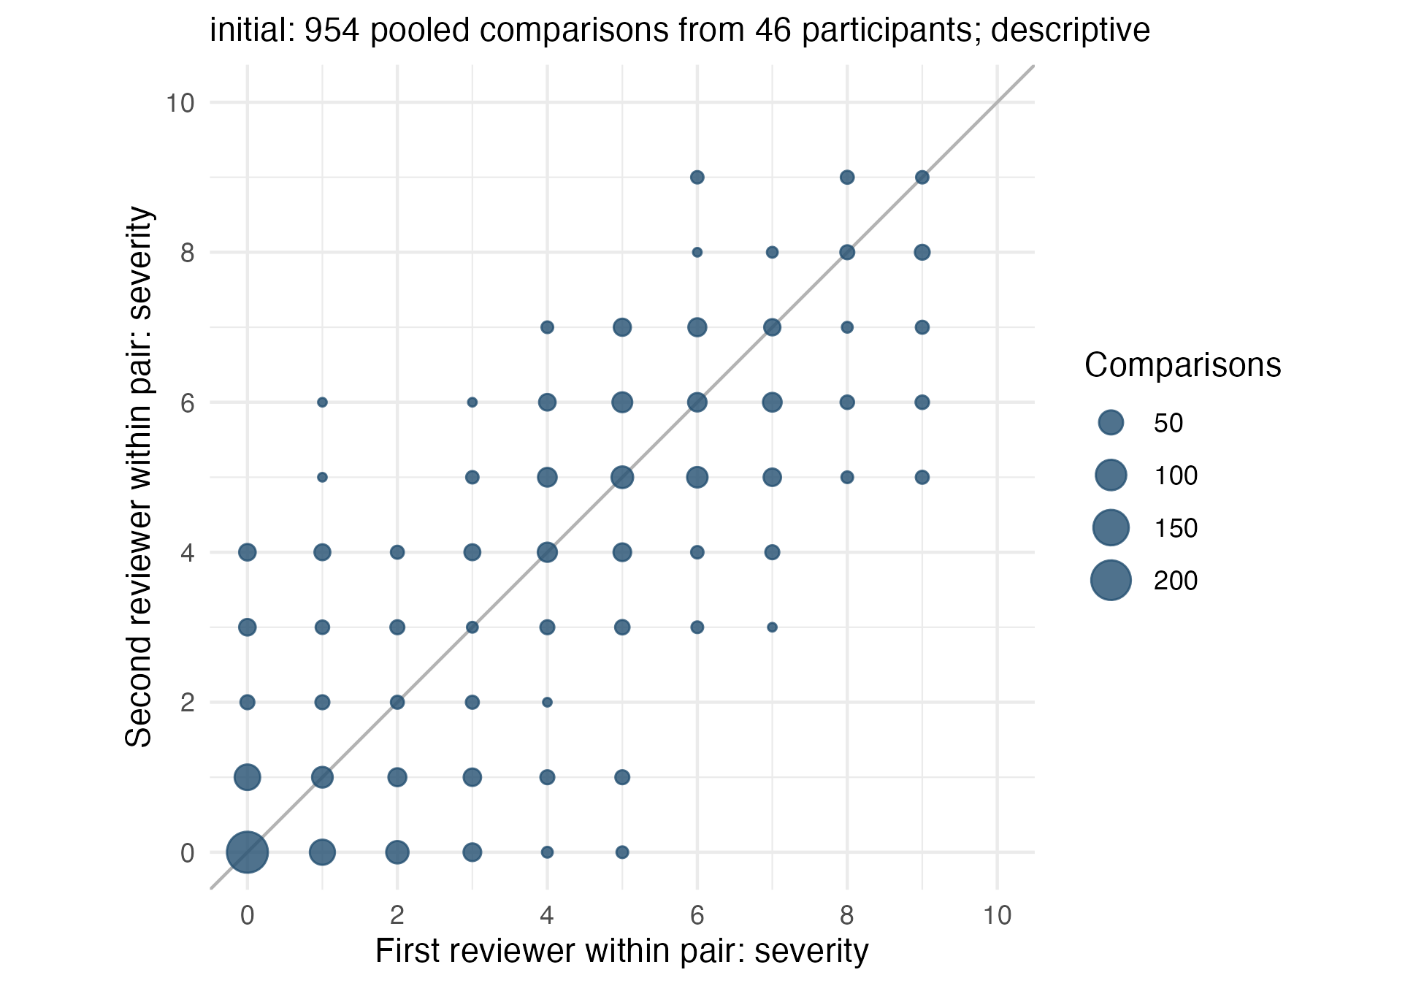
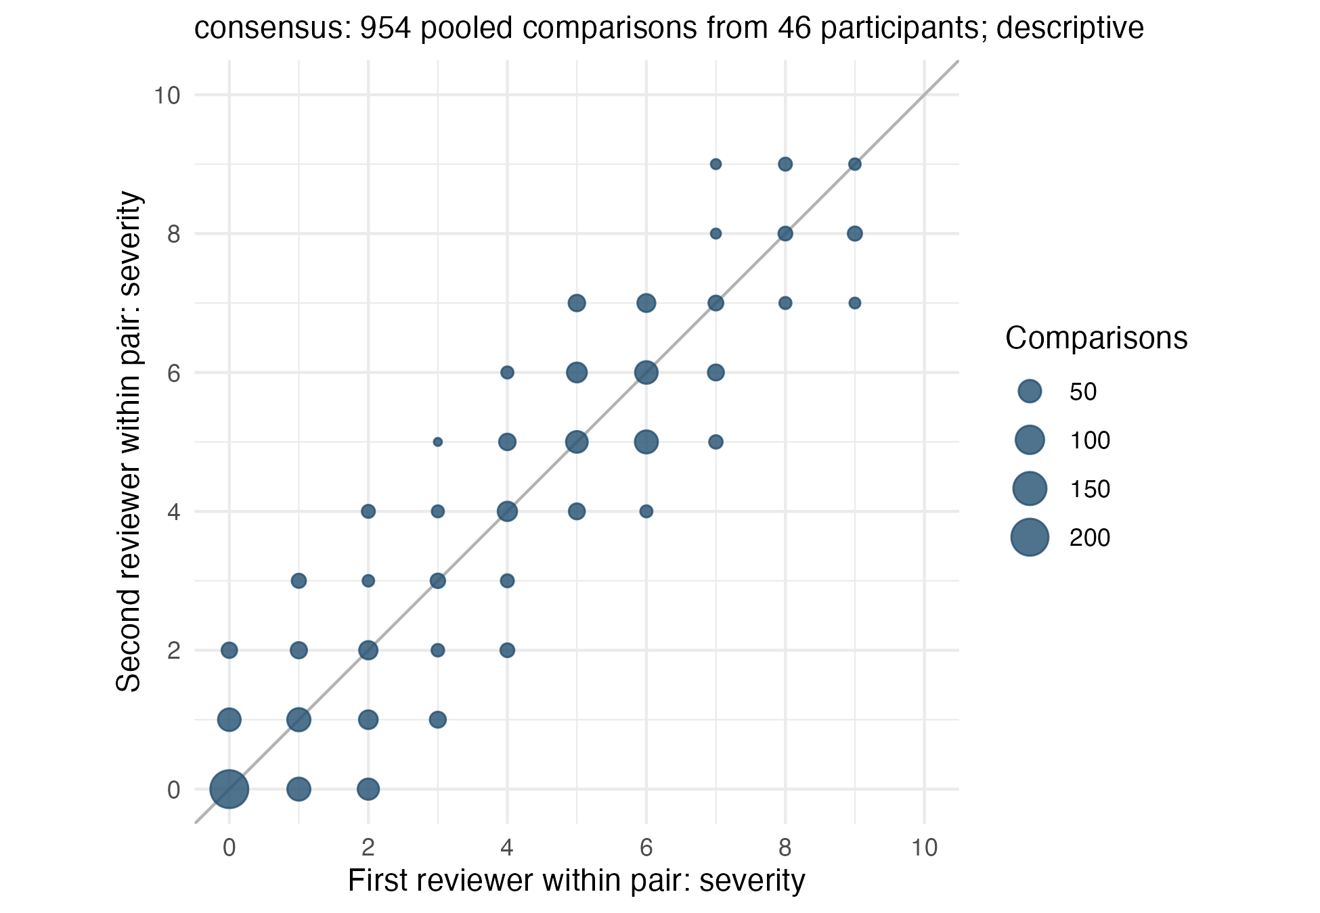

Differences across severity levels
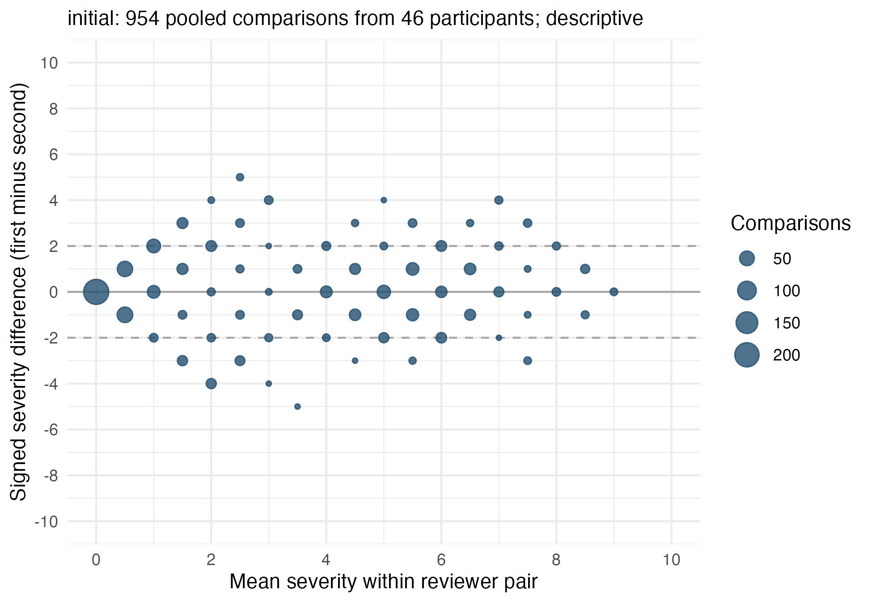
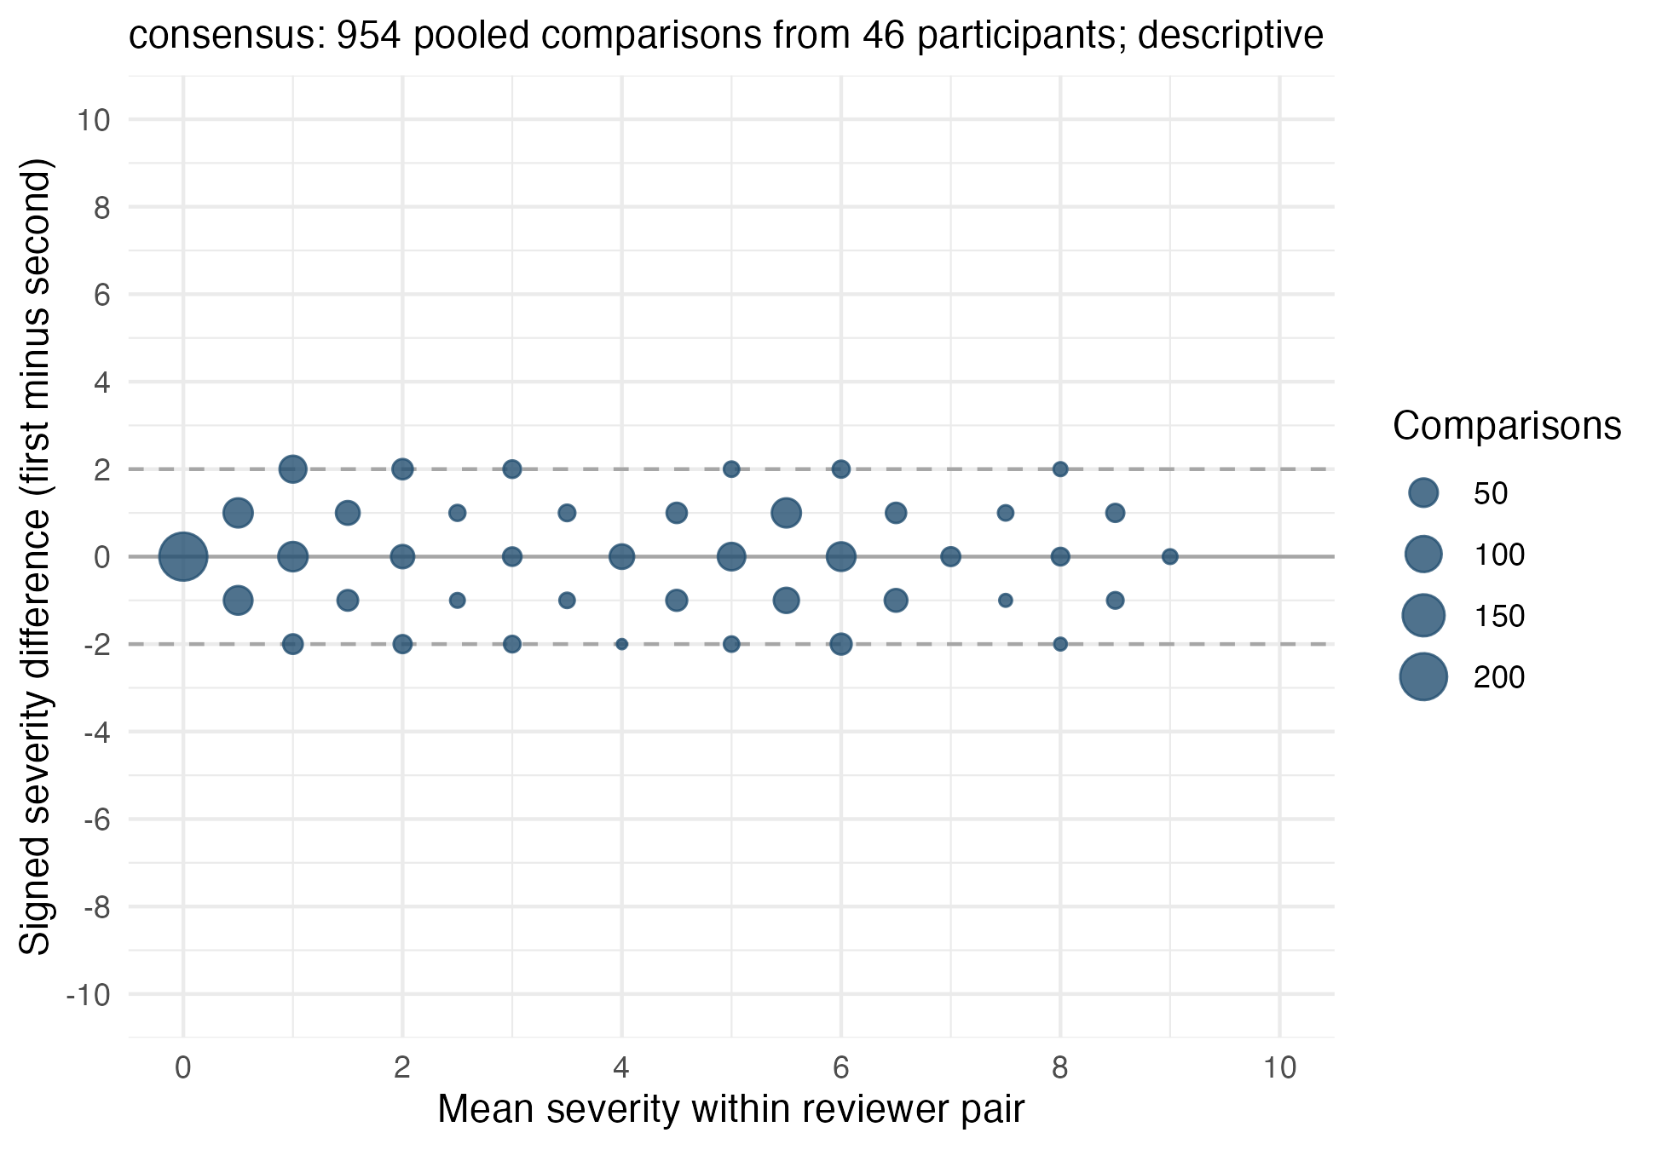
These Bland–Altman-style displays show signed differences. Positive and negative differences may cancel, and reversing the reviewer order reverses their sign. A flat signed trend would therefore not establish constant absolute disagreement across severity. Reference lines at ±2 mark the prespecified tolerance, not estimated limits of agreement. No conventional independent-pair limits of agreement or slope tests are computed for these dependent pooled comparisons.

Abstract: analysis unit
Original (Internal: REFERENCES/BASIL_CA_combined.pdf, p. 3):
Participants: Subsample (n=46) of participant cases for a reliability analysis conducted on 954 paired ratings by 7 clinical assessors across sites.
Revised:
Participants: A subsample of 46 participants was reviewed by 7 independent reviewers using identical standardized clinical information packets. The participant was the analysis unit for multiple-reviewer agreement.

Abstract: statistical results
Original (Internal: REFERENCES/BASIL_CA_combined.pdf, p. 3):
Results: Clinical assessors demonstrated high inter-rater agreement in delirium severity ratings (weighted kappa, κ=0.84), which improved following consensus discussions (κ=0.93). Bland- Altman analysis showed no evidence of systematic disagreement across the full range of severity scores (linear trend for differences over average of two rater scores, b=0.03, 95% confidence interval, -0.13, 0.20).
Revised:
Results: Using our participant-weighted extension of Conger’s κ with entropy-balanced participant weights, initial severity agreement was 0.821 (95% CI 0.736 to 0.877); after discussion, κ was 0.927 (95% CI 0.892 to 0.946). Binary delirium-presence agreement was 0.745 (95% CI 0.619 to 0.850) initially and 0.790 (95% CI 0.665 to 0.887) after discussion. Quadratic agreement weights were used for severity; only identical presence ratings received agreement credit.
Revision note: The old numerical values are preserved only in the struck-out quotation. Revised values are inserted by local execution; no result is inferred from the earlier coefficients.

Abstract: conclusion, first portion
Original (Internal: REFERENCES/BASIL_CA_combined.pdf, p. 3):
Conclusions: Trained clinical assessors demonstrated high inter-rater reliability in delirium severity ratings across a reliability sample that included patients with dementia and a wide range of delirium severity. These findings support feasibility of structured clinical assessment
Revised:
Conclusions: Agreement among independent reviewers was evaluated for severity ratings assigned from standardized clinical information packets. The estimates characterize reproducibility under the study’s review procedures, conditional on the information supplied.

Abstract: conclusion, continuation
Original (Internal: REFERENCES/BASIL_CA_combined.pdf, p. 4):
approaches for generating reproducible delirium severity measurements in multisite research studies.
Revised:
The findings concern interpretation of shared information; bedside data collection, rating accuracy, and feasibility were not evaluated.
Revision note: This continuation belongs to the preceding abstract conclusion (PDF pp. 3-4).

Study purpose
Original (Internal: REFERENCES/BASIL_CA_combined.pdf, p. 6):
The present analysis was conducted to evaluate the reliability of data collection by the clinical assessors, which was essential to assure the validity of the overall BASIL II study.
Revised:
The present analysis evaluated agreement among independent reviewers who assigned delirium severity ratings from identical packets of previously collected clinical information. The reliability and fidelity of the original bedside assessments were assumed and were not independently evaluated in this substudy.

Participant count and missingness
Original (Internal: REFERENCES/BASIL_CA_combined.pdf, p. 6):
Each of the 46 cases were rated by 7 clinical assessors resulting in 21 unique pairwise comparisons; this resulted in 966 paired ratings across 46 participants (Supplemental Figure 1). Missing ratings from one clinical assessor (for two participants) resulted in loss of 12 pairwise comparisons, yielding a final reliability sample of 954 paired ratings. Gold standard assessment of delirium for the full BASIL II sample employed an expert panel adjudication process, described previously.9,12 The gold standard diagnoses were used in the present study.
Revised:
The same 7 reviewers rated each of the 46 participant packets, with 2 reviewer ratings missing. Agreement analyses used participant-by-reviewer matrices, retaining the observed ratings for each participant. Descriptive graphics included the 954 observed unique reviewer-pair comparisons (966 possible comparisons minus 12 involving the missing ratings). Expert panel adjudication supplied the study reference-standard diagnoses.
Revision note: Replace gold standard with reference standard elsewhere in manuscript text and legends; preserve the published title in the reference list.

Statistical analysis: estimators and subgroups
Original (Internal: REFERENCES/BASIL_CA_combined.pdf, p. 8):
We evaluated inter-rater reliability for delirium severity scores (0-10 scale) using all possible paired combinations of the 7 clinical assessors (n = 954 unique pairs). We examined both Pearson correlation coefficients and weighted kappa coefficients (with quadratic weights) to summarize the agreement among pairs and confirmed that both approaches yielded identical results. We report these statistics as weighted kappa coefficients. These agreement statistics were calculated before and after the structured consensus discussion to assess its effect on reliability. For the binary classification of delirium (present/absent), we also calculated kappa (κ) before and after consensus to assess diagnostic agreement. To address whether reliability differed by the presence of dementia, we repeated weighted κ and percent agreement analyses stratified by dementia status (present vs. absent, per gold-standard adjudication). We also computed mean absolute differences between paired rater scores as a complementary continuous index of disagreement on the 0-10 severity scale.
Revised:
Agreement was summarized using our participant-weighted extension of Conger’s generalized κ for the fixed panel of 7 reviewers. Quadratic category weights were used for delirium severity (0–10); only identical ratings received agreement credit for delirium presence (0/1). Entropy-balanced participant weights were used for both outcomes and entered both observed agreement and reviewer-specific category proportions in the chance-agreement calculation. We adapted the irrCAC::conger.kappa.raw implementation and verified that setting every participant weight to 1 reproduced its estimates within 0.00001, using identical categories and agreement weights. The complete category sets were retained, and available ratings were used without imputing missing scores. Initial and post-discussion estimates were reported separately. Agreement was also estimated separately for participants with and without reference-standard dementia. Exact agreement, agreement within 2 severity points, and mean absolute severity difference were calculated within participant and averaged using the entropy weights. Percentile 95% confidence intervals were obtained by resampling participants with their reviewer columns and fixed weights intact; the same resampled participants were used to estimate the paired change between stages. Intervals condition on this reviewer panel and the estimated weights, and omit weight-estimation uncertainty.
Revision note: Subgroup κ differences depend on subgroup category distributions and cannot alone establish differences in reviewer performance. The revised plan was developed in response to review; remove the earlier claim that this revised plan was prespecified.

Statistical analysis: plots and participant weights
Original (Internal: REFERENCES/BASIL_CA_combined.pdf, p. 8):
We used Bland-Altman analysis20 to examine agreement between rater pairs across the full range of severity (0-10). For each plot, we regressed the difference in scores (Rater A – Rater B) on the pairwise mean score to test whether disagreement varied by severity level. A slope that is approximately 0 indicates no systematic bias in agreement across the severity spectrum. To reduce potential sampling bias and improve representativeness, we applied analytic weights using entropy balancing21 to more closely match the subsample distribution to the full BASIL II sample on site and delirium severity rating.
Revised:
Pooled reviewer-pair scatterplots and signed-difference-versus-mean plots were retained as descriptive displays. Each participant contributed multiple dependent comparisons; no pooled-pair κ, correlation, independent-pair confidence interval, regression test, or conventional limits of agreement were reported. The primary analysis used entropy balancing to match the reliability sample to the full enrolled BASIL II cohort on mean reference-standard delirium severity and site proportions. The same participant weights were used in both rating stages and retained within dementia strata, without imposing separate subgroup targets. Balancing these measured covariates does not establish that agreement generalizes to the full cohort.

Results: overall agreement
Original (Internal: REFERENCES/BASIL_CA_combined.pdf, p. 9):
Figure 1 illustrates the high inter-rater agreement in delirium severity rating prior to and following the consensus process. The weighted kappa was κ=0.84 (95% confidence interval, CI 0.82, 0.86) indicating strong consistency across assessors. Following the consensus meeting, the weighted kappa increased to κ=0.93 (95% CI 0.92, 0.94). Table 1 shows a crosstab of paired delirium presence (clinical assessor diagnosis) before (κ=0.77, 95% CI 0.73, 0.81) and after consensus (κ=0.81, 95% CI 0.77, 0.85), both indicating excellent agreement.22
Revised:
Initial severity agreement among the 7 reviewers was 0.821 (95% CI 0.736 to 0.877) using our participant-weighted extension of Conger’s κ with quadratic agreement weights. Following discussion, κ was 0.927 (95% CI 0.892 to 0.946). For delirium presence, κ was 0.745 (95% CI 0.619 to 0.850) initially and 0.790 (95% CI 0.665 to 0.887) following discussion, with agreement credit restricted to identical ratings. All estimates used entropy-balanced participant weights. Figure 1 shows the observed pooled reviewer-pair comparisons; Table 1 summarizes the participant-weighted multiple-reviewer analysis.

Results: dementia strata
Original (Internal: REFERENCES/BASIL_CA_combined.pdf, p. 9):
Reliability was also examined separately for patients with and without dementia (Supplemental Table 2). Inter-rater agreement was high and comparable across both strata. The weighted kappa was κ=0.85 (95% CI 0.82, 0.88) in cases without dementia and κ= 0.84 (95% CI 0.81, 0.86) in cases with dementia prior to consensus, improving to κ=0.94 and κ=0.93 after consensus. Percent agreement reached 100 in both strata following consensus. Mean absolute differences between paired rater scores were higher in dementia cases (1.20 pre, 0.77 post) than non-dementia cases (0.84 pre, 0.52 post) but remained within the prespecified 2- point rater agreement window.
Revised:
Estimates for participants with and without reference-standard dementia are shown in the agreement table, with subgroup participant counts and bootstrap confidence intervals. Exact agreement and agreement within 2 points are reported separately. The within-2-point percentage describes a tolerance criterion, while mean absolute difference summarizes the average discrepancy; a mean below 2 does not establish that every comparison met the tolerance. The subgroup coefficients were not used to establish equivalent reliability.
Revision note: Subgroup estimates and descriptive percentages should be taken from the locally executed table. The legacy 100% claim must be checked against the revised participant-weighted estimand.

Results: severity-dependent discrepancies
Original (Internal: REFERENCES/BASIL_CA_combined.pdf, p. 9):
To evaluate whether rating discrepancies varied as a function of delirium severity, Bland- Altman analysis was conducted. There was no significant association between the mean severity score and absolute disagreement across rater pairs before (linear regression coefficient, b=0.03, 95% CI -0.13, 0.20) and after consensus (b=-0.01, 95% CI -0.13, 0.12) suggesting that disagreement was not systematically greater at lower or higher ends of the severity spectrum (Figure 2).
Revised:
Figure 2 shows signed differences between reviewers as a function of their mean severity rating. The direction of a difference follows the fixed reviewer ordering. The display describes the observed discrepancies; it does not establish constant absolute disagreement across severity levels, because positive and negative differences may cancel.

Discussion: scope
Original (Internal: REFERENCES/BASIL_CA_combined.pdf, p. 10):
This reliability study embedded in the larger BASIL II cohort shows that trained clinical assessors can follow standardized protocols to produce highly reliable delirium severity ratings across diverse care settings. Inter-rater agreement was strong prior to consensus discussion and improved further after the structured consensus process. Importantly, agreement did not vary across levels of delirium severity, supporting the consistency of this approach across the full clinical spectrum. Agreement was also similarly high in cases with and without dementia, supporting reliability of this approach in the population for whom delirium severity measurement is most clinically needed and most challenging.
Revised:
This substudy evaluated agreement when independent reviewers interpreted identical standardized clinical information packets. Initial and post-discussion estimates characterize 2 stages of that procedure. The design permits a description of agreement conditional on shared information, but does not identify a causal effect of consensus discussion or establish reliability of bedside assessment across sites. Dementia-stratified estimates describe agreement within each group. Their precision and dependence on rating-category distributions limit conclusions about differences in reviewer performance or equivalent agreement between groups.

Discussion: limitations
Original (Internal: REFERENCES/BASIL_CA_combined.pdf, p. 11):
A few limitations should be noted. First, the reliability study was conducted on standardized summaries, which were condensed in-person assessments. A bedside clinical impression was incorporated into the standardized materials for review but remained constant across each rater. While this approach minimizes contextual biases, it may not fully reflect clinical variation that may be appreciated at the bedside.24 Second, this relatively small reliability sample (n=46 cases) is sufficient for inter-rater reliability estimation but not well-suited for comparisons across study sites. For site and other levels of analysis, see Boockvar et al.’s report of expert panel ratings using the full BASILII cohort. Third, assessors were part of a research team with dedicated training and time, limiting generalizability to routine clinical care. However, the high reliability achieved across independent raters from multiple disciplines highlights the feasibility of this approach for research studies requiring graded measurement of delirium severity.
Revised:
Agreement was evaluated conditional on standardized packets, which incorporated a single bedside clinical impression shared by all reviewers. Shared errors or omissions may coexist with high reviewer agreement. The substudy therefore did not independently establish the reliability or accuracy of the original assessments. The selected sample and fixed reviewer panel limit generalization beyond comparable cases and review procedures; entropy balancing addresses measured differences in site and reference-standard severity only. Post-discussion ratings share information from the consensus process, and their agreement should be interpreted within that procedure. Feasibility was not measured. Replication requires comparable rigor in both the original clinical assessments and subsequent packet review.

Figure 1 legend
Original (Internal: REFERENCES/BASIL_CA_combined.pdf, p. 17):
Figure 1. Agreement of delirium severity rating before (left panel) and after (right panel) consensus. Scatterplot of delirium severity rating agreement between rater A (horizontal axis) and rater B (vertical axis), shown before (left) and after (right) consensus process. Axis tick labels indicate delirium severity (0-10) and the number of ratings is noted in parentheses. The weighted kappa (κ) between rater A and rater B delirium severity ratings (0-10) prior to the consensus process was 0.84 (95% CI: 0.82, 0.86). After the consensus process, the κ was 0.93 (95% CI 0.92, 0.94).
Revised:
Figure 1. Descriptive pooled reviewer-pair severity ratings before and after discussion. Each point combines observed comparisons at the same 2 severity scores, and point size represents the comparison count. First and second reviewer denote positions within each of the 21 possible unique pairs among 7 reviewers. Participants contribute multiple dependent comparisons; these are not independent observations or ratings from 2 particular reviewers. The plots show observed comparisons without entropy weights; primary estimates from our participant-weighted extension of Conger’s κ are reported in Table 1.
Revision note: Apply this replacement to the duplicate caption on PDF p. 18 as well. The generated caption reports the locally observed participant and comparison counts.

Figure 2 legend
Original (Internal: REFERENCES/BASIL_CA_combined.pdf, p. 17):
Figure 2. Bland Altman plot of variability in agreement as a function of delirium severity before (left panel), and after (right panel) consensus process. Differences in agreement (y- axis) are shown as a function of average severity ratings, comparing pairs of raters, before (left) and after (right) consensus process The linear trend lines show systematic differences in agreement. Regression coefficients are not importantly different from 0 in both panels b (95% confidence interval) = 0.03 (-0.13, 0.20) before and b = -0.01(-0.13, 0.12) after consensus process. This suggests there were no systematic differences in level of agreement across the spectrum of delirium severity.
Revised:
Figure 2. Descriptive signed severity differences versus mean severity for pooled reviewer-pair comparisons, before and after discussion. Difference is first reviewer minus second reviewer under a fixed ordering; reversing the ordering reverses its sign. Point size represents the comparison count. Lines at ±2 mark the tolerance criterion. The displays do not estimate independent-pair regression uncertainty or conventional limits of agreement, and a flat signed pattern would not establish constant absolute disagreement.
Revision note: Apply this replacement to the duplicate caption on PDF p. 19 as well.

Supplemental analysis-unit legend
Original (Internal: REFERENCES/BASIL_CA_combined.pdf, p. 21):
Supplemental Figure 1. Derivation of 954 Paired Ratings for Inter-Rater Reliability Analysis. The BASIL II study enrolled n=488 participants into the full cohort. From the full cohort, a sample of n=46 participants were selected to create a reliability sample. Cases were selected sequentially to ensure representation of both delirium positive and negative cases across all study sites, with an intended sample size of 25-50 to assure statistical stability. Seven clinical assessors rated delirium severity in each of the participants in the reliability sample. For the analysis, this resulted in 21 unique rater pairs [(7 assessors x 6 pairs)/2], with a total number of possible pairs 21 rater pairs x 46 participants = 966 paired ratings. Because one assessor had missing ratings for two participants, there was a total of 12 missing paired ratings. Thus, the analysis sample was 954 paired ratings.
Revised:
Supplemental Figure 1. Derivation of the reliability sample and descriptive reviewer-pair comparisons. From the enrolled cohort of 488 participants, 46 were selected for standardized packet review by the same 7 independent reviewers. Agreement estimation used participant-by-reviewer matrices. With 2 reviewer ratings missing, 954 of the 966 possible unique reviewer-pair comparisons were available for descriptive graphics. The 954 comparisons were not treated as independent analysis units.
Revision note: Apply this replacement to the duplicate caption on PDF p. 24. Replace the pooled cross-tabulation in Table 1 (p. 20) and legacy subgroup estimates in Supplemental Table 2 (p. 23) with the locally generated agreement tables.

Items requiring author input
The reviewer-response outline leaves the rating rubric, rationale for the severity measure, possible CAM-S comparison, and several clinical design questions unresolved (Internal: REFERENCES/AMGP-26-510-reviews-RESPONSES.md, Reviewer 2, comments 2–4; Reviewer 3; Reviewer 4). The analysis implements the specified agreement revision. It does not invent rating anchors, equate packet-rating agreement with instrument validity, or add diagnostic sensitivity and specificity without an agreed reference-standard comparison plan. The manuscript describes broad severity anchors on PDF p. 7; a complete rubric and its instructions still require author confirmation.
The retained participant data include reference-standard dementia severity and CAM-S for later author-directed descriptive work. Initial and post-discussion score distributions, missingness, and dementia composition should be checked against the manuscript before submission. Existing numerical claims are replaced only when this report is executed locally.

Tables for the revised manuscript
The original main table, “Table 1. Cross-tab of paired ratings of delirium presence” (Internal: REFERENCES/BASIL_CA_combined.pdf, p. 20), is replaced by an entropy-balanced panel-agreement table covering severity and presence. “Supplemental Table 1. Descriptive Statistics” (p. 22) describes the observed reliability participants, and “Supplemental Table 2. Agreement statistics by dementia status” (p. 23) is replaced by entropy-balanced stratified estimates.
The manuscript presents only entropy-balanced agreement results. Equal-participant-weight comparisons, package validation, and complete-reviewer sensitivity analyses remain in the technical report. No comparison supplement is included; the technical output allows the authors to reconsider that decision if weighting changes the scientific interpretation.
These tables retain manuscript numbering (Table 1, Supplemental Table 1, and Supplemental Table 2); technical tables elsewhere in the report use T-prefixed letter labels (Table TA, Table TB, and so on). Every value is calculated from the current Analysis2 objects during rendering. No estimate or confidence interval is copied from the submitted manuscript. Tables are native Word tables; markdown versions are written to MD/ with the prefix Analysis2_manuscript-. Individually formatted HTML exports remain the responsibility of the HTML workflow.
Table 1. Entropy-balanced agreement among reviewers on delirium severity and presence
Measure | Initial | Post-discussion
Delirium severity
Participants, n | 46 | 46
Available reviewer ratings, n | 320 | 320
Conger's kappa (95% CI) | 0.821 (0.736, 0.877) | 0.927 (0.892, 0.946)
Exact agreement, % (95% CI) | 44.1 (34.3, 54.9) | 53.2 (44.9, 62.0)
Agreement within 2 points, % (95% CI) | 88.8 (84.2, 93.4) | 100.0 (100.0, 100.0)
Mean absolute difference, points (95% CI) | 0.94 (0.73, 1.16) | 0.59 (0.47, 0.71)
Delirium presence
Participants, n | 46 | 46
Available reviewer ratings, n | 320 | 320
Conger's kappa (95% CI) | 0.745 (0.619, 0.850) | 0.790 (0.665, 0.887)
Exact agreement, % (95% CI) | 88.5 (83.1, 93.6) | 90.3 (84.9, 95.1)
Notes: Kappa is our participant-weighted extension of Conger’s generalized kappa for the fixed panel of 7 reviewers. Severity uses quadratic agreement weights on the 0-10 scale; presence gives credit only to identical ratings. Exact agreement, agreement within 2 points, and mean absolute difference are calculated within participant, then averaged using entropy-balanced participant weights. Entropy balancing targets mean reference-standard delirium severity and site proportions in the full cohort (n = 488). Participant and rating counts are observed counts, not sums of weights. Parentheses contain 95% percentile confidence intervals from 2000 participant-bootstrap samples. Participant weights remain fixed during resampling; intervals omit weight-estimation uncertainty. CI, confidence interval. Available ratings are used without imputing missing scores. Post-discussion agreement is descriptive, not an estimate of a causal effect of discussion.
Supplemental Table 1. Characteristics of the reliability sample by enrollment site
Characteristic | Overall (n = 46) | BIDMC (n = 10) | UF (n = 14) | TNJH (n = 22)
Age, years, mean (SD) | 80.0 (6.2) | 80.1 (7.2) | 77.4 (3.9) | 81.5 (6.7)
Female, n (%) | 27 (58.7) | 6 (60.0) | 7 (50.0) | 14 (63.6)
White, n (%) | 31 (67.4) | 8 (80.0) | 13 (92.9) | 10 (45.5)
Black or African-American, n (%) | 13 (28.3) | 2 (20.0) | 1 (7.1) | 10 (45.5)
Asian, n (%) | 0 (0.0) | 0 (0.0) | 0 (0.0) | 0 (0.0)
Other racial groups, n (%) | 0 (0.0) | 0 (0.0) | 0 (0.0) | 0 (0.0)
Race uncertain or not reported, n (%) | 2 (4.3) | 0 (0.0) | 0 (0.0) | 2 (9.1)
Hispanic ethnicity, n (%) | 0 (0.0) | 0 (0.0) | 0 (0.0) | 0 (0.0)
Education, years, mean (SD) | 14.3 (3.2) | 14.5 (2.7) | 14.7 (2.6) | 14.0 (3.7)
English as a second language, n (%) | 1 (2.2) | 0 (0.0) | 0 (0.0) | 1 (4.5)
Married, n (%) | 15 (32.6) | 2 (20.0) | 10 (71.4) | 3 (13.6)
Lives alone, n (%) | 9 (19.6) | 5 (50.0) | 4 (28.6) | 0 (0.0)
Lives in a nursing home, n (%) | 22 (47.8) | 0 (0.0) | 0 (0.0) | 22 (100.0)
Charlson Comorbidity Index, mean (SD) | 2.8 (2.5) | 2.9 (2.5) | 2.1 (2.3) | 3.2 (2.6)
Charlson Comorbidity Index: 0, n (%) | 11 (24.4) | 2 (20.0) | 4 (30.8) | 5 (22.7)
Charlson Comorbidity Index: 1, n (%) | 3 (6.7) | 1 (10.0) | 2 (15.4) | 0 (0.0)
Charlson Comorbidity Index: 2 or more, n (%) | 31 (68.9) | 7 (70.0) | 7 (53.8) | 17 (77.3)
Hearing impairment, n (%) | 14 (30.4) | 2 (20.0) | 4 (28.6) | 8 (36.4)
Vision impairment, n (%) | 16 (39.0) | 2 (20.0) | 3 (21.4) | 11 (64.7)
Reference-standard dementia, n (%) | 27 (58.7) | 3 (30.0) | 3 (21.4) | 21 (95.5)
Reference-standard mild cognitive impairment, n (%) | 9 (19.6) | 5 (50.0) | 3 (21.4) | 1 (4.5)
Reference-standard delirium, n (%) | 21 (45.7) | 6 (60.0) | 6 (42.9) | 9 (40.9)
Reference-standard delirium severity (0-10), mean (SD) | 2.4 (2.6) | 2.7 (2.3) | 2.0 (2.6) | 2.5 (2.9)
Notes: Values are mean (SD) or n (%), describing the observed reliability sample without reweighting. Percentages use the number with nonmissing data for each characteristic; race percentages use all participants, with uncertain or unreported race shown separately. SD, standard deviation. BIDMC, Beth Israel Deaconess Medical Center; UF, University of Florida; TNJH, The New Jewish Home. Missing observations (Overall/BIDMC/UF/TNJH): Education: 1/0/0/1; Charlson Comorbidity Index: 1/0/1/0; Vision impairment: 5/0/0/5.
Supplemental Table 2. Entropy-balanced reviewer agreement by reference-standard dementia status
Measure | Initial | Post-discussion
Overall (n = 46)
Severity: Conger's kappa (95% CI) | 0.821 (0.736, 0.877) | 0.927 (0.892, 0.946)
Severity: Exact agreement, % (95% CI) | 44.1 (34.3, 54.9) | 53.2 (44.9, 62.0)
Severity: Agreement within 2 points, % (95% CI) | 88.8 (84.2, 93.4) | 100.0 (100.0, 100.0)
Severity: Mean absolute difference, points (95% CI) | 0.94 (0.73, 1.16) | 0.59 (0.47, 0.71)
Presence: Conger's kappa (95% CI) | 0.745 (0.619, 0.850) | 0.790 (0.665, 0.887)
Presence: Exact agreement, % (95% CI) | 88.5 (83.1, 93.6) | 90.3 (84.9, 95.1)
No dementia (n = 19)
Severity: Conger's kappa (95% CI) | 0.832 (0.691, 0.910) | 0.941 (0.894, 0.962)
Severity: Exact agreement, % (95% CI) | 52.6 (36.7, 68.5) | 61.6 (50.0, 73.8)
Severity: Agreement within 2 points, % (95% CI) | 90.4 (83.2, 96.4) | 100.0 (100.0, 100.0)
Severity: Mean absolute difference, points (95% CI) | 0.79 (0.47, 1.13) | 0.46 (0.31, 0.62)
Presence: Conger's kappa (95% CI) | 0.753 (0.567, 0.894) | 0.768 (0.586, 0.902)
Presence: Exact agreement, % (95% CI) | 89.0 (81.5, 95.9) | 89.5 (82.4, 96.2)
Dementia (n = 27)
Severity: Conger's kappa (95% CI) | 0.799 (0.655, 0.866) | 0.905 (0.840, 0.930)
Severity: Exact agreement, % (95% CI) | 31.3 (26.1, 36.1) | 40.5 (35.2, 47.8)
Severity: Agreement within 2 points, % (95% CI) | 86.5 (80.2, 92.6) | 100.0 (100.0, 100.0)
Severity: Mean absolute difference, points (95% CI) | 1.17 (1.02, 1.35) | 0.78 (0.67, 0.86)
Presence: Conger's kappa (95% CI) | 0.734 (0.534, 0.883) | 0.822 (0.640, 0.947)
Presence: Exact agreement, % (95% CI) | 87.8 (79.7, 95.2) | 91.6 (84.4, 97.7)
Notes: Kappa is our participant-weighted extension of Conger’s generalized kappa for the fixed panel of 7 reviewers. Severity uses quadratic agreement weights on the 0-10 scale; presence gives credit only to identical ratings. Exact agreement, agreement within 2 points, and mean absolute difference are calculated within participant, then averaged using entropy-balanced participant weights. Entropy balancing targets mean reference-standard delirium severity and site proportions in the full cohort (n = 488). Participant and rating counts are observed counts, not sums of weights. Parentheses contain 95% percentile confidence intervals from 2000 participant-bootstrap samples. Participant weights remain fixed during resampling; intervals omit weight-estimation uncertainty. CI, confidence interval. Strata retain the overall entropy weights; no separate dementia target is imposed. Estimates describe agreement within each dementia group. Category distributions influence kappa; differences do not by themselves establish differences in reviewer performance, and similar estimates do not establish equivalent agreement.

Execution record
R version 4.6.1 (2026-06-24)
Platform: aarch64-apple-darwin23
Running under: macOS Tahoe 26.6.2
Matrix products: default
BLAS: /Library/Frameworks/R.framework/Versions/4.6/Resources/lib/libRblas.0.dylib
LAPACK: /Library/Frameworks/R.framework/Versions/4.6/Resources/lib/libRlapack.dylib; LAPACK version 3.12.1
locale:
[1] en_US.UTF-8/en_US.UTF-8/en_US.UTF-8/C/en_US.UTF-8/en_US.UTF-8
time zone: America/New_York
tzcode source: internal
attached base packages:
[1] stats graphics grDevices utils datasets methods base
other attached packages:
[1] stringr_1.6.0 tidyr_1.3.2 dplyr_1.2.1
loaded via a namespace (and not attached):
[1] gtable_0.3.6 xfun_0.61 ggplot2_4.0.3
[4] processx_3.9.0 tzdb_0.5.0 vctrs_0.7.3
[7] tools_4.6.1 generics_0.1.4 tibble_3.3.1
[10] pkgconfig_2.0.3 data.table_1.18.6.1 RColorBrewer_1.1-3
[13] S7_0.2.2 readxl_1.5.0.1 uuid_1.2-2
[16] lifecycle_1.0.5 flextable_0.10.1 compiler_4.6.1
[19] farver_2.1.2 textshaping_1.0.5 janitor_2.2.1
[22] ebal_0.2.1 snakecase_0.11.1 fontquiver_0.2.1
[25] fontLiberation_0.1.0 htmltools_0.5.9 yaml_2.3.12
[28] later_1.4.8 pillar_1.11.1 openssl_2.4.2
[31] fontBitstreamVera_0.1.1 tidyselect_1.2.1 zip_3.0.2
[34] digest_0.6.39 stringi_1.8.9 purrr_1.2.2
[37] labeling_0.4.3 quarto_1.5.1 forcats_1.0.1
[40] labelled_2.16.1 rprojroot_2.1.1 fastmap_1.2.0
[43] grid_4.6.1 here_1.0.2 cli_3.6.6
[46] magrittr_2.0.5 patchwork_1.3.2 readr_2.2.0
[49] withr_3.0.3 gdtools_0.5.1 scales_1.4.0
[52] lubridate_1.9.5 timechange_0.4.0 rmarkdown_2.32
[55] officer_0.7.6 otel_0.2.0 cellranger_1.1.0
[58] askpass_1.2.1 ragg_1.5.2 irrCAC_1.4
[61] hms_1.1.4 kableExtra_1.4.1 evaluate_1.0.5
[64] knitr_1.52 haven_2.5.5 viridisLite_0.4.3
[67] rlang_1.3.0 Rcpp_1.1.2 glue_1.8.1
[70] xml2_1.6.0 svglite_2.2.2 rstudioapi_0.19.0
[73] jsonlite_2.0.0 R6_2.6.1 systemfonts_1.3.2

