Two HRS Core cognitive classification methods informed by HRS/HCAP: Figures, tables, and appendices
Richard N. Jones
Jennifer J. Manly
Douglas Tommet
Lindsay Kobayashi
Lindsay H. Ryan
Deborah A. Levine
Ryan J. McCammon
Steven G. Heeringa
David Weir
Kenneth M. Langa
2025-07-22

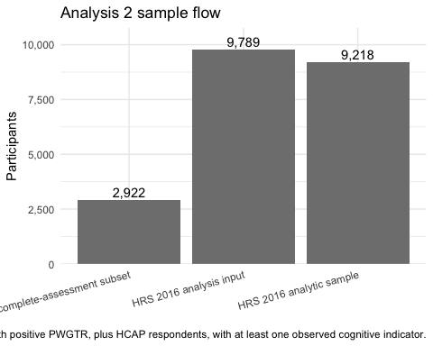
Figure 1: Analysis 2 sample flow
Source: R/MS_MAIN/MS_001_analysis_cohort.R; R_objects/A7_005_hrs16_merged.rds; and R_objects/030_hcap.rds. The bars use the current Analysis 2 eligibility rule and complete-assessment HCAP identifier set.
Characteristic |  | HRS 2016 Wave N = 9,218¹ |  | HCAP complete-assessment subsample N = 2,922¹
Sex
Female |  | 5,500 (60%) |  | 1,750 (60%)
Male |  | 3,718 (40%) |  | 1,172 (40%)
Age (in years) |  | 75.4 (7.4) |  | 75.6 (7.4)
Race
White |  | 7,167 (78%) |  | 2,339 (80%)
Black |  | 1,519 (16%) |  | 442 (15%)
All other groups |  | 524 (5.7%) |  | 140 (4.8%)
Not collected |  | 8 (<0.1%) |  | 1 (<0.1%)
Hispanic origin
Not Hispanic |  | 5 (<0.1%) |  | 1 (<0.1%)
Hispanic |  | 1,023 (11%) |  | 307 (11%)
Not obtained |  | 8,190 (89%) |  | 2,614 (89%)
Years of education |  | 12.7 (3.2) |  | 12.8 (3.1)
Blank, partial interview |  | 24 |  | 4
¹n (%); Mean (SD)
Table 1. Participant Characteristics
Characteristic | HRS 2016 analytic sample  (N = 9,218) |  | HCAP complete-assessment subsample  (N = 2,922)
Sex (N (%))
Female | 5,500 (59.7%) |  | 1,750 (59.9%)
Male | 3,718 (40.3%) |  | 1,172 (40.1%)
Age in years (Mean (SD)) | 75.4 (7.4) |  | 75.6 (7.4)
Race (N (%))
White | 7,167 (77.8%) |  | 2,339 (80.0%)
Black | 1,519 (16.5%) |  | 442 (15.1%)
All other groups | 524 (5.7%) |  | 140 (4.8%)
Not collected | 8 (0.1%) |  | 1 (0.0%)
Hispanic origin (N (%))
Not Hispanic | 8,190 (88.8%) |  | 2,614 (89.5%)
Hispanic | 1,023 (11.1%) |  | 307 (10.5%)
Not obtained | 5 (0.1%) |  | 1 (0.0%)
Years of education (Mean (SD)) | 12.7 (3.2) |  | 12.8 (3.1)
Source: R/MS_MAIN/MS_001_analysis_cohort.R; R_objects/A7_005_hrs16_merged.rds; R_objects/030_hcap.rds.
Notes: The HRS 2016 analytic sample includes 9,218 participants with at least one observed cognitive indicator. It includes Core respondents age 65 and older with a non-missing, positive 2016 sampling weight, plus all HCAP participants so the HCAP comparison sample is retained. The HCAP comparator sample includes 2,922 participants who completed the neuropsychological assessment sufficiently that none of their five derived cognitive domain scores used in the dementia and MCI classification algorithm had to be imputed. Race and ethnicity data were gathered via self-report at the time of first interview and are considered to be markers of exposure to evolving systems of racism, not as a proxy for genetic variation or any other biological variable. Race was self-selected by participants at the time of the first interview from a list of options defined by the 2000 US Census criteria. Other race includes a pooled group of participants who identified as American Indian or Alaska Native, Asian, Native Hawaiian or Pacific Islander, or another self-described race, consolidated due to small sample sizes and risk of identification.

Table 2. HCAP classification margins by method
method | Dementia_n | MCI_n | Normal_n | Dementia_weighted_percent | MCI_weighted_percent | Normal_weighted_percent
HRS/HCAP Algorithm | 375 | 808 | 2,313 | 9.2 | 21.4 | 69.4
Core algorithm | 308 | 735 | 2,453 | 8.0 | 20.5 | 71.4
Langa-Weir | 333 | 731 | 2,432 | 7.9 | 17.3 | 74.9
Hudomiet | 286 | 865 | 2,326 | 7.2 | 21.0 | 71.1
PMM | 53,073 | 36,100 | 260,427 | 13.4 | 9.2 | 77.4
Source: A7 methods: R_objects/A7_100_hcap_tables.rds; PMM method: R/PMM_110_Comparison_of_Consensus_Langa_Weir.R and Mplus saved data. Weighted percentages use HCAP16WGTR; PMM replication weights sum to HCAP16WGTR.

Table 3. Agreement among Core classifications and comparison diagnoses
method | comparator | three_class_kappa | binary_kappa | result_source
Core algorithm | HRS/HCAP Algorithm | 0.505 | 0.352 | A7
Core algorithm | HCAP consensus | 0.284 | 0.675 | A7
Core algorithm | Hudomiet | 0.603 | 0.474 | A7
Langa-Weir | HRS/HCAP Algorithm | 0.510 | 0.407 | A7
Langa-Weir | HCAP consensus | 0.099 | 0.736 | A7
Hudomiet | HRS/HCAP Algorithm | 0.551 | 0.457 | A7
Hudomiet | HCAP consensus | 0.396 | 0.806 | A7
PMM | HRS/HCAP Algorithm | 0.509 | 0.437 | PMM
PMM | HCAP consensus | 0.528 | 0.384 | PMM
Source: A7 rows: R_objects/A7_100_hcap_tables.rds, generated by R/A7_100-comparison_of_diagnoses.R. PMM rows: R/PMM_110_Comparison_of_Consensus_Langa_Weir.R. Three-class values are quadratic weighted kappas; binary values are kappas for dementia versus non-dementia. Consensus comparisons use normalized HCAP16WGTR / samplingP weights; other comparisons use HCAP16WGTR.

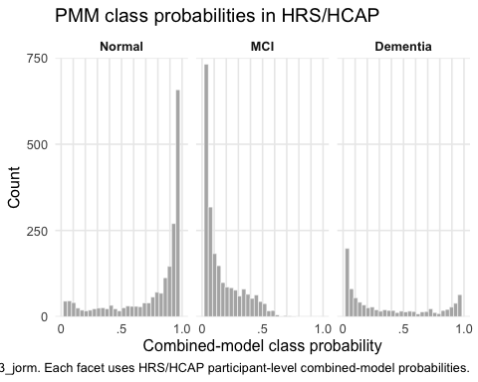
Figure 2: PMM class probabilities in HRS/HCAP

Table 4. Pairwise three-class agreement among HCAP comparison methods
method | Consensus diagnosis | Algorithmic diagnosis | Langa-Weir | HRS classification model | Hudomiet
Consensus diagnosis | 1.000 | 0.728 | 0.099 | 0.284 | 0.396
Algorithmic diagnosis | 0.728 | 1.000 | 0.510 | 0.505 | 0.551
Langa-Weir | 0.099 | 0.510 | 1.000 | 0.561 | 0.717
HRS classification model | 0.284 | 0.505 | 0.561 | 1.000 | 0.603
Hudomiet | 0.396 | 0.551 | 0.717 | 0.603 | 1.000
Source: Source: R_objects/A7_100_hcap_tables.rds, generated by R/A7_100-comparison_of_diagnoses.R. Entries are quadratic weighted kappas. Consensus comparisons use normalized HCAP16WGTR / samplingP weights; other comparisons use HCAP16WGTR.

Thanks for reading.

