Two HRS Core cognitive classification methods informed by HRS/HCAP: Figures, tables, and appendices
Richard N. Jones
Jennifer J. Manly
Douglas Tommet
Lindsay Kobayashi
Lindsay H. Ryan
Deborah A. Levine
Ryan J. McCammon
Steven G. Heeringa
David Weir
Kenneth M. Langa
2026-09-23

Table 1. Participant Characteristics
Characteristic | HRS/HCAP 2016 participants  (N = 3,496)
Sex (N (%))
Female | 2,095 (59.9%)
Male | 1,401 (40.1%)
Age in years (Mean (SD)) | 76.0 (7.6)
Race (N (%))
White | 2,755 (78.8%)
Black | 563 (16.1%)
All other groups | 177 (5.1%)
Not collected | 1 (0.0%)
Hispanic origin (N (%))
Not Hispanic | 3,111 (89.0%)
Hispanic | 383 (11.0%)
Not obtained | 2 (0.1%)
Years of education (Mean (SD)) | 12.7 (3.2)
HRS/HCAP Classification (N (%))
Normal | 2,313 (66.2%)
Mild cognitive impairment | 808 (23.1%)
Dementia | 375 (10.7%)
Langa-Weir Classification (N (%))
Normal | 2,432 (69.6%)
Cognitively impaired, not demented | 731 (20.9%)
Dementia | 333 (9.5%)
Missing | 0
Jorm IQCODE score from Core (missing) | 3,283
Jorm IQCODE score from Core (Mean (SD)) | 3.8 (0.8)
Source: R/MS_MAIN/MS_001_analysis_cohort.R; R_objects/A7_005_hrs16_merged.rds.
Jorm IQCODE was collected in the HRS Core interview, not HCAP, and only from participants who did not complete Core cognitive testing.
Notes: The study sample includes all 3,496 HRS/HCAP 2016 participants, including participants without Core cognitive testing who were classified from informant (Jorm IQCODE) data. Race and ethnicity data were gathered via self-report at the time of first interview and are considered to be markers of exposure to evolving systems of racism, not as a proxy for genetic variation or any other biological variable. Race was self-selected by participants at the time of the first interview from a list of options defined by the 2000 US Census criteria. Other race includes a pooled group of participants who identified as American Indian or Alaska Native, Asian, Native Hawaiian or Pacific Islander, or another self-described race, consolidated due to small sample sizes and risk of identification.

Table 2. HCAP classification margins by method
 | Normal |  | MCI |  | Dementia
Method | N | Weighted % | N | Weighted % | N | Weighted %
HRS/HCAP Algorithm | 2,313 | 69.4% | 808 | 21.4% | 375 | 9.2%
Core algorithm | 2,453 | 71.4% | 735 | 20.5% | 308 | 8.0%
PMM | 2,780 | 82.3% | 200 | 4.7% | 516 | 12.9%
Secondary comparators
Langa-Weir | 2,432 | 74.9% | 731 | 17.3% | 333 | 7.9%
Hudomiet | 2,326 | 71.1% | 865 | 21.0% | 286 | 7.2%
Note. N values are unweighted HRS/HCAP participant counts. Percentages use HCAP16WGTR; PMM counts and percentages use the non-replicated combined cognition/Jorm model sample.
References. Manly, J. J., Jones, R. N., Langa, K. M., Ryan, L. H., Levine, D. A., McCammon, R., Heeringa, S. G., & Weir, D. (2022). Estimating the prevalence of dementia and mild cognitive impairment in the US: The 2016 Health and Retirement Study Harmonized Cognitive Assessment Protocol Project. JAMA Neurology, 79(12), 1242-1249. https://doi.org/10.1001/jamaneurol.2022.3543
Langa, K. M., Weir, D. R., Kabeto, M., & Sonnega, A. (2023). Langa-Weir Classification of Cognitive Function (1995-2020). https://hrsdata.isr.umich.edu/sites/default/files/documentation/data-descriptions/1695907706/Data_Description_Langa_Weir_Classifications2020_V2.pdf
Hudomiet, P., Hurd, M. D., & Rohwedder, S. (2022). Trends in inequalities in the prevalence of dementia in the United States. Proceedings of the National Academy of Sciences, 119(46), e2212205119. https://doi.org/10.1073/pnas.2212205119

Table 3. Agreement among Core classifications and comparison diagnoses
Classification 1 | Classification 2 | Three-class quadratic weighted kappa | Dementia versus non-dementia kappa
Core Algorithm | HRS/HCAP Algorithm | 0.505 | 0.352
PMM | HRS/HCAP Algorithm | 0.509 | 0.437
Langa-Weir | HRS/HCAP Algorithm | 0.510 | 0.407
Hudomiet | HRS/HCAP Algorithm | 0.551 | 0.457
HCAP Consensus | HRS/HCAP Algorithm | 0.728 | 0.536
Core Algorithm | Langa-Weir | 0.561 | 0.444
PMM | Langa-Weir | 0.583 | 0.487
Hudomiet | Langa-Weir | 0.717 | 0.670
HCAP Consensus | Langa-Weir | 0.099 | 0.736
Core Algorithm | Hudomiet | 0.603 | 0.474
PMM | Hudomiet | 0.633 | 0.515
HCAP Consensus | Hudomiet | 0.396 | 0.806
Core Algorithm | HCAP Consensus | 0.284 | 0.675
PMM | HCAP Consensus | 0.528 | 0.384
Source: A7 rows: R_objects/A7_100_hcap_tables.rds, generated by R/A7_100-comparison_of_diagnoses.R. PMM rows: R/PMM_110_Comparison_of_Consensus_Langa_Weir.R; PMM-Hudomiet was calculated from the same saved probabilities and A7 comparison data. Three-class values are quadratic weighted kappas; binary values are kappas for dementia versus non-dementia. Consensus comparisons use normalized HCAP16WGTR / samplingP weights; other comparisons use HCAP16WGTR.

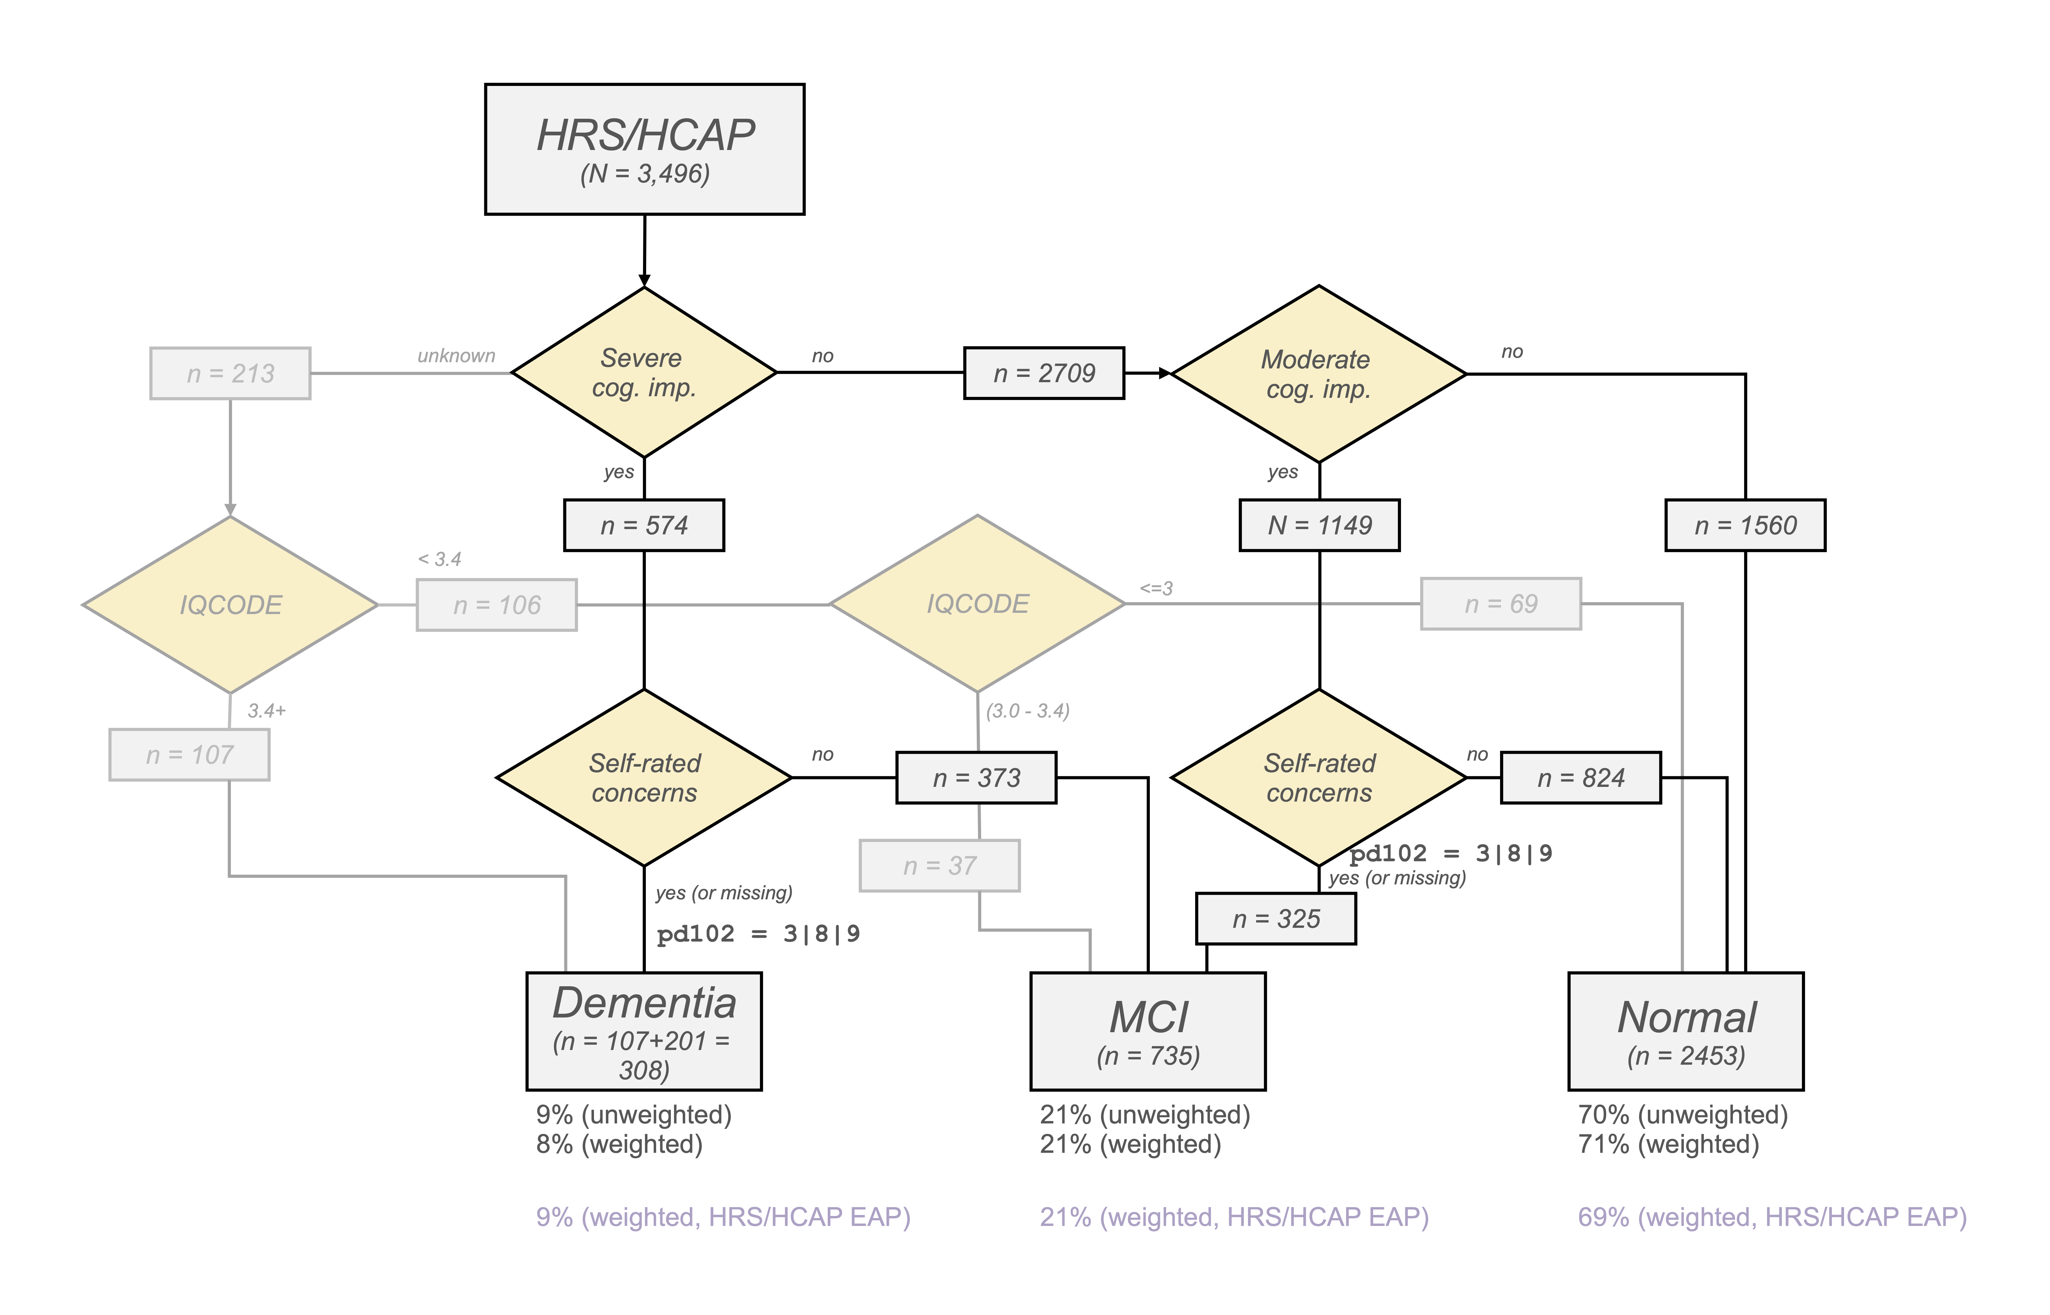
Figure 1: Core algorithm

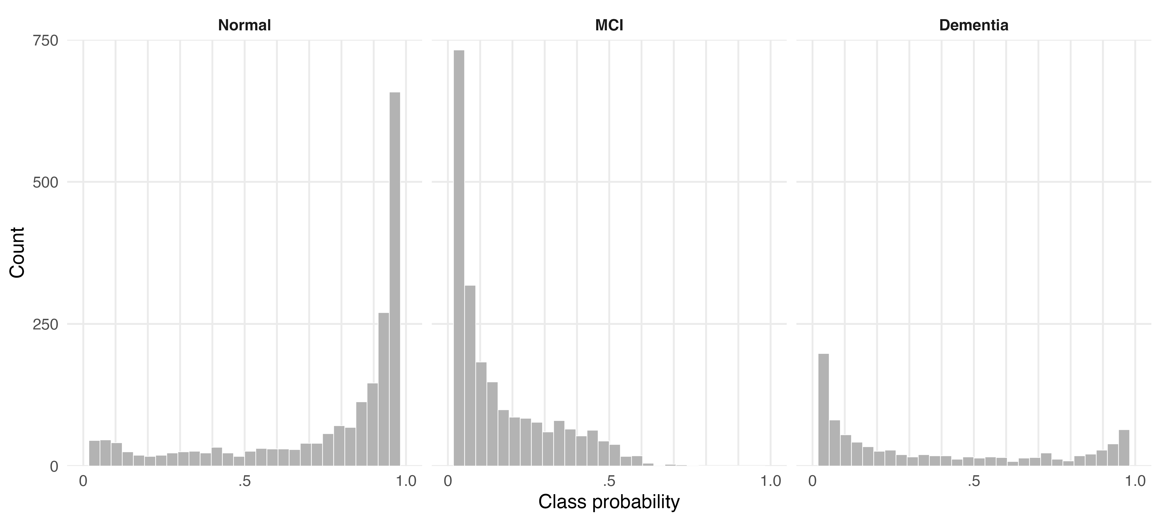
Figure 2: PMM class probabilities in HRS/HCAP

Thanks for reading.

