Omnicell Blueprinting Tool Guide
Omnicell Blueprinting Tool
09.28.2022 – Sr. Architect – Maintained by Doug Vidakovich

Contents
Overview 1
Omnicell Blueprinting tool 2
Noteworthy: 2
Tools: Available on Box 2
Prep Work: 2
Go Live: 3

Date | Description | Revision
9/27/2022 | Initial draft of the User Guide | 1.00

Overview
This guide provides comprehensive help and documentation for the latest version (3.0) of the Omnicell Blueprinting Tool. Published and released on Oct XX, 2022, Omnicell Blueprinting Tool allows for users to automatically generate diagrams to represent data flows and network architecture based on customer-specific hardware. This tool automates network architecture / data flow diagrams in MS Visio. Using an excel file the designer has full control of shapes and positions where to be placed on the diagram as well as how shapes are connected as well as shape colors connection colors and labels.
- This tool requires Visio and Excel to be installed on the computer running this tool
- An Excel files will be used populated by the users which will be used with placing shapes and connections on the Visio diagram
- Multiple Visio page supported
- Multiple Visio stencils files supported
- Visio template file supported (can contain existing stencils or have additional stencils attached)

Omnicell Blueprinting tool

Noteworthy:
- At this time no installer has been created for this tool so a command file will be used to perform the installation.
  - A new folder “Omnicell_Blueprinting_Tool” will be created in the C: Root
    - Under this folder an additional sub-folder will be created
      - “Data” - data files
    - Under the “Data” folder three sub-folders will be created
      - “ScriptData” - Place for excel data file to read for creating the diagram
      - “Stencils” - Visio stencil files to be placed here
      - “Templates” - Visio Template files to be placed here

Tools: Available on Box
- GetOisSetup.exe – Creates a listing of all interfaces which can be exported to a spreadsheet and searched. This is especially useful in larger customer environments.
- MSMQ Builde.exe – This can read a .txt file and build all Windows queues with the correct permission.

Prep Work:
- Identify - It is critical to identify the customer details that will be used
  - Add data that needs to be collected
    - For large IDN’s, this can exist under a different Hospital name or CSN
  - Add Integrations to list
    - ???
  - Determine new server final IP address working with customer IT
    - Omnicell recommends re-using old server IP if possible

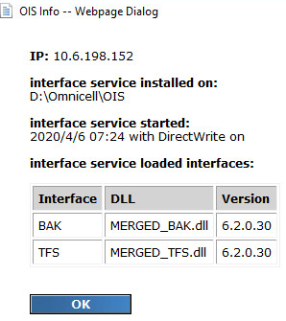

  - SQL scripts listed that will be used to connect system information

- Download Required Files from FTP
  - Download latest OIS version
  - Download latest DLL’s that match what was identified in step 1d
    - Search FTP for “DLL”
    - Departments > International > Intl Distributors > Releases > OIS > Interface Packages > DLL
- Document work in JIRA

Go Live:
- Communicate out you are starting and get verification customer is ready
- Have customer pause their interfaces
  - If IP address is changing, have customer point to new IP and let messages queue up
- Wait for interfaces to stop receiving data and shut down old server interfaces
- Export Interfaces from old server
  - Warning doing this requires the interfaces to be stopped temporarily
  - Log into IFS Workbench (Right click and run as administrator)
  - Stop Service for Interface 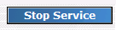
  - On the top left tabs, select “Interfaces”
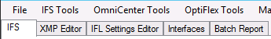

  - You will see 3 sections across the screen.
    - Deployed Interfaces – Current Active Interfaces as shown on main IFS tab
    - Interface Package Contents – Interfaces Opened from Interface Packages but not live
    - Interface Packages – Exported interfaces in a zip file
  - Under Deployed Interfaces each Interface group is displayed expanded with each node listed under it
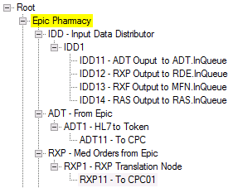
  - Right Click the Root and select “Export”
  - Name something appropriate and save to default location
    - Default is D:\Omnicell\OIS\Root
    - Refresh the screen, you will now see your package under Interface Packages
    - Copy the file you created to the new server D:\Omnicell\OIS\Root
  - Turn Interfaces service back on
- Import Interfaces
  - Just like exporting, Stop Service for Interface
  - On the top left tabs, select “Interfaces”
  - In the right section for Interface Packages select your zip package
    - Notice this shows all the interfaces fully expanded in the middle section
  - In the middle section for “Interface Package Contents” Right click the first highlighted group and select copy.
    - Your interface names may be different from below
    - Do not copy “System” interfaces
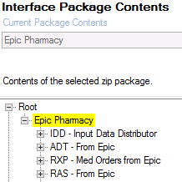
  - In the left screen for “Deployed Interfaces” right click on Root and select Paste.
  - Repeat steps d & e for each highlighted group in Interface Package Contents
  - Right click your new groups and select move up so they are in the same order as the old server. “System” should always be at the bottom
- DLL’s are located at D:\Omnicell\OIS\Trans\Bin
  - Interfaces should still be stopped
  - Check your list of DLL’s that you have downloaded to replace.
    - Any existing DLL being replaced should be moved into the save folder
  - Move your new DLL’s into place
    - If you have issues moving, ensure that all instances of OIS are stopped
  - Restart Interface Service
- Go back to the main IFS home page that shows all the interfaces
  - You should now see all the interfaces you brought over in a disabled state
  - Enable each one that was enabled on old server but leave stopped
