Javacard NG – Memory Architecture

Environmental constraints:

- small amount of RAM (~ 8K)
- larger amount of EEPROM (8 – 32K)
- RAM is fast to write – 100ns
- EEPROM is slow to write (5ms/page) and has limited write endurance (100,000 cycles)
- tear (i.e. loss of power source) can occur at any time → need for transactions

Each section below details the proposed memory schemes.

Automatic transitions from RAM → EEPROM

Object creation:

- All allocation is performed on transient heap (i.e RAM).
- Failed allocation (i.e. insufficient RAM) results in OutOfMemory exception
- RAM → EEPROM only occurs at transaction commit points. That is, all reachable objects in RAM heap at commit time are moved to EEPROM
- Programmer’s responsibility to ‘trim’ object graph to include only those objects that should be committed to EEPROM

Object modification:

- Transient objects modified in situ (i.e. directly in RAM)
- Permanent object modification is more complex – need to minimise writing to EEPROM. Possibilities include:

  - Automatically/manually shadow object (graph) to RAM, modify object, re-commit modified graph.
  - Direct write to EEPROM
  - Explicit API for writing to EEPROM (similar to the DmWrite API in the PalmOS).

Garbage collection and object deletion:

- GC for RAM happens automatically. This will at least be when an allocation fails initially and could also include periodic GCs as well as programmer requested GC (i.e. System.gc() invocations).
- EEPROM clean up is triggered by explicit programmer request.

Manual transitions from RAM → EEPROM

This is similar to 1. except that moving objects from RAM to EEPROM is only done through an API. Instead of graph trimming as in 1., this can be thought of as specifying the roots of the graph that is to be transferred to EEPROM.

The object modification semantics/issues are the same as 1 as is garbage collection and object deletion.

For both proposal 1 & 2, there needs to be a means for detecting and fixing pointers from EEPROM to RAM. This is analogous to the write barrier in generational GC systems. The mechanism proposed was to use a table of forwarding pointers where the EEPROM objects refer to RAM objects via entries in the forwarding table. The entries are updated by every GC. Upon card reset, all permanent objects are scanned and references to the pointer forwsding table are reset. The precise meaning of reset is contingent upon how the EEPROM objects reference table entries (e.g. index or direct pointer).

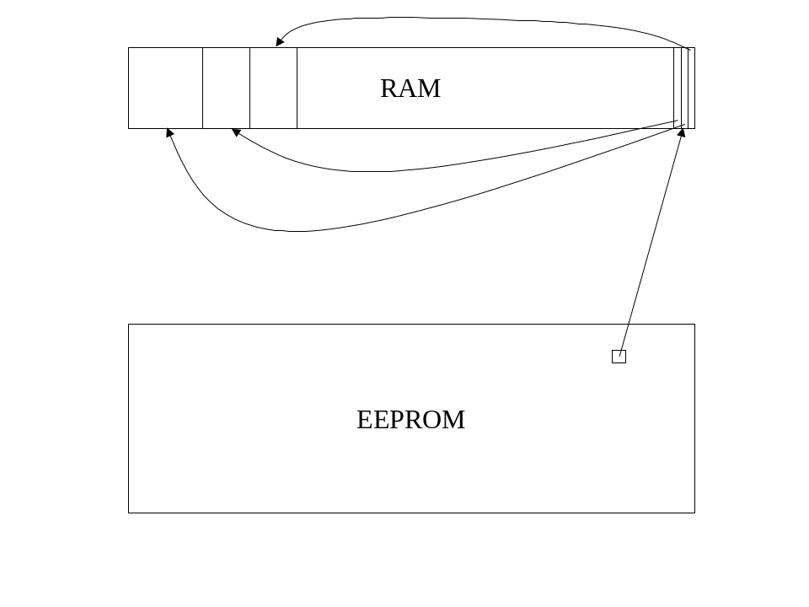
It was agreed upon that any new memory architecture seems needs to support the semantics of the current memory architecture. In particular, the semantics of memory allocated with the makeTransient methods needs to be supported.

