The Squawk3G System

Nik Shaylor

July 2003

Introduction

Squawk3G is the third generation of a small Java virtual machine technology that is constructed using the general principal that as much as possible of the implementation should be constructed using the high level programming languages and tools. In general this has meant that the VM is written in Java (or a subset of Java). A second, and equally important, principal has been that Java bytecodes as presented in a class file are always transformed into a private internal format that is easier to execute at runtime.

The first VM was a system that used a register based bytecode instruction set, which, it was hoped, would produce a denser bytecode format, and would be an easy point from which to generate jitted code. This proved hard to achieve without more advanced compilation technology than we had at the time, and, although it looked like it could work well got a jitted technology it proved hard to write an interpreter that would efficiently execute these bytecodes. This system had an integrated bytecode translator that ran as a system task. The translator emitted each class as an XML document, and this was later parsed by a loader task that read the document from the translator through an HTTP connection. The decoupling of the translator and loader was done this way in order to provide a simple way to build a “split VM” as an option. In order to get the best possible runtime performance the translator performed a large part of the linking process. This allowed, for example, class variables to be accessed by simply indexing into a “global vector”. The translator thus needed to know what the existing state of the VM was in order to perform its job. Although this produced an efficient system were access to a class variable was as efficient as access to an instance variable the requirement of translator to know the state of the running system was a complication that made it hard to build a split VM where the translator could be restarted while the VM was running. The initialization of this system was quite complicated because of the intricate operations of the romizer had to perform. The system supported the basic “Isolate” API.

The second system was written as a part of Sun’s proposal for the next generation Javacard. It is a split VM system that uses a new binary class file container format called a “Suite file”. The system supports three memory types: read-only, non-volatile, and volatile. These are typically some from of ROM, EEPROM, and RAM. The suite file contains enough information to be verified, and after this is done much of the meta-data for a class can be discarded. The loader-verifier can also “quicken” many bytecodes before they are written into EEPROM making the system ideal for this type of memory. However the linkage of class variables is done associatively making these slower to access than the first VM.

Motivation
The third Squawk VM is targeted at embedded system that requires relatively high execution performance (around that of compiled C) while maintaining a relatively small footprint. The system should be credible alternative to the static Java compilers that are available for this kind of computing environment. This is achieved using a sophisticated bytecode optimizer, an interpreter and a bytecode compiler. The compiler can either be run at runtime as a JIT, or before execution as an AOT compiler. It is in this latter mode that the most embedded systems are expected to work. It may work as a split VM or normal VM.

Features
- Isolate API.
- Lisp2 garbage collector.
- Fast interpreter.
- Not-in-time compiler.
- Generalized native code that can be executed in EEPROM.
- 16 or 32 bit memory architecture.
- Compact strings.
- Finalization.

Features not supported
- Object migration.
- User programmable non-volatile object memory.
- Special processing for memory store operations (other than write barrier).

System architecture

Bytecode Optimizer
The bytecode optimizer is an independent and optional component of this system. It simply transforms class files before they are introduced into the main VM system. It is however an important component of the high performance aspects of the system. The optimizer performs many classic compiler optimizations. It also includes method inlining, which may be done very aggressively for selected applications and libraries.

The Translator
The translator converts standard Java bytecodes into internal Squawk bytecodes. Local variables are split into the following types to ease compilation:
- int
- long
- float
- double
- references
Variables of the same type that have disjoint live ranges may share the same location. It must be possible for the runtime system to accurately identify the variable types from the internal bytecode format.

Memory Subsystem

ROM/EEPROM.
These memories are not intended as user programmable areas. The only objects in these memories are system components and they do not necessarily behave in a way that is consistent with the Java programming language.

Specifically, they have the following characteristics:
- They exist independently of any class state.
- If they have finalizers they are never run.
- They never move (the EEPROM is not compacted).
- No pointers from NVM or ROM to RAM may exist.

The common components included in these memories are class and method data structures, and compiled code. The initial contents of these memories are built by the romizer, but these can subsequently be added to or modified by the system class loader and compiler. The initial romizer output is three binary files as follows.
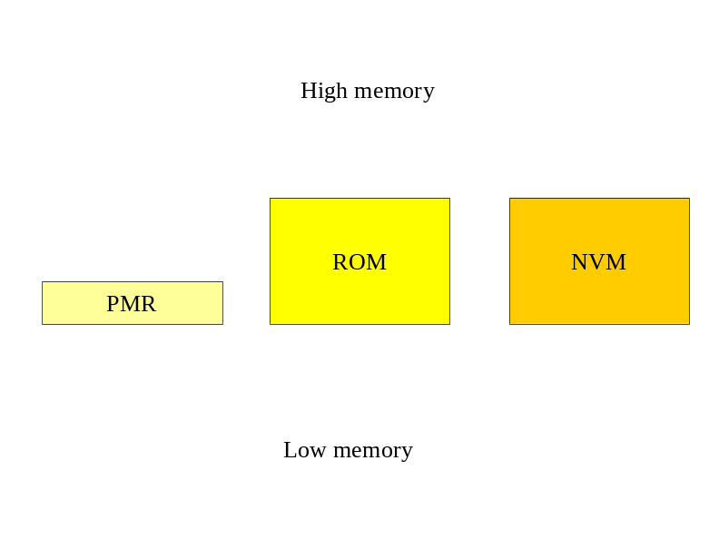
The romizer will automatically relocate objects in the ROM and NVM to specified segment addresses. The PMR (Permanent memory record) contains all this information.

typedef struct PMRstruct {
int PMR_magicNumber; // The value 0x03021957
int PMR_romStart; // Address of ROM in image
int PMR_romSize; // Size of ROM segment
int PMR_eepromStart; // Address of EEPROM in image
int PMR_eepromSize; // Size of EEPROM segment
int PMR_ramSize; // The RAM size
int PMR_freeList; // The address of the first free area
int PMR_suiteTable; // The address of the Suite[] table
int PMR_objectTable; // The address of the Object[] table
} PMR;

All the objects in these memories are shared between isolates.

RAM
RAM is divided into one, or more, heap memories. The heaps are used to contain all regular object instances and class state. Each heap may be logically segmented into isolate partitions.

Object migration
This system does not include automatic object from RAM to EEPROM migration.

Romizer

Garbage collector.

Interpreter
There are two interpreters. One is a simple non-optimized interpreter that is written in Java and can be converted into C using the Java to C converter that is used in SquawkNG. The advanced interpreter is generated as a part of the romizer and this is implemented as native machine code that uses the target platform C calling convention.

NOT SURE ABOUT THIS. PERHAPS JUST THE OPTOMIZING INTERPRETER WOULD BE SIMPLER.

Compiler
The dynamic compiler can only be used in a system that uses the advanced interpreter. It translates whole methods into native machine code for the target platform and then replaces the bytecode array with the native method array in the appropriate vtable entry. Initially the compiler will be run as a part of the romizer on selected methods that have been selected by profiling of some kind, but it should be possible also to run the compiler dynamically like a JIT.

System Metadata
The system metadata forms a natural hierarchy is as follows.

Method – Vtable – Class – Suite – SuiteTable

Methods are always implemented as Java byte arrays and they either contain bytecodes or native code. The end of the byte array is an area that contains information about the method.

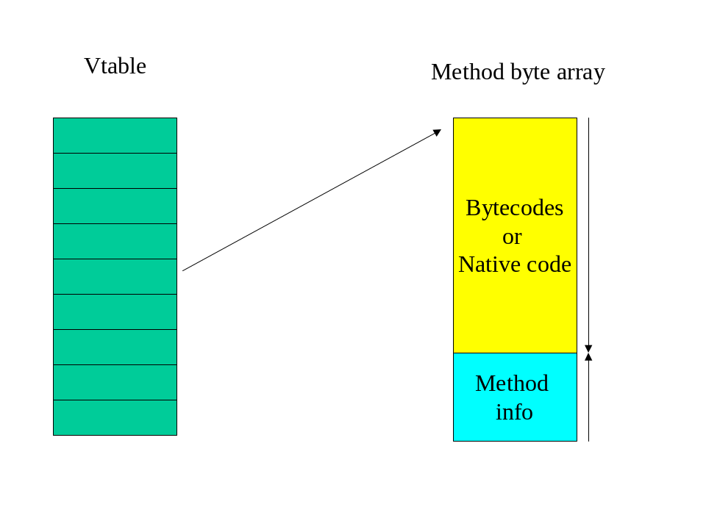
The method information area contains an array of bytes that contains the following information in a compressed form:
- The defining class.
- The number of parameters.
- The number of locals.
- Oopmap for the locals and parameters.
- Exception handler table.

This information is decoded serially by reading the data byte-by-byte backwards from the end of the byte array until it is complete.

PERHAPS THE METHOD INFO SHOULD GO INTO THE OBJECT HEADER.

The beginning of the bytecode/native code section must contain executable code. In the bytecode case a jump instruction is placed that will go to the method prolog processing code. On entry to this code a known fixed register will contain the address of the method (see next section).

Calling convention
The calling convention for the advanced interpreter and compiled code is the same. When porting to a new platform a fixed register must be assigned to point to the target method when the call is made. The machine code to call a method given a register that points to an object would be something like:

ld cls, [obj, #class]
ld tmp, [cls, #vtable]
ld mth, [tmp, #slot]
call [mth] // mth must be a fixed register

This is the equivalent of :

(obj->class->vtable[slot])(parms);

However the right registers must be set on entry to the method so one cannot actually call Java code directly from C.

The above calling appears to produce the class of the method but it does not. It produces the class of the receiver which may be different. The target method may need a reference to its defining class for things like the resolution of literals and this needs to be resolved from the method reference directly.

On entry to a method the class is found by examining the method header. Compiled code can do this by simply compiling the address inline whenever this is needed.

mov cls, #classAddress

Activation record format
The standard ABI for the target platform is used where possible (at least well enough for a C debugger to work), and this will normally include the return address and previous frame pointer. The first few slots of the activation record need to be reserved for:

- The current method address
- The current class address*
- The current IP*

*The latter two are only needed for interpreter frames.

Runtime System

Isolates

Class state records
Class state records are the same as SquawkNG. The same class state hash table is used, but there is one per isolate. There is also an extra level of caching, a sort of L1 cache which is done by a single entry being cached by a global variable. This should allow jitted class state access code to be something like:

ld reg, [pc, #lastClass]
cmp reg, cls
beq $+4
call getClassState
ld reg, [pc, #lastClassState]

Or on the ARM

ld reg, [pc, #lastClass]
cmp reg, cls
callne getClassState
ldeq reg, [pc, #lastClassState]

Activation records
Activation records for the advanced interpreter and compiler are compatible with the C activation records of the target platform.

Object associations
SquawkNG introduced object associations as a way to dynamically extend the information associated with an object where necessary. This was done using an associative map that was maintained by the garbage collector. It solved a general problem of how to extend object information for read-only and read-write objects in a uniform way. However, the maintenance of this associative map proved difficult and so the arguably less elegant, but easier to maintain system of SquawkVM is being used.

The basic mechanism is for a one-word object header to point to its class definition.
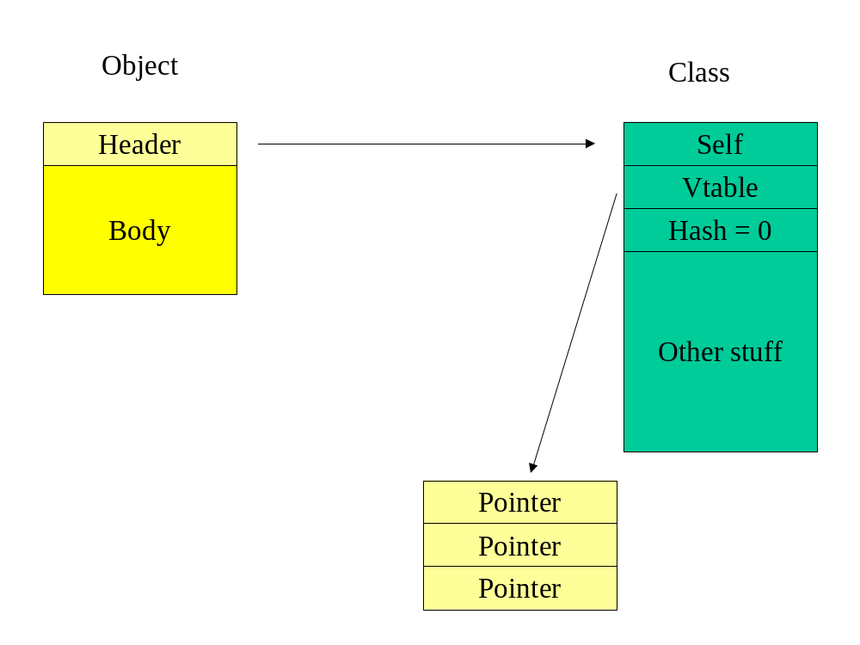
The first word of the class refers to itself. The second work points to the table of virtual methods and the third word contains a dummy hash code value of zero. (Zero is never a valid hashcode in this system.) When an object association is required it is interposed between the object and the class when the object is in read-write (RAM) memory.

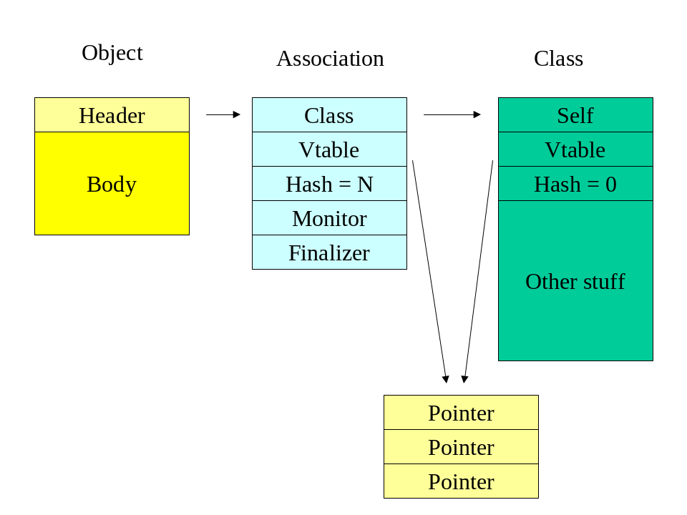

The Monitor data structure is exactly that used in SquawkNG. The Finalizer data structure is as follows:

class Finalizer {
Object object;
Finalizer next;
}

The next field is used to chain Finalizer objects together in one of two ways. Firstly before the object dies. This is the list of objects that will need finalization. Secondly after the object dies. In this case the objects are awaiting finalization. The garbage collector knows when marking the Finalizer object to work in one of two ways. When tracing objects generally the next field is regarded as a weak reference and not followed when marking. When the awaiting finalization queue is being traced the reference are regarded as strong.

Objects in read-only memory are treated differently. Their hash code is their object address, they never have their finializer methods called, and their monitors are maintained a different way. The monitors are maintained in a Hashtable associated with the current isolate. This Hashtable is manually culled of dead monitors when the garbage collector runs.

Oopmaps in Classes

At the moment Oopmaps are byte[] arrays that are pointed to from a class data structure. This causes problems with the LISP2 GC because in the “update pointers” phase the pointer has to be changed after which the Oopmap cannot be found until the relocation phase is complete. The proposed solution to this is to simply allocate space for the Oopmap immediately after the Klass. Various functions in the GC will have to be aware of this, but it does probably save space, and it solves the problem of wanting to compact Klass objects.

Having said this it will be hard to move classes if jitted code refer to them.

Kernel cleanup

VMExtension_abstractMethodError_21
VMExtension_unsatisfiedLinkError_22

Are to be removed from the VM. The translator needs to build normal code that does a invokestatic to some class which will allocate and throw these exceptions.

Endiness translation

The translator should do the endiness conversion for platforms that support the ability to load things larger than a byte from an odd-byte boundry.

