SVM Architecture Modification Proposal
This document describes two proposed modifications to the SVM architecture.

Explicit trust domains and identifiers

In the current SVM architecture, the concept of a trusted domain (i.e. community) is only represented implicitly as an emergent property of inter-class privileges. While the simplicity of such a scheme is attractive, it has a significant disadvantage. In a typical system, one would expect the number of inter-class relationships to be quite high, especially within application boundaries. Apart from the obvious runtime resource overheads of storing and verifying numerous privileges, there is also a negative effect this has on the conceptual complexity and usability of the architecture. A truly useful security architecture should pose a minimal overhead on development of co-operating components. A higher overhead will be tolerated for securing interactions between mutually distrusting components. Of course, the aforementioned ease of development should not compromise the security assurances offered by the original SVM architecture.

To this end, a new mechanism for explicitly representing trust domains is proposed. Before describing the mechanism in detail, it is important to show how it improves the SVM architecture. If we use non-forgeable trust domain identities, we can remove the need for explicit privileges between components in the same domain. This has the dual benefit of reducing the runtime resources used by privileges as well as development effort expended in cross-certifying classes within the same domain. It should be noted that the granularity of a domain is completely at the discretion of the domain owner. The granularity scale ranges from one domain per class to one domain for all classes. We expect typical usage to be closer to the latter end of the scale, mirroring natural application boundaries. Further discussion on the semantics of domain membership with respect to privileges is deferred until the mechanism is described.

The mechanism is fairly simple and is implemented via digital signatures (as are the rest of the privileges). All classes within a domain are signed by a key pair belonging to the owner of the domain. The key pair for each domain must be unique. These signatures and the corresponding public keys used for signature verification are appended to the end of a class’s trust certificate. The content signed is the original class plus the trust certificate minus the trust domain signatures and keys. This not only gives a domain owner a complete description of the class’s semantics but it also ensures that these semantics cannot be modified without them being notified. Each trusted class must be in at least one trust domain and exactly one of the trust domains for a class must be specified as the primary trust domain. Note that the uniqueness of trust domain keys can be checked at load time by ensuring that there is no duplication within the trust domain keys appended to the Trusted attribute.

For a given class A, the set of domains of which it is a member is denoted by DOM(A) and its primary domain is denoted by PDOM(A). The semantics of automatic privileges can now be clearly stated. For A to subclass or instantiate B, the intersection of DOM(A) and DOM(B) must not be empty or A must have the appropriate subclass or instantiation permit from B. For A and B to be considered in the same package, PDOM(A) must equal PDOM(B) and the package name of A and B must match. For example, in the diagram below, the following relationships exist:

- Classes foo.A, foo.B and foo.C are all in the same SVM package foo_{PDOM1} which also happens to correlate with the standard Java package of the same name. These classes are also in the primary domain PDOM1.
- Classes bar.Y and bar.Z are in primary domain PDOM2 and SVM package bar_{PDOM2} while bar.X is in primary domain PDOM3 and SVM package bar_{PDOM3}. Package level access is restricted to SVM packages and so bar.X does not have package level access to bar.Y and bar.Z and vice versa.
- Classes foo.C, bar.X, bar.Y and bar.Z are all in the same secondary domain DOM4. This enables the inheritance relationship between bar.Z and foo.Z to exists without the need for an explicit subclassing privilege.
- The instantiation relationship between foo.A and bar.X does require an explicit instantiation privilege as neither class is in a common domain.

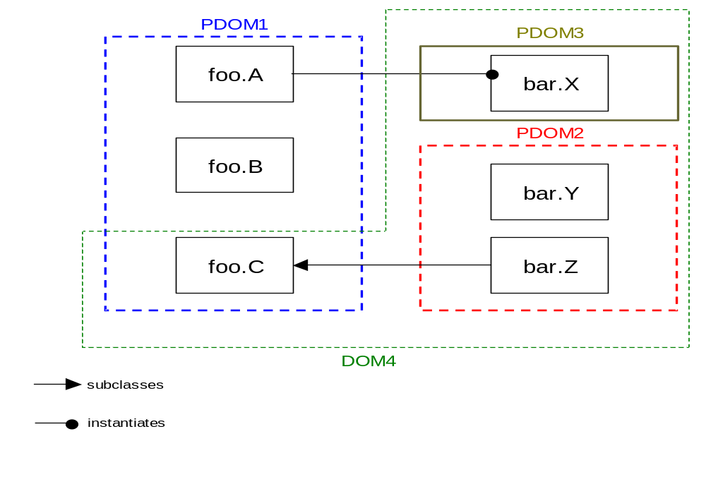

Note that it is also possible for a primary domain to cross Java package boundaries (as opposed to SVM package boundaries). For example, in the following diagram, PDOM1 and PDOM2 cross Java package boundaries. This implicity certifies both of the interclasses relationships shown. However, there are now 4 SVM packages: foo_{PDOM1}, foo_{PDOM2}, bar_{PDOM}1 and bar_{PDOM2}. That is, foo.A does not enjoy package level access to bar.X. However, it is not clear whether or not this would ever be useful. If not, then it is probably best to prevent primary domains from crossing package boundaries.
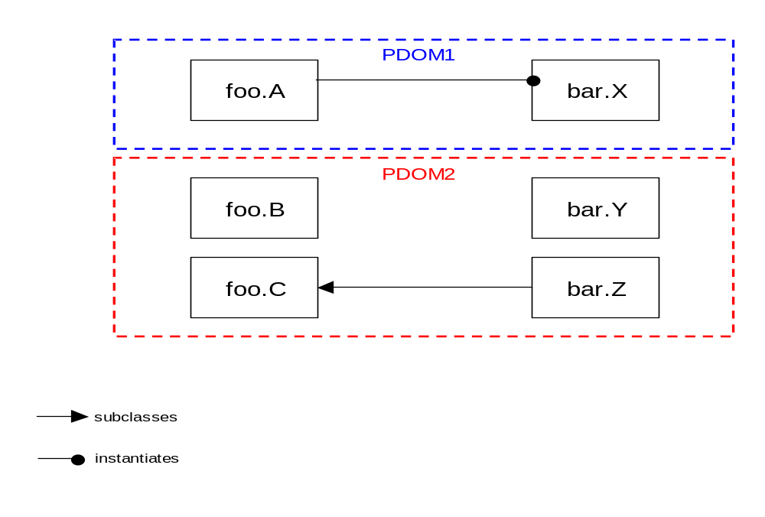

Note how this simply extends (or generalizes) the mechanism the SVM currently has for securing packages. The major modification is the use of explicit (and therefore testable) non-forgeable domain membership to grant privileges implicitly between classes. Also note that the ability of a class to be in more than one trust domain, does not mean it can be used by another class in one of its domains as a ‘backdoor’ into another one of its domains.

Recast the instantiation privilege as a class resource access privilege

The purpose of the instantiation privilege is to provide support for applications in the SVM to use a capabilities based security (CBS) model. Such a model leverages the type-safety of Java which ensures that object references cannot be forged. Combined with a strict adherence to pure object oriented programming, security policies can be expressed clearly and implemented efficiently. Almost. There is currently one spanner in the works. Public class level resources (i.e. static fields and methods) are accessible by anyone who has access to the class itself. For instance, any class can access System.out.As such they currently fall outside the purview of object based access control. We propose to remedy this by recasting the instantiation privilege as a class resource access privilege. After all, object instantiation can be viewed as a class level resource, albeit with special meaning. We could have considered retaining the instantiation privilege as is and added a separate class resource access privilege. However, we expect most secure applications to abstain from using class level resources. Adding an extra privilege seems too heavyweight and not justified under this usage assumption. In practice, we hope that it is only the CLDC API class level resources that will require protection via this mechanism.

Related work on using safe language technology for protection/security (cite J-Kernel paper) discusses other features that can be added to a capabilities based security architecture. Examples of such features include rights revocation and thread protection. Each of these features enhance the the architecture in the case where it is not feasible or desirable to implement all inter-domain security with the sharing of capabilities alone. This applies to the domain of application servers for example where two mutually untrusting applications may want to collaborate with each other where such collaboration is achieved through capability sharing. However, it may not be feasible for either application to completely audit each other and so some finer grain of control over the semantics of capability sharing is desirable. The SVM adopts a minimalist approach with respect to these features. That is, it has no direct support for them but at the same time, does not prevent them from being implemented at the application level. For example, the following paragraph demonstrates how rights revocation can be implemented by an application.

Rights revocation refers to the ability to revoke a capability given to a client. In the context of Java, this equates to revoking access to an object through a reference. As shown in (J-Kernel paper), this can be achieved via extra indirection implemented as an object wrapper. The J-Kernel authors go on to state that this simple mechanism is inferior for a number of reasons including programmers forgetting to use wrappers and the complexity of wrapping the transitive closure of objects referenced from the object being shared. However, we feel that sharing capabilities that need to be revokable is more the exception than the rule in SVM applications and as such SVM developers would rather accept the complexity of implementing the wrapper mechanism correctly than having the overhead of system provided revocation support imposed on all sharing of capabilities, even those that don’t require revocation.

