1. App/Website/UI name

Answer: fastest media app

1. Group No & member ID’s

Answer: group 16

16301100 孙守诚

16301085 窦锦涛

16301086 褚志峰

16301092 何雅伦

1. State the Single Statement of Need (SSON) (2-3 sentences)

Answer: （1）users can use the app to see videos, movies, listen to music etc.

（2）users can find some information by searching

（3）users can find their history

（4）users can see what's new or newest content

（5）users can adjust font size and the UI language

（6）users can easily follow a video, movie or music etc.

1. First step: Who are your users? List them!

Answer: users who want to see videos, movies, listen to music etc.

1. List requirements for your App/Website/UI & divide them into types (we talked about two main types in lectures)

Answer:

（1）users can login, logout and register

(Functional requirement)

（2）users can go to different partition(movie video music)

(Non-functional requirement)

（3）users can watch movie video and listen to music

(Functional requirement)

（4）users can change the default language

(Functional requirement)

（5）users can only login an account at a time

(Non-functional requirement)

（6）users need a beautiful UI

(Non-functional requirement)

（7）users can get his history browse record

(Functional requirement)

（8）users can search by some key word

(Functional requirement)

（9）users can refresh the content to watch the newest content at any time (Non-functional requirement)

（10）users can send a movie(video, music) to his social media (Functional requirement)

（11）users can easily follow a video, movie or music. (Non-functional requirement)

1. Develop at least 4 Personas and list them (each team member should pick a persona from a user group).

Answer: Person1 Middle age women

Person2 young lovers

Person3 white collar

Person4 college student*

1. Discuss and pick one of the personas as primary Persona (indicate this by a ‘*’ next to the name of the persona; discuss this with your team. There should be a good reason why you choose this Persona over the others

Answer: The major person is college student. Because undergraduate is the biggest user group of the international world, and they is more likely to see video, movie and listen to music then others.

1. Now write at a problem scenario that describes how people would use the media platform in the current situation, without the system that you are proposing. This might involve non-technological means, support from older technologies, a combination of technologies etc. Remember, this scenario not called problem scenario because there is necessarily a problem. It is just a description of the problem domain. So, you write a story how a user (your persona) would use the system at the current state.
2. Now re-write the scenario as an activity scenario (again in relation to your persona(s)) – introducing the system you are proposing, but only mentioning it at the level of the whole activity, not the specifics of how the user will interact with it. You can mention technology; however, you should not be mentioning specific button presses, gestures or other interaction styles.
3. Include a use-case table for requirements & appropriate use cases (see lecture slides)

Answer for 8,9,10 :



Personal background

age：55

sex：male

country ：China

language：Chinese

Role

job: Retired middle age women

skill required：Love life, like square dancing

gain：Leisure and entertainment after dinner, and have a good mood

Aim of using the app:

Can use the app to watch the favorite dancing video

Can use the app learn how to dance for a group

Favorite area:

Video area

Pain point

The steps to watch the video are too cumbersome, and most middle age women can’t master it well.

The problem she may meet in the old app:

1. The video player is outdated and many popular dances are not found.
2. The video player has few features and cannot search for the dance video that you want to watch.
3. The video player can't view the history and can't find the dance videos I've seen before.

Old App Solution:

1. Users can only choose to watch the dance videos already available on the player, and can't find more
2. Users can only browse the dance video list in order and find the dance video they like to watch.
3. Users can only revisit the video list to find dance videos they have already seen.

New App solutions:

1. Users can update to get the most popular dance videos for viewing.
2. Users can use the search function to find the dance videos they like to watch and learn.
3. Users can view the videos they have watched by viewing the history, and can click to watch again.



Personal background

age：26

sex：male and female

relationship: lovers

country ：China

language：Chinese and English

Role

Job: Academic Research

Skill required: research and analysis ability

Gain：Relax after a busy academic job

Aim of using the app:

Can use the app to watch the favorite movie

Can use the app to watch movies anytime, anywhere, convenient

Favorite area:

Movie area

Pain point

The content of the movie is too old, and the comedy movies that can alleviate the mood are too few.

The problem they may meet in the old app:

1. Users can't search for movies they like to watch.
2. The movie list is chaotic and disorderly, with no clear classification
3. The movie player can't view the history and can't find the movie they've seen before.
4. The movie player is simple and cannot interact in real time.

New App solutions:

1. Users can search for movies they like by searching, and support watching the latest hottest movies online.
2. User-classified movies, users can select movies of their favorite category by category
3. Users can query the movies they have already seen by viewing the history function, and click to watch again.
4. New online interactive function, users can leave comments and comments in real time

Old App Solution:

1. Users can only browse the movie list in order and find the movie they like to watch.
2. Users can only judge the movie category by their own feelings.
3. Users can find movie records that have already been seen by viewing the movie list again.
4. Viewers can only communicate with people around them and can't interact online.



Personal background

Age: 38

Gender: female

Education: Doctor of biology

Country and language: China Chinese

Role

Job: A Doctor of hospital

Skill required: University knowledge, Master the pathogenesis and pathophysiolo- gy

Gain: A relax mood after work



Aim of using the app:

Usually using the app to listen to music

Sometimes to watch some interesting video

Favorite area:

Music Zone

Pain point

The music which the app provide is disorganized can not find the relax type music

Hard to find the music named xxx

Hard to find the relax type music

Can not collect the favorite music

Old App Solution:

1. I should listen to music one by one to check the type and weather it is the type I like.
2. I should ask somebody who know the id for the music named ‘secret base’ and find it use old search function.
3. I should move to somewhere have WIFI, and download the music I like.

The problem she will meet in the old app:

* When I come into the app and go to the music zone, the recommend music is disorganized. It can not include your interest type to recommend your favorite music.
* When I come into the app, I wander to listen to a music named ‘secret base’, but I can not find it easily.
* It provides music need a lot of traffic download, but I don’t have it.

New App Solution:

1. I can set my favorite music type and go to recommend area to find the type music I like, or watch the introduce about a music to know what’s type it is.
2. I just need input the name of a music to search, then I will be show many music related, and I can find the music I want to listen to.
3. When I want to download a music, I can choice the quality about music. If my mobile traffic is insufficient, I will download in lower quality.

************************************************************************************************



Personal background

Age: 18-22

Sex: man

Education: Undergraduate

Country and language: China Chinese

Role

Job: college student

Skill: can use a lot of electronic product, and have strong learning ability

Aim of using the app:

1. Passing time when bored
2. Watch some interesting movie or humorous short film
3. Listening to music at doing homework

Favorite area:

1. Movie
2. Music

Space material

Pain point 

1. Music don’t have partition and song list.
2. The interface is not good.
3. Movie is hard to send my comment and communicate with others who is watching together

The problem he may meet in old app:

1. When I do homework and listen to music by auto play, it play a very loud music accidently and I can not pay attention to my study.
2. I very like a director’s movie, but it very hard to find the movie which is directed by the director.
3. Sometime I don’t have time to watch the full movie, and quit the app. But when I come back and it is hard find the movie that I didn’t finish watching last time.

New App solutions:

1. I can choose a song list which only have the songs fit study to auto play.
2. I can input the director name to searching all of the movie he directed.
3. I can go to the history watch area to find the history I have watched.

Old App Solution:

1. Close the app and open other app to listen to music.
2. Search which movie is directed by the director, and then ask others to get the id about the movie, finally search the id in the app.
3. If I remember the name, I can get the movie id from others. If no, you can only click other movie and to watch it.

|  |  |
| --- | --- |
| **requirement** | **use case** |
| When I come into the app and go to the music zone, the recommend music is disorganized. It can’t include your interest type to recommend your favorite music. | Search by type (A Doctor of hospital)  Recommend by my Favorite type(A Doctor of hospital) |
| When I come into the app, I wander to listen to a music named ‘secret base’, but I can’t find it easily. | Search by name (A Doctor of hospital) |
| It provides music need a lot of traffic download, but I don’t have it. | Choose download quality(such as 720p 1080p, Normal sound quality, ultimate sound quality) |
| When I do homework and listen to music by auto play, it plays a very loud music accidently and I can’t pay attention to my study. | Auto play by type (college student)  Auto play by song list(college student) |
| I very like a director’s movie, but it very hard to find the movie which is directed by the director. | Search by author name (college student) |
| The video player is outdated and many popular dances are not found. | Update the video list (Retired middle age women) |
| The video player has few features and cannot search for the dance video that you want to watch. | browse the video list (Retired middle age women) |
| The video player can't view the history and can't find the dance videos I've seen before. | view the video history list (Retired middle age women) |
| Users can't search for movies they like to watch | Use the search function(lovers) |
| The movie list is chaotic and disorderly, with no clear classification | judge the movie category(lovers) |
| The movie player can't view the history and can't find the movie they've seen before | view the history function(lovers) |
| The movie player is simple and cannot interact in real time | online interactive function(lovers) |

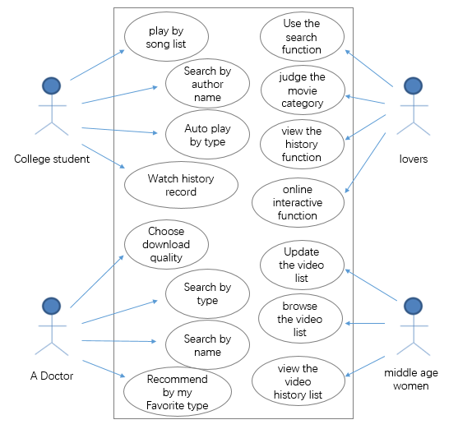

1. Prototype: Show a screenshot of your proposed UI (only one picture is enough as the presentation should show the rest)

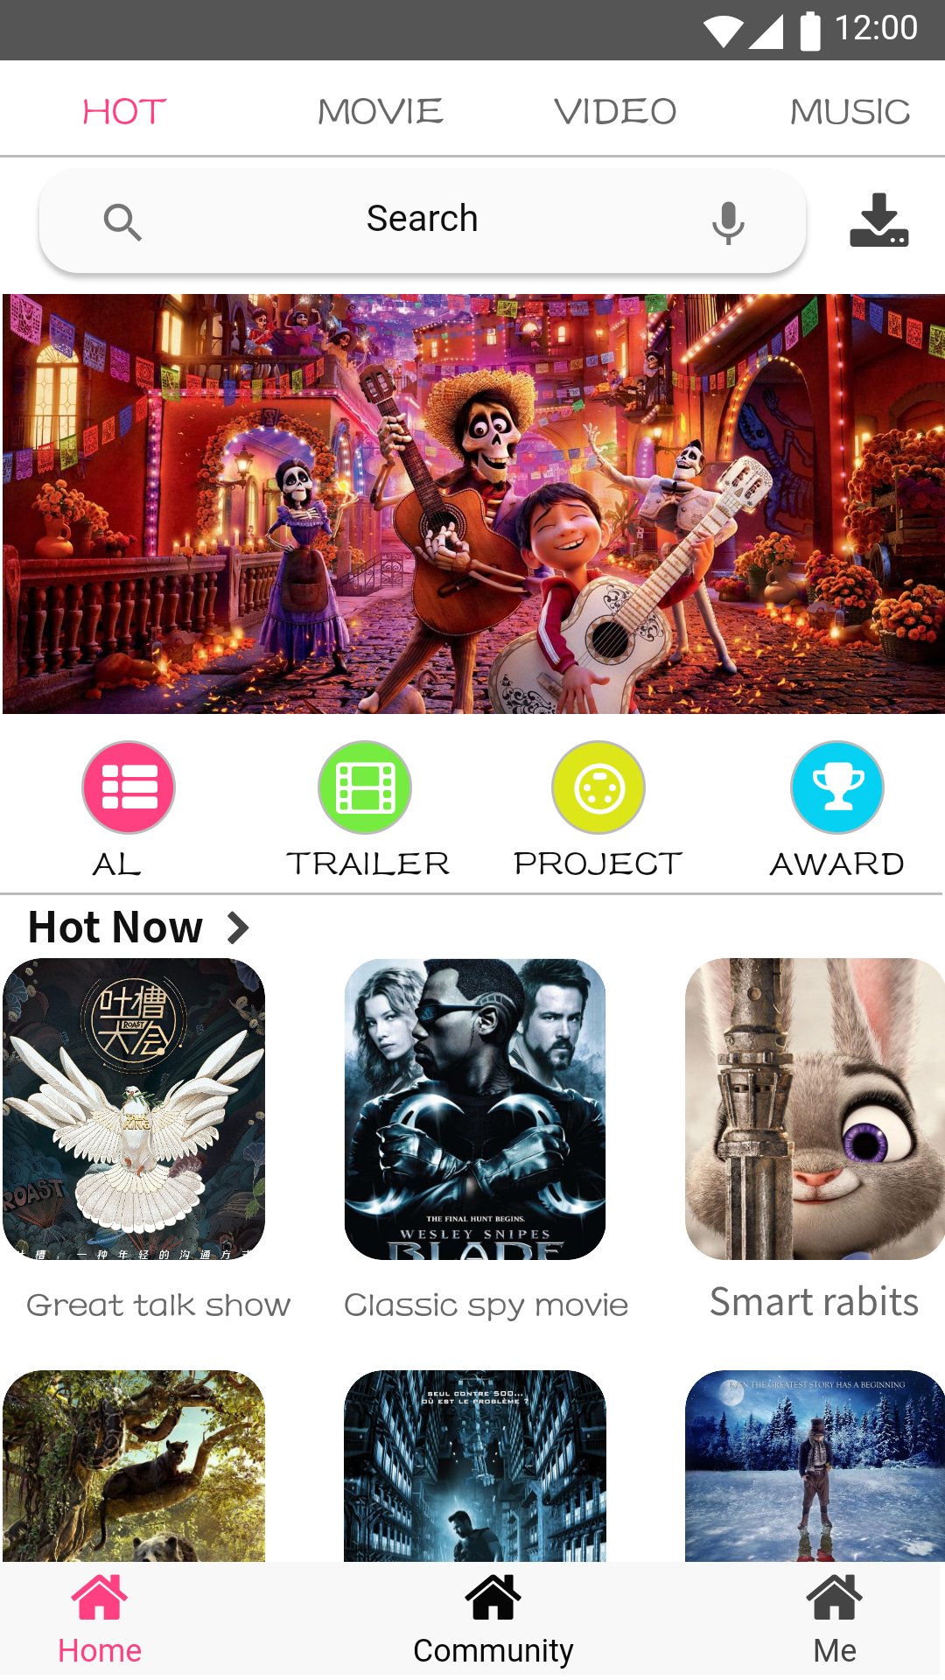

1. Perform a hierarchical task analysis on the proposed App/Website/UI in form of a HTA diagram for two tasks to be done in relation to the current state above (using your UI etc.).

Answer:

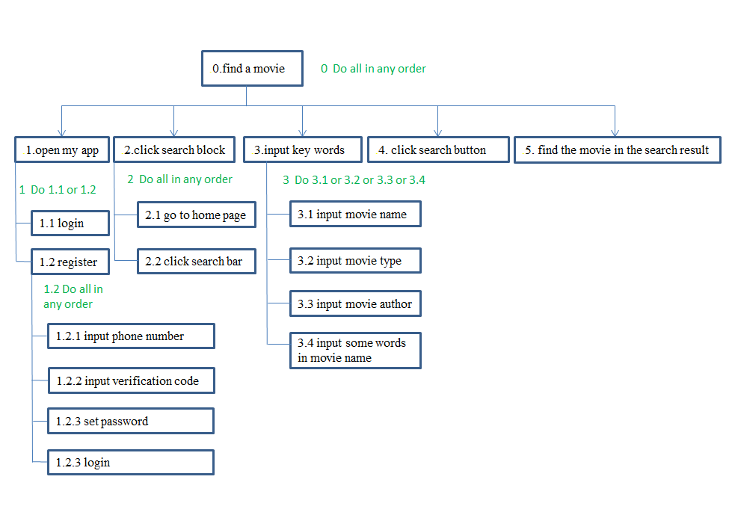

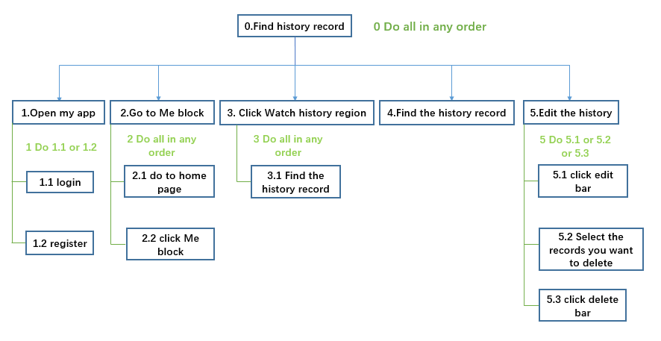

1. Evaluation 1: Use Nielsen’s heuristics to see if you discovered any problems with your UI design; you may not need all of them (as some may not apply) but list all that apply in a table showing what you found; usually people always find some issues in the first iteration; ( table: <heuristic><evaluation result>)

Answer:

|  |  |
| --- | --- |
| **heuristic** | **evaluation result** |
| Visibility of system status | The guide page does not have a clearly defined operation |
| Visibility of system status | Login page does not have the option to remember the password |
| Error strategy | Did not give the user a prompt of error message |
| Recognition rather than recall | Some features are hidden, users are not easy to find |

1. Evaluation 2: Pick a student from another team & perform a think aloud study on him or her using your website/app/UI; choose two tasks and let him or her do it without help; make a table and note down any issues: <step> <comments> <result>

Answer:

|  |  |  |  |
| --- | --- | --- | --- |
| **Task** | **Step** | **Comments** | **Result** |
| Modify language settings | Main interface->Me->settings  ->Language | This feature is very difficult to find | Successfully modified language settings |
| Query history | Main interface->Me->Watch history | Unable to edit history | Successfully viewed history |

1. What did you learn? (2-3 sentences)

Answer:

（1）A lot of observations of other people's works, absorbing their essence, and innovating, can become a good work that makes people shine.

（2）It is the best shortcut for UI design to do a good job in preparation, to clarify user needs, and to improve user experience.

（3）Teamwork is the core of a team, and a good cooperation environment can ensure the smooth operation of the program.