NIH Library Markdown: March 2023

# Turning on Our Packages

library(tidyverse)

── Attaching core tidyverse packages ──────────────────────── tidyverse 2.0.0 ──  
✔ dplyr 1.1.0 ✔ readr 2.1.4  
✔ forcats 1.0.0 ✔ stringr 1.5.0  
✔ ggplot2 3.4.1 ✔ tibble 3.1.8  
✔ lubridate 1.9.2 ✔ tidyr 1.3.0  
✔ purrr 1.0.1   
── Conflicts ────────────────────────────────────────── tidyverse_conflicts() ──  
✖ dplyr::filter() masks stats::filter()  
✖ dplyr::lag() masks stats::lag()  
ℹ Use the ]8;;http://conflicted.r-lib.org/conflicted package]8;; to force all conflicts to become errors

library(quarto)  
library(rmarkdown)

# Save Our Plot Object

air_quality_plot <- airquality %>%   
 ggplot(mapping = aes(x = Temp, y = Ozone)) +  
 geom_point()

# Create Our Plot

air_quality_plot +  
 geom_smooth(method = "lm")

`geom_smooth()` using formula = 'y ~ x'

Warning: Removed 37 rows containing non-finite values (`stat_smooth()`).

Warning: Removed 37 rows containing missing values (`geom_point()`).

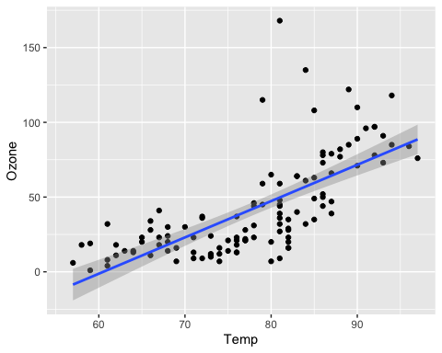

# Insert Code Chunks in a Couple of Languages

## R

library(gapminder)  
summary(gapminder$lifeExp)

Min. 1st Qu. Median Mean 3rd Qu. Max.   
 23.60 48.20 60.71 59.47 70.85 82.60

## Python

# #| label: fig-polar  
# #| fig-cap: "A line plot on a polar axis"  
#   
# import numpy as np  
# import matplotlib.pyplot as plt  
#   
# r = np.arange(0, 2, 0.01)  
# theta = 2 * np.pi * r  
# fig, ax = plt.subplots(  
# subplot_kw = {'projection': 'polar'}   
# )  
# ax.plot(theta, r)  
# ax.set_rticks([0.5, 1, 1.5, 2])  
# ax.grid(True)  
# plt.show()