Intro to Quarto

Table of Contents

# This is H1

This is my **first** *class* on markdown.

R is a programming language that is especially [powerful](https://www.nihlibrary.nih.gov/services/bioinformatics-support) for data exploration, visualization, and statistical analysis RStudio is an integrated development environment (IDE) that makes using R easier. In this course we use RStudio to interact with R. If you don’t already have R and RStudio installed, follow the instructions for your operating system below. You have to install R before you install RStudio. Add a link to [Bioinformatics](https://www.nihlibrary.nih.gov/services/bioinformatics-support) support program (Figure 1).

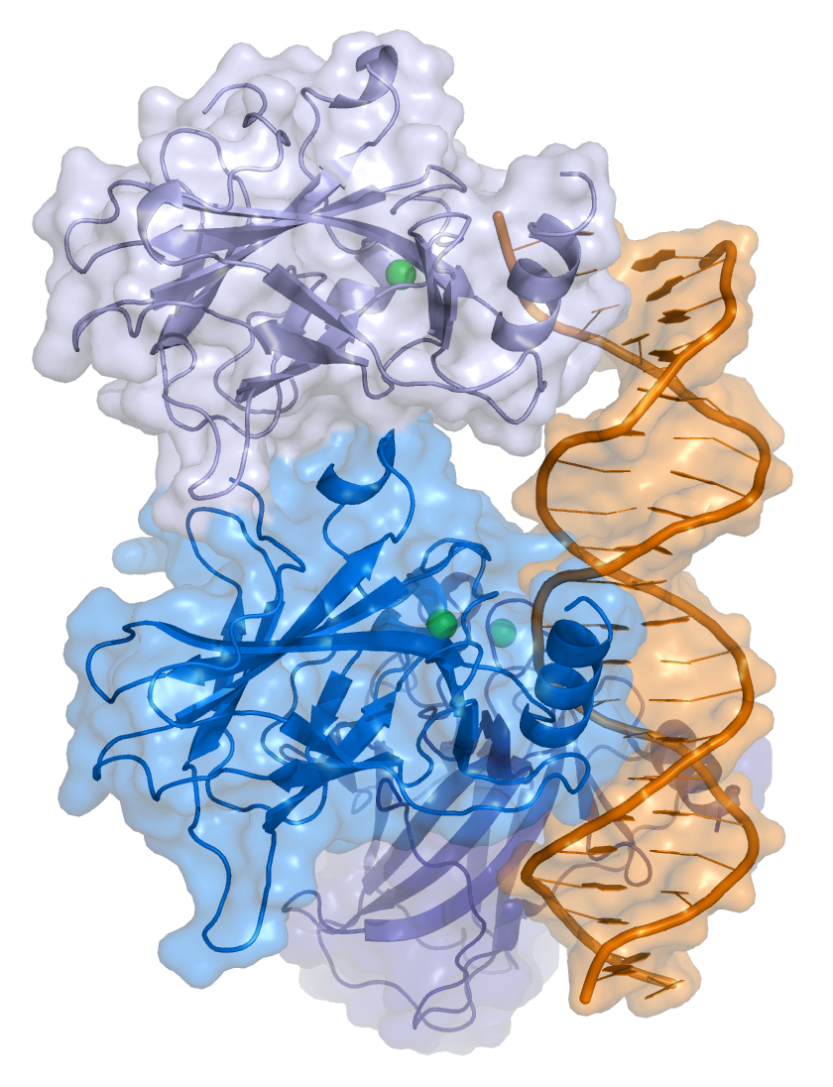

Figure 01: P53 image for wiki.

### This is H2

#### This is H3

This is an example of an equation

$${\left(6+5\right)}^{5}/\left(x^{2}\right)$$

(6 + 5)^5/ (10^2)

[1] 1610.51

library(tidyverse)

── Attaching core tidyverse packages ──────────────────────── tidyverse 2.0.0 ──  
✔ dplyr 1.1.0 ✔ readr 2.1.4  
✔ forcats 1.0.0 ✔ stringr 1.5.0  
✔ ggplot2 3.4.1 ✔ tibble 3.1.8  
✔ lubridate 1.9.2 ✔ tidyr 1.3.0  
✔ purrr 1.0.1   
── Conflicts ────────────────────────────────────────── tidyverse_conflicts() ──  
✖ dplyr::filter() masks stats::filter()  
✖ dplyr::lag() masks stats::lag()  
ℹ Use the ]8;;http://conflicted.r-lib.org/conflicted package]8;; to force all conflicts to become errors

mpg_doug <- mpg %>%   
 select(drv, cty)