LSC 563 Lecture 1: Introduction to data visualization

Doug Joubert

2021-10-22

Table of Contents

Learning Objectives 1

Introduction 2

Foundations for an Applied Science of Data Visualization 3

Visualization Stages 5

Human Visual Processing 5

Visible Light 6

Mechanism of sight 6

Major Components of the Eye 7

Perceptual Processing 7

A Model of Perceptual Processing 8

Low-Level Visual Processing (Stage 1) 10

Retina 10

Rods and Cones 11

Trichromacy 11

Theories of Color Vision 13

Trichromatic Theory 14

Psychophysical evidence for three cone photoreceptors 14

Limitations of Trichromatic Theory 15

Opponent-Process Theory 15

Color Vision Deficiency 16

References 18

# Learning Objectives

By the end of this section, students should be able to:

* List the four stages of visualization as outlined by Ware
* Describe the basic functions of the:
  + Cornea
  + Iris
  + Retina
  + Optic Nerve
* List the three basic stages of vision
* Distinguish between rods and cones
* Define trichromacy theory
* Distinguish between the three cone wavelengths
* List the basic characteristics for the 3 stages of perceptual processing

# Introduction

Cognitive neuroscience has made rapid progress in the last few years. The theory of predictive cognition provides a new and much more solid foundation for understanding information visualization . In addition, the idea that cognition occurs in a distributed fashion, combining brain function with cognitive tools, such as visualizations, is now mainstream (Ware, 2019b).

In a way, this book is a direct result of my ongoing attempt to reconcile the scientific study of perception with the need to convey meaningful information . It is about art in the sense that “form should follow function,” and it is about science because the science of perception can tell us what kinds of patterns are most readily perceived (Ware, 2019b).

The eye and the visual cortex of the brain form a massively parallel processor that provides the highest bandwidth channel into human cognitive centers. At higher levels of processing, perception and cognition are closely interrelated (Ware, 2019b).

Following perception-based rules, we can present our data in such a way that the important and informative patterns stand out (Ware, 2019b). If we disobey these rules, our data could be incomprehensible or misleading (Ware, 2019b).

Visualization can be approached in many ways. However, following a scientific approach based on perception uniquely promises design rules that transcend the vagaries of design fashion, being based on the relatively stable structure of the human visual system (Ware, 2019b).

The study of perception by psychologists and neuroscientists has advanced enormously over the past three decades, and it is possible to say a great deal about how we see that is relevant to data visualization (Ware, 2019b).

Information Visualization: Perception for Design is intended to make this science and its applications available to the non-specialist. The book/class is organized according to bottom-up perceptual principles (Ware, 2019b):

* The first chapter provides a conceptual framework and the theoretical context for a vision-science-based approach. A classification of abstract data classes is provided as the basis for mapping data to visual representations.
* Chapters 2 through 5 discuss low-level perceptual elements of vision, color, texture, motion, and elements of form. These primitives of vision tell us about the design of attention-grabbing features and the best ways of coding data so that one object will be distinct from another.
* Chapter 2 The Environment, Optics, Resolution, and the Display deals with the basic inputs to perception. We are only focusing on the eye and mechanisms of vision.
* Chapter 3: Lightness, Brightness, Contrast, and Constancy The visual system does not measure the amount of light in the environment; instead, it measures changes in light and color. How the brain uses this information to discover properties of the surfaces of objects in the environment is presented.
* Chapter 4: Color introduces the science of color vision, starting with receptors and trichromacy theory. Color measurement systems and color standards are presented, and Opponent process theory is introduced.
* Chapter 5: Visual Salience: Finding and Reading Data Glyphs introduces the “searchlight” model of visual attention to describe the way eye movements are used to sweep for information. The bulk of the chapter is taken up with a description of the massively parallel processes whereby the visual image is broken into elements of color, form, and motion. Preattentive processing theory is applied to critical issues of making one data object distinct from another.

The later chapters move on to discussing what it takes to perceive patterns in data and visualization design, data space navigation, interaction techniques, and visual problem solving are discussed.

* Chapter 6: Static and Moving Patterns looks at the process whereby the brain segments the world into regions and finds links, structure, and prototypical objects.
* Chapter 10: Interacting with Visualizations defines the major interaction cycles are defined. This chapter also focuses on low-level data manipulation, dynamic control over data views, and navigation.
* Chapter 11: Thinking with Visualizations begins by outlining the cognitive system involved in thinking with visualizations. These are processes that occur partly in a computer and partly in the visual brain of the user.
* Chapter 12: Designing Cognitively Efficient Visualizations provides a design methodology for producing cognitively efficient visualizations.

# Foundations for an Applied Science of Data Visualization

One of the greatest benefits of data visualization is the sheer quantity of information that can be rapidly interpreted if it is presented well. Figure L1.1 shows an exterior image of Lake Dian, China. Lake Dian, the largest lake on South China’s Yunnan-Guizhou Plateau. This lake is interesting because it exhibits two abnormal funnel-like features in the deepest part of the lake (Wu et al., 2021). What makes this lake interesting is that it is unclear when these funnels formed. To address these questions, Wu carried out a detailed multi-method survey including underwater topographic monitoring, extraction of sediment records, and geophysical exploration across the funnel areas (Wu et al., 2021).



Figure L1.1: Lake Dian, China, Image source: By I, Emitchan, CC BY 2.5, (Wu et al., 2021).

Fig. L1.2 shows the show the enlargements of the DEMs of the larger funnel in 2015 and 2019.



Figure L1.2:Comparison of October 2015 and September 2019 enlargements of the DEMs of the larger funnel (Wu et al., 2021).

As you can see in Figure L1.2, when the data is converted to an area field and displayed visually, many patterns become visible.

The Lake Dian image highlights a number of the advantages of visualization:

1. Visualization provides an ability to comprehend huge amounts of data.
2. Visualization allows the perception of emergent properties that were not anticipated. The perception of a pattern can often be the basis of a new insight.
3. Visualization often enables problems with the data to become immediately apparent. With an appropriate visualization, errors and artifacts in the data often jump out at you. For this reason, visualizations can be invaluable in quality control.
4. Visualization facilitates understanding of both large-scale and small-scale features of the data. It can be especially valuable in allowing the perception of patterns linking local features.

## Visualization Stages

The process of data visualization includes four basic stages, combined in a number of feedback loops (Ware, 2019b):

1. The collection and storage of data. This stage is the longest feedback loop, which involves gathering data.
2. A preprocessing stage designed to transform the data into something that is easier to manipulate. Usually there is some form of data reduction to reveal selected aspects. Data exploration is the process of changing the subset that is currently being viewed.
3. Mapping from the selected data to a visual representation. User input can transform the mappings, highlight subsets, or transform the view.
4. The human perceptual and cognitive system (the perceiver).

Both the physical environment and the social environment are involved in the data gathering loop. The physical environment is a source of data, while the social environment determines what is collected and how it is interpreted.

# Human Visual Processing

From an evolutionary perspective, our visual system is designed to extract useful information from the environment and lessons from this can lead to the design of better visualizations (Ware, 2019c).

The theory of evolution tells us that the visual system has survival value, and adopting this perspective allows us to understand visual mechanisms in the broader context . Adapting skills include navigation, food seeking (which is an optimization problem like information seeking), and using tools(which depends on object-shape perception) (Ware, 2019c).

## Visible Light

Perception is about understanding patterns of light. Visible light constitutes a very small part of the electromagnetic spectrum, as is shown in Figure L1.3.

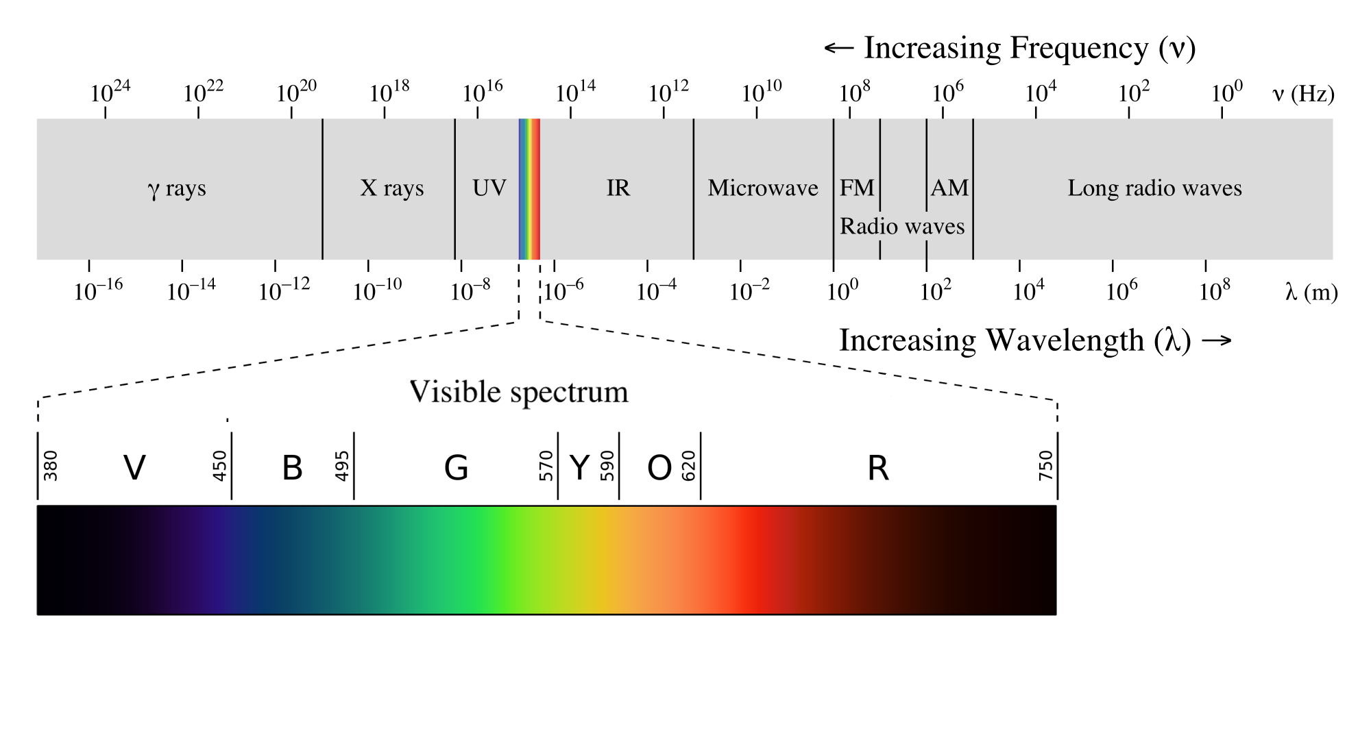

Figure L1.3: The visible light spectrum is a tiny part of a much larger spectrum of electromagnetic radiation.

In vision research, wavelength is generally expressed in units of nanometers (Ware, 2019c). Humans can perceive light only in the range of 400-700nm (Ware, 2019c). At wavelengths shorter than 400 nm are ultraviolet light and Xrays (Ware, 2019c). At wavelengths longer than 700nm are infrared light, microwaves, and radio waves (Ware, 2019c).

Much of human visual processing becomes more understandable if we assume that a key function of the visual system is to extract properties of surfaces (Ware, 2019c).

## Mechanism of sight

About 70% of the sense receptors in our bodies are dedicated to vision (Ware, 2019c). Our eyes have several components working together to sense information that is contained in light (Ware, 2019c). The major components of the eye are illustrated in Figure L1.4.

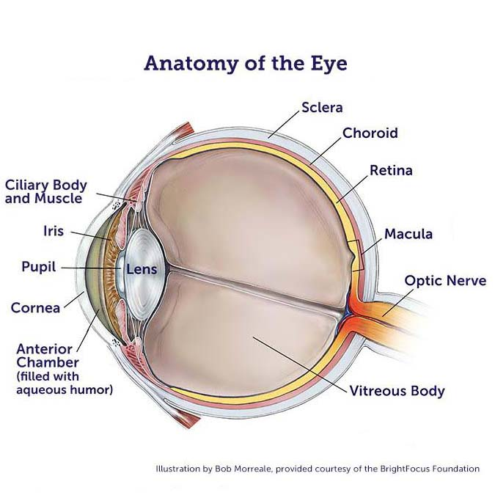

Figure L1.4: Major components of the eye .

Some people find it difficult to understand how we can see the world properly when the image is upside down 1. The right way to think about this is to adopt a computational perspective 1. We do not perceive what is on the retina; instead, an image is formed through a complex chain of neural computations (Ware, 2019c).

## Major Components of the Eye

* **Cornea** protects the eye.
* **Iris** controls the size of the pupil.
* The **pupil** controls how much light enters to the eye.
* The **lens** thickens to focus on objects that are near and thins to focus on distant objects.
* **Retina** is the rear, inner surface of the eye. Coated with millions of specialized nerve cells called **rods** and **cones**. We will discuss rods and cones in more detail when we cover color.
* **Optic nerve** is a paired nerve that transmits visual information from the retina to the brain.

# Perceptual Processing

The modern study of sensation and perception began in the 19th century with the emergence of experimental psychology as a scientific discipline (Kandel, 2013a). Psychophysics describes the relationship between the physical characteristics of a stimulus and the attributes of the sensory experience (Kandel, 2013a). Sensory physiology examines how the stimulus is transduced by sensory receptors and processed in the brain (Kandel, 2013a):

* How sensory stimuli could be isolated and measured precisely
* The size, shape, amplitude, velocity, and timing of stimuli
* These measurements can be plotted as psychometric function [Figure L1.5]

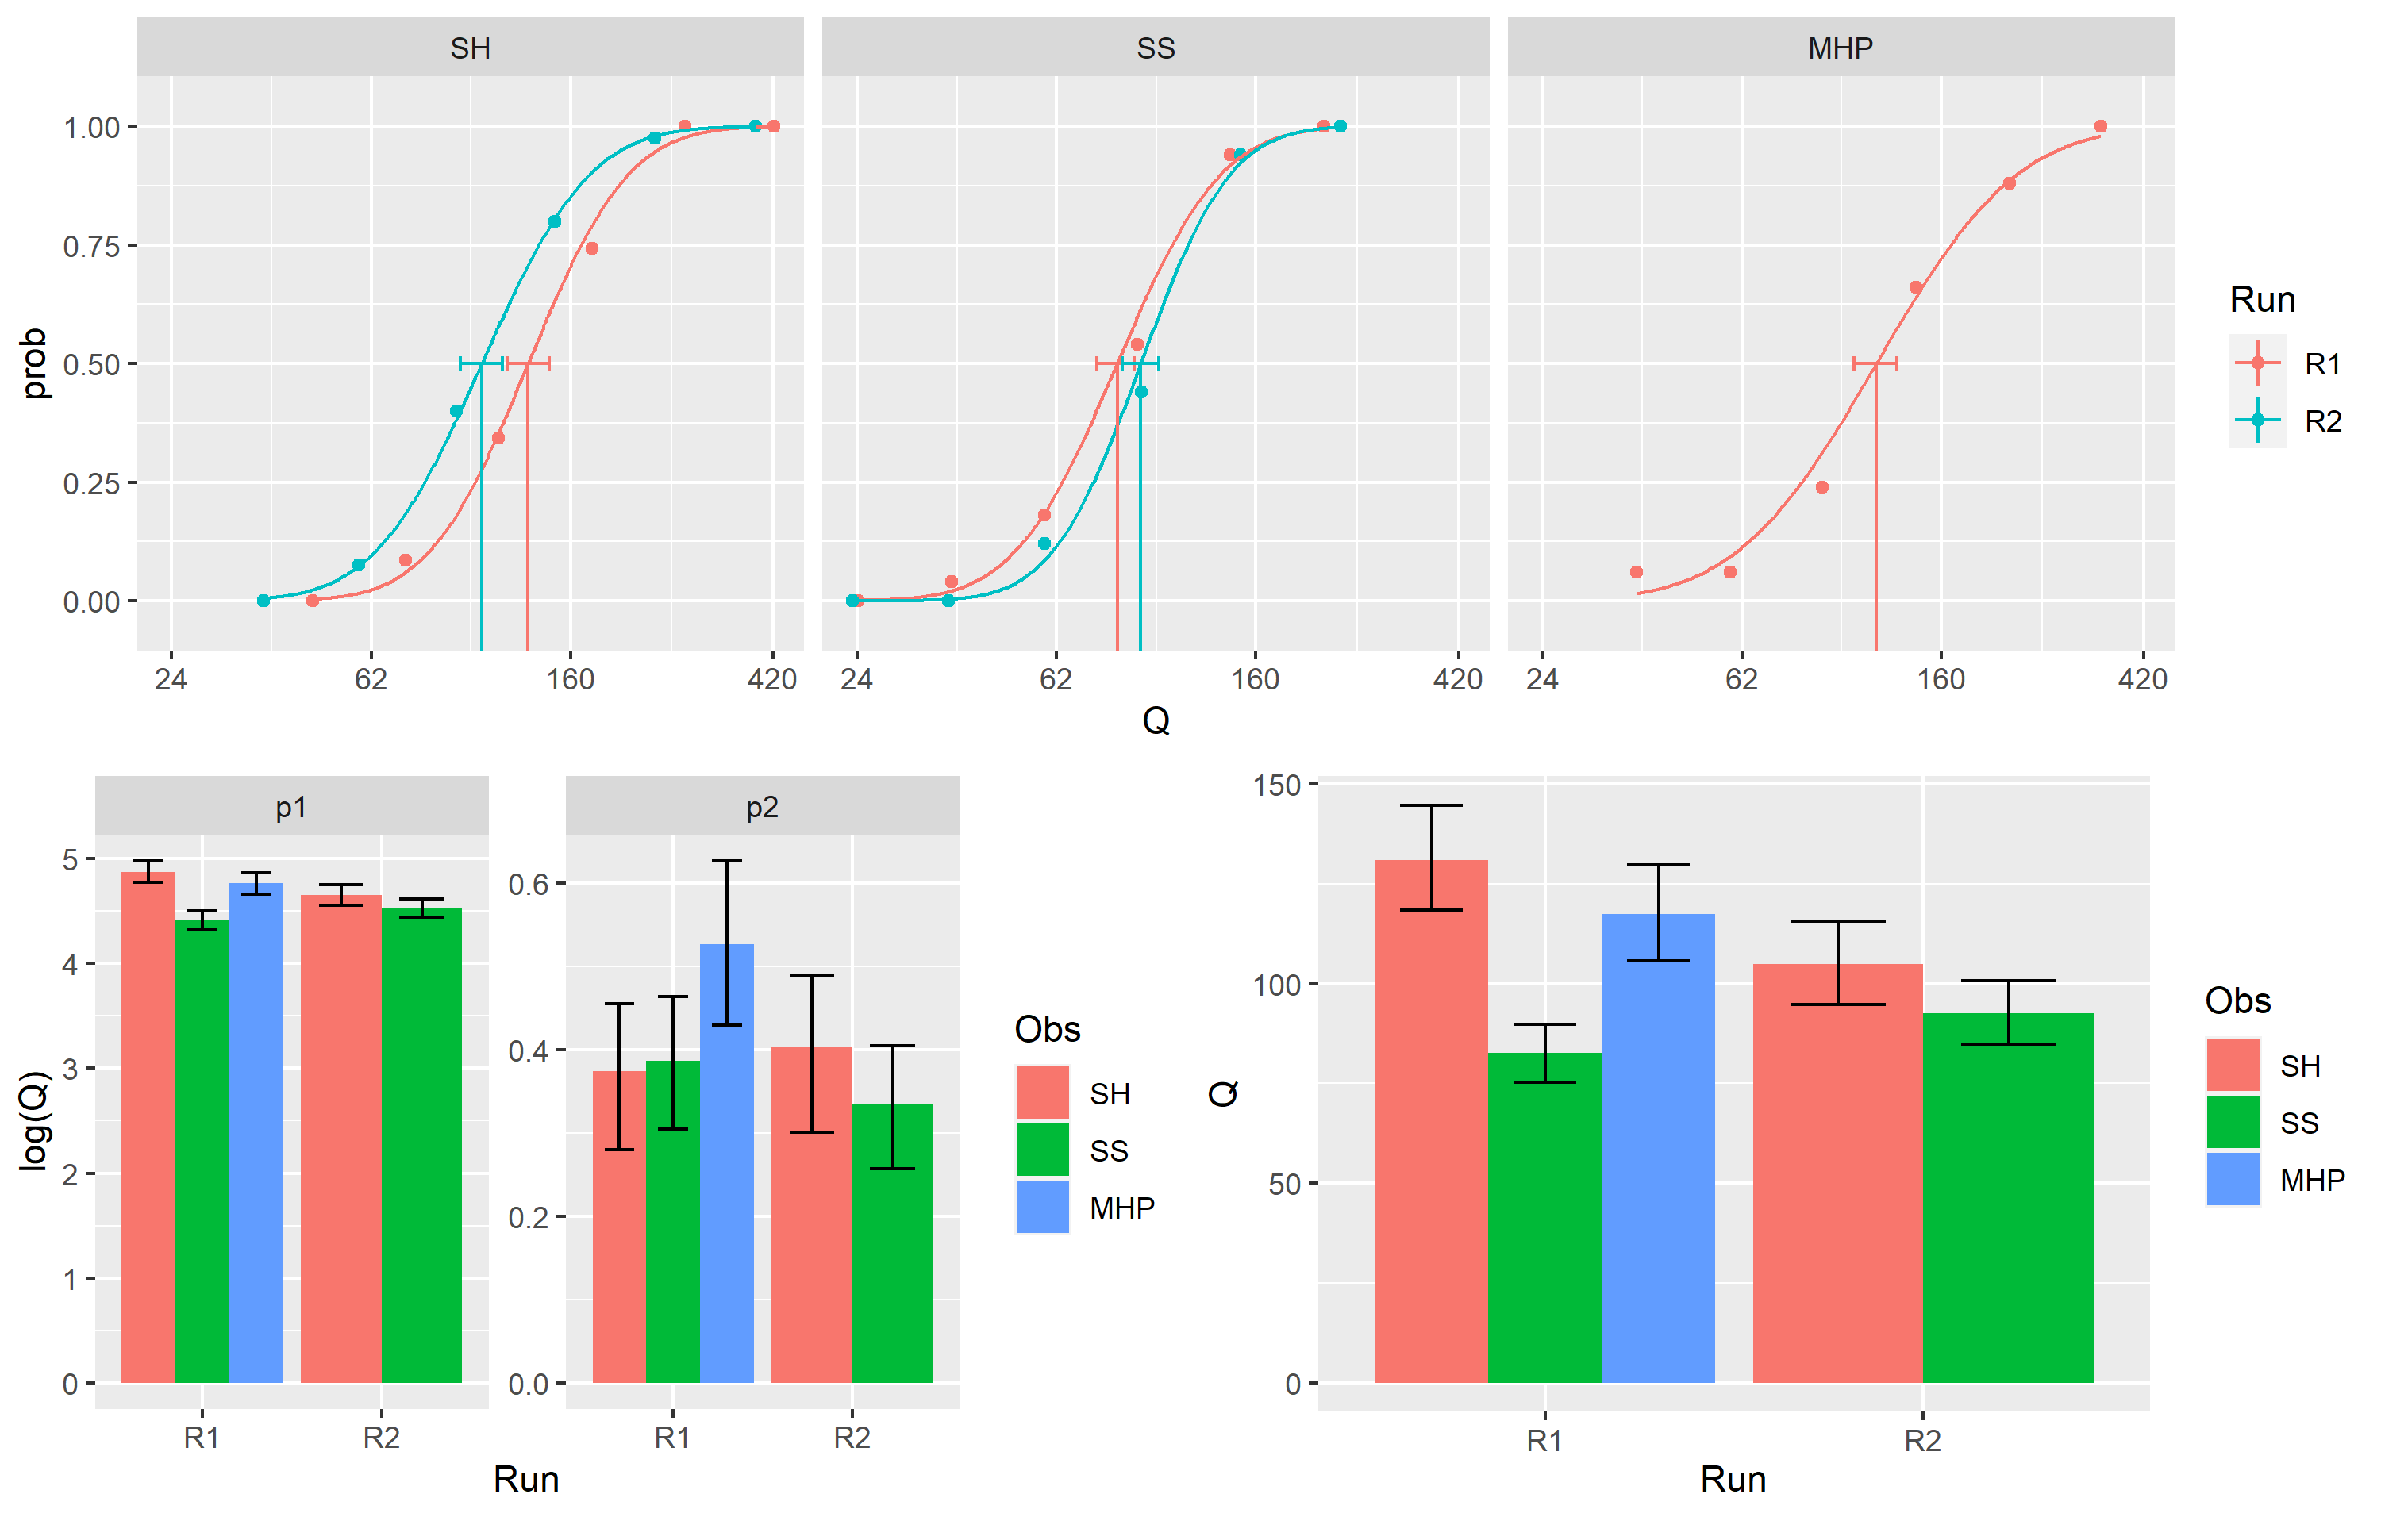

Figure L1.5: Graph of a psychometric function (Wichmann et al., 2002).

Psychometric function defines the mathematical relationship between the amplitude of a stimulus and the intensity of the sensation felt by the subject (Ware, 2019c).

## A Model of Perceptual Processing

The brain analyzes a visual scene at three stages: low, intermediate, and high. This is visualized in Figure L1.6.

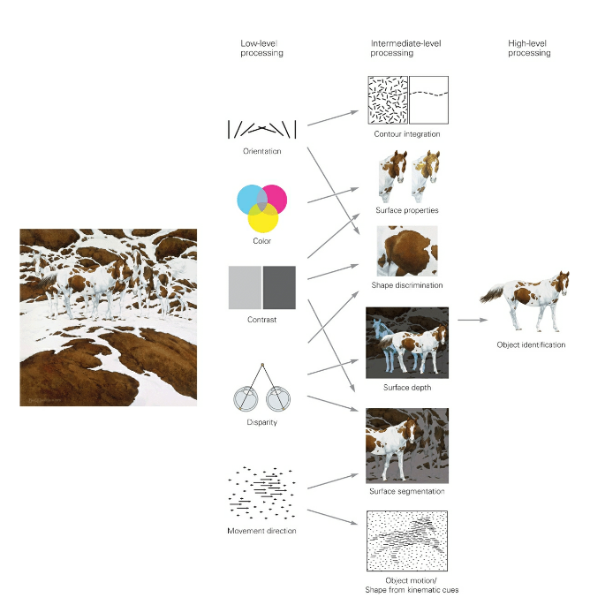

Figure L1.6: A visual scene is analyzed at three levels (Ware, 2019c).

Each stage has important characteristics (Ware, 2019c):

* Stage 1 (low-level processing): simple attributes of the visual environment are extracted such as: orientation, color, texture, and movement. Processing is parallel, unconscious, and transitory. Stored in iconic memory, which works kind of like a buffer for the sensory information.
* Stage 2 (intermediate-level processing): involves analysis of the layout of scenes and of surface properties, parsing the visual image into surfaces and global contours, and distinguishing foreground from background (Kandel, 2013b). Also, low level features are aggregated together to create patterns (Ware, 2019c). Perception of these patterns is sequential, which makes it much slower than parallel processing (Ware, 2019c).
* Stage 3 (high-level processing): Detected patterns through previous stages are transformed into objects that are retained in working memory (Kandel, 2013b). The objects can be matched with memories of shapes and their associated meanings (Ware, 2019c).

# Low-Level Visual Processing (Stage 1)

## Retina

The retina is the brain’s window to the world. All visual experience is based on information processed by this neural circuit in the eye (Kandel, 2013b).The retina is a thin sheet of neurons, a few hundred micrometers thick, composed of five major cell types (Figure L1.7) (Kandel, 2013b).

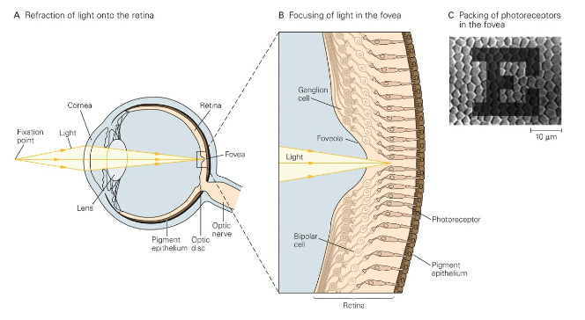

Figure L1.7: The eye projects the visual scene onto the retina’s photoreceptors (Meister & Tessier-Lavigne, 2013).

As illustrated in Figure L1.7, vision occurs in the following stages (Kandel, 2013b):

1. Light from an object in the visual field is refracted by the cornea and lens and focused onto the retina.
2. The image is projected onto the densely packed photoreceptors in the fovea. Although less sharply focused than shown here as a result of diffraction by the eye’s optics
3. The photoreceptor cells absorb light and convert it into a neural signal, an essential process known as phototransduction.

The retinal circuit performs low-level visual processing as it extracts the raw images in the left and right eyes (Kandel, 2013b).

Low-level processing is very plastic, the retina is constantly adjusting its sensitivity to ever-changing conditions of illumination [Kandel (2013b). This adaptation provides stability despite the vast range of light intensities encountered by the retina (Kandel, 2013b).

### Rods and Cones

We have already discussed the anatomy of the eye. In this section we are only focusing on those aspects related to color.

Most vertebrates have two types of photoreceptors, rods and cones, distinguished by their morphology (Kandel, 2013b).

Rods and cones also differ in function, most importantly in their sensitivity to light (Kandel, 2013b). Rods can signal the absorption of a single photon and are responsible for vision under dim illumination such as moonlight [Kandel (2013b). Cones are responsible for color vision which begins in cone-selective circuits (Kandel, 2013b).

### Trichromacy

The most important fact about color vision is that we have three distinct color receptors called cones, that are active in normal light, hence trichromacy (Ware, 2019a).

States that the visual cortex combines information coming from the 3 sensors to generate color perception. This means that some of them are more sensitive to light than others. Also, it means that every color can be expressed as a combination of the three main channels. However, we do not perceive color in terms of the amount of red, green, or blue.

Cones are much less sensitive to light and they are solely responsible for vision in daylight (Meister & Tessier-Lavigne, 2013). Their response is considerably faster than that of rods. Primates have only one type of rod but three kinds of cone photoreceptors, distinguished by the range of wavelengths to which they respond (Meister & Tessier-Lavigne, 2013):

* Short wavelength (S), the “blue” cones
* Medium wavelength (M), the “green” cones
* Long wavelength (L), the “red” cones

Figure L1.8 shows how light of different wavelengths is absorbed by the three different receptor types (S, M, L). Also illustrated in Figure L1.8, the different classes of photoreceptors are sensitive to broad and overlapping ranges of wavelengths.

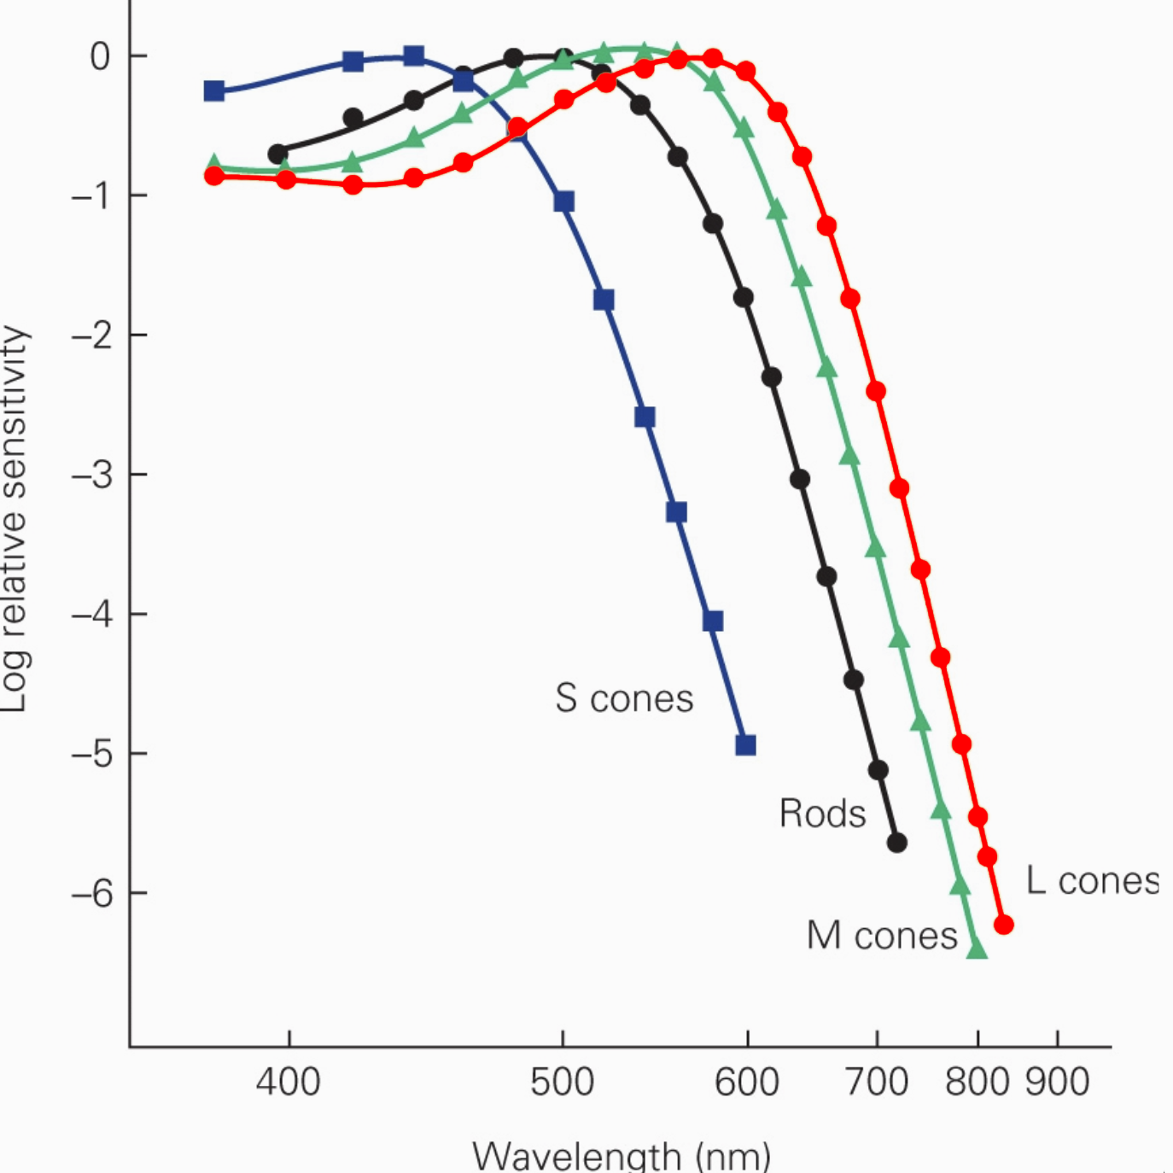

Figure L1.8: Cone sensitivity functions. The colors are only rough approximations to spectrum hues.

What does this really mean? These spectra demonstrate that the packaging of pigment molecules within the cells is highly specific (Schnapf et al., 1987). For example, at 600 nm the blue cones were nearly 105 times less sensitive than the red and green cones (Schnapf et al., 1987).

In addition, certain colors are perceived more easily than others (Feisner & Reed, 2014). Yellows and greens are seen before other hues, while red and violet are the most difficult to perceive (Feisner & Reed, 2014). If we take another look at the hue order of the visual spectrum (Figure L1.7), we see that a perception curve is formed (Feisner & Reed, 2014). Specifically, yellow and green hues at the curve’s height and red and violet forming its lower extremities [Figure L1.9] (Feisner & Reed, 2014).

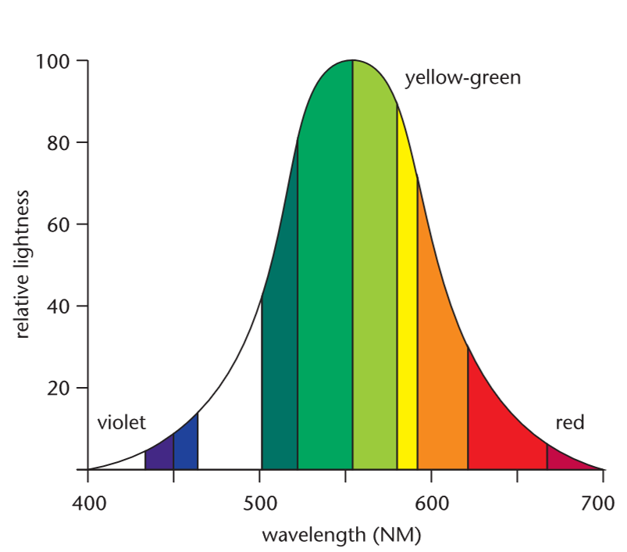

Figure L1.9: Color perception curve.

The yellow and green wavelengths register highest on the relative lightness axis. Someone with normal vision will register the yellow-green segments of the spectrum first, because they appear brighter than all the other ones.

# Theories of Color Vision

Throughout recorded history philosophers and scientists have been fascinated by the perception of color (Meister & Tessier-Lavigne, 2013). This interest was fueled by the relevance of color to art, later by its relation to the physical properties of light, and finally by commercial interests in television and photography (Meister & Tessier-Lavigne, 2013).

Colorimetry is a measure of visual function at the photoreceptor level (Forrester et al., 2016a). Colorimetry or the measurement of color is based on techniques of color matching, which have a long history going back to the days of Newton, Helmholtz and particularly Maxwell in the mid-nineteenth century (Forrester et al., 2016b). Early experiments on color matching showed that the percept of any given light could be matched by mixing together appropriate amounts of three primary lights (Meister & Tessier-Lavigne, 2013).

The 19th century witnessed a profusion of theories to explain color perception, of which two have survived modern scrutiny (Meister & Tessier-Lavigne, 2013). They are based on careful psychophysics that placed strong constraints on the underlying neural mechanisms (Meister & Tessier-Lavigne, 2013).

There are two major theories that explain and guide research on color vision: the trichromatic theory also known as the Young-Helmholtz theory, and the opponent-process theory (Meister & Tessier-Lavigne, 2013).  These two theories are complementary and explain processes that operate at different levels of the visual system (Meister & Tessier-Lavigne, 2013).

As you will see, both theories are needed to explain what is known about color vision. The trichromatic theory explains color vision phenomena at the photoreceptor level; the opponent-process theory explains color vision phenomena that result from the way in which photoreceptors are interconnected (Meister & Tessier-Lavigne, 2013).

## Trichromatic Theory

This theory explains color vision phenomena at the photoreceptor level. Trichromatic theory of color vision was developed based on the work of Maxwell, Young, and Helmholtz (Meister & Tessier-Lavigne, 2013). They recognized that there must be three types of receptors, approximately sensitive to the red, green, and blue regions of the spectrum, respectively (Meister & Tessier-Lavigne, 2013).

### Psychophysical evidence for three cone photoreceptors

Individuals with normal color vision needed three different wavelengths (i.e., the Red, Green, and Blue primaries) to match any other wavelength in the visible spectrum .  This finding led to the hypothesis that normal color vision is based on the activity of three types of receptors, each with a different peak sensitivity (Meister & Tessier-Lavigne, 2013).

The trichromatic theory assumed that three images of the world were formed by these three sets of receptors and then transmitted to the brain where the ratios of the signals in each of the images were compared in order to sort out color appearances (Meister & Tessier-Lavigne, 2013).

Consistent with the trichromatic theory, we now know that the overall balance of activity in S (short wavelength), M (medium wavelength), and L (long wavelength) cones determines our perception of color as shown in Figure L1.10 (Meister & Tessier-Lavigne, 2013).

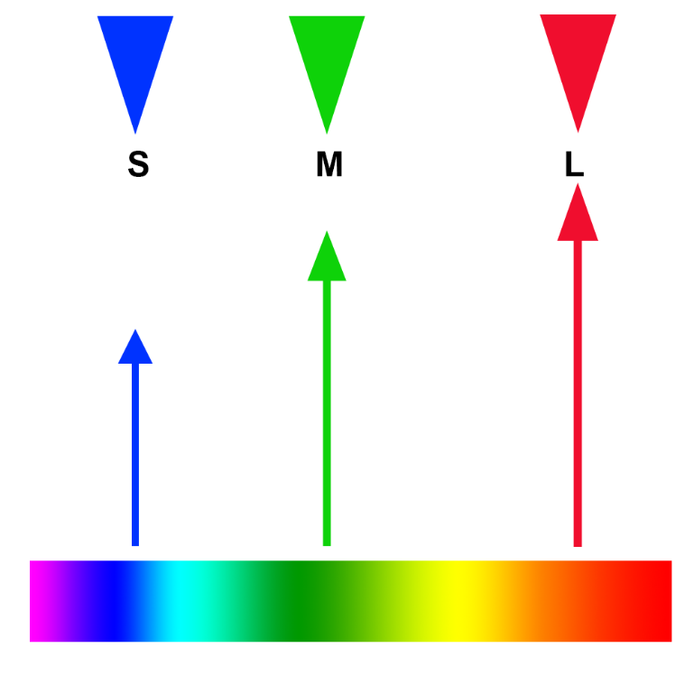

Figure L1.10: Visual representation of trichromatic theory.

There is also molecular evidence for three receptors. However, a discussion of this is beyond the scope of this class. Please consult (Forrester et al., 2016b) for more information.

### Limitations of Trichromatic Theory

Trichromatic theory assumes that images were formed by these three sets of receptors and then transmitted to the brain where the ratios of the signals in each of the images were compared in order to sort out color appearances (Fairchild, 2013). This idea of three images being transmitted to the brain is both inefficient and fails to explain several visually observed phenomena (Fairchild, 2013).

The trichromatic theory cannot exclusively explain several color perception phenomena. For example, it cannot account for the complementary afterimages in which the extended inspection of one color will lead to the subsequent perception of its complementary color. Complementary afterimages are better explained by the opponent-process theory.

## Opponent-Process Theory

In an effort to explain our perception of different hues, Ewald Hering proposed the opponent-process theory, later formalized by Leo Hurvich and Dorothea James (Meister & Tessier-Lavigne, 2013).

According to this theory, color vision involves three processes that respond in opposite ways to light of different colors (Meister & Tessier-Lavigne, 2013). Activation of one member of the pair inhibits activity in the other (Meister & Tessier-Lavigne, 2013):

* Y-B would be stimulated by yellow and inhibited by blue light
* R-G stimulated by red and inhibited by green
* White-Black stimulated by white and inhibited by black.

Consistent with this theory, no two members of a pair can be seen at the same location, which explains why we do not experience such colors as “bluish yellow” or “reddish green.”

Diving deeper than this is beyond the scope of this class. However, Figure L1.11 displays how the opponent-process theory works (these calculations are done in the brain).

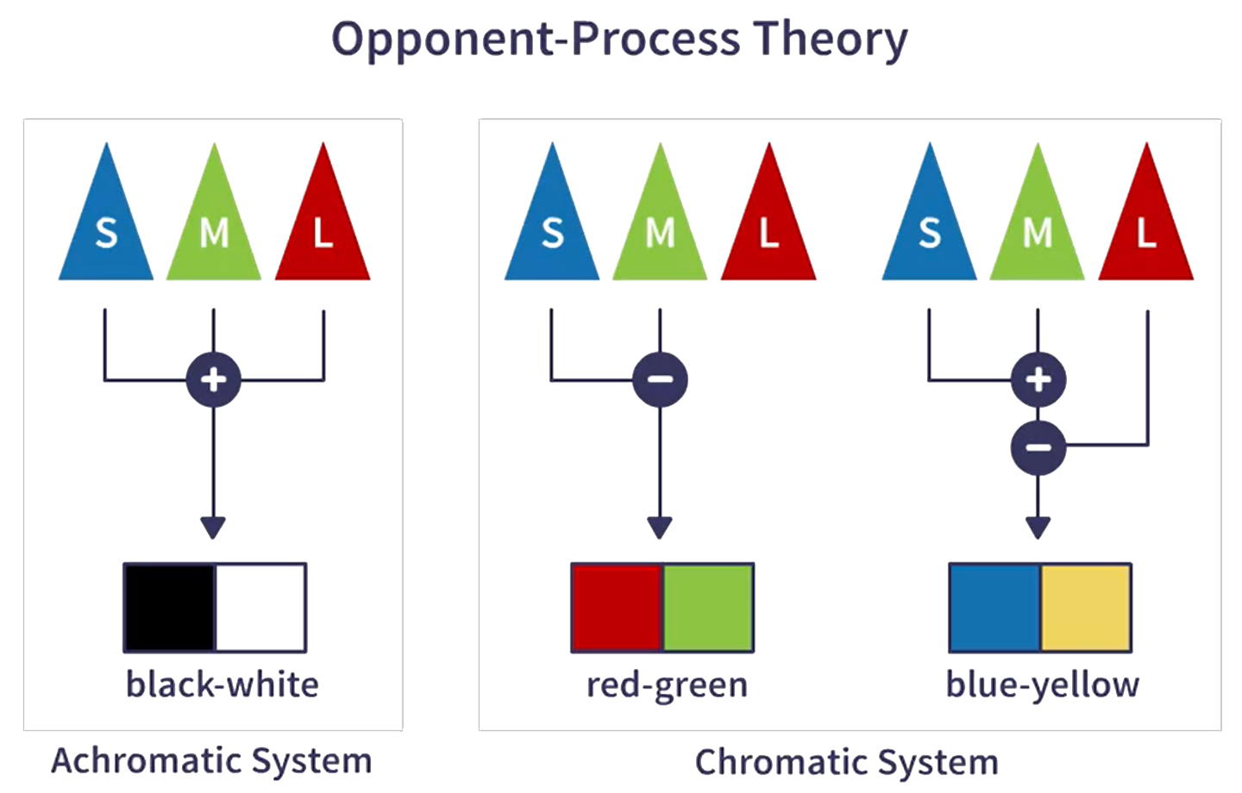

Figure L1.11: Schematic drawing of opponent-process theory.

# Color Vision Deficiency

The study of inherited variation in color vision has contributed in important ways to our understanding of the mechanisms of normal color vision (Meister & Tessier-Lavigne, 2013). The first major insight, well understood in the 19th century, is that some people have only two classes of receptors instead of the three in normal trichromatic vision (Meister & Tessier-Lavigne, 2013).

About 10% of the male population and about 1 % of the female population have some form of color vision deficiency. The most common deficiencies are explained by lack of either the long-wavelength-sensitive cones (protanopia), or the medium-wavelength-sensitive cones (deuteranopia). Both protanopia and deuteranopia result in an inability to distinguish red and green.

Color also tells us a lot about the material properties of objects. For example, is this apple still ripe? When we were hunter-gathers this distinction could be a life or death decision. In the past, men did the hunting and women did the gathering. This might explain why most men have color vision deficiency vision (CVD). If they had been gatherers, they would have been more likely to eat poison berries, which would have been a selective disadvantage.

Figure L1.12 displays the three most common types of vision deficiencies. If you are wondering why there are two images for red-green color deficiency, it is because this type of deficiency is divided into two types. Protanopia (R) people are less sensitive to red light. In contrast, deuteranopia people are less sensitiveness to green light.

Figure L1.12: Example of the three most common types of vision deficiencies.

# References

Fairchild, M. D. (2013). Human color vision [Book Section]. In M. D. Fairchild (Ed.), *Color appearance models* (pp. 1–37). <https://doi.org/10.1002/9781118653128.ch1>

Feisner, E. A., & Reed, R. (2014). What is color? [Book Section]. In *Color studies* (Third edition /, pp. xvi, 279 pages). Fairchild Books.

Forrester, J. V., Dick, A. D., McMenamin, P. G., Roberts, F., & Pearlman, E. (2016a). Chapter 1 - anatomy of the eye and orbit [Book Section]. In J. V. Forrester, A. D. Dick, P. G. McMenamin, F. Roberts, & E. Pearlman (Eds.), *The eye (fourth edition)* (pp. 1–102.e2). W.B. Saunders. https://doi.org/<https://doi.org/10.1016/B978-0-7020-5554-6.00001-0>

Forrester, J. V., Dick, A. D., McMenamin, P. G., Roberts, F., & Pearlman, E. (2016b). Chapter 5 - physiology of vision and the visual system [Book Section]. In J. V. Forrester, A. D. Dick, P. G. McMenamin, F. Roberts, & E. Pearlman (Eds.), *The eye (fourth edition)* (pp. 269–337.e2). W.B. Saunders. https://doi.org/<https://doi.org/10.1016/B978-0-7020-5554-6.00005-8>

Kandel, E. R. (2013a). Sensory coding [Book Section]. In E. R. Kandel, J. H. Schwartz, T. M. Jessell, S. A. Siegelbaum, & A. J. Hudspeth (Eds.), *Principles of neural science* (5th ed.). McGraw-Hill Medical.

Kandel, E. R. (2013b). The constructive nature of visual processing [Book Section]. In E. R. Kandel, J. H. Schwartz, T. M. Jessell, S. A. Siegelbaum, & A. J. Hudspeth (Eds.), *Principles of neural science* (5th ed.). McGraw-Hill Medical.

Meister, M., & Tessier-Lavigne, M. (2013). Low-level visual processing: The retina [Book Section]. In E. R. Kandel, J. H. Schwartz, T. M. Jessell, S. A. Siegelbaum, & A. J. Hudspeth (Eds.), *Principles of neural science* (5th ed.). McGraw-Hill Medical.

Schnapf, J. L., Kraft, T. W., & Baylor, D. A. (1987). Spectral sensitivity of human cone photoreceptors [Journal Article]. *Nature*, *325*, 439. <https://doi.org/10.1038/325439a0>

Ware, C. (2019a). Color [Book Section]. In *Information visualization: Perception for design* (4th ed., pp. 95–142). Morgan Kaufmann (Elsevier). https://doi.org/<https://doi.org/10.1016/B978-0-12-812875-6.00004-9>

Ware, C. (2019b). Foundations for an applied science of data visualization [Book Section]. In *Information visualization: Perception for design* (4th ed., pp. 1–30). Morgan Kaufmann (Elsevier). <https://doi.org/10.1016/B978-0-12-812875-6.00001-3>

Ware, C. (2019c). The environment, optics, and the display [Book Section]. In *Information visualization: Perception for design* (4th ed., pp. 31–68). Morgan Kaufmann (Elsevier). <https://doi.org/10.1016/B978-0-12-812875-6.00002-5>

Wichmann, F. A., Sharpe, L. T., & Gegenfurtner, K. R. (2002). The contributions of color to recognition memory for natural scenes [Journal Article]. *Journal of Experimental Psychology: Learning, Memory, and Cognition*, *28*(3), 509–520. <https://doi.org/10.1037//0278-7393.28.3.509>

Wu, H., Zhang, H., Zhang, X., Peng, W., Liu, Q., Liu, F., Zhang, Y., & Duan, L. (2021). Potential catastrophic water outflow from lake dian, china: Possible hydrological and ecological risks [Journal Article]. *CATENA*, *207*, 105589. https://doi.org/<https://doi.org/10.1016/j.catena.2021.105589>