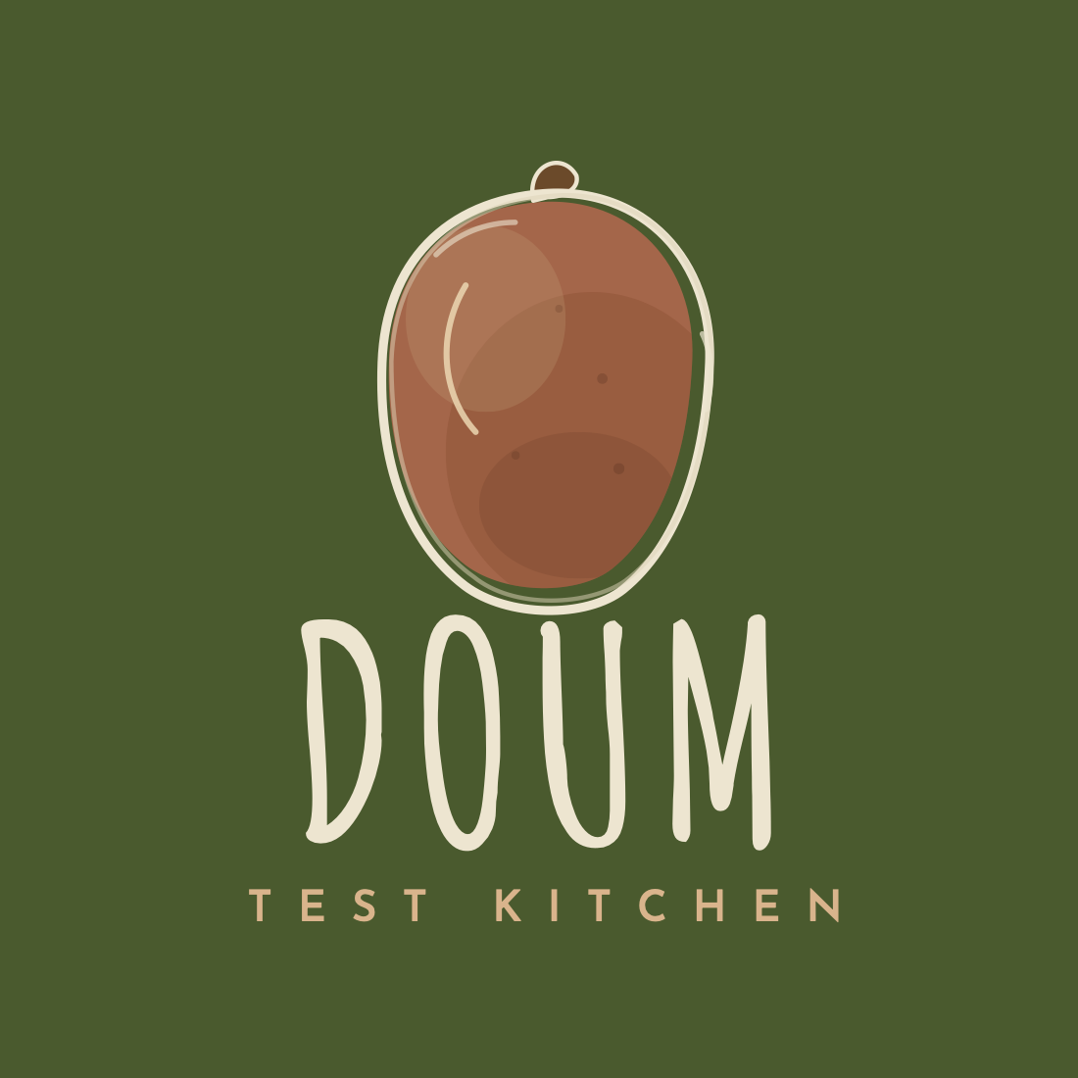
BRAND MANUAL
Doum Test Kitchen
Cairo · Egypt
Version 1.0 · 2026

1 · The Brand

Doum Test Kitchen is a Cairo-based test kitchen built on curiosity, collaboration, and a deep respect for ingredients. We pair rigorous, laboratory-minded technique with the warmth of Egyptian heritage cooking.
Our promise is fine dining, made approachable — hearty, generous food rooted in memory, presented without pretension. This manual sets out how the brand looks and sounds so that every touchpoint feels unmistakably Doum.

Brand idea
Where culinary science meets heritage.

2 · The Logo

The mark is a hand-drawn doum fruit — the fruit of the doum palm, native to Egypt. It is drawn loosely, in the spirit of an illustrator’s ink-and-wash sketch: a confident outline that sits slightly off-register from a soft terracotta wash, with gentle shading, a few skin speckles, and a small stem. The looseness is intentional; it signals a kitchen that is handmade, exploratory, and human.
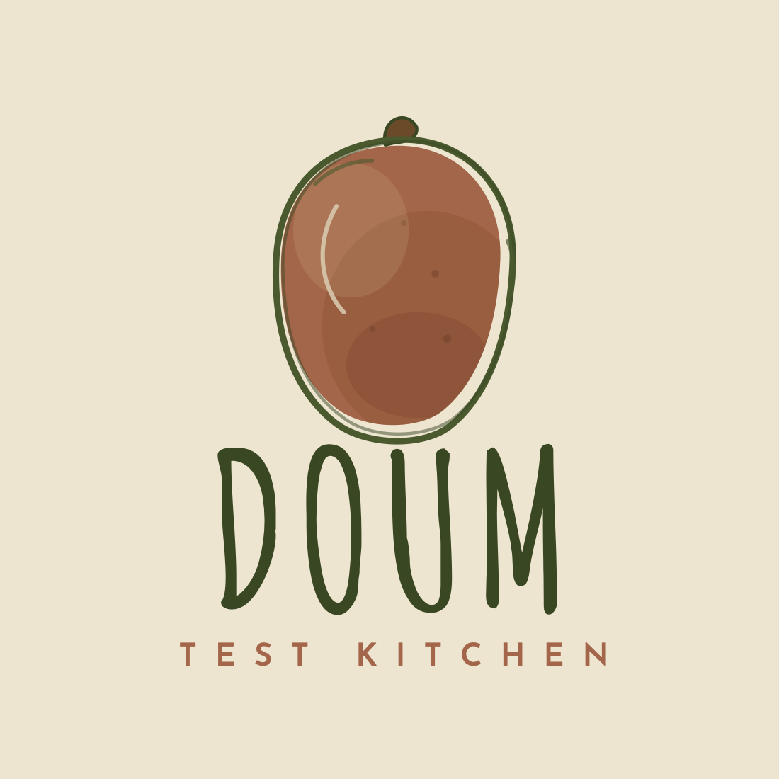
Primary lockup — fruit mark with the Amatic SC wordmark and Josefin Sans sub-label.

3 · Logo Variations

Use the version that gives the clearest contrast against its background. The badge and minimal marks exist for small and square placements.
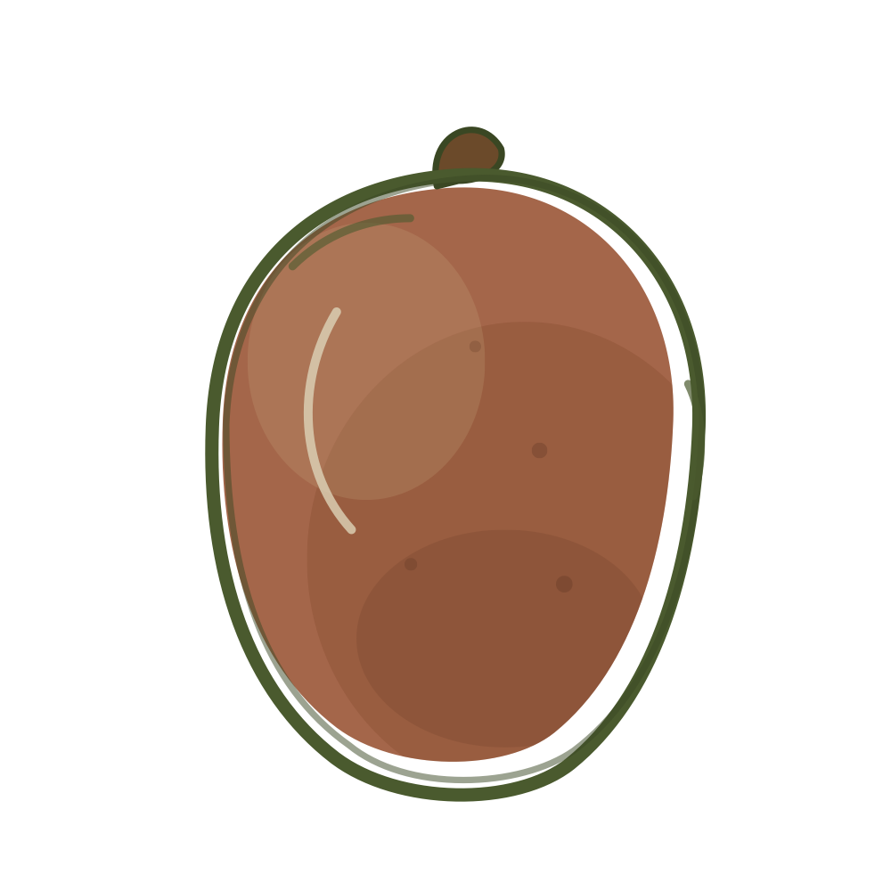  Primary mark  Light backgrounds | 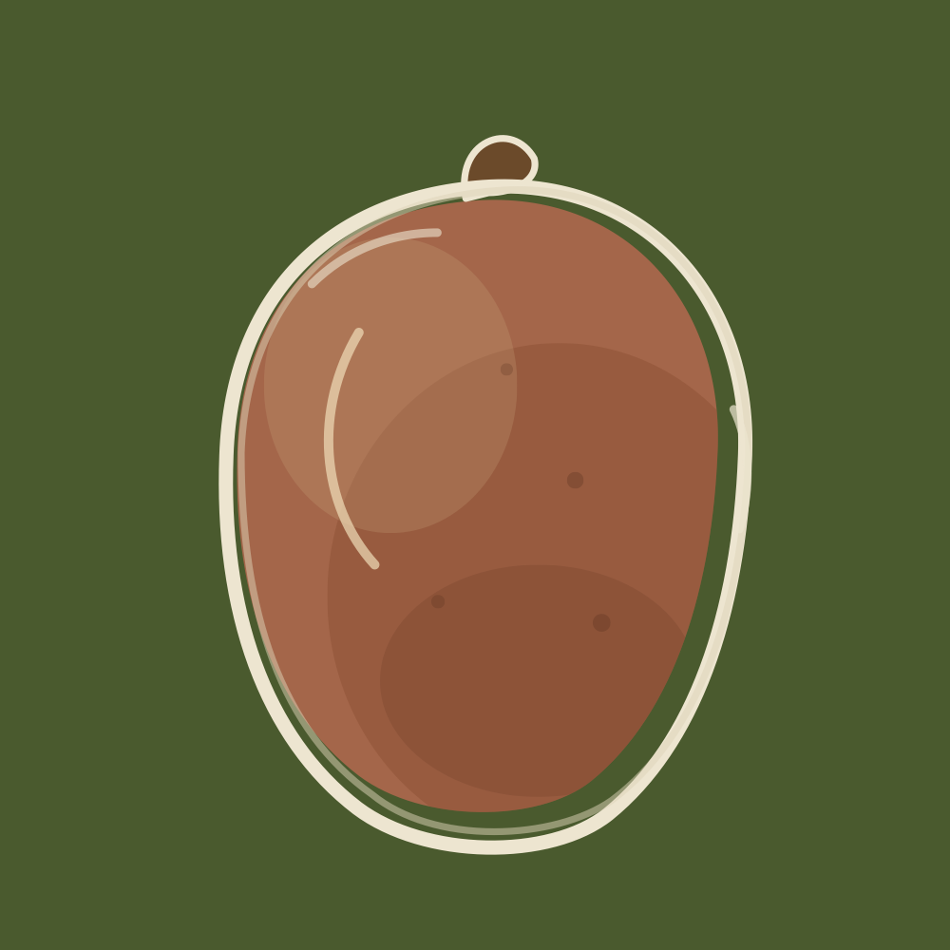  Reversed  Dark / green backgrounds
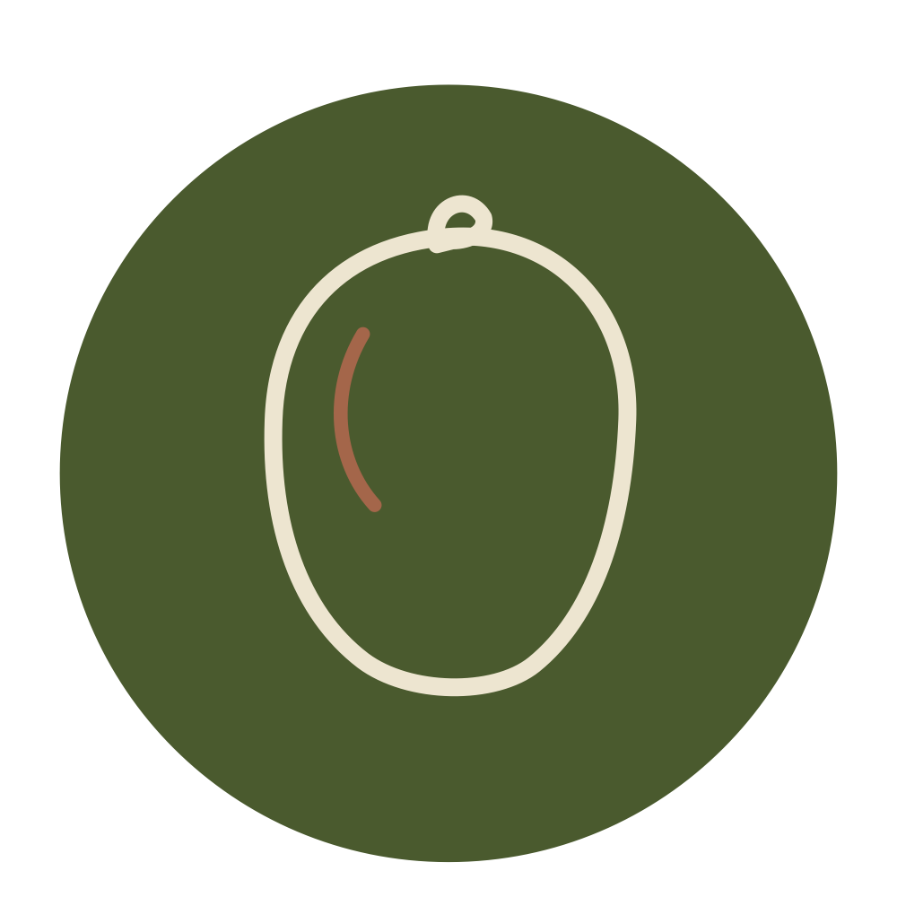  Badge  Avatar · social · stamps | 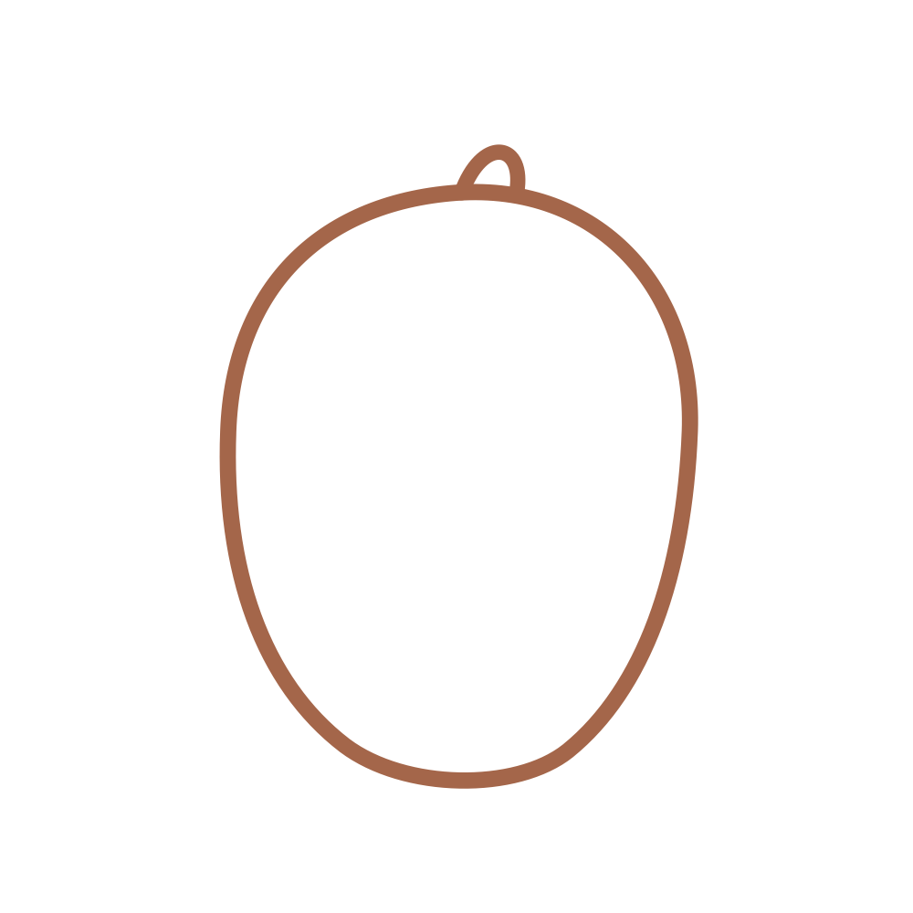  Minimal  Favicon · tiny sizes
  Lockup — light  Full logo on cream |   Lockup — dark  Full logo on green

4 · Usage & Clear Space

Do
- Keep clear space around the logo equal to at least the height of the fruit’s stem on all sides.
- Use the reversed (cream-outline) mark on olive green or photography; use the primary (olive-outline) mark on cream and light surfaces.
- Reach for the badge on circular placements — social avatars, stickers, stamps — and the minimal mark for favicons.

Don’t
- Don’t recolour the fruit outside the brand palette or add effects, gradients, or drop shadows.
- Don’t stretch, rotate, or outline the wordmark, and don’t place the olive-outline mark on a dark background where it disappears.
- Don’t reintroduce the old palm-sprout symbol — the doum fruit alone is the mark.

5 · Colour Palette

Four core colours carry the brand, supported by two secondary shades. Pair olive green with cream, and let terracotta do the accenting.
 | Olive Green  #4A5A2E | Primary brand colour — backgrounds, the Services section, headings.
 | Deep Olive  #3A4723 | Logo outline, footers, deepest shade for contrast.
 | Cream  #EDE5D0 | Primary surface and reversed type on dark backgrounds.
 | Terracotta  #A4664A | Accent — the doum fruit, labels, dividers, call-to-action highlights.
 | Mid Olive  #5C7139 | Secondary green for hover states and subtle layering.
 | Cream Dark  #DDD3B8 | Secondary surface, sheen highlights, soft borders.

6 · Typography

Amatic SC — Display & wordmark
The hand-drawn display face used for “DOUM” and large headlines. It carries the same warm, handmade quality as the fruit mark. Use Bold weight for the wordmark.

Josefin Sans — Labels & body
A clean geometric sans for sub-labels, navigation, captions, and running text. Use generous letter-spacing in uppercase for small labels such as “TEST KITCHEN”.
Both are free Google Fonts, keeping the brand easy to apply across web and print.

7 · Contact

EMAIL
doumtestkitchen@gmail.com
PHONE
+20 102 255 9335
+20 111 600 2086
LOCATION
Cairo, Egypt
WEB
doum-kitchen.github.io

