**Q1) Explain the following diagrams:**

**USTHB / FGMGP / Master I (TMPF) / Technical English / 2024-2025 / deadline: 09/ 02/2025 First homework SII**

**Name: MADANI BadrEddine**

**Ref. N°:181831085907**

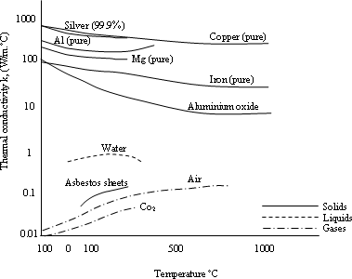a)

The thermal conductivity also various with

temperature, this variation, for some materials

over certain temperature range is small enough to be neglected, but for many cases the variation

of k with temperature is significant. Especially at very low temperature k varies rapidly with

temperature; for example, the thermal conductivities of copper, aluminum or silver reach values

50 to 100 times those that occur at room temperature.

The Figure. illustrates how the thermal

conductivity of some engineering materials varies with

1. in the figure the highest value is for highly conducting pure metals and lowest value is for gases

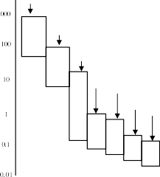

Thermal conductivity k, (W/m.°C)

Solid metals

Liquid metals

Non-metallic solids

Non-metallic liquids

Insulating materials

Evacuated insulating materials

and vapors, excluding the evacuated insulating 1

Non-metallic gases

systems. The nonmetallic solids and liquids have thermal conductivities that lie between them.

Metallic single crystals are exceptions,which may have very high thermal conductivities

**Q2) Define the following terms:**

# Conduction

Heat transfer through direct molecular interaction or electron drift, especially in solids

# Thermal conductivity

A material property quantifying heat conduction ability, defined by Fourier’s Law

# Heat flow

The rate of thermal energy transfer from one body to another due to a temperature difference.

# Heat

Thermal energy transferred due to a temperature difference, governed by the second law of thermodynamics.

# Metallic single crystals

Metallic single crystals are metals with a very high thermal conductivity value.

# Convection

Transfer of heat by conduction in a moving medium, such as a fluid

# Radiation

Transfer of heat by electromagnetic radiation or, equivalently, by photons.

# Heat transfer coefficient

A measure of convective heat transfer efficiency, relating heat flux to temperature difference.

# Evacuated insulating systems

Insulation materials with air removed, minimizing gas conduction for ultra-low k.

# Silver and copper

Metals with the highest thermal and electrical conductivity due to abundant free electrons.

|  |  |
| --- | --- |
| **Q3) Complete the following sentences:** |  |
| - Highest thermal conductivity metals | (Silver and copper.) |
| - Highest electrical conductivity metals | (Silver and copper.) |
| - Highest values of k are for | (Pure metals) |
| - How carries the heat of boiling | (Steam) |
| - Properties can dictate the use of materials | (Thermal conductivity, melting point, electrical conductivity.) |
| - Highest melting point metals | (Tungsten) |
| - Amount of k depends on | (Material type, temperature, and atomic structure) |
| - Heat transfer occurs as a result of | (Temperature difference) |
| - Why metals are good electric conductors | (Abundance of free electrons facilitating charge and heat transfer.) |
| - Lowest electrical conductivity elements | (Nonmetals) |

**Good Luck**

1