OFFICE RESEARCH REPORT
Document parsing regression sample for Collector Issue #122
Audience: Research-tool evaluators
Status: Synthetic and public-safe
Purpose: Office-document regression only; not the core research benchmark

1. Executive summary
This synthetic report checks whether a DOCX parser preserves headings, paragraphs, a real table, and an embedded image while keeping a stable paragraph-level location. It is intentionally ordinary: office documents are a regression group, not the benchmark's main research-material claim.

1.1 Decision criteria
A candidate passes this sample when the reading order is intact, the heading ladder remains visible, table cells remain associated with their row and column, and the figure is reported as an image resource rather than fabricated prose.

2. Observed results
Parser mode | Reading value | Citation value
Plain text | Partial | Low
Structure aware | High | High
Silent fallback | Misleading | Unacceptable
Source: anonymous synthetic measurements for #122.
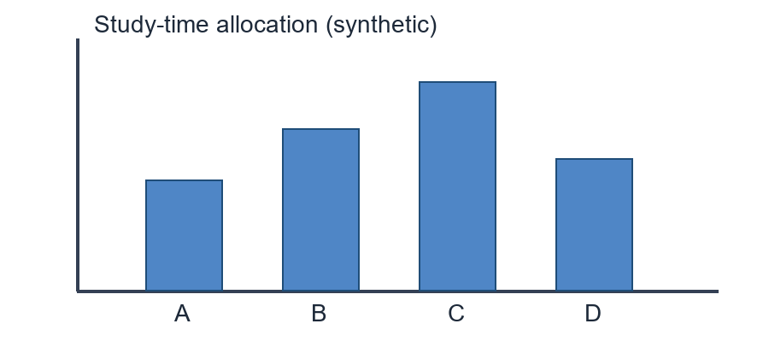
Figure 1. Synthetic quality profile used only to test image extraction.

3. Reproducibility notes
The sample is generated from source code and contains no personal names, private files, external URLs, or copied publication text. A parser may legitimately omit visual styling, but it must not change the meaning of the table or invent a description for the figure.

3.1 References
- Example Standards Group. Structured office documents. Synthetic edition, 2025.
- Collector Project. Anonymous document parsing protocol #122, 2026.

