Document title

The following image has no caption and is inline. 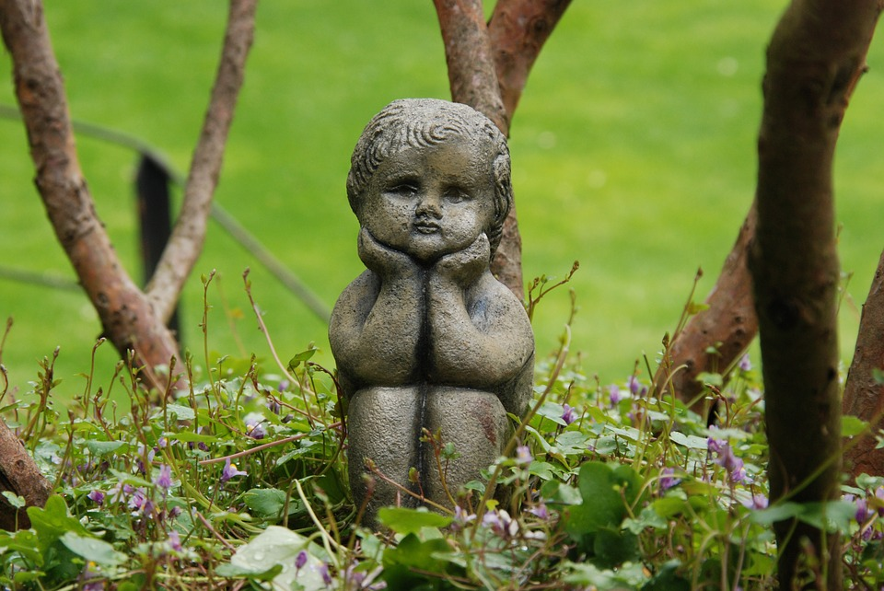

The following image has no caption and lives in its own paragraph.



The following image has a caption.



Figure 1This image comes from <https://pixabay.com/photos/image-statue-brass-child-art-1465348/> and is free to use, even for commercial purposes, even without attribution. [Another link](https://pixabay.com/photos/image-statue-brass-child-art-1465348/).