CS5200 Homework10
Question1
In this problem I do not show the exact operation like “X=X-N”, “Y=Y+N”, “X=X+M”
Schedule1:
Time | Transaction1 | Transaction2
T1 | READ(X)
T2 | WRITE(X)
T3 |  | READ(X)
T4 |  | WRITE(X)
T5 | READ(Y)
T6 | WRITE(Y)
Sechdule1 is conflict serializable.

Schedule2:
Time | Transaction1 | Transaction2
T1 | READ(X)
T2 | WRITE(X)
T3 | READ(X)
T4 | WRITE(Y)
T5 |  | READ(X)
T6 |  | WRITE(X)
Schedule2 is conflict serializable (serial schedule).

Schedule3:
Time | Transaction1 | Transaction2
T1 |  | READ(X)
T2 |  | WRITE(X)
T3 | READ(X)
T4 | WRITE(X)
T5 | READ(Y)
T6 | WRITE(Y)
Schedule3 is conflict serializable (serial schedule).

Schedule4:
Time | Transaction1 | Transaction2
T1 | READ(X)
T2 | WRITE(X)
T3 | READ(Y)
T4 |  | READ(X)
T5 |  | WRITE(X)
T6 | WRITE(Y)
Schedule 4 is conflict serializable.
Schedule5:
Time | Transaction1 | Transaction2
T1 | READ(X)
T2 | WRITE(X)
T3 |  | READ(X)
T4 | READ(Y)
T5 |  | WRITE(X)
T6 | WRITE(Y)
Schedule5 is conflict serializable.

Schedule6:
Time | Transaction1 | Transaction2
T1 | READ(X)
T2 | WRITE(X)
T3 |  | READ(X)
T4 | READ(Y)
T5 | WRITE(Y)
T6 |  | WRITE(X)
Schedule6 is conflict serializable.

Schedule7:
Time | Transaction1 | Transaction2
T1 | READ(X)
T2 | WRITE(X)
T3 | READ(Y)
T4 |  | READ(X)
T5 | WRITE(Y)
T6 |  | WRITE(X)
Schedule7 is conflict serializable.

Schedule8:
Time | Transaction1 | Transaction2
T1 | READ(X)
T2 |  | READ(X)
T3 |  | WRITE(X)
T4 | WRITE(X)
T5 | READ(Y)
T6 | WRITE(Y)
Schedule8 is not conflict serializable.

Schedule 9:
Time | Transaction1 | Transaction2
T1 | READ(X)
T2 |  | READ(X)
T3 | WRITE(X)
T4 |  | WRITE(X)
T5 | READ(Y)
T6 | WRITE(Y)
Schedule9 is not conflict serializable.

Schedule10:
Time | Transaction1 | Transaction2
T1 |  | READ(X)
T2 | READ(X)
T3 |  | WRITE(X)
T4 | WRITE(X)
T5 | READ(Y)
T6 | WRITE(Y)
Schedule10 is not conflict serializable.

Schedule11:
Time | Transaction1 | Transaction2
T1 | READ(X)
T2 |  | READ(X)
T3 |  | WRITE(X)
T4 | WRITE(X)
T5 | READ(Y)
T6 | WRITE(Y)
Schedule11 is not conflict serializable.

Schedule12:
Time | Transaction1 | Transaction2
T1 | READ(X)
T2 |  | READ(X)
T3 | WRITE(X)
T4 | READ(Y)
T5 |  | WRITE(X)
T6 | WRITE(Y)
Schedule12 is not conflict serializable.

Schedule13:
Time | Transaction1 | Transaction2
T1 | READ(X)
T2 |  | READ(X)
T3 | WRITE(X)
T4 | READ(Y)
T5 | WRITE(Y)
T6 |  | WRITE(X)
Schedule13 is not conflict serializable.

Schedule14:
Time | Transaction1 | Transaction2
T1 |  | READ(X)
T2 | READ(X)
T3 | WRITE(X)
T4 | READ(Y)
T5 |  | WRITE(X)
T6 | WRITE(Y)
Schedule14 is not conflict serializable.

Schedule15:
Time | Transaction1 | Transaction2
T1 |  | READ(X)
T2 | READ(X)
T3 | WRITE(X)
T4 | READ(Y)
T5 | WRITE(Y)
T6 |  | WRITE(X)
Schedule15 is not conflict serializable.

Question2
Schedule1 and schedule2 are not conflict serializable.
Schedule3 is conflict serializable.
Schedule3 can be converted into serial schedule as below:
Serial schedule (converted from schedule3)
T2 Read(X)
T3 Read(X)
T3 Write(X)
T1 Read(X)
T1 Write(X)

Question3*
Schedule1:
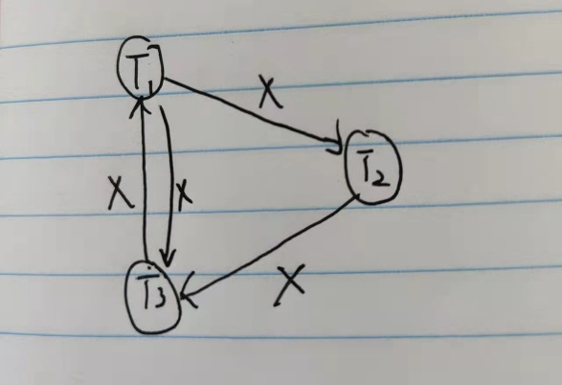
Schedule2:
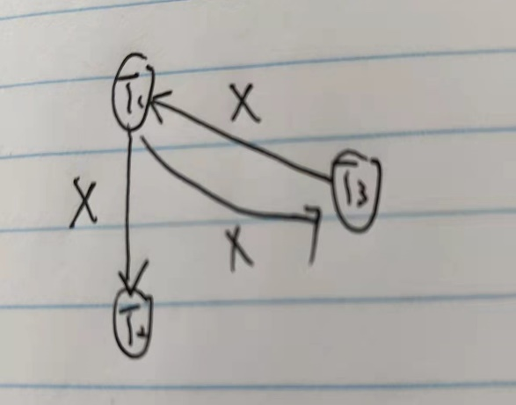
Schedule3:
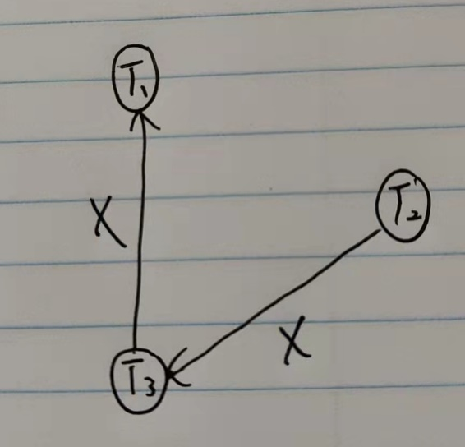

Question4
As we can see in the plot above, transaction T17 first begins and it applies a write_lock to lock the item bal_{x}, and then transaction T18 begins and it applies a write_lock to lock the item bal_{y.}
After writing the bal_{x}, transaction T17 wants to apply write_lock on bal_{y} in the next, so it needs to wait T18 for committing/unlocking bal_{y}. In the same way, T18 wants to lock bal_{x} after writing bal_{y} but it needs to wait T17’s committing/unlocking bal_{x}. And then T17 waits T18’s committing/unlocking and T18 waits T17’s committing/unlocking and there is no end for this waiting. It can be called deadlock.
In a word, deadlock is an impasse that may result when two (or more) transactions are each waiting for locks held by the other to be released.

Question5
I use tables to show the process of timestamp protocol (I will not show all time but some time).
When time = 3:
 | X | Y | Z
READ |  | 1 | 1
WRITE |  | 1

 | Transaction A | Transaction B | Transaction C
TS |  | 1

When time = 4:
TS(C) = 4, WRITE(Y) = 1, READ(Y) = 1, so operation is accepted and executed, set READ(Y) = 4
When time = 5:
Set READ(Z) = 4
 | X | Y | Z
READ |  | 4 | 4
WRITE |  | 1

 | Transaction A | Transaction B | Transaction C
TS |  | 1 | 4
When time = 7:
 | X | Y | Z
READ | 6 | 4 | 4
WRITE | 6 | 1

 | Transaction A | Transaction B | Transaction C
TS | 6 | 1 | 4

When time = 8:
Originally, WRITE(Y) = 1, READ(Y) = 4, and TS(C) = 4, so transaction C’s version of Y is not obsolete. Operation is accepted and executed. Set WRITE(Y) = TS(C).
 | X | Y | Z
READ | 6 | 4 | 4
WRITE | 6 | 4

 | Transaction A | Transaction B | Transaction C
TS | 6 | 1 | 4

When time = 9:
 | X | Y | Z
READ | 6 | 4 | 4
WRITE | 6 | 4 | 4

 | Transaction A | Transaction B | Transaction C
TS | 6 | 1 | 4

When time = 10:
We can find that WRITE(X) = 6, and TS(B) = 1, so TS(B) < WRITE(X), so at this time transaction B need to be rolled back and restarted (using a later timestamp, i.e. 13).

 | X | Y | Z
READ | 6 | 4 | 4
WRITE | 6 | 4 | 4

 | Transaction A | Transaction B | Transaction C
TS | 6 | 13 | 4

When time = 11:
TS(A) = 6, WRITE(Y) = 4, so transaction A’s version of Y is not obsolete. Operation is accepted and executed. Set READ(Y) = 6.
 | X | Y | Z
READ | 6 | 6 | 4
WRITE | 6 | 4 | 4

 | Transaction A | Transaction B | Transaction C
TS | 6 | 13 | 4

When time = 12:
TS(A) = 6, WRITE(Y) = 4, so set WRITE(Y) = 6.
 | X | Y | Z
READ | 6 | 6 | 4
WRITE | 6 | 6 | 4

 | Transaction A | Transaction B | Transaction C
TS | 6 | 13 | 4

In conclusion, transaction B needs to be restarted at time = 10 (using BTO).

Question6
We can find that T1 commits before checkpoint, so T1 data has been flushed into disk. We do not need to do anything on operations of T1.
T4 commits after checkpoint before system crashes, so all operations of T4 in the log need to be redone. So T4 READ(D), T4 WRITE(D, 25, 15), T4 READ(A), T4 WRITE(A, 30, 20) are redone.
T2 and T3 do not commit before system crashes, so all operations of T2 and T3 are undone. So T2 READ(B), T2 WRITE(B, 12, 18), T3 WRITE(C, 30, 40), T2 READ(D), T2 WRITE(D, 15, 25) are undone.
T4 processes data item A and D, T2 processes data item B and D, but T4 commits before T2, and T2 reads (D) after T4 commits (A and D), so it is cascadeless schedule and this schedule is recoverable(D), this will not cause a rollback, so there will be no cascading rollback.

Question7
Cascading rollback is when a single transaction failure leads to a series of transaction rollbacks.
Such a single transaction (which fails) must operate on the same data item with other transactions, and commit(if not fails) before other transactions read the data item.

Like the plot below, transaction 11 writes A and C before transaction 12 reads A,B and transaction 13 reads B,C. When t = 12, transaction 11 rollbacks, transaction 12 has written B but not written A, and transaction 13 has not written B,C. So when transaction 11 rollbacks, the value of A in transaction 12 and the value of B,C in transaction 13 are not correct, so transaction 12 and 13 need to be restarted. It is can be an example of cascading rollback.
